*[Bear Run Village | 100 Bear Run Dr, Pittsburgh, PA](https://www.zillow.com/b/bear-run-village-pittsburgh-pa-5Xt4Pg/)*

$1,286+ 1 bd

* + **$1,557+** 2 bds
  + **$2,036+** 3 bds

[[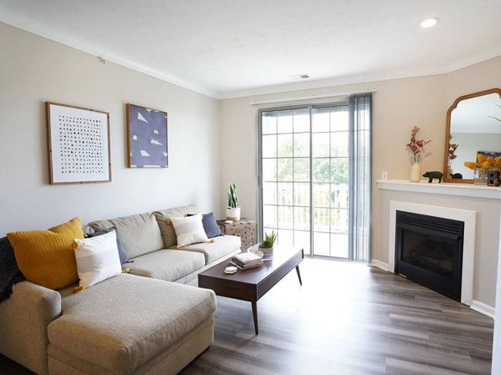](https://www.zillow.com/b/bear-run-village-pittsburgh-pa-5Xt4Pg/)](https://www.zillow.com/b/bear-run-village-pittsburgh-pa-5Xt4Pg/)

*[Maiden Bridge and Canongate Apartment Homes | 100 White Hampton Ln, Pittsburgh, PA](https://www.zillow.com/b/maiden-bridge-and-canongate-apartment-homes-pittsburgh-pa-5Xj9DZ/)*

$1,285+ 1 bd

* **$1,525+** 2 bds

[[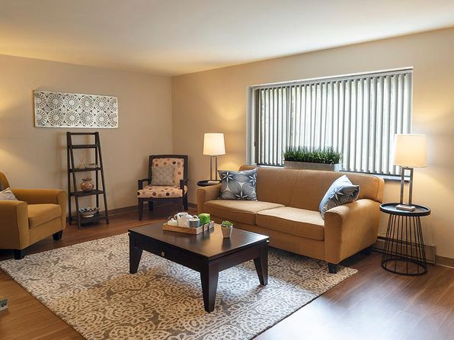](https://www.zillow.com/b/maiden-bridge-and-canongate-apartment-homes-pittsburgh-pa-5Xj9DZ/)](https://www.zillow.com/b/maiden-bridge-and-canongate-apartment-homes-pittsburgh-pa-5Xj9DZ/)

• Loading...

•

*[St. Clair Woods Apartments | 1000 Painters Dr, Pittsburgh, PA](https://www.zillow.com/b/st.-clair-woods-apartments-pittsburgh-pa-BdcNjp/)*

$1,395+ 2 bds

[[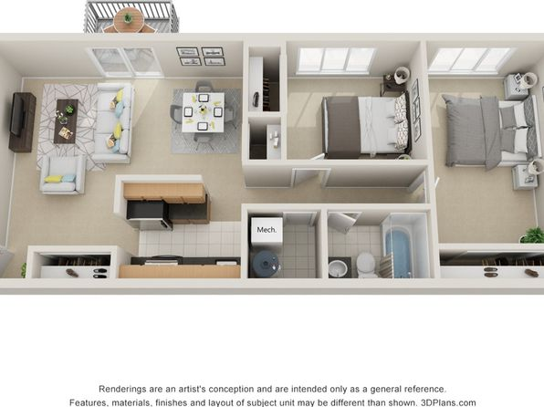](https://www.zillow.com/b/st.-clair-woods-apartments-pittsburgh-pa-BdcNjp/)](https://www.zillow.com/b/st.-clair-woods-apartments-pittsburgh-pa-BdcNjp/)

*[Club at North Hills Apartment Homes | 700 Duncan Ave, Pittsburgh, PA](https://www.zillow.com/b/club-at-north-hills-apartment-homes-pittsburgh-pa-5yFX8T/)*

$1,215+ 1 bd

* **$1,640+** 2 bds

[[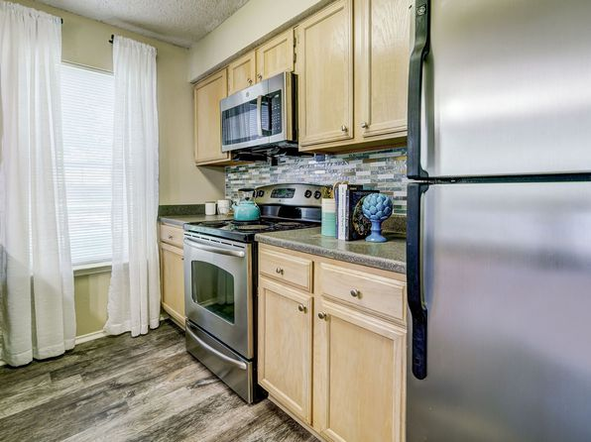](https://www.zillow.com/b/club-at-north-hills-apartment-homes-pittsburgh-pa-5yFX8T/)](https://www.zillow.com/b/club-at-north-hills-apartment-homes-pittsburgh-pa-5yFX8T/)

*[Kaufmann's | 434 5th Ave, Pittsburgh, PA](https://www.zillow.com/b/kaufmann%27s-pittsburgh-pa-B75ZTC/)*

$1,550+ Studio

* **$1,795+** 1 bd
* **$2,875+** 2 bds

[[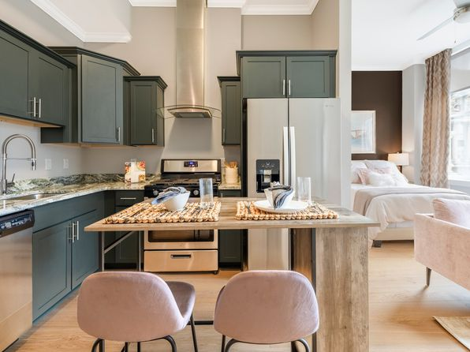](https://www.zillow.com/b/kaufmann%27s-pittsburgh-pa-B75ZTC/)](https://www.zillow.com/b/kaufmann%27s-pittsburgh-pa-B75ZTC/)

*[Flats at Southside Works | 2635 E Carson St, Pittsburgh, PA](https://www.zillow.com/b/flats-at-southside-works-pittsburgh-pa-5jBr9d/)*

$1,595+ 1 bd

* **$2,195+** 2 bds

[[](https://www.zillow.com/b/flats-at-southside-works-pittsburgh-pa-5jBr9d/)](https://www.zillow.com/b/flats-at-southside-works-pittsburgh-pa-5jBr9d/)

*[The Cascades Apartments and Townhomes | 100 E West Dr, Pittsburgh, PA](https://www.zillow.com/b/the-cascades-apartments-and-townhomes-pittsburgh-pa-5Xj98c/)*

$1,135+ 1 bd

* **$1,385+** 2 bds

[[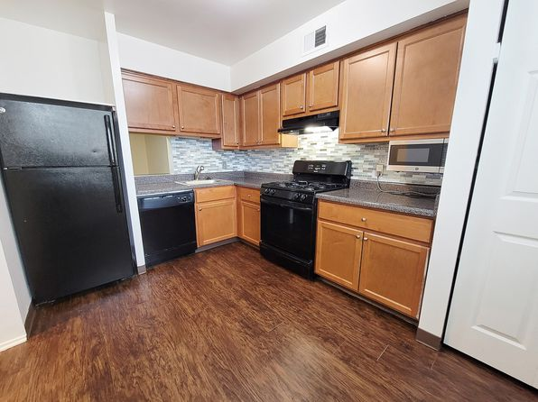](https://www.zillow.com/b/the-cascades-apartments-and-townhomes-pittsburgh-pa-5Xj98c/)](https://www.zillow.com/b/the-cascades-apartments-and-townhomes-pittsburgh-pa-5Xj98c/)

*[2626 South Side Flats | 2626 Tunnel Blvd, Pittsburgh, PA](https://www.zillow.com/b/2626-south-side-flats-pittsburgh-pa-65d6zy/)*

$1,228+ Studio

* **$1,565+** 1 bd
* **$1,910+** 2 bds

[[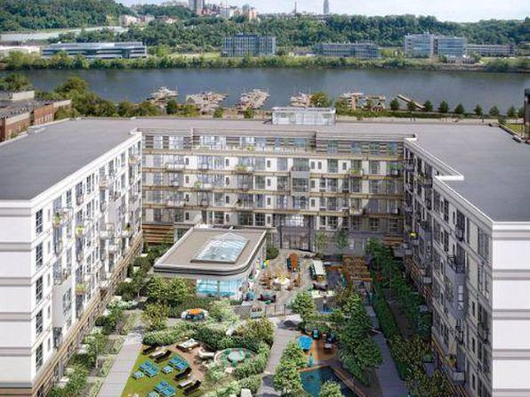](https://www.zillow.com/b/2626-south-side-flats-pittsburgh-pa-65d6zy/)](https://www.zillow.com/b/2626-south-side-flats-pittsburgh-pa-65d6zy/)

*[The Foundry at 41st | 4107 Willow St, Pittsburgh, PA](https://www.zillow.com/b/the-foundry-at-41st-pittsburgh-pa-98N2jm/)*

$1,548+ Studio

* **$2,254+** 1 bd
* **$3,345+** 2 bds

[[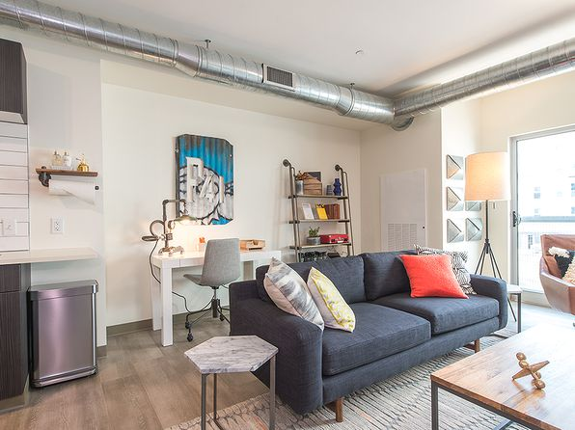](https://www.zillow.com/b/the-foundry-at-41st-pittsburgh-pa-98N2jm/)](https://www.zillow.com/b/the-foundry-at-41st-pittsburgh-pa-98N2jm/)

*[Edge 1909 | 1909 Waterfront Pl, Pittsburgh, PA](https://www.zillow.com/b/edge-1909-pittsburgh-pa-BChH5Q/)*

$1,892+ 1 bd

* **$2,651+** 2 bds

3D Tour

[[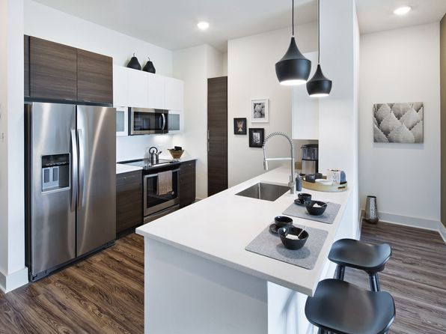](https://www.zillow.com/b/edge-1909-pittsburgh-pa-BChH5Q/)](https://www.zillow.com/b/edge-1909-pittsburgh-pa-BChH5Q/)

*[Torrente Apartment Homes | 2565 Boyce Plaza Rd, Pittsburgh, PA](https://www.zillow.com/b/torrente-apartment-homes-upper-saint-clair-pa-63HfVj/)*

$1,400+ 1 bd

* **$1,670+** 2 bds

[[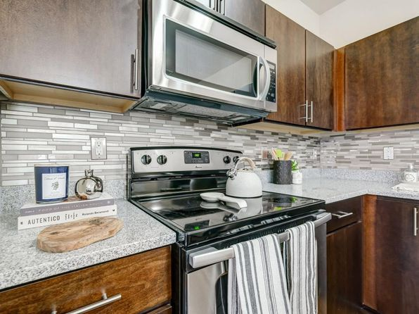](https://www.zillow.com/b/torrente-apartment-homes-upper-saint-clair-pa-63HfVj/)](https://www.zillow.com/b/torrente-apartment-homes-upper-saint-clair-pa-63HfVj/)

*[Industry Pittsburgh | 5803 Centre Ave, Pittsburgh, PA](https://www.zillow.com/b/industry-pittsburgh-pittsburgh-pa-98NJB2/)*

$1,945+ Studio

* **$2,105+** 1 bd
* **$3,150+** 2 bds

[[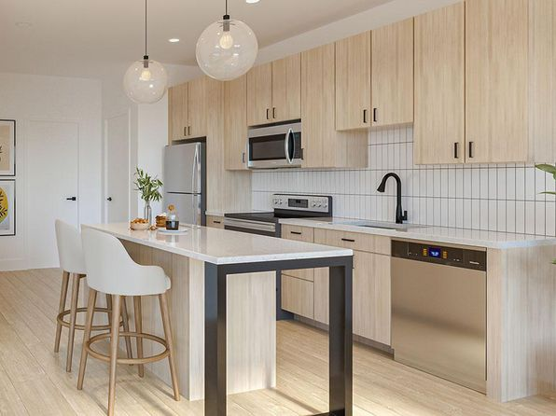](https://www.zillow.com/b/industry-pittsburgh-pittsburgh-pa-98NJB2/)](https://www.zillow.com/b/industry-pittsburgh-pittsburgh-pa-98NJB2/)

*[Connection at South Side | 2984 Sidney St, Pittsburgh, PA](https://www.zillow.com/b/connection-at-south-side-pittsburgh-pa-BXD49d/)*

$1,735+ Studio

* **$1,795+** 1 bd
* **$2,375+** 2 bds

Updated yesterday

[[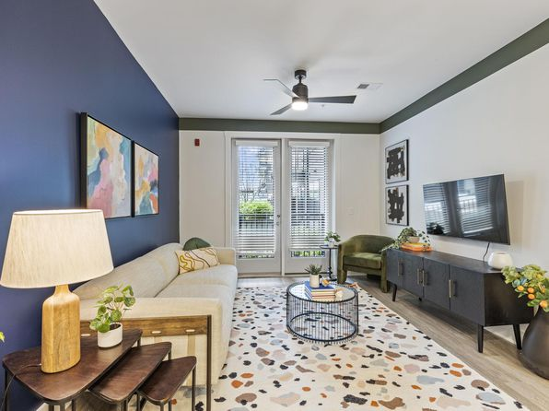](https://www.zillow.com/b/connection-at-south-side-pittsburgh-pa-BXD49d/)](https://www.zillow.com/b/connection-at-south-side-pittsburgh-pa-BXD49d/)

*[Encore Apartments | 100 7th St, Pittsburgh, PA](https://www.zillow.com/b/the-encore-on-7th-pittsburgh-pa-5Xj9Qq/)*

$2,040+ 1 bd

* **$2,155+** 2 bds

[[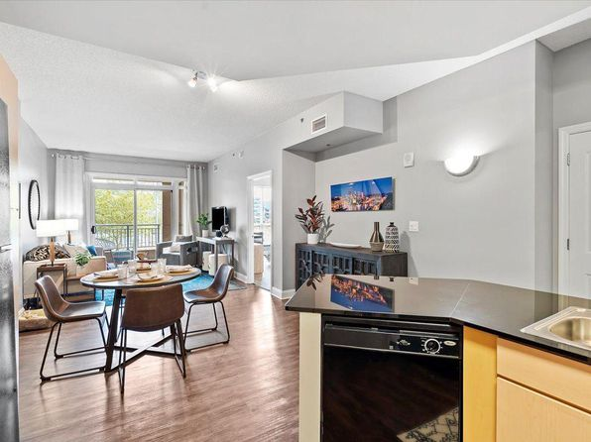](https://www.zillow.com/b/the-encore-on-7th-pittsburgh-pa-5Xj9Qq/)](https://www.zillow.com/b/the-encore-on-7th-pittsburgh-pa-5Xj9Qq/)

*[Bryn Mawr | 100 Bryn Mawr Ct, Pittsburgh, PA](https://www.zillow.com/b/bryn-mawr-pittsburgh-pa-5Xj8VF/)*

$1,201+ 1 bd

* **$1,401+** 2 bds

3D Tour

[[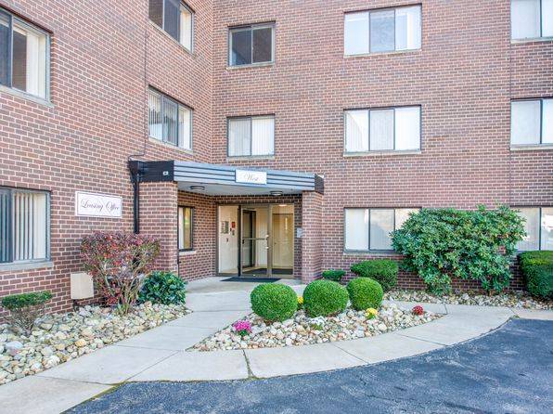](https://www.zillow.com/b/bryn-mawr-pittsburgh-pa-5Xj8VF/)](https://www.zillow.com/b/bryn-mawr-pittsburgh-pa-5Xj8VF/)

• Loading...

•

*[Park West 205 Apartment Homes | 1000 Park West Pl, Pittsburgh, PA](https://www.zillow.com/b/park-west-205-apartment-homes-pittsburgh-pa-BLmmhK/)*

$1,440+ 1 bd

* **$1,720+** 2 bds

[[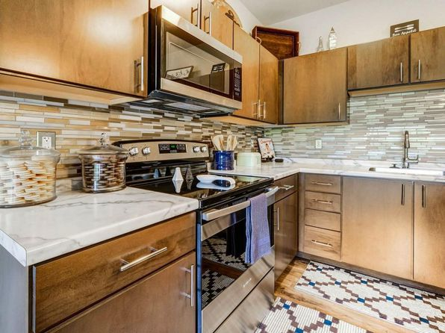](https://www.zillow.com/b/park-west-205-apartment-homes-pittsburgh-pa-BLmmhK/)](https://www.zillow.com/b/park-west-205-apartment-homes-pittsburgh-pa-BLmmhK/)

*[The Ashby at South Hills Village Station | 1100 Village Dr, Pittsburgh, PA](https://www.zillow.com/b/the-ashby-at-south-hills-village-station-pittsburgh-pa-BJ345N/)*

$1,624+ 1 bd

* **$2,086+** 2 bds
* **$2,303+** 3 bds

[[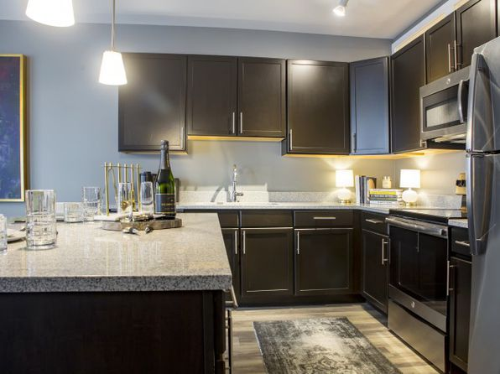](https://www.zillow.com/b/the-ashby-at-south-hills-village-station-pittsburgh-pa-BJ345N/)](https://www.zillow.com/b/the-ashby-at-south-hills-village-station-pittsburgh-pa-BJ345N/)

*[Apartments at River View | 300 Liberty Ave, Pittsburgh, PA](https://www.zillow.com/b/apartments-at-river-view-pittsburgh-pa-5XsV6P/)*

$1,199+ Studio

* **$1,299+** 1 bd
* **$3,000+** 2 bds

3D Tour

[[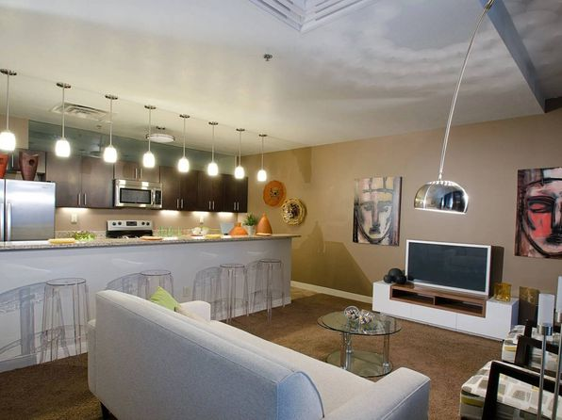](https://www.zillow.com/b/apartments-at-river-view-pittsburgh-pa-5XsV6P/)](https://www.zillow.com/b/apartments-at-river-view-pittsburgh-pa-5XsV6P/)

*[Coda on Centre | 5765 Centre Ave, Pittsburgh, PA](https://www.zillow.com/b/coda-on-centre-pittsburgh-pa-B8WNtc/)*

$1,855+ Studio

* **$2,150+** 1 bd
* **$3,175+** 2 bds

3D Tour

[[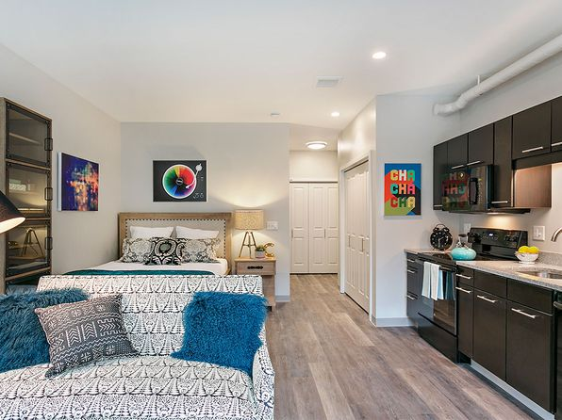](https://www.zillow.com/b/coda-on-centre-pittsburgh-pa-B8WNtc/)](https://www.zillow.com/b/coda-on-centre-pittsburgh-pa-B8WNtc/)

*[The Yards at 3 Crossings | 2645 Railroad St E, Pittsburgh, PA](https://www.zillow.com/b/the-yards-at-3-crossings-pittsburgh-pa-98PLCt/)*

$1,449+ Studio

* **$1,899+** 1 bd
* **$2,701+** 2 bds

3D Tour

[[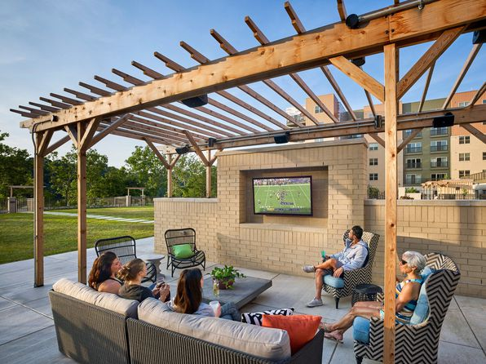](https://www.zillow.com/b/the-yards-at-3-crossings-pittsburgh-pa-98PLCt/)](https://www.zillow.com/b/the-yards-at-3-crossings-pittsburgh-pa-98PLCt/)

*[The District | 1759 Waterfront Pl, Pittsburgh, PA](https://www.zillow.com/b/the-district-pittsburgh-pa-BMh3kq/)*

$1,610+ Studio

* **$1,840+** 1 bd
* **$3,000+** 2 bds
* **$3,615+** 3 bds

3D Tour

[[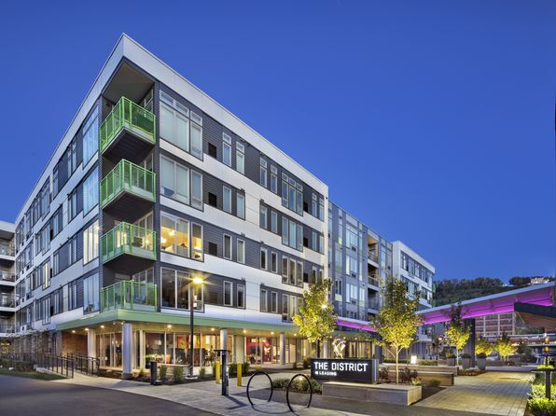](https://www.zillow.com/b/the-district-pittsburgh-pa-BMh3kq/)](https://www.zillow.com/b/the-district-pittsburgh-pa-BMh3kq/)

*[Highland House Tower by Albion | 5700 Bunkerhill St, Pittsburgh, PA](https://www.zillow.com/b/highland-house-tower-by-albion-pittsburgh-pa-5Xxb2J/)*

$1,700+ 1 bd

* **$1,965+** 2 bds
* **$2,300+** 3 bds

[[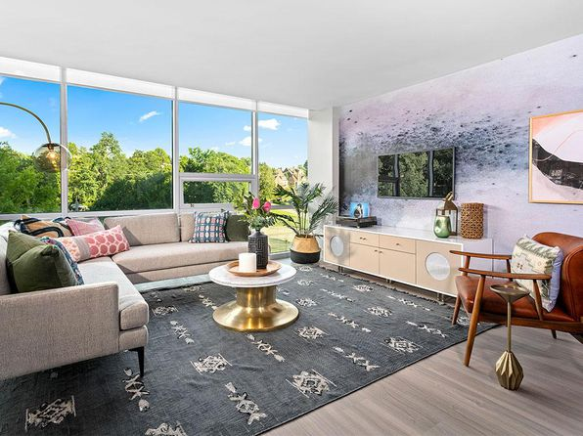](https://www.zillow.com/b/highland-house-tower-by-albion-pittsburgh-pa-5Xxb2J/)](https://www.zillow.com/b/highland-house-tower-by-albion-pittsburgh-pa-5Xxb2J/)

*[1709 Fifth | 1709 5th Ave, Pittsburgh, PA](https://www.zillow.com/b/1709-fifth-pittsburgh-pa-BFzw8h/)*

$1,475+ Studio

* **$1,550+** 1 bd
* **$2,300+** 2 bds

[[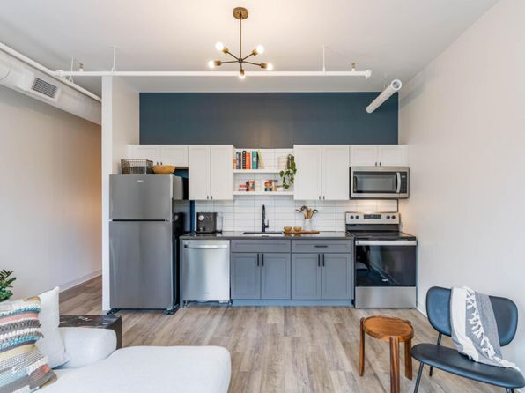](https://www.zillow.com/b/1709-fifth-pittsburgh-pa-BFzw8h/)](https://www.zillow.com/b/1709-fifth-pittsburgh-pa-BFzw8h/)

*[The Commonwealth | 318 4th Ave, Pittsburgh, PA](https://www.zillow.com/b/the-commonwealth-pittsburgh-pa-BtVbrn/)*

$1,510+ 1 bd

3D Tour

[[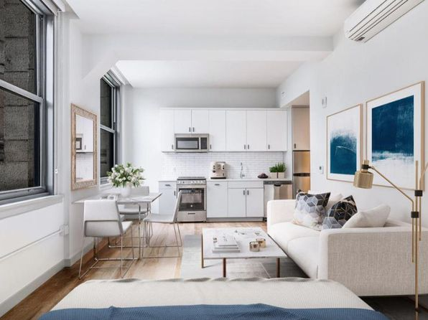](https://www.zillow.com/b/the-commonwealth-pittsburgh-pa-BtVbrn/)](https://www.zillow.com/b/the-commonwealth-pittsburgh-pa-BtVbrn/)

*[The Brix at 26, A Hudson Property, 75 S 26th St, Pittsburgh, PA 15203](https://www.zillow.com/b/the-brix-at-26,-a-hudson-property-pittsburgh-pa-5Xr6xC/)*

$1,900+/mo

* **1** bd
* **1** ba
* **915** sqft

- Apartment for rent

87 days ago

[[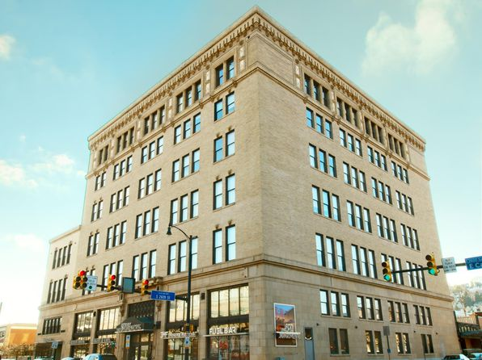](https://www.zillow.com/b/the-brix-at-26,-a-hudson-property-pittsburgh-pa-5Xr6xC/)](https://www.zillow.com/b/the-brix-at-26,-a-hudson-property-pittsburgh-pa-5Xr6xC/)

*[Cosmopolitan Apartment Homes | 3001 McKnight East Dr, Pittsburgh, PA](https://www.zillow.com/b/cosmopolitan-apartment-homes-pittsburgh-pa-B6jmk8/)*

$1,310+ 1 bd

* **$1,830+** 2 bds

[[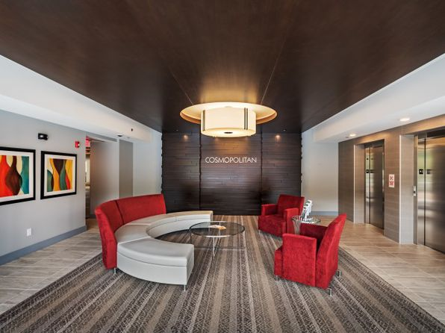](https://www.zillow.com/b/cosmopolitan-apartment-homes-pittsburgh-pa-B6jmk8/)](https://www.zillow.com/b/cosmopolitan-apartment-homes-pittsburgh-pa-B6jmk8/)

*[Allegheny City Stables Lofts, 840 W North Ave UNIT 110, Pittsburgh, PA 15233](https://www.zillow.com/b/allegheny-city-stables-lofts-pittsburgh-pa-9PRKWm/)*

$1,399/mo

* **Studio**
* **1** ba
* **750** sqft

- Apartment for rent

93 days ago

[[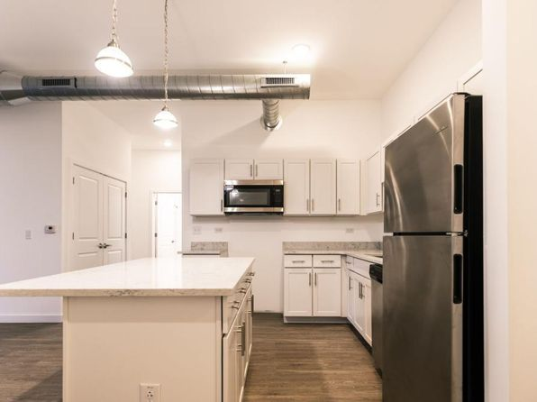](https://www.zillow.com/b/allegheny-city-stables-lofts-pittsburgh-pa-9PRKWm/)](https://www.zillow.com/b/allegheny-city-stables-lofts-pittsburgh-pa-9PRKWm/)

*[Heinz 950 | 950 Progress St, Pittsburgh, PA](https://www.zillow.com/b/heinz-950-pittsburgh-pa-98Nk6B/)*

$1,289+ 1 bd

* **$1,829+** 2 bds

3D Tour

[[](https://www.zillow.com/b/heinz-950-pittsburgh-pa-98Nk6B/)](https://www.zillow.com/b/heinz-950-pittsburgh-pa-98Nk6B/)

*[Emerald Gardens | 2400 Village Rd, Pittsburgh, PA](https://www.zillow.com/b/emerald-gardens-pittsburgh-pa-5ZJQhx/)*

$1,115+ 1 bd

* **$1,330+** 2 bds
* **$1,595+** 3 bds

[[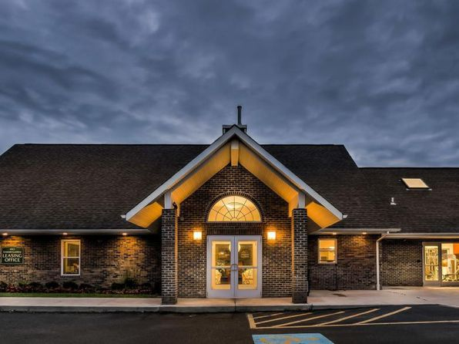](https://www.zillow.com/b/emerald-gardens-pittsburgh-pa-5ZJQhx/)](https://www.zillow.com/b/emerald-gardens-pittsburgh-pa-5ZJQhx/)

*[Hot Metal Flats | 2915 Sidney St, Pittsburgh, PA](https://www.zillow.com/b/hot-metal-flats-pittsburgh-pa-98N7cF/)*

$1,320+ Studio

* **$1,460+** 1 bd
* **$2,610+** 2 bds

3D Tour

[[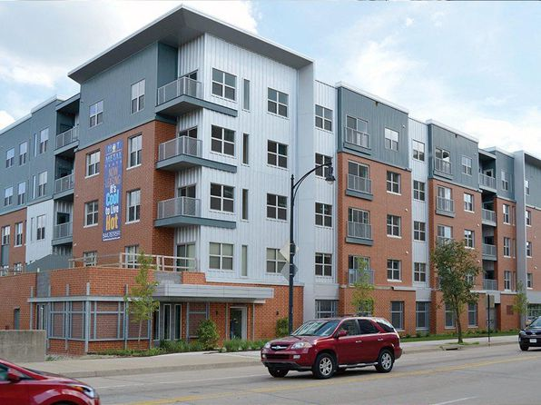](https://www.zillow.com/b/hot-metal-flats-pittsburgh-pa-98N7cF/)](https://www.zillow.com/b/hot-metal-flats-pittsburgh-pa-98N7cF/)

*[Walnut on Highland | 121 S Highland Ave, Pittsburgh, PA](https://www.zillow.com/b/walnut-on-highland-pittsburgh-pa-5XqdVq/)*

$1,805+ Studio

* **$1,860+** 1 bd
* **$3,005+** 2 bds

3D Tour

[[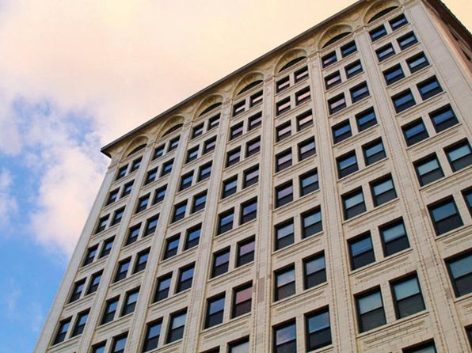](https://www.zillow.com/b/walnut-on-highland-pittsburgh-pa-5XqdVq/)](https://www.zillow.com/b/walnut-on-highland-pittsburgh-pa-5XqdVq/)

*[Lot 24, 2404 Railroad St APT 313, Pittsburgh, PA 15222](https://www.zillow.com/b/lot-24-pittsburgh-pa-5XrMrH/)*

$1,995/mo

* **1** bd
* **1** ba
* **747** sqft

- Apartment for rent

6 days ago

[[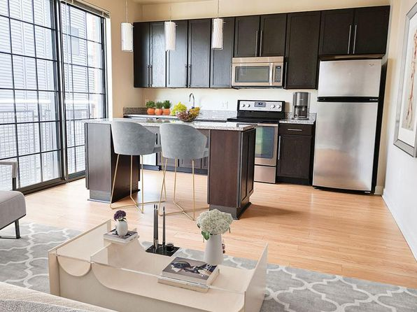](https://www.zillow.com/b/lot-24-pittsburgh-pa-5XrMrH/)](https://www.zillow.com/b/lot-24-pittsburgh-pa-5XrMrH/)

*[Cork Factory | 2349 Railroad St, Pittsburgh, PA](https://www.zillow.com/b/cork-factory-pittsburgh-pa-5XqszX/)*

$1,950+ 1 bd

* **$2,995+** 2 bds
* **$4,125+** 3 bds

[[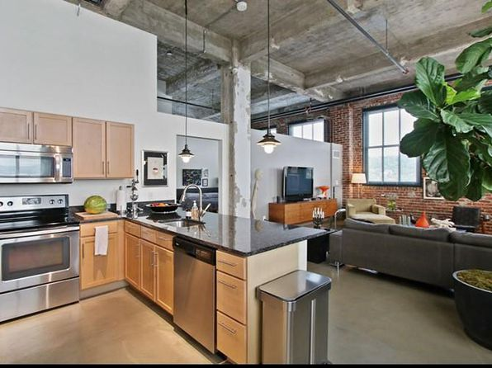](https://www.zillow.com/b/cork-factory-pittsburgh-pa-5XqszX/)](https://www.zillow.com/b/cork-factory-pittsburgh-pa-5XqszX/)

*[Rossview Heights Townhomes | 112 Hilands Pl, Pittsburgh, PA](https://www.zillow.com/b/rossview-heights-townhomes-pittsburgh-pa-5Xr87k/)*

$1,350+ 2 bds

* **$1,450+** 3 bds

[[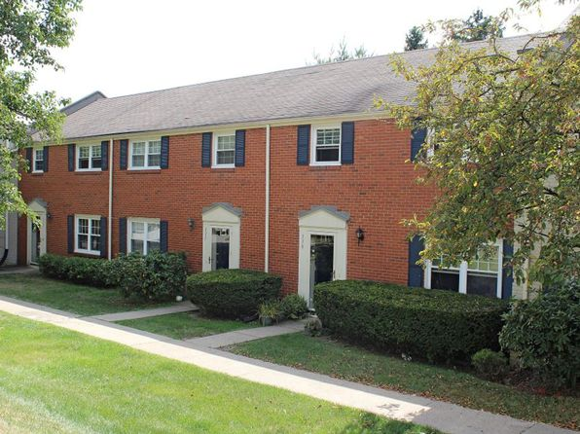](https://www.zillow.com/b/rossview-heights-townhomes-pittsburgh-pa-5Xr87k/)](https://www.zillow.com/b/rossview-heights-townhomes-pittsburgh-pa-5Xr87k/)

*[The Docks Apartments and Townhomes | 501 Riverfront Dr, Pittsburgh, PA](https://www.zillow.com/b/the-docks-apartments-and-townhomes-pittsburgh-pa-5XqfgM/)*

$1,565+ 1 bd

* **$2,110+** 2 bds
* **$2,840+** 3 bds

[[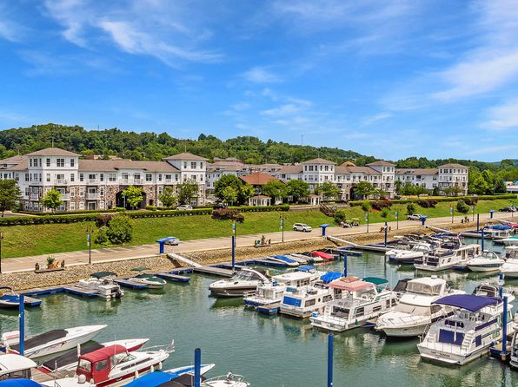](https://www.zillow.com/b/the-docks-apartments-and-townhomes-pittsburgh-pa-5XqfgM/)](https://www.zillow.com/b/the-docks-apartments-and-townhomes-pittsburgh-pa-5XqfgM/)

*[Shadyside Commons | 401 Amberson Ave, Pittsburgh, PA](https://www.zillow.com/b/shadyside-commons-pittsburgh-pa-5XqzCk/)*

$1,995+ 1 bd

[[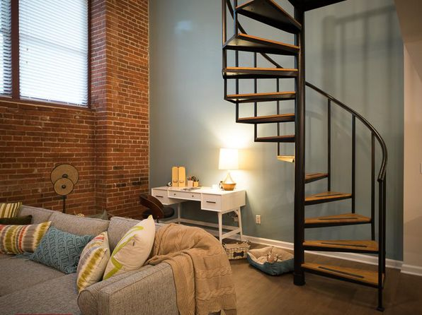](https://www.zillow.com/b/shadyside-commons-pittsburgh-pa-5XqzCk/)](https://www.zillow.com/b/shadyside-commons-pittsburgh-pa-5XqzCk/)

*[Nineteen North Apartments and Townhomes | 1050 Nineteen North Dr, Pittsburgh, PA](https://www.zillow.com/b/nineteen-north-apartments-and-townhomes-pittsburgh-pa-5Xt9Gj/)*

$1,240+ 1 bd

* **$1,405+** 2 bds

Updated today

[[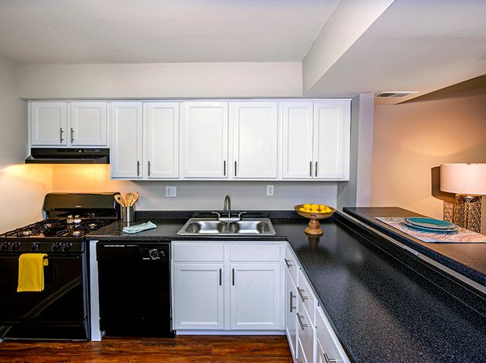](https://www.zillow.com/b/nineteen-north-apartments-and-townhomes-pittsburgh-pa-5Xt9Gj/)](https://www.zillow.com/b/nineteen-north-apartments-and-townhomes-pittsburgh-pa-5Xt9Gj/)

*[Morrowfield | 2715 Murray Ave, Pittsburgh, PA](https://www.zillow.com/b/morrowfield-pittsburgh-pa-5Xt56j/)*

$885+ Studio

* **$1,100+** 1 bd
* **$1,470+** 2 bds

[[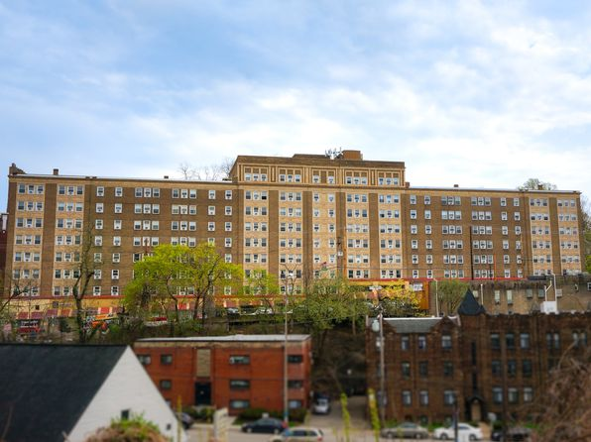](https://www.zillow.com/b/morrowfield-pittsburgh-pa-5Xt56j/)](https://www.zillow.com/b/morrowfield-pittsburgh-pa-5Xt56j/)

*[Arlington | 515 S Aiken Ave, Pittsburgh, PA](https://www.zillow.com/b/arlington-pittsburgh-pa-5XkfBr/)*

$865+ Studio

* **$1,610+** 1 bd
* **$2,140+** 2 bds

[[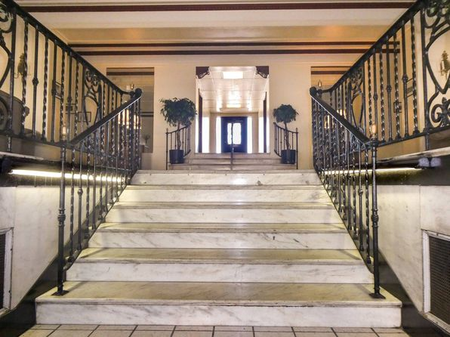](https://www.zillow.com/b/arlington-pittsburgh-pa-5XkfBr/)](https://www.zillow.com/b/arlington-pittsburgh-pa-5XkfBr/)

*[Mulberry Lofts | 3205 Penn Ave, Pittsburgh, PA](https://www.zillow.com/b/mulberry-lofts-pittsburgh-pa-C9m4Jk/)*

$1,560+ Studio

* **$1,740+** 1 bd
* **$2,465+** 2 bds

3D Tour

[[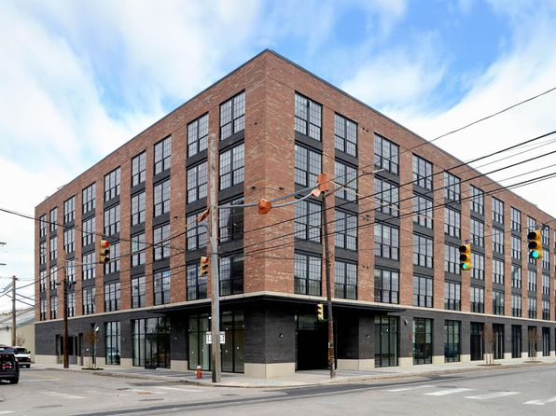](https://www.zillow.com/b/mulberry-lofts-pittsburgh-pa-C9m4Jk/)](https://www.zillow.com/b/mulberry-lofts-pittsburgh-pa-C9m4Jk/)

to get email alerts when listings hit the market.

*[Carson Street Commons | 2529 E Carson St, Pittsburgh, PA](https://www.zillow.com/b/carson-street-commons-pittsburgh-pa-5XqpVS/)*

$1,370+ 1 bd

* + **$1,770+** 2 bds

[[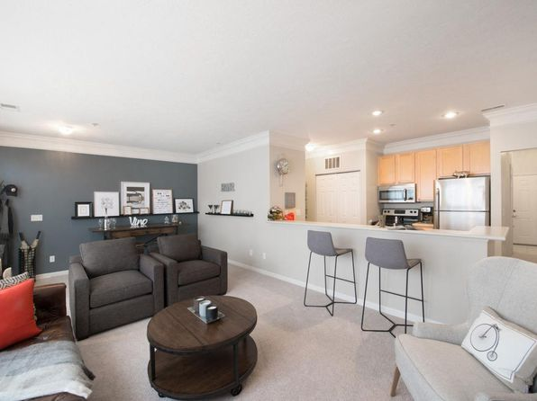](https://www.zillow.com/b/carson-street-commons-pittsburgh-pa-5XqpVS/)](https://www.zillow.com/b/carson-street-commons-pittsburgh-pa-5XqpVS/)

*[Bakery Living | 6454 Living Pl, Pittsburgh, PA](https://www.zillow.com/b/bakery-living-pittsburgh-pa-65fPkK/)*

$1,825+ Studio

* **$2,150+** 1 bd
* **$2,495+** 2 bds

3D Tour

[[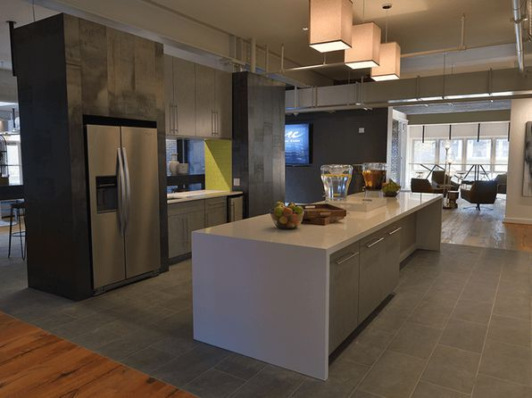](https://www.zillow.com/b/bakery-living-pittsburgh-pa-65fPkK/)](https://www.zillow.com/b/bakery-living-pittsburgh-pa-65fPkK/)

• Loading...

•

*[Wellington Square | 3910 Old William Penn Hwy, Pittsburgh, PA](https://www.zillow.com/b/wellington-square-pittsburgh-pa-9n3MsV/)*

$949+ 1 bd

* **$1,149+** 2 bds

[[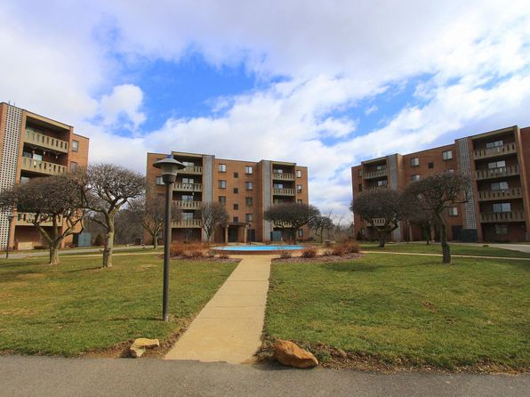](https://www.zillow.com/b/wellington-square-pittsburgh-pa-9n3MsV/)](https://www.zillow.com/b/wellington-square-pittsburgh-pa-9n3MsV/)

*[Terminal 21 | 615 1st Ave, Pittsburgh, PA](https://www.zillow.com/b/terminal-21-pittsburgh-pa-98P8dr/)*

$1,185+ Studio

* **$1,218+** 1 bd
* **$1,639+** 2 bds

[[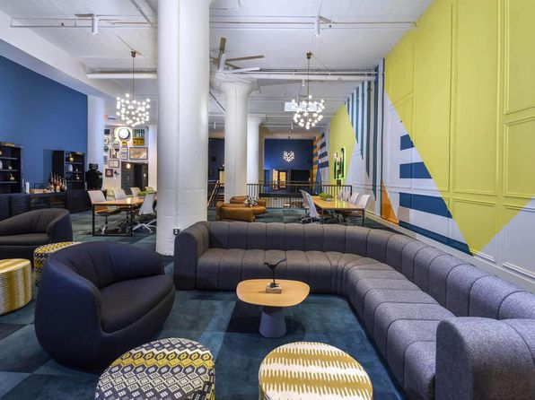](https://www.zillow.com/b/terminal-21-pittsburgh-pa-98P8dr/)](https://www.zillow.com/b/terminal-21-pittsburgh-pa-98P8dr/)

*[Royal Gardens Apartments | 6236 5th Ave, Pittsburgh, PA](https://www.zillow.com/b/royal-gardens-apartments-pittsburgh-pa-5Y2YQv/)*

$1,570+ 2 bds

[[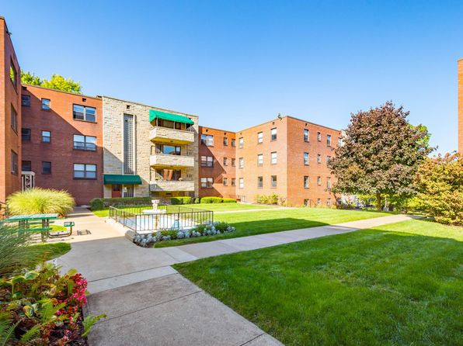](https://www.zillow.com/b/royal-gardens-apartments-pittsburgh-pa-5Y2YQv/)](https://www.zillow.com/b/royal-gardens-apartments-pittsburgh-pa-5Y2YQv/)

*[Highland Village, 450 Highland Ave #213, Pittsburgh, PA 15229](https://www.zillow.com/b/highland-village-pittsburgh-pa-5y6MtG/)*

$2,490/mo

* **2** bds
* **2.5** ba
* **1,450** sqft

- Apartment for rent

10 days ago

[[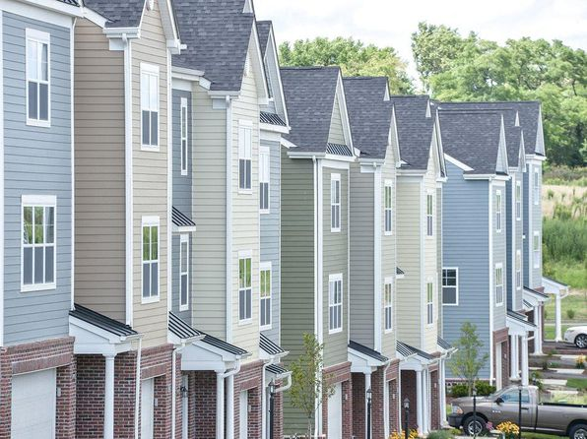](https://www.zillow.com/b/highland-village-pittsburgh-pa-5y6MtG/)](https://www.zillow.com/b/highland-village-pittsburgh-pa-5y6MtG/)

*[Alder Ridge, 114 Tally Dr, Pittsburgh, PA 15237](https://www.zillow.com/b/alder-ridge-pittsburgh-pa-5Xt458/)*

$1,350+/mo

* **3** bds
* **2** ba
* **1,115** sqft

- Apartment for rent

74 days ago

[[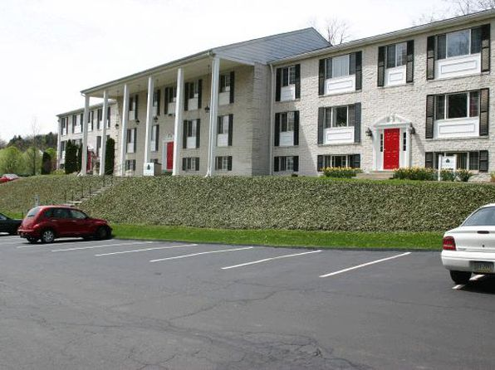](https://www.zillow.com/b/alder-ridge-pittsburgh-pa-5Xt458/)](https://www.zillow.com/b/alder-ridge-pittsburgh-pa-5Xt458/)

*[The View North Hills | 1000 Johnanna Dr, Pittsburgh, PA](https://www.zillow.com/b/the-view-north-hills-pittsburgh-pa-5XjCD8/)*

$1,079+ 1 bd

* **$1,115+** 2 bds

[[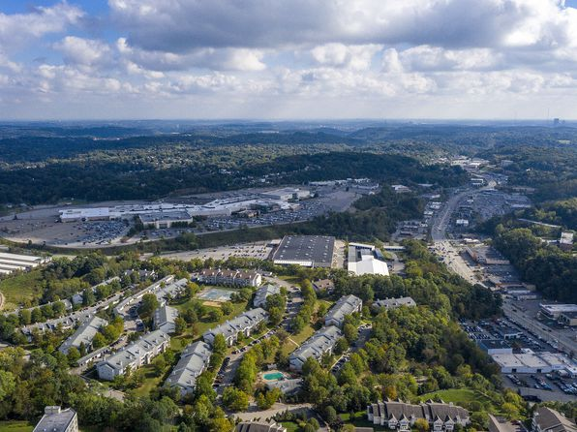](https://www.zillow.com/b/the-view-north-hills-pittsburgh-pa-5XjCD8/)](https://www.zillow.com/b/the-view-north-hills-pittsburgh-pa-5XjCD8/)

*[Highland Plaza | 301 S Highland Ave, Pittsburgh, PA](https://www.zillow.com/b/highland-plaza-pittsburgh-pa-5Xt9Ft/)*

$1,385+ 1 bd

* **$1,710+** 2 bds

[[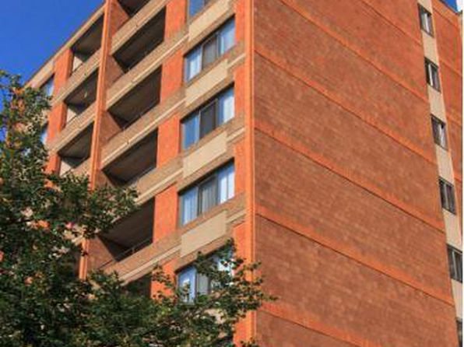](https://www.zillow.com/b/highland-plaza-pittsburgh-pa-5Xt9Ft/)](https://www.zillow.com/b/highland-plaza-pittsburgh-pa-5Xt9Ft/)

*[The Wendover Community | 5562 Hobart St, Pittsburgh, PA](https://www.zillow.com/b/the-wendover-community-pittsburgh-pa-5XkfGQ/)*

$790+ Studio

* **$1,235+** 1 bd
* **$1,435+** 2 bds

[[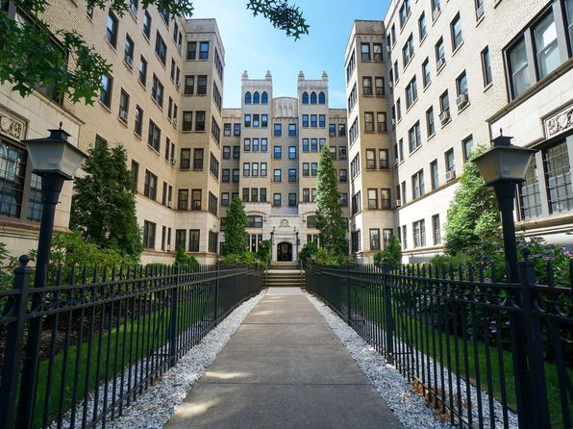](https://www.zillow.com/b/the-wendover-community-pittsburgh-pa-5XkfGQ/)](https://www.zillow.com/b/the-wendover-community-pittsburgh-pa-5XkfGQ/)

*[The Avalon Apartment Homes | 841 California Ave, Pittsburgh, PA](https://www.zillow.com/b/the-avalon-apartment-homes-avalon-pa-5hQXmj/)*

$1,125+ 1 bd

* **$1,410+** 2 bds

[[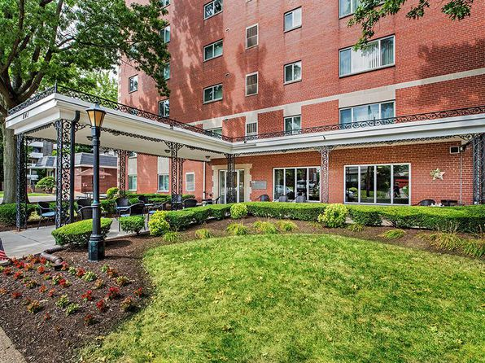](https://www.zillow.com/b/the-avalon-apartment-homes-avalon-pa-5hQXmj/)](https://www.zillow.com/b/the-avalon-apartment-homes-avalon-pa-5hQXmj/)

*[Chateaugay Apartments | 500 Hoodridge Dr, Pittsburgh, PA](https://www.zillow.com/b/chateaugay-apartments-pittsburgh-pa-5YDhxL/)*

$1,099+ 1 bd

* **$1,250+** 2 bds

3D Tour

[[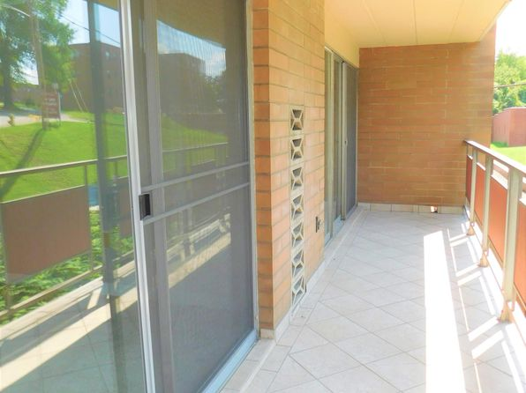](https://www.zillow.com/b/chateaugay-apartments-pittsburgh-pa-5YDhxL/)](https://www.zillow.com/b/chateaugay-apartments-pittsburgh-pa-5YDhxL/)

*[Glasshouse Pittsburgh | 160 E Station Square Dr, Pittsburgh, PA](https://www.zillow.com/b/glasshouse-pittsburgh-pittsburgh-pa-BPCCN4/)*

$2,030+ 1 bd

* **$2,903+** 2 bds

3D Tour

[[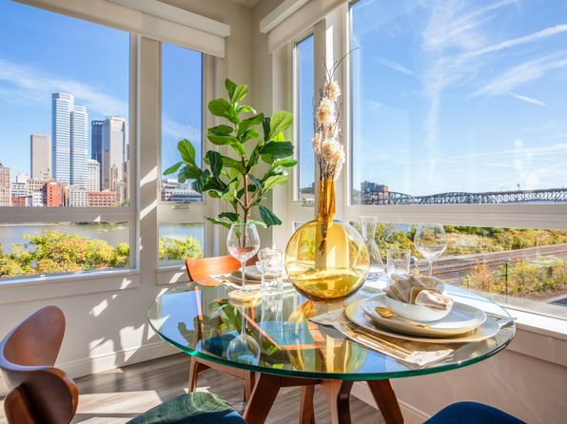](https://www.zillow.com/b/glasshouse-pittsburgh-pittsburgh-pa-BPCCN4/)](https://www.zillow.com/b/glasshouse-pittsburgh-pittsburgh-pa-BPCCN4/)

*[Hobart Court | 5557 Hobart St, Pittsburgh, PA](https://www.zillow.com/b/hobart-court-pittsburgh-pa-98P29D/)*

$1,430+ 2 bds

[[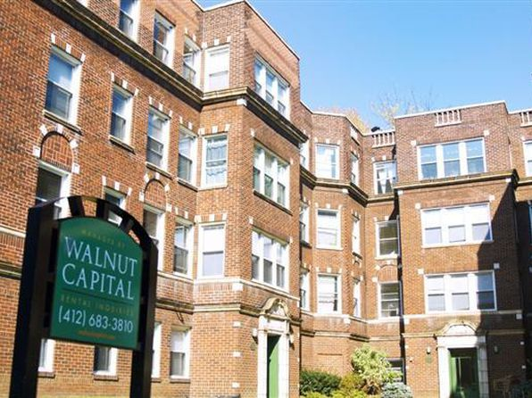](https://www.zillow.com/b/hobart-court-pittsburgh-pa-98P29D/)](https://www.zillow.com/b/hobart-court-pittsburgh-pa-98P29D/)

*[Oak Hill Apartments - Pittsburgh | 475 Garner Ct, Pittsburgh, PA](https://www.zillow.com/b/oak-hill-apartments-pittsburgh-pittsburgh-pa-98NmqH/)*

$1,385+ Studio

* **$1,515+** 1 bd
* **$1,650+** 2 bds
* **$2,350+** 3 bds

[[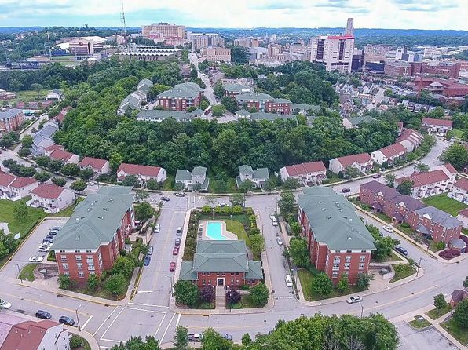](https://www.zillow.com/b/oak-hill-apartments-pittsburgh-pittsburgh-pa-98NmqH/)](https://www.zillow.com/b/oak-hill-apartments-pittsburgh-pittsburgh-pa-98NmqH/)

• Loading...

•

*[Southcrest Heights | 631 Southcrest Dr, Pittsburgh, PA](https://www.zillow.com/b/southcrest-heights-pittsburgh-pa-5Xt9Fx/)*

$870+ 2 bds

* **$1,230+** 3 bds

Updated today

[[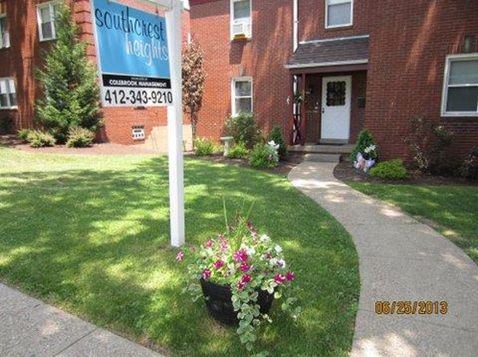](https://www.zillow.com/b/southcrest-heights-pittsburgh-pa-5Xt9Fx/)](https://www.zillow.com/b/southcrest-heights-pittsburgh-pa-5Xt9Fx/)

*[The Revival on Carson | 1700 E Carson St, Pittsburgh, PA](https://www.zillow.com/b/the-revival-on-carson-pittsburgh-pa-9PRD8B/)*

$1,585+ 1 bd

* **$2,100+** 2 bds

[[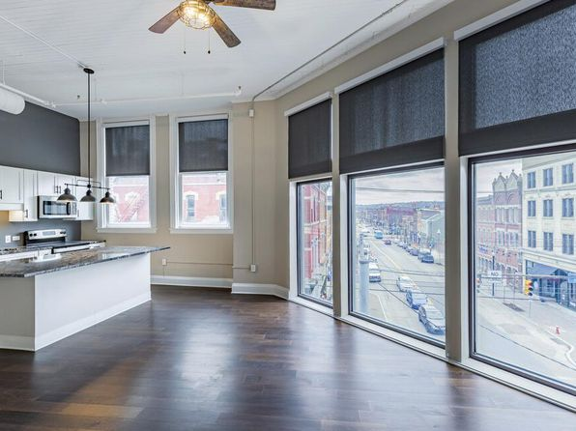](https://www.zillow.com/b/the-revival-on-carson-pittsburgh-pa-9PRD8B/)](https://www.zillow.com/b/the-revival-on-carson-pittsburgh-pa-9PRD8B/)

*[Fieldbrook Apartments | 1425 McFarland Rd, Pittsburgh, PA](https://www.zillow.com/b/fieldbrook-apartments-pittsburgh-pa-98Nv7X/)*

$899+ Studio

* **$1,019+** 1 bd

3D Tour

[[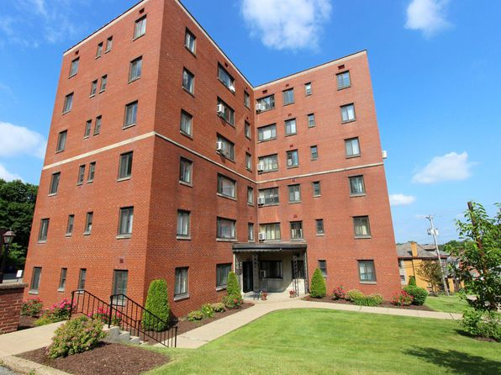](https://www.zillow.com/b/fieldbrook-apartments-pittsburgh-pa-98Nv7X/)](https://www.zillow.com/b/fieldbrook-apartments-pittsburgh-pa-98Nv7X/)

*[Lofts of Mt Washington | 200 Cowan St, Pittsburgh, PA](https://www.zillow.com/b/lofts-of-mt-washington-pittsburgh-pa-63SR9n/)*

$1,300+ Studio

* **$1,900+** 2 bds

[[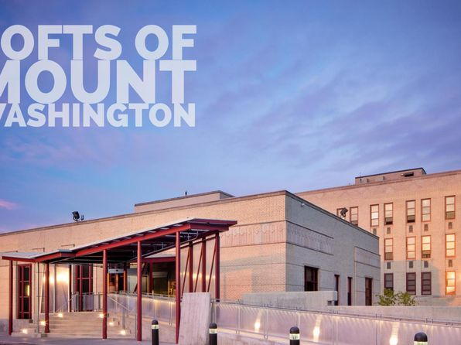](https://www.zillow.com/b/lofts-of-mt-washington-pittsburgh-pa-63SR9n/)](https://www.zillow.com/b/lofts-of-mt-washington-pittsburgh-pa-63SR9n/)

*[Kennilworth Apartments | 5700 Centre Ave, Pittsburgh, PA](https://www.zillow.com/b/kennilworth-apartments-pittsburgh-pa-5hJB3z/)*

$1,125+ 1 bd

* **$1,700+** 2 bds

[[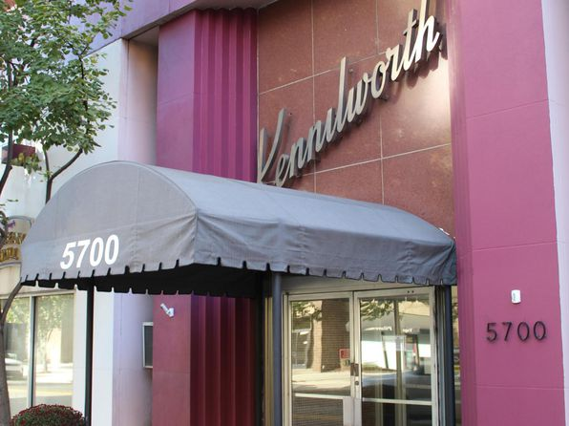](https://www.zillow.com/b/kennilworth-apartments-pittsburgh-pa-5hJB3z/)](https://www.zillow.com/b/kennilworth-apartments-pittsburgh-pa-5hJB3z/)

*[Hempstead Road Properties | 5625 Hempstead St, Pittsburgh, PA](https://www.zillow.com/b/hempstead-road-properties-pittsburgh-pa-Bt4tMS/)*

$1,362+ 1 bd

* **$1,532+** 2 bds

3D Tour

[[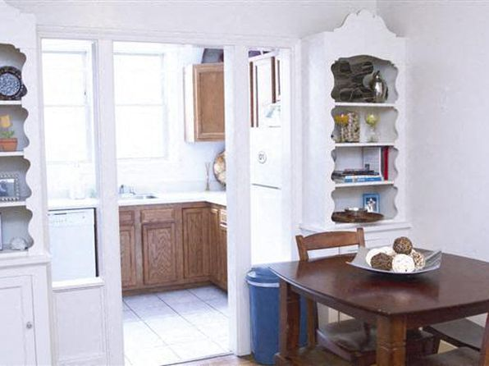](https://www.zillow.com/b/hempstead-road-properties-pittsburgh-pa-Bt4tMS/)](https://www.zillow.com/b/hempstead-road-properties-pittsburgh-pa-Bt4tMS/)

*[Baldwin Cathell Townhouses, 1567 Cathell Rd #C3, Pittsburgh, PA 15236](https://www.zillow.com/b/baldwin-cathell-townhouses-pittsburgh-pa-5gm2RD/)*

$1,149/mo

* **2** bds
* **1** ba
* **800** sqft

- Apartment for rent

16 days ago

[[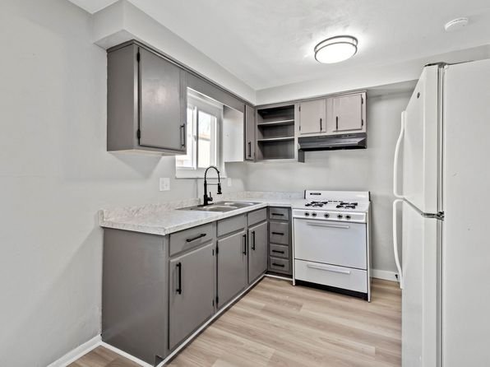](https://www.zillow.com/b/baldwin-cathell-townhouses-pittsburgh-pa-5gm2RD/)](https://www.zillow.com/b/baldwin-cathell-townhouses-pittsburgh-pa-5gm2RD/)

*[Market Square Place | 222 5th Ave, Pittsburgh, PA](https://www.zillow.com/b/market-square-place-pittsburgh-pa-5XrPj4/)*

$1,825+ 1 bd

* **$2,300+** 2 bds

[[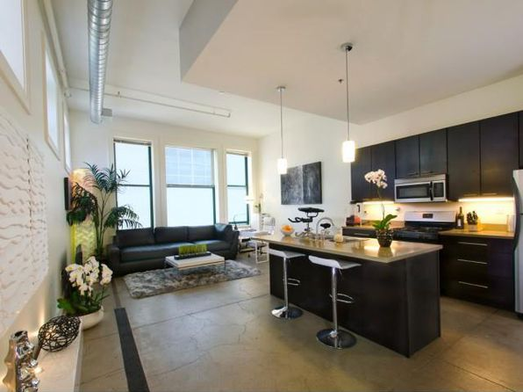](https://www.zillow.com/b/market-square-place-pittsburgh-pa-5XrPj4/)](https://www.zillow.com/b/market-square-place-pittsburgh-pa-5XrPj4/)

*[Forbes Terrace | 5703 Forbes Ave, Pittsburgh, PA](https://www.zillow.com/b/forbes-terrace-pittsburgh-pa-5XpJSz/)*

$2,338+ 3 bds

[[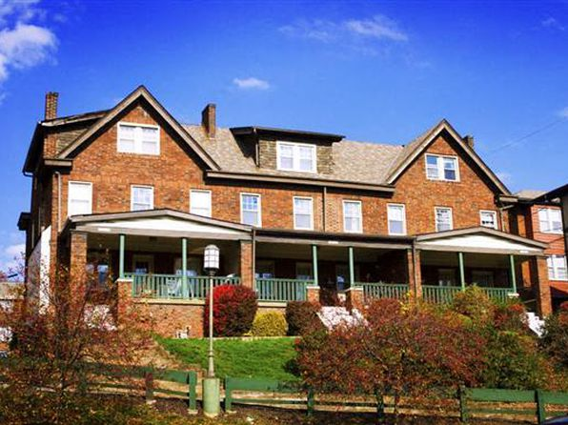](https://www.zillow.com/b/forbes-terrace-pittsburgh-pa-5XpJSz/)](https://www.zillow.com/b/forbes-terrace-pittsburgh-pa-5XpJSz/)

*[Hillcrest Residences Senior Community | 2948 Brownsville Rd, Pittsburgh, PA](https://www.zillow.com/b/hillcrest-residences-senior-community-pittsburgh-pa-9pZMsv/)*

$900+ 1 bd

* **$961+** 2 bds

[[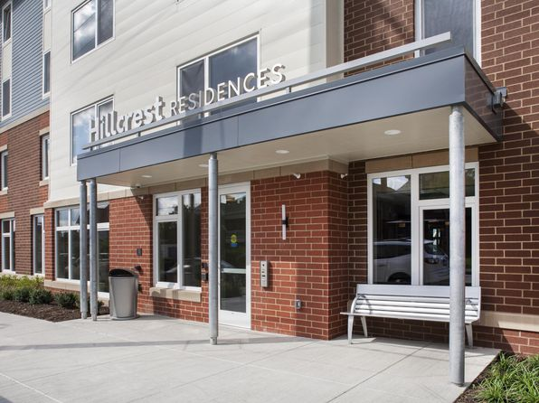](https://www.zillow.com/b/hillcrest-residences-senior-community-pittsburgh-pa-9pZMsv/)](https://www.zillow.com/b/hillcrest-residences-senior-community-pittsburgh-pa-9pZMsv/)

*[Walnut on Forbes, 5695 Forbes Ave, Pittsburgh, PA 15217](https://www.zillow.com/b/walnut-on-forbes-pittsburgh-pa-5jQhgL/)*

$3,330+/mo

* **3** bds
* **2.5** ba
* **2,000** sqft

- Apartment for rent

16 days ago

[[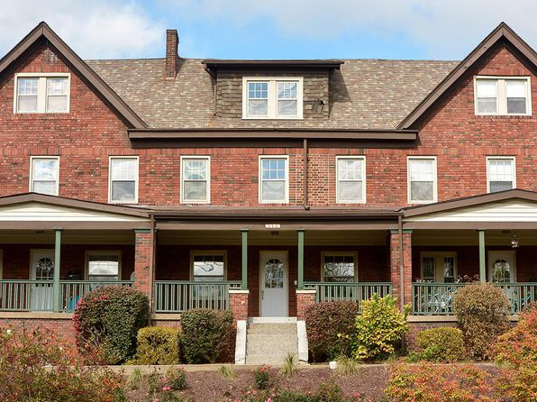](https://www.zillow.com/b/walnut-on-forbes-pittsburgh-pa-5jQhgL/)](https://www.zillow.com/b/walnut-on-forbes-pittsburgh-pa-5jQhgL/)

*[Poplar Apartments | 1810-1848 Chessland St, Pittsburgh, PA](https://www.zillow.com/b/poplar-apartments-pittsburgh-pa-CHLn95/)*

$789+ 1 bd

* **$899+** 2 bds

3D Tour

[[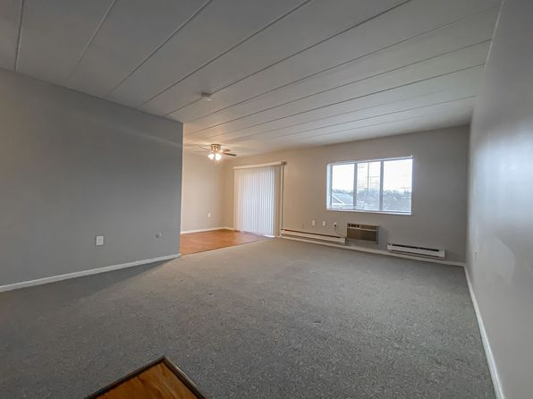](https://www.zillow.com/b/poplar-apartments-pittsburgh-pa-CHLn95/)](https://www.zillow.com/b/poplar-apartments-pittsburgh-pa-CHLn95/)

*[Crossroad Towers | 200 Sophia Ave, Pittsburgh, PA](https://www.zillow.com/b/crossroad-towers-pittsburgh-pa-65fB2T/)*

$955+ Studio

* **$1,155+** 1 bd
* **$1,575+** 2 bds

[[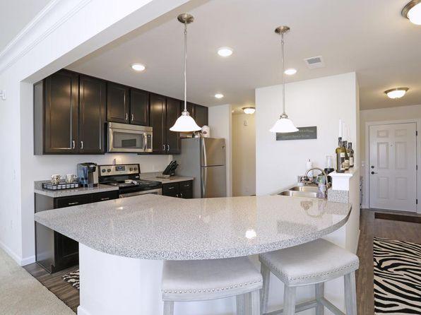](https://www.zillow.com/b/crossroad-towers-pittsburgh-pa-65fB2T/)](https://www.zillow.com/b/crossroad-towers-pittsburgh-pa-65fB2T/)

*[Fifth Avenue School Lofts | 1800 5th Ave, Pittsburgh, PA](https://www.zillow.com/b/fifth-avenue-school-lofts-pittsburgh-pa-5Yy6H6/)*

$1,790+ 2 bds

[[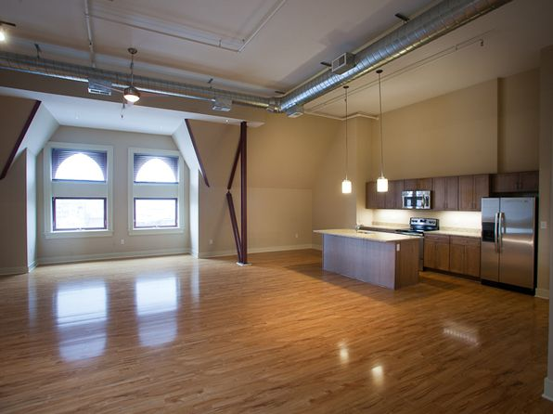](https://www.zillow.com/b/fifth-avenue-school-lofts-pittsburgh-pa-5Yy6H6/)](https://www.zillow.com/b/fifth-avenue-school-lofts-pittsburgh-pa-5Yy6H6/)

*[School House Apartments | 500 Tripoli St, Pittsburgh, PA](https://www.zillow.com/b/school-house-apartments-pittsburgh-pa-5Xt45V/)*

$1,250+ 1 bd

* **$1,600+** 2 bds

[[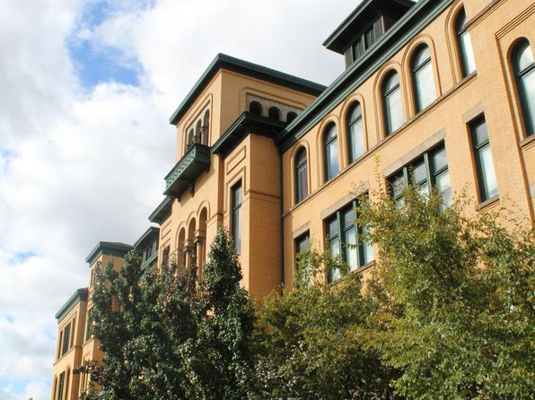](https://www.zillow.com/b/school-house-apartments-pittsburgh-pa-5Xt45V/)](https://www.zillow.com/b/school-house-apartments-pittsburgh-pa-5Xt45V/)

*[Walnut Towers at Frick Park | 7070 Forward Ave, Pittsburgh, PA](https://www.zillow.com/b/walnut-towers-at-frick-park-pittsburgh-pa-5XmPBC/)*

$1,385+ 1 bd

* **$1,610+** 2 bds

3D Tour

[[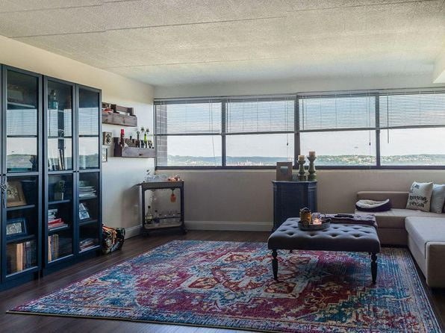](https://www.zillow.com/b/walnut-towers-at-frick-park-pittsburgh-pa-5XmPBC/)](https://www.zillow.com/b/walnut-towers-at-frick-park-pittsburgh-pa-5XmPBC/)

*[Lando Lofts | 908 Penn Ave, Pittsburgh, PA](https://www.zillow.com/b/lando-lofts-pittsburgh-pa-5XnZqW/)*

$1,475+ 1 bd

[[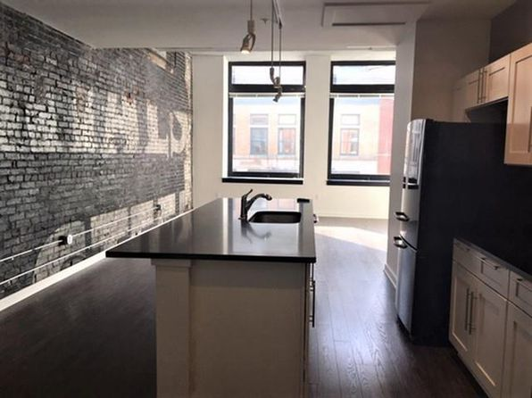](https://www.zillow.com/b/lando-lofts-pittsburgh-pa-5XnZqW/)](https://www.zillow.com/b/lando-lofts-pittsburgh-pa-5XnZqW/)

*[Holden Street Apartments, 5733 Holden St APT A, Pittsburgh, PA 15232](https://www.zillow.com/b/holden-street-apartments-pittsburgh-pa-5Yy6S6/)*

$2,590/mo

* **3** bds
* **1** ba
* **1,375** sqft

- Apartment for rent

79 days ago

[[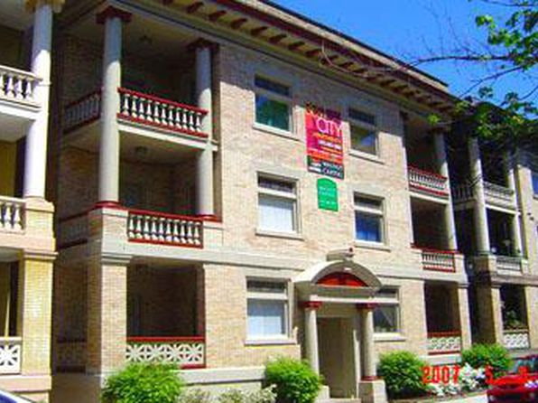](https://www.zillow.com/b/holden-street-apartments-pittsburgh-pa-5Yy6S6/)](https://www.zillow.com/b/holden-street-apartments-pittsburgh-pa-5Yy6S6/)

*[Emsworth Arms | 8228 Ohio River Blvd, Pittsburgh, PA](https://www.zillow.com/b/emsworth-arms-pittsburgh-pa-5Xt45R/)*

$650+ Studio

* **$750+** 1 bd
* **$875+** 2 bds

[[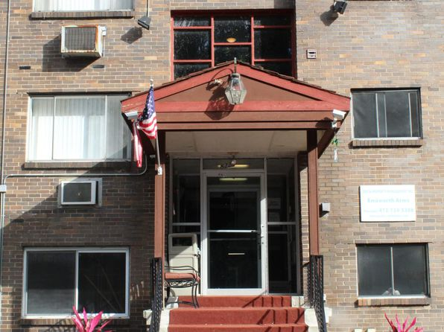](https://www.zillow.com/b/emsworth-arms-pittsburgh-pa-5Xt45R/)](https://www.zillow.com/b/emsworth-arms-pittsburgh-pa-5Xt45R/)

*[New Pennley Place, 5601 Penn Ave, Pittsburgh, PA 15206](https://www.zillow.com/b/new-pennley-place-pittsburgh-pa-5YyDfk/)*

$1,300+/mo

* **2** bds
* **1** ba
* **990** sqft

- Apartment for rent

89 days ago

[[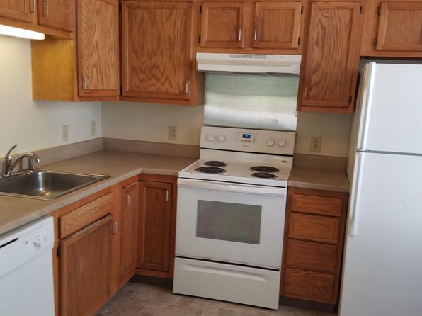](https://www.zillow.com/b/new-pennley-place-pittsburgh-pa-5YyDfk/)](https://www.zillow.com/b/new-pennley-place-pittsburgh-pa-5YyDfk/)

*[Waldorf Park Apartments | 103 McKnight Cir, Pittsburgh, PA](https://www.zillow.com/b/waldorf-park-apartments-pittsburgh-pa-5XjDwW/)*

$800+ Studio

* **$875+** 1 bd
* **$1,125+** 2 bds

3D Tour

[[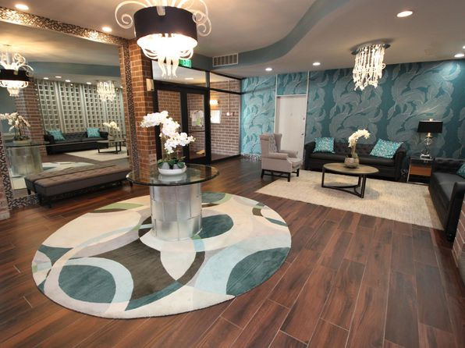](https://www.zillow.com/b/waldorf-park-apartments-pittsburgh-pa-5XjDwW/)](https://www.zillow.com/b/waldorf-park-apartments-pittsburgh-pa-5XjDwW/)

*[Neville Street Properties - Student Housing, 414 N Neville St, Pittsburgh, PA 15213](https://www.zillow.com/b/neville-street-properties-student-housing-pittsburgh-pa-5jBryW/)*

$1,030+/mo

* **1** bd
* **1** ba
* **630** sqft

- Apartment for rent

93 days ago

[[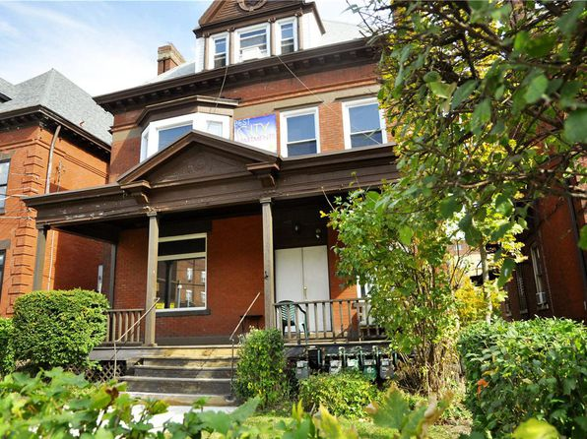](https://www.zillow.com/b/neville-street-properties-student-housing-pittsburgh-pa-5jBryW/)](https://www.zillow.com/b/neville-street-properties-student-housing-pittsburgh-pa-5jBryW/)

*[First Avenue Lofts | 436 1st Ave, Pittsburgh, PA](https://www.zillow.com/b/first-avenue-lofts-pittsburgh-pa-BHbRK3/)*

$1,495+ 1 bd

* **$2,050+** 2 bds

[[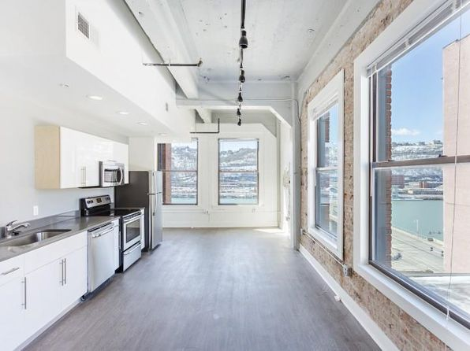](https://www.zillow.com/b/first-avenue-lofts-pittsburgh-pa-BHbRK3/)](https://www.zillow.com/b/first-avenue-lofts-pittsburgh-pa-BHbRK3/)

*[The Alden South Hills Apartment Homes | 5492 Youngridge Dr, Pittsburgh, PA](https://www.zillow.com/b/the-alden-south-hills-apartment-homes-pittsburgh-pa-5XrtdM/)*

$815+ Studio

* **$780+** 1 bd
* **$860+** 2 bds
* **$815+** 3 bds

[[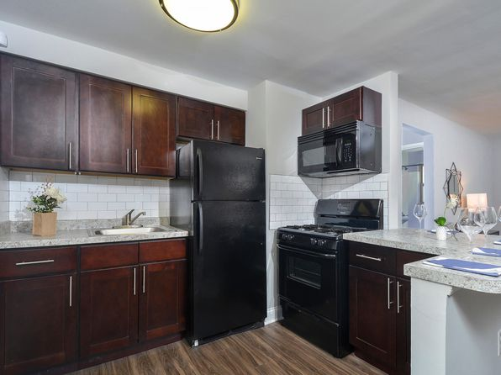](https://www.zillow.com/b/the-alden-south-hills-apartment-homes-pittsburgh-pa-5XrtdM/)](https://www.zillow.com/b/the-alden-south-hills-apartment-homes-pittsburgh-pa-5XrtdM/)

*[Park View Apartments | 10 Allegheny Ctr, Pittsburgh, PA](https://www.zillow.com/b/park-view-apartments-pittsburgh-pa-5hFZPB/)*

$940+ Studio

* **$1,105+** 1 bd
* **$1,605+** 2 bds
* **$2,485+** 3 bds

[[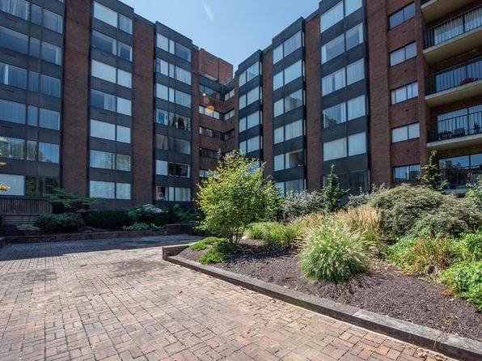](https://www.zillow.com/b/park-view-apartments-pittsburgh-pa-5hFZPB/)](https://www.zillow.com/b/park-view-apartments-pittsburgh-pa-5hFZPB/)

**Pittsburgh PA Rental Listings**

1,570 results

*[Howe and Maryland, 5754 Howe St, Pittsburgh, PA 15232](https://www.zillow.com/b/howe-and-maryland-pittsburgh-pa-5XrfmF/)*

$2,095+/mo

* + **3** bds
  + **1** ba
  + **1,106** sqft

- Apartment for rent

93 days ago

[[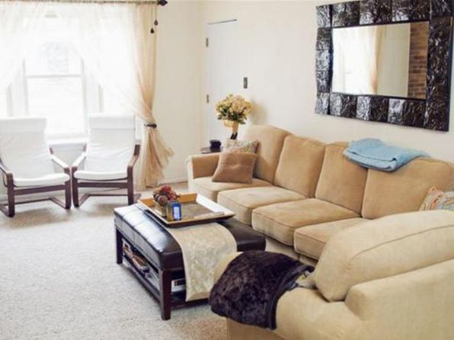](https://www.zillow.com/b/howe-and-maryland-pittsburgh-pa-5XrfmF/)](https://www.zillow.com/b/howe-and-maryland-pittsburgh-pa-5XrfmF/)

*[Helm on the Allegheny | 2239 Railroad St, Pittsburgh, PA](https://www.zillow.com/b/helm-on-the-allegheny-pittsburgh-pa-BLxMYg/)*

$1,025+ Studio

* **$1,080+** 1 bd

[[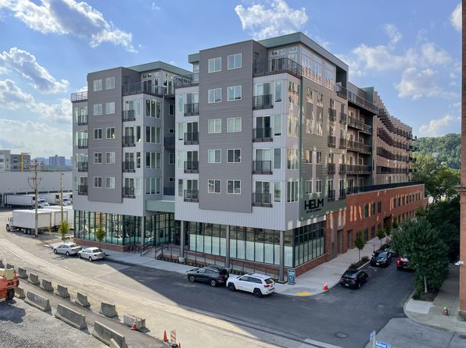](https://www.zillow.com/b/helm-on-the-allegheny-pittsburgh-pa-BLxMYg/)](https://www.zillow.com/b/helm-on-the-allegheny-pittsburgh-pa-BLxMYg/)

• Loading...

•

*[Walnut on Wightman, 1720 Wightman St #1702, Pittsburgh, PA 15217](https://www.zillow.com/b/walnut-on-wightman-pittsburgh-pa-5ZdJ6Z/)*

$3,500/mo

* **4** bds
* **2.5** ba
* **1,727** sqft

- Apartment for rent

12 days ago

[[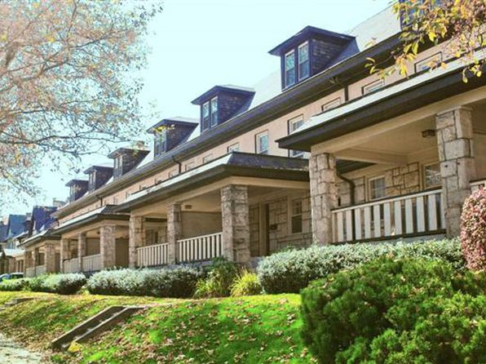](https://www.zillow.com/b/walnut-on-wightman-pittsburgh-pa-5ZdJ6Z/)](https://www.zillow.com/b/walnut-on-wightman-pittsburgh-pa-5ZdJ6Z/)

*[Beechwood Gardens | 3245 Beechwood Blvd, Pittsburgh, PA](https://www.zillow.com/b/beechwood-gardens-pittsburgh-pa-5XrLV6/)*

$800+ 1 bd

* **$900+** 2 bds

[[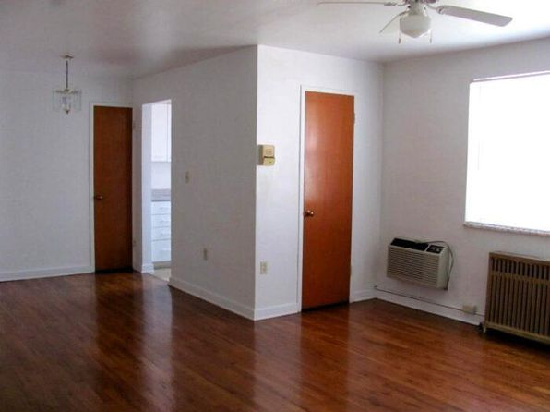](https://www.zillow.com/b/beechwood-gardens-pittsburgh-pa-5XrLV6/)](https://www.zillow.com/b/beechwood-gardens-pittsburgh-pa-5XrLV6/)

*[800 Penn | 800 Penn Ave, Pittsburgh, PA](https://www.zillow.com/b/800-penn-pittsburgh-pa-98PLcb/)*

$1,350+ 1 bd

[[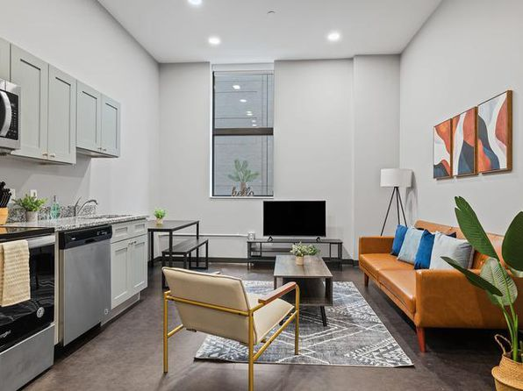](https://www.zillow.com/b/800-penn-pittsburgh-pa-98PLcb/)](https://www.zillow.com/b/800-penn-pittsburgh-pa-98PLcb/)

*[Beacon Commons, 5629 Beacon St #5653, Pittsburgh, PA 15217](https://www.zillow.com/b/beacon-commons-pittsburgh-pa-5YYy92/)*

$2,320/mo

* **3** bds
* **1.5** ba
* **843** sqft

- Apartment for rent

81 days ago

[[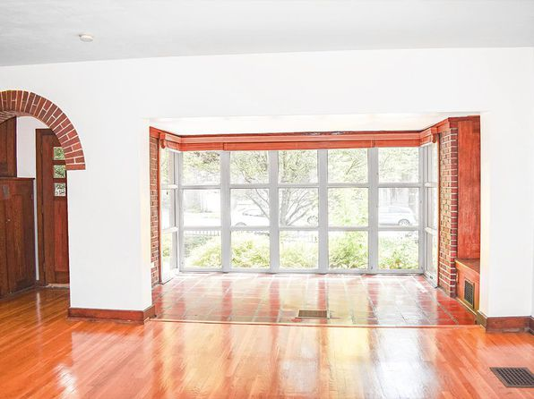](https://www.zillow.com/b/beacon-commons-pittsburgh-pa-5YYy92/)](https://www.zillow.com/b/beacon-commons-pittsburgh-pa-5YYy92/)

*[City View Apartments | 1420 Centre Ave, Pittsburgh, PA](https://www.zillow.com/b/city-view-apartments-pittsburgh-pa-5XmvjF/)*

$970+ Studio

* **$1,172+** 1 bd
* **$1,687+** 2 bds
* **$2,262+** 3 bds

Updated yesterday

[[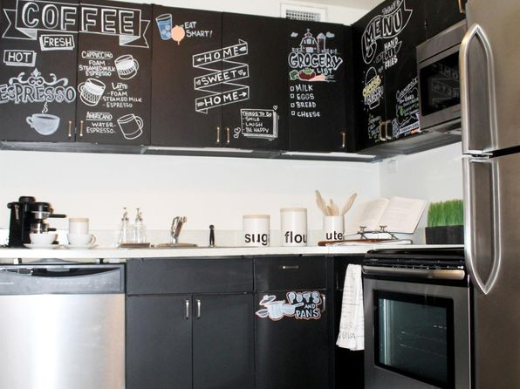](https://www.zillow.com/b/city-view-apartments-pittsburgh-pa-5XmvjF/)](https://www.zillow.com/b/city-view-apartments-pittsburgh-pa-5XmvjF/)

*[Walnut on the Park, 5326 Pocusset St, Pittsburgh, PA 15217](https://www.zillow.com/b/walnut-on-the-park-pittsburgh-pa-5Yy6Q7/)*

$1,500+/mo

* **2** bds
* **1** ba
* **858** sqft

- Apartment for rent

5 days ago

[[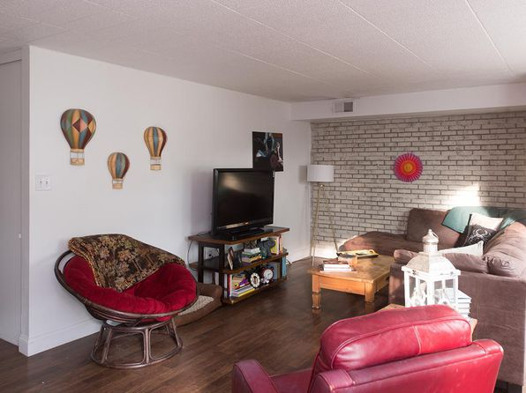](https://www.zillow.com/b/walnut-on-the-park-pittsburgh-pa-5Yy6Q7/)](https://www.zillow.com/b/walnut-on-the-park-pittsburgh-pa-5Yy6Q7/)

*[Centre Court | 4720 Centre Ave, Pittsburgh, PA](https://www.zillow.com/b/centre-court-pittsburgh-pa-5XqtZK/)*

$985+ Studio

* **$1,125+** 1 bd

3D Tour

[[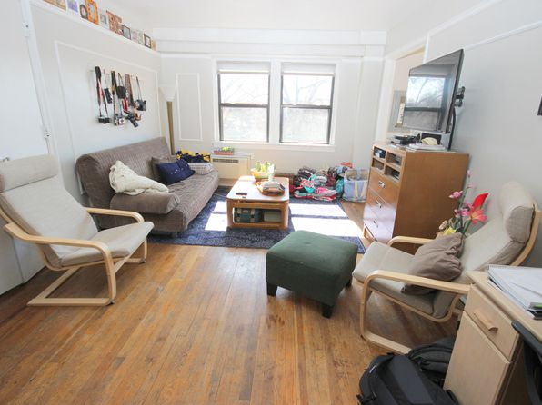](https://www.zillow.com/b/centre-court-pittsburgh-pa-5XqtZK/)](https://www.zillow.com/b/centre-court-pittsburgh-pa-5XqtZK/)

*[The Adrian | 4629 Bayard St, Pittsburgh, PA](https://www.zillow.com/b/the-adrian-pittsburgh-pa-5YCDyT/)*

$989+ Studio

* **$1,195+** 1 bd

3D Tour

[[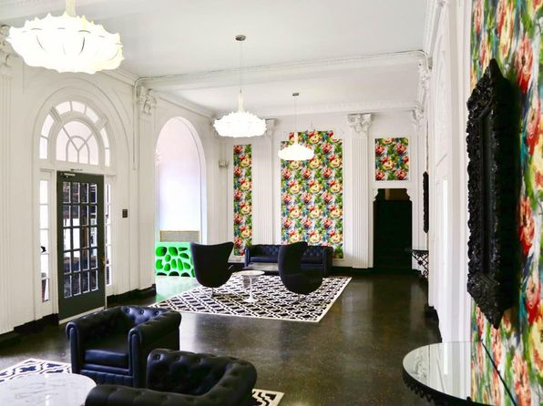](https://www.zillow.com/b/the-adrian-pittsburgh-pa-5YCDyT/)](https://www.zillow.com/b/the-adrian-pittsburgh-pa-5YCDyT/)

*[Friendship Court, 261 S Winebiddle St, Pittsburgh, PA 15224](https://www.zillow.com/b/friendship-court-pittsburgh-pa-5c48tW/)*

$1,299+/mo

* **2** bds
* **1** ba
* **690** sqft

- Apartment for rent

93 days ago

[[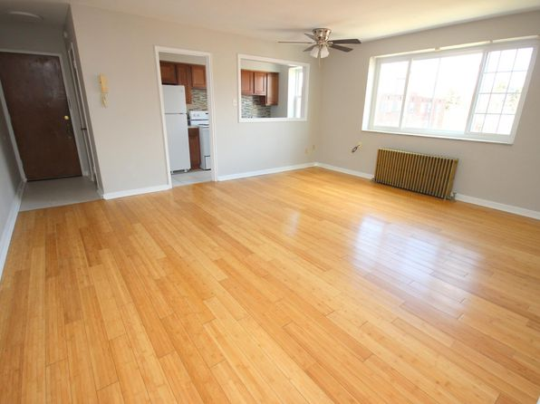](https://www.zillow.com/b/friendship-court-pittsburgh-pa-5c48tW/)](https://www.zillow.com/b/friendship-court-pittsburgh-pa-5c48tW/)

*[Arsenal 201 | 147 39th St, Pittsburgh, PA](https://www.zillow.com/b/arsenal-201-pittsburgh-pa-Bfzdwz/)*

$1,378+ Studio

* **$889+** 1 bd
* **$1,067+** 2 bds

[[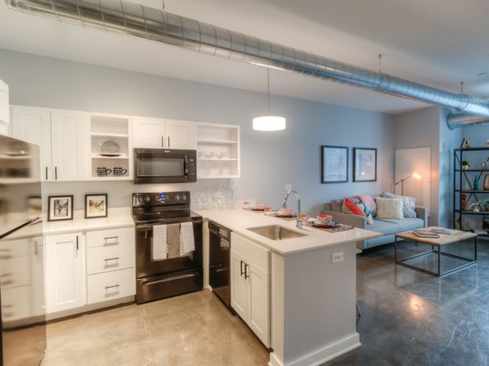](https://www.zillow.com/b/arsenal-201-pittsburgh-pa-Bfzdwz/)](https://www.zillow.com/b/arsenal-201-pittsburgh-pa-Bfzdwz/)

*[University Commons | 308 McKee Pl, Pittsburgh, PA](https://www.zillow.com/b/university-commons-pittsburgh-pa-5XqvKb/)*

$1,150+ Studio

* **$1,060+** 1 bd
* **$1,650+** 2 bds
* **$2,390+** 3 bds
* **$3,200+** 4 bds

3D Tour

[[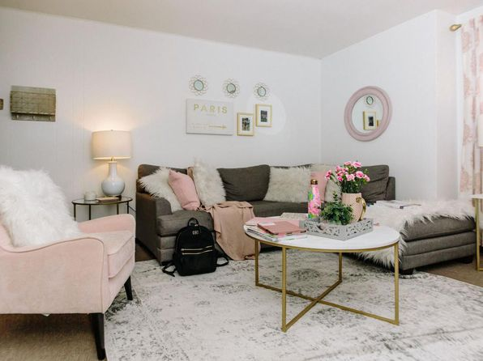](https://www.zillow.com/b/university-commons-pittsburgh-pa-5XqvKb/)](https://www.zillow.com/b/university-commons-pittsburgh-pa-5XqvKb/)

*[Pennley Commons, 5653 Broad St, Pittsburgh, PA 15206](https://www.zillow.com/b/pennley-commons-pittsburgh-pa-98NJ6W/)*

$669+/mo

* **1** bd
* **1** ba
* **--** sqft

- Apartment for rent

89 days ago

[[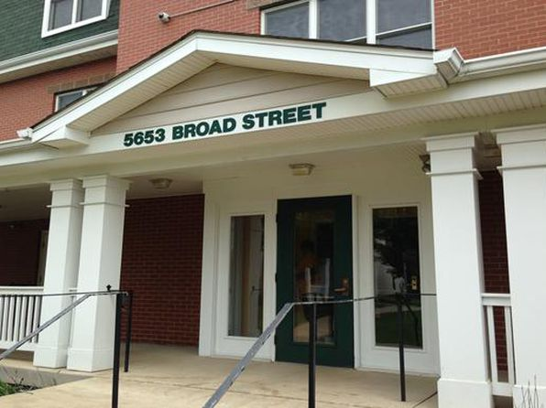](https://www.zillow.com/b/pennley-commons-pittsburgh-pa-98NJ6W/)](https://www.zillow.com/b/pennley-commons-pittsburgh-pa-98NJ6W/)

*[1627 on the Strip | 1627 Penn Ave, Pittsburgh, PA](https://www.zillow.com/b/1627-on-the-strip-pittsburgh-pa-98PL22/)*

$1,400+ Studio

* **$1,700+** 1 bd
* **$2,100+** 2 bds

[[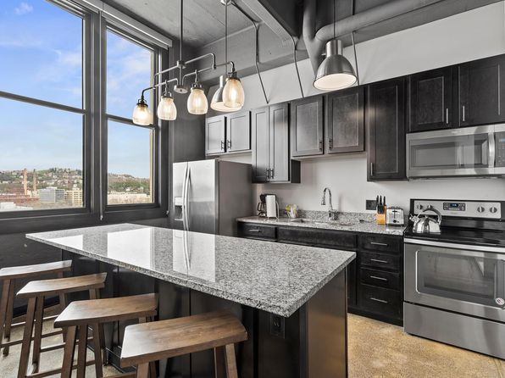](https://www.zillow.com/b/1627-on-the-strip-pittsburgh-pa-98PL22/)](https://www.zillow.com/b/1627-on-the-strip-pittsburgh-pa-98PL22/)

• Loading...

•

*[Flats on 5th | 1655 5th Ave, Pittsburgh, PA](https://www.zillow.com/b/flats-on-5th-pittsburgh-pa-98P6Yy/)*

$1,181+ 1 bd

* **$1,400+** 2 bds

[[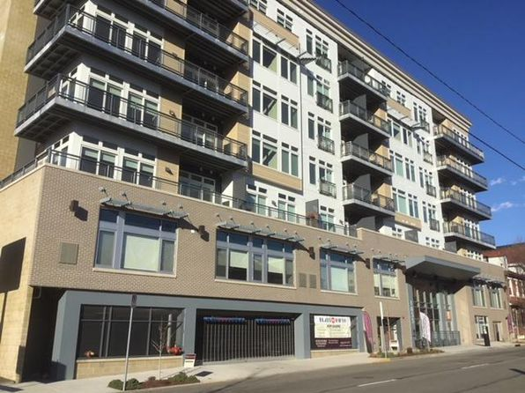](https://www.zillow.com/b/flats-on-5th-pittsburgh-pa-98P6Yy/)](https://www.zillow.com/b/flats-on-5th-pittsburgh-pa-98P6Yy/)

*[Lawrenceville Place, 103 Honeycrisp Ln, Pittsburgh, PA 15201](https://www.zillow.com/b/lawrenceville-place-pittsburgh-pa-65fnXV/)*

$2,675+/mo

* **3** bds
* **2.5** ba
* **1,654** sqft

- Apartment for rent

93 days ago

[[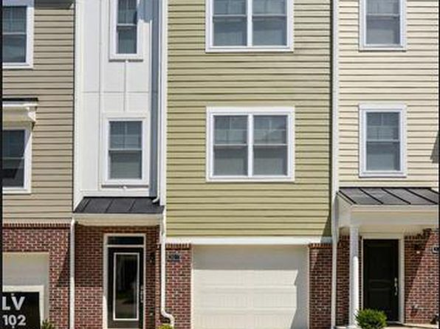](https://www.zillow.com/b/lawrenceville-place-pittsburgh-pa-65fnXV/)](https://www.zillow.com/b/lawrenceville-place-pittsburgh-pa-65fnXV/)

*[Frontenac | 490 S Highland Ave, Pittsburgh, PA](https://www.zillow.com/b/frontenac-pittsburgh-pa-5YD8hB/)*

$938+ Studio

* **$1,299+** 1 bd

[[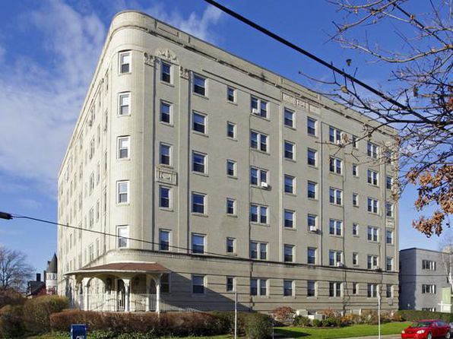](https://www.zillow.com/b/frontenac-pittsburgh-pa-5YD8hB/)](https://www.zillow.com/b/frontenac-pittsburgh-pa-5YD8hB/)

*[Frontenac | 490 S Highland Ave, Pittsburgh, PA](https://www.zillow.com/b/frontenac-pittsburgh-pa-5YD8hB/)*

$799+ Studio

[[](https://www.zillow.com/b/frontenac-pittsburgh-pa-5YD8hB/)](https://www.zillow.com/b/frontenac-pittsburgh-pa-5YD8hB/)

*[East Liberty Place | 115 N Beatty St, Pittsburgh, PA](https://www.zillow.com/b/east-liberty-place-pittsburgh-pa-5ZRVL7/)*

$950+ 1 bd

* **$1,300+** 2 bds

[[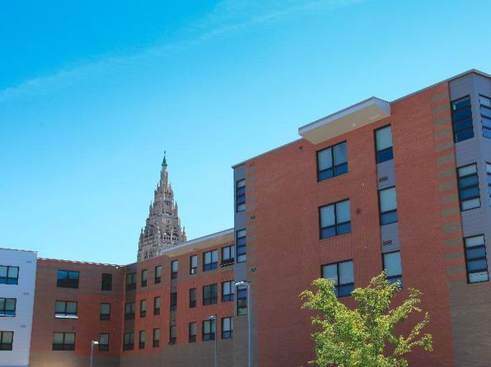](https://www.zillow.com/b/east-liberty-place-pittsburgh-pa-5ZRVL7/)](https://www.zillow.com/b/east-liberty-place-pittsburgh-pa-5ZRVL7/)

*[Hampshire Hall | 4730 Centre Ave, Pittsburgh, PA](https://www.zillow.com/b/hampshire-hall-pittsburgh-pa-5Xt45L/)*

$483+ Studio

* **$595+** 1 bd

[[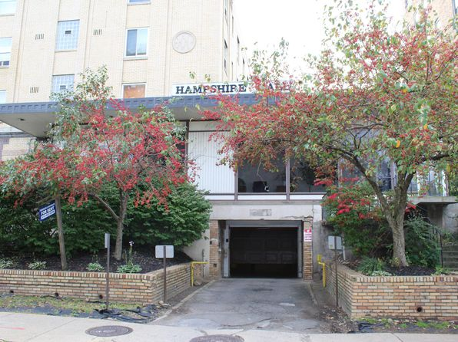](https://www.zillow.com/b/hampshire-hall-pittsburgh-pa-5Xt45L/)](https://www.zillow.com/b/hampshire-hall-pittsburgh-pa-5Xt45L/)

•

*[5552 Beacon St, Pittsburgh, PA](https://www.zillow.com/b/5552-beacon-st-pittsburgh-pa-5YSBYN/)*

$1,500+ 2 bds

5 days ago

[[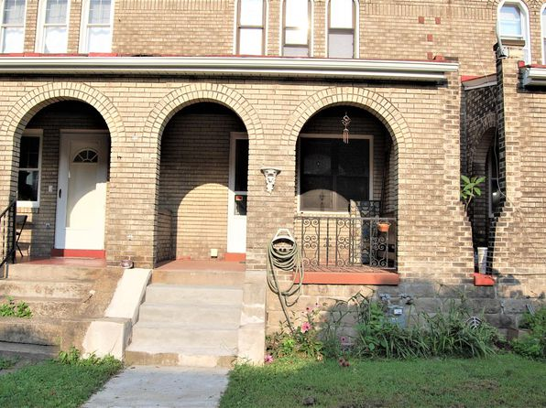](https://www.zillow.com/b/5552-beacon-st-pittsburgh-pa-5YSBYN/)](https://www.zillow.com/b/5552-beacon-st-pittsburgh-pa-5YSBYN/)

•

*[256 N Craig St APT 4, Pittsburgh, PA 15213](https://www.zillow.com/homedetails/256-N-Craig-St-APT-4-Pittsburgh-PA-15213/2105905174_zpid/)*

$1,650/mo

* **3** bds
* **1** ba
* **--** sqft

- Apartment for rent

5 days ago

[[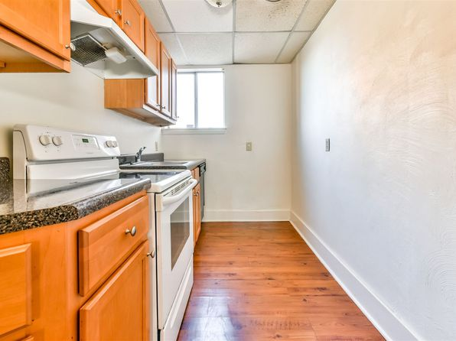](https://www.zillow.com/homedetails/256-N-Craig-St-APT-4-Pittsburgh-PA-15213/2105905174_zpid/)](https://www.zillow.com/homedetails/256-N-Craig-St-APT-4-Pittsburgh-PA-15213/2105905174_zpid/)

*[7924 Edgewood Avenue - B-1-L, 7924 Edgewood Ave, Pittsburgh, PA 15218](https://www.zillow.com/b/7924-edgewood-avenue-c-2-l-pittsburgh-pa-5fwkcY/)*

$1,000+/mo

* **2** bds
* **1** ba
* **--** sqft

- Apartment for rent

3 hours ago

[[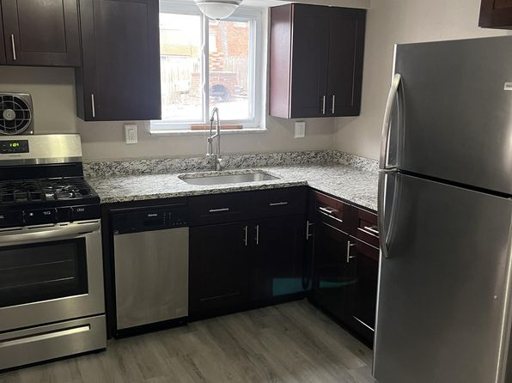](https://www.zillow.com/b/7924-edgewood-avenue-c-2-l-pittsburgh-pa-5fwkcY/)](https://www.zillow.com/b/7924-edgewood-avenue-c-2-l-pittsburgh-pa-5fwkcY/)

*[125 Orchard Pl, Pittsburgh, PA 15210](https://www.zillow.com/homedetails/125-Orchard-Pl-Pittsburgh-PA-15210/11316521_zpid/)*

$1,295/mo

* **3** bds
* **1.5** ba
* **--** sqft

- House for rent

2 days ago

[[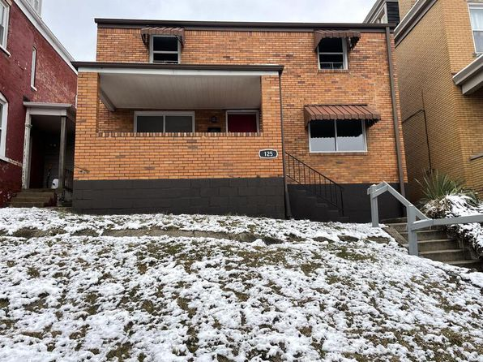](https://www.zillow.com/homedetails/125-Orchard-Pl-Pittsburgh-PA-15210/11316521_zpid/)](https://www.zillow.com/homedetails/125-Orchard-Pl-Pittsburgh-PA-15210/11316521_zpid/)

*[126 Tecumseh St, Pittsburgh, PA 15207](https://www.zillow.com/homedetails/126-Tecumseh-St-Pittsburgh-PA-15207/2059774021_zpid/)*

$950/mo

* **2** bds
* **1** ba
* **--** sqft

- House for rent

1 day ago

[[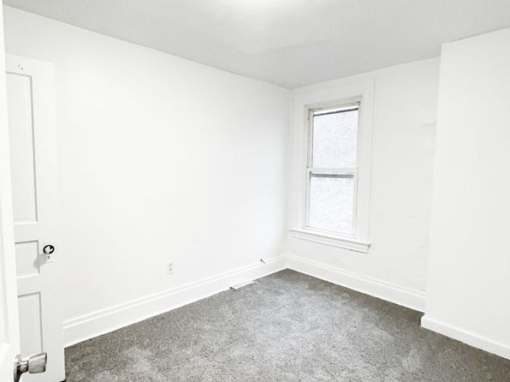](https://www.zillow.com/homedetails/126-Tecumseh-St-Pittsburgh-PA-15207/2059774021_zpid/)](https://www.zillow.com/homedetails/126-Tecumseh-St-Pittsburgh-PA-15207/2059774021_zpid/)

*[3101 Perrysville Ave APT 2, Pittsburgh, PA 15214](https://www.zillow.com/homedetails/3101-Perrysville-Ave-APT-2-Pittsburgh-PA-15214/2059781909_zpid/)*

$1,195/mo

* **3** bds
* **1** ba
* **1,100** sqft

- Apartment for rent

2 days ago

[[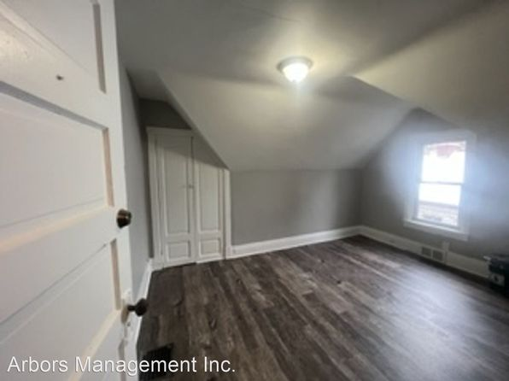](https://www.zillow.com/homedetails/3101-Perrysville-Ave-APT-2-Pittsburgh-PA-15214/2059781909_zpid/)](https://www.zillow.com/homedetails/3101-Perrysville-Ave-APT-2-Pittsburgh-PA-15214/2059781909_zpid/)

*[139 Sumner Ave, Pittsburgh, PA 15221](https://www.zillow.com/homedetails/139-Sumner-Ave-Pittsburgh-PA-15221/11456144_zpid/)*

$1,375/mo

* **3** bds
* **1** ba
* **1,478** sqft

- House for rent

1 day ago

[[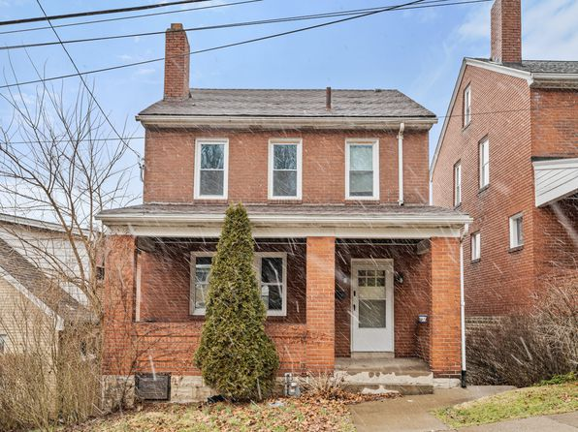](https://www.zillow.com/homedetails/139-Sumner-Ave-Pittsburgh-PA-15221/11456144_zpid/)](https://www.zillow.com/homedetails/139-Sumner-Ave-Pittsburgh-PA-15221/11456144_zpid/)

*[516 McCandless Ave #3, Pittsburgh, PA 15201](https://www.zillow.com/homedetails/516-McCandless-Ave-3-Pittsburgh-PA-15201/2071252106_zpid/)*

$1,150/mo

* **2** bds
* **1** ba
* **--** sqft

- Townhouse for rent

1 day ago

[[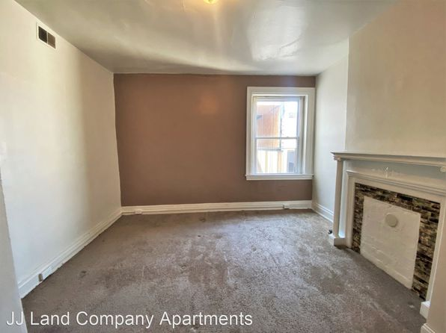](https://www.zillow.com/homedetails/516-McCandless-Ave-3-Pittsburgh-PA-15201/2071252106_zpid/)](https://www.zillow.com/homedetails/516-McCandless-Ave-3-Pittsburgh-PA-15201/2071252106_zpid/)

*[5932 Elwood St APT 1, Pittsburgh, PA 15232](https://www.zillow.com/homedetails/5932-Elwood-St-APT-1-Pittsburgh-PA-15232/2071257956_zpid/)*

$1,450/mo

* **2** bds
* **1** ba
* **--** sqft

- Apartment for rent

2 days ago

[[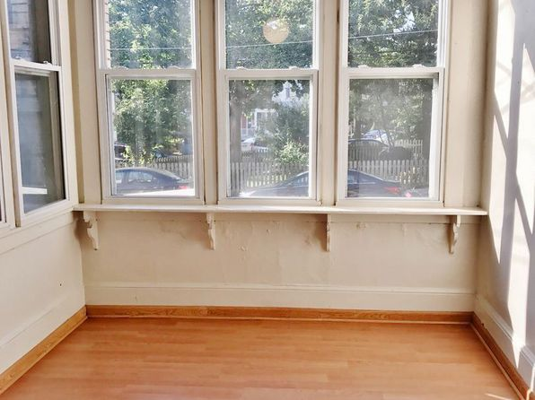](https://www.zillow.com/homedetails/5932-Elwood-St-APT-1-Pittsburgh-PA-15232/2071257956_zpid/)](https://www.zillow.com/homedetails/5932-Elwood-St-APT-1-Pittsburgh-PA-15232/2071257956_zpid/)

*[03 - 101 Southern, 101 Southern Ave #2, Pittsburgh, PA 15211](https://www.zillow.com/b/03-101-southern-pittsburgh-pa-5hH23h/)*

$1,050/mo

* **2** bds
* **1** ba
* **--** sqft

- Apartment for rent

1 day ago

[[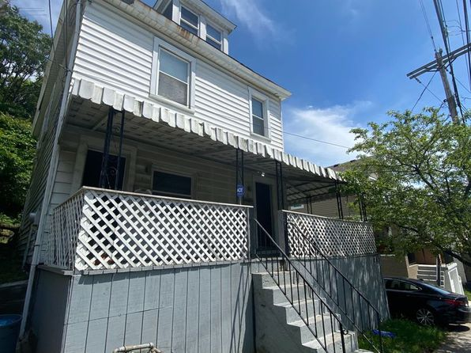](https://www.zillow.com/b/03-101-southern-pittsburgh-pa-5hH23h/)](https://www.zillow.com/b/03-101-southern-pittsburgh-pa-5hH23h/)

*[04 - 615 E Warrington, 615 E Warrington Ave APT 1, Pittsburgh, PA 15210](https://www.zillow.com/b/04-615-e-warrington-pittsburgh-pa-9PRGNk/)*

$960/mo

* **1** bd
* **1** ba
* **--** sqft

- Apartment for rent

1 day ago

[[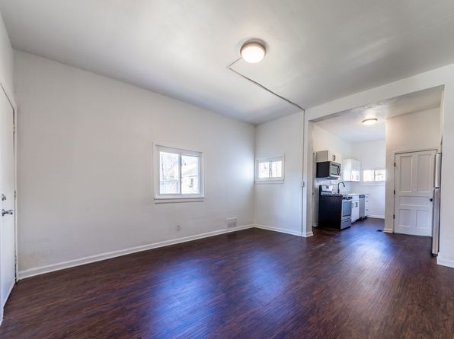](https://www.zillow.com/b/04-615-e-warrington-pittsburgh-pa-9PRGNk/)](https://www.zillow.com/b/04-615-e-warrington-pittsburgh-pa-9PRGNk/)

*[430 Greenfield Avenue | 430 Greenfield Ave, Pittsburgh, PA](https://www.zillow.com/b/430-greenfield-avenue-pittsburgh-pa-5y5d3b/)*

$1,125+ 1 bd

[[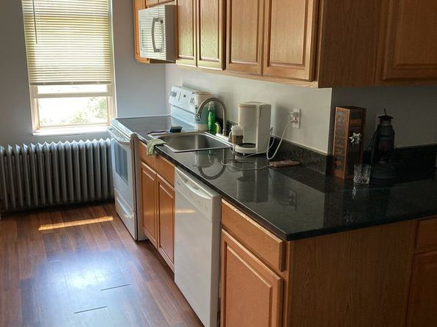](https://www.zillow.com/b/430-greenfield-avenue-pittsburgh-pa-5y5d3b/)](https://www.zillow.com/b/430-greenfield-avenue-pittsburgh-pa-5y5d3b/)

*[95 S 22nd St #3, Pittsburgh, PA 15203](https://www.zillow.com/homedetails/95-S-22nd-St-3-Pittsburgh-PA-15203/2089855184_zpid/)*

$1,400/mo

* **1** bd
* **1** ba
* **--** sqft

- Apartment for rent

2 days ago

[[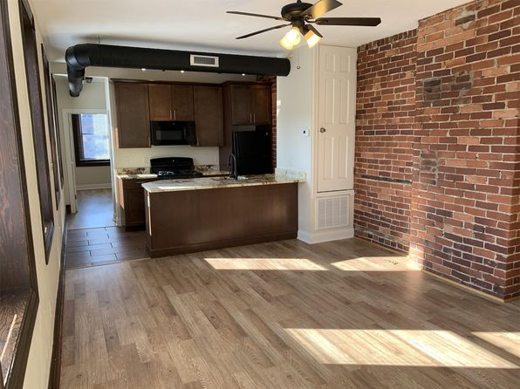](https://www.zillow.com/homedetails/95-S-22nd-St-3-Pittsburgh-PA-15203/2089855184_zpid/)](https://www.zillow.com/homedetails/95-S-22nd-St-3-Pittsburgh-PA-15203/2089855184_zpid/)

*[1363 Sturdy Oak Dr, Pittsburgh, PA 15220](https://www.zillow.com/homedetails/1363-Sturdy-Oak-Dr-Pittsburgh-PA-15220/11460577_zpid/)*

$2,240/mo

* **3** bds
* **2.5** ba
* **1,596** sqft

- House for rent

2 days ago

[[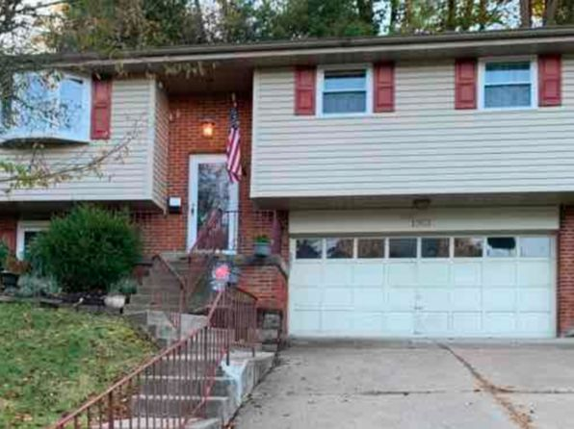](https://www.zillow.com/homedetails/1363-Sturdy-Oak-Dr-Pittsburgh-PA-15220/11460577_zpid/)](https://www.zillow.com/homedetails/1363-Sturdy-Oak-Dr-Pittsburgh-PA-15220/11460577_zpid/)

*[200 Saint Thomas St, Pittsburgh, PA 15203](https://www.zillow.com/homedetails/200-Saint-Thomas-St-Pittsburgh-PA-15203/11315246_zpid/)*

$2,150/mo

* **3** bds
* **2** ba
* **1,272** sqft

- House for rent

2 days ago

[[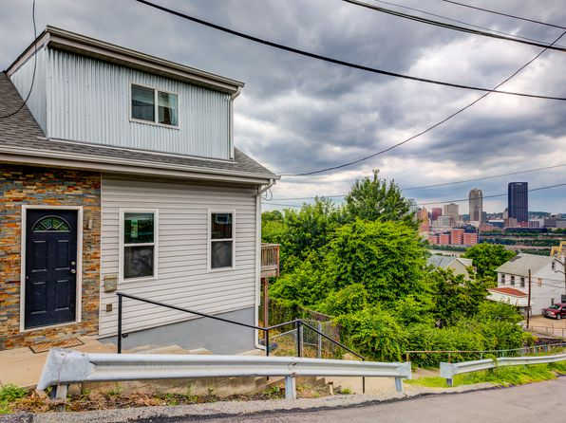](https://www.zillow.com/homedetails/200-Saint-Thomas-St-Pittsburgh-PA-15203/11315246_zpid/)](https://www.zillow.com/homedetails/200-Saint-Thomas-St-Pittsburgh-PA-15203/11315246_zpid/)

*[94 S 25th St, Pittsburgh, PA 15203](https://www.zillow.com/homedetails/94-S-25th-St-Pittsburgh-PA-15203/11291678_zpid/)*

$1,250/mo

* **2** bds
* **1** ba
* **--** sqft

- House for rent

1 day ago

[[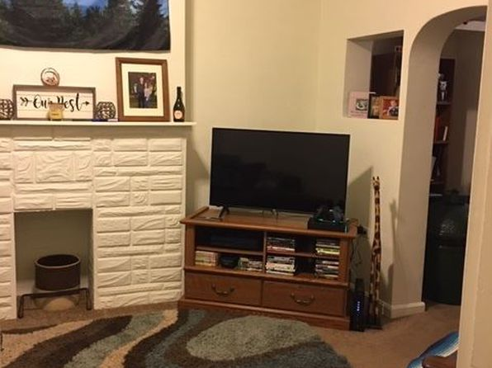](https://www.zillow.com/homedetails/94-S-25th-St-Pittsburgh-PA-15203/11291678_zpid/)](https://www.zillow.com/homedetails/94-S-25th-St-Pittsburgh-PA-15203/11291678_zpid/)

*[225 Hallock St, Pittsburgh, PA 15211](https://www.zillow.com/homedetails/225-Hallock-St-Pittsburgh-PA-15211/11586258_zpid/)*

$2,200/mo

* **3** bds
* **2.5** ba
* **--** sqft

- House for rent

2 days ago

[[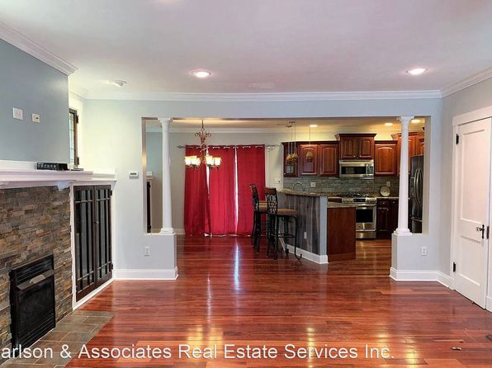](https://www.zillow.com/homedetails/225-Hallock-St-Pittsburgh-PA-15211/11586258_zpid/)](https://www.zillow.com/homedetails/225-Hallock-St-Pittsburgh-PA-15211/11586258_zpid/)

*[5400 Stanton Ave APT 7, Pittsburgh, PA 15206](https://www.zillow.com/homedetails/5400-Stanton-Ave-APT-7-Pittsburgh-PA-15206/2088107468_zpid/)*

$950/mo

* **1** bd
* **1** ba
* **--** sqft

- Apartment for rent

2 days ago

[[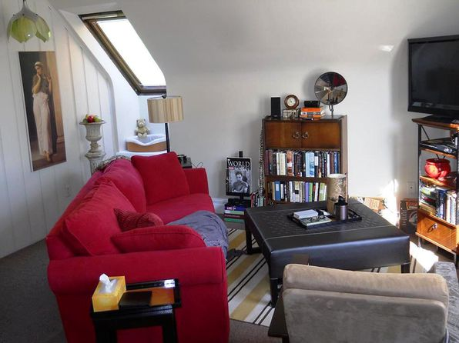](https://www.zillow.com/homedetails/5400-Stanton-Ave-APT-7-Pittsburgh-PA-15206/2088107468_zpid/)](https://www.zillow.com/homedetails/5400-Stanton-Ave-APT-7-Pittsburgh-PA-15206/2088107468_zpid/)

*[848 Proctor Way, Pittsburgh, PA 15210](https://www.zillow.com/homedetails/848-Proctor-Way-Pittsburgh-PA-15210/11315575_zpid/)*

$1,399/mo

* **3** bds
* **1** ba
* **1,364** sqft

- House for rent

*[2510 School St APT B, Pittsburgh, PA 15235](https://www.zillow.com/homedetails/2510-School-St-APT-B-Pittsburgh-PA-15235/2059818641_zpid/)*

$1,450/mo

* + **3** bds
  + **1** ba
  + **850** sqft

- Townhouse for rent

3 days ago

[[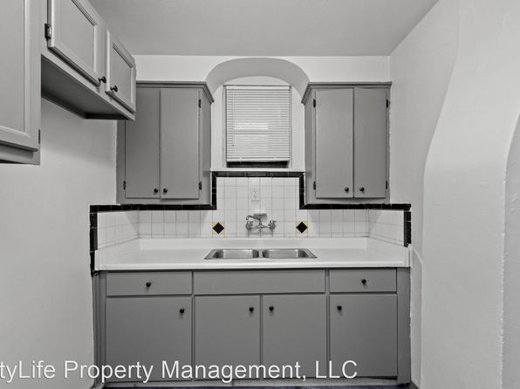](https://www.zillow.com/homedetails/2510-School-St-APT-B-Pittsburgh-PA-15235/2059818641_zpid/)](https://www.zillow.com/homedetails/2510-School-St-APT-B-Pittsburgh-PA-15235/2059818641_zpid/)

*[Kennebec - 954, 954 Kennebec St, Pittsburgh, PA 15217](https://www.zillow.com/homedetails/954-Kennebec-St-Pittsburgh-PA-15217/2078891779_zpid/)*

$1,375+/mo

* **1** bd
* **1** ba
* **--** sqft

- Apartment for rent

3 days ago

[[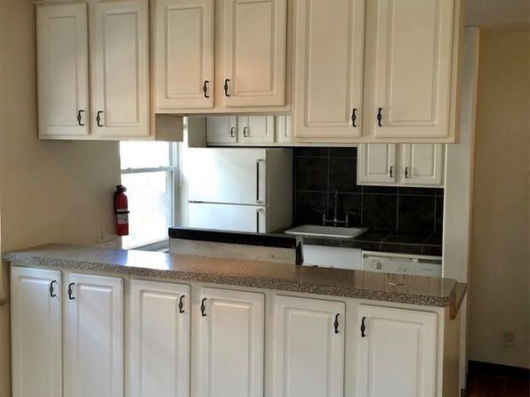](https://www.zillow.com/homedetails/954-Kennebec-St-Pittsburgh-PA-15217/2078891779_zpid/)](https://www.zillow.com/homedetails/954-Kennebec-St-Pittsburgh-PA-15217/2078891779_zpid/)

• Loading...

•

*[525 Park Ave, Pittsburgh, PA 15221](https://www.zillow.com/homedetails/525-Park-Ave-Pittsburgh-PA-15221/11383550_zpid/)*

$775/mo

* **1** bd
* **1** ba
* **604** sqft

- House for rent

1 day ago

[[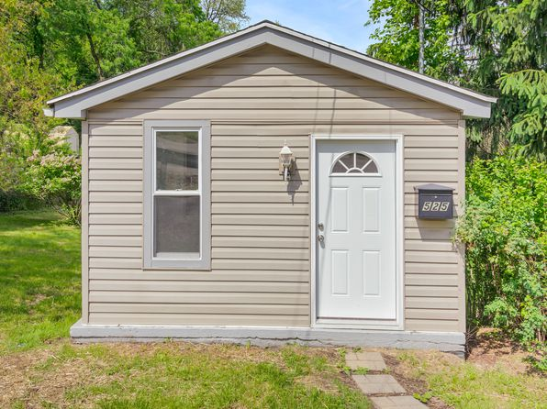](https://www.zillow.com/homedetails/525-Park-Ave-Pittsburgh-PA-15221/11383550_zpid/)](https://www.zillow.com/homedetails/525-Park-Ave-Pittsburgh-PA-15221/11383550_zpid/)

*[4709-4711 Lorigan Street, 4709-4711 Lorigan St, Pittsburgh, PA 15224](https://www.zillow.com/homedetails/4709-4711-Lorigan-St-Pittsburgh-PA-15224/11402939_zpid/)*

$1,795/mo

* **2** bds
* **1** ba
* **1,200** sqft

- Apartment for rent

2 days ago

[[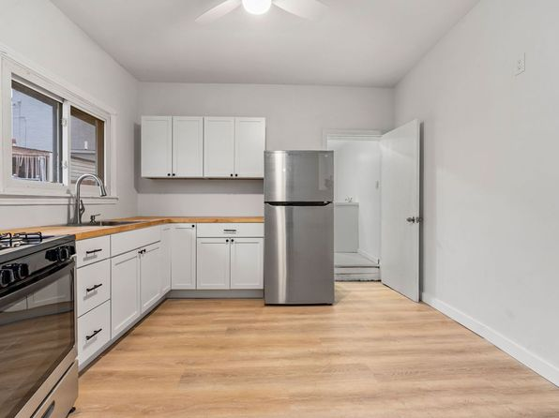](https://www.zillow.com/homedetails/4709-4711-Lorigan-St-Pittsburgh-PA-15224/11402939_zpid/)](https://www.zillow.com/homedetails/4709-4711-Lorigan-St-Pittsburgh-PA-15224/11402939_zpid/)

*[785 Fairston St, Pittsburgh, PA](https://www.zillow.com/b/785-Fairston-St-Pittsburgh-PA/40.44918,-80.05334_ll/)*

$950+ 2 bds

4 days ago

[[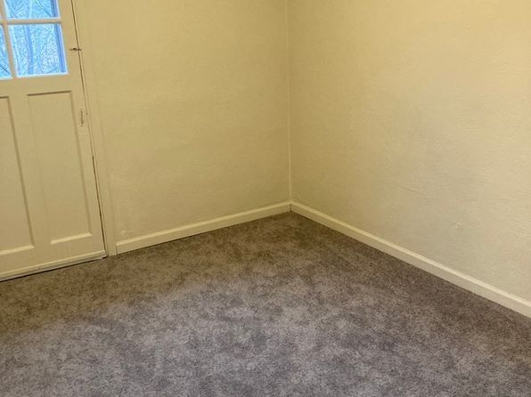](https://www.zillow.com/b/785-Fairston-St-Pittsburgh-PA/40.44918,-80.05334_ll/)](https://www.zillow.com/b/785-Fairston-St-Pittsburgh-PA/40.44918,-80.05334_ll/)

*[Beacon St Apts, 5608 Beacon St #D30977651, Pittsburgh, PA 15217](https://www.zillow.com/b/beacon-st-apts-squirrel-hill-pa-5yB9QV/)*

$2,350/mo

* **3** bds
* **1** ba
* **--** sqft

- Apartment for rent

2 days ago

[[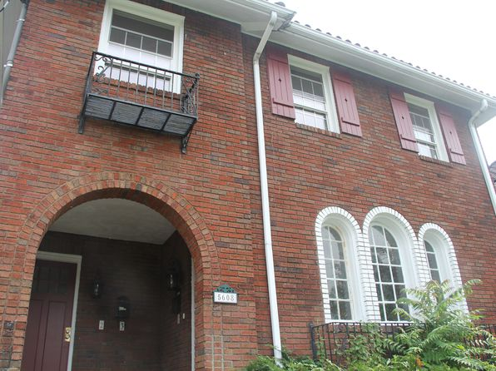](https://www.zillow.com/b/beacon-st-apts-squirrel-hill-pa-5yB9QV/)](https://www.zillow.com/b/beacon-st-apts-squirrel-hill-pa-5yB9QV/)

*[89 S 22nd St #1, Pittsburgh, PA 15203](https://www.zillow.com/homedetails/89-S-22nd-St-1-Pittsburgh-PA-15203/2092460015_zpid/)*

$1,675/mo

* **2** bds
* **1** ba
* **--** sqft

- Apartment for rent

3 days ago

[[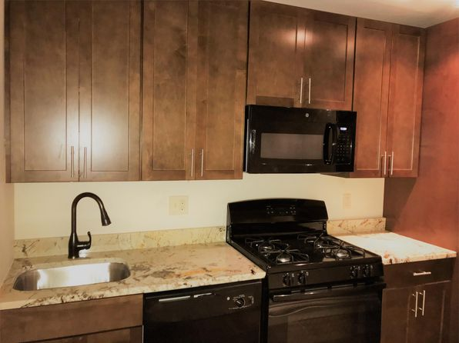](https://www.zillow.com/homedetails/89-S-22nd-St-1-Pittsburgh-PA-15203/2092460015_zpid/)](https://www.zillow.com/homedetails/89-S-22nd-St-1-Pittsburgh-PA-15203/2092460015_zpid/)

*[163 Meridan St, Pittsburgh, PA 15211](https://www.zillow.com/homedetails/163-Meridan-St-Pittsburgh-PA-15211/11586343_zpid/)*

$2,400/mo

* **4** bds
* **2** ba
* **1,200** sqft

- House for rent

5 days ago

[[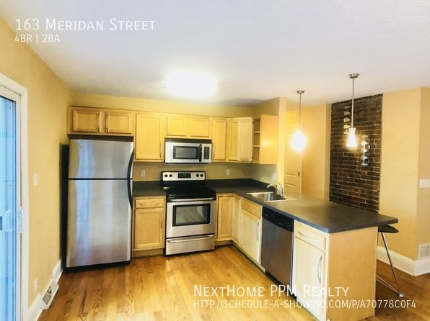](https://www.zillow.com/homedetails/163-Meridan-St-Pittsburgh-PA-15211/11586343_zpid/)](https://www.zillow.com/homedetails/163-Meridan-St-Pittsburgh-PA-15211/11586343_zpid/)

•

*[311 Franklin Ave, Pittsburgh, PA](https://www.zillow.com/b/311-franklin-ave-pittsburgh-pa-5jBrS2/)*

$899+ 1 bd

Updated today

[[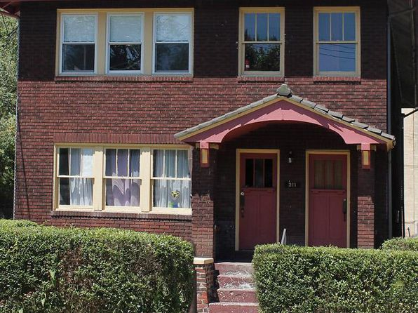](https://www.zillow.com/b/311-franklin-ave-pittsburgh-pa-5jBrS2/)](https://www.zillow.com/b/311-franklin-ave-pittsburgh-pa-5jBrS2/)

•

*[125-129 Central Sq, Pittsburgh, PA](https://www.zillow.com/b/125-129-central-sq-pittsburgh-pa-BLZKFB/)*

$925+ 1 bd

4 days ago

[[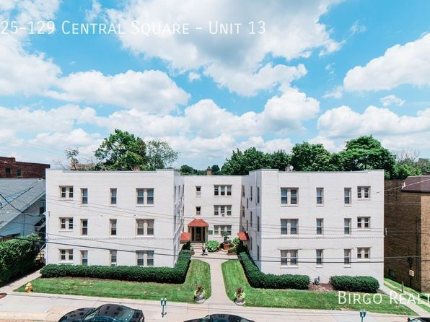](https://www.zillow.com/b/125-129-central-sq-pittsburgh-pa-BLZKFB/)](https://www.zillow.com/b/125-129-central-sq-pittsburgh-pa-BLZKFB/)

•

*[119 43rd St, Pittsburgh, PA 15201](https://www.zillow.com/homedetails/119-43rd-St-Pittsburgh-PA-15201/11613238_zpid/)*

$2,300/mo

* **3** bds
* **1** ba
* **1,326** sqft

- House for rent

2 days ago

[[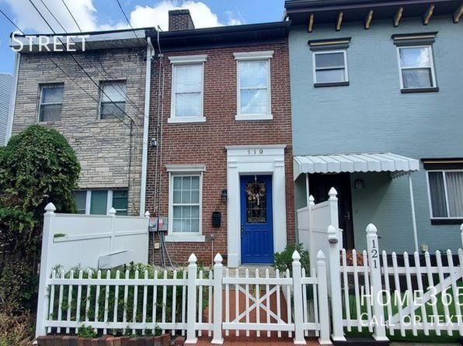](https://www.zillow.com/homedetails/119-43rd-St-Pittsburgh-PA-15201/11613238_zpid/)](https://www.zillow.com/homedetails/119-43rd-St-Pittsburgh-PA-15201/11613238_zpid/)

*[620 Bellefonte Street, 620 Bellefonte St APT 1, Shadyside, PA 15232](https://www.zillow.com/b/620-bellefonte-street-pittsburgh-pa-5jBqw4/)*

$1,450/mo

* **1** bd
* **1** ba
* **750** sqft

- Apartment for rent

2 days ago

[[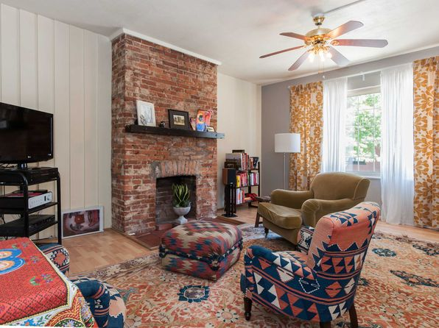](https://www.zillow.com/b/620-bellefonte-street-pittsburgh-pa-5jBqw4/)](https://www.zillow.com/b/620-bellefonte-street-pittsburgh-pa-5jBqw4/)

*[5960 Wellesley Ave | 5960 Wellesley Ave, Pittsburgh, PA](https://www.zillow.com/b/5960-wellesley-ave-pittsburgh-pa-98NJL4/)*

$975+ Studio

* **$1,250+** 1 bd

[[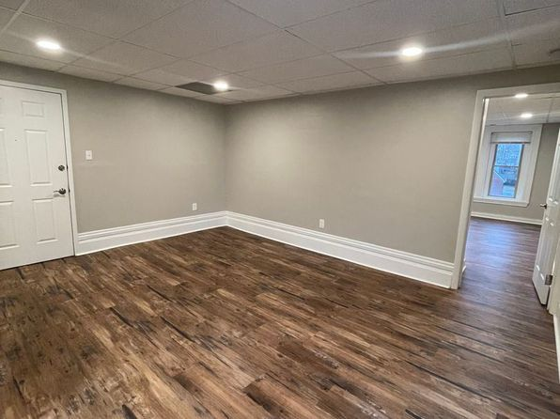](https://www.zillow.com/b/5960-wellesley-ave-pittsburgh-pa-98NJL4/)](https://www.zillow.com/b/5960-wellesley-ave-pittsburgh-pa-98NJL4/)

*[333 Lehigh Ave #2, Pittsburgh, PA 15232](https://www.zillow.com/homedetails/333-Lehigh-Ave-2-Pittsburgh-PA-15232/2079280225_zpid/)*

$2,995/mo

* **3** bds
* **2** ba
* **1,400** sqft

- Apartment for rent

6 days ago

[[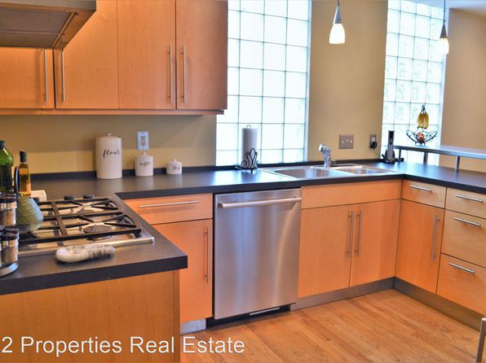](https://www.zillow.com/homedetails/333-Lehigh-Ave-2-Pittsburgh-PA-15232/2079280225_zpid/)](https://www.zillow.com/homedetails/333-Lehigh-Ave-2-Pittsburgh-PA-15232/2079280225_zpid/)

•

*[700 Ivy Street - 3 | 700 Ivy St, Pittsburgh, PA](https://www.zillow.com/b/700-ivy-street-5-pittsburgh-pa-98PgB5/)*

$1,295+ 1 bd

[[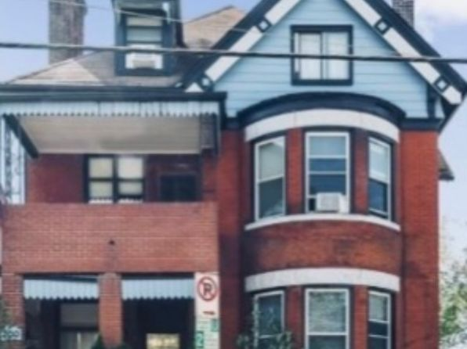](https://www.zillow.com/b/700-ivy-street-5-pittsburgh-pa-98PgB5/)](https://www.zillow.com/b/700-ivy-street-5-pittsburgh-pa-98PgB5/)

• • Loading...

•

*[2933 Mary Street | 2933 Mary St, Pittsburgh, PA](https://www.zillow.com/b/2933-mary-street-pittsburgh-pa-5dpTG4/)*

$1,650+ 1 bd

* **$2,100+** 2 bds

[[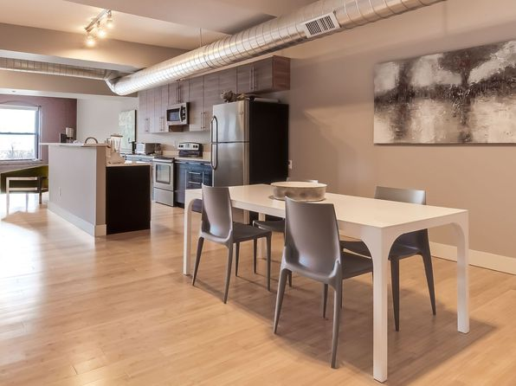](https://www.zillow.com/b/2933-mary-street-pittsburgh-pa-5dpTG4/)](https://www.zillow.com/b/2933-mary-street-pittsburgh-pa-5dpTG4/)

*[6009 Walnut St APT 33, Pittsburgh, PA 15206](https://www.zillow.com/homedetails/6009-Walnut-St-APT-33-Pittsburgh-PA-15206/2102182072_zpid/)*

$1,490/mo

* **1** bd
* **1** ba
* **--** sqft

- Apartment for rent

6 days ago

[[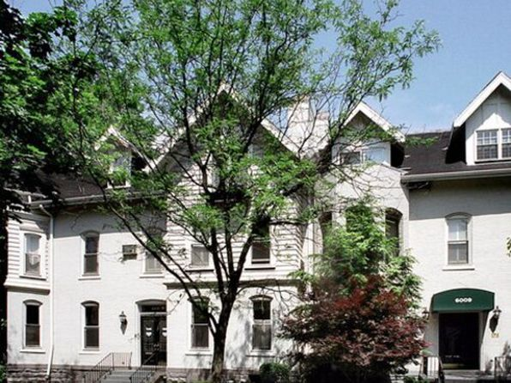](https://www.zillow.com/homedetails/6009-Walnut-St-APT-33-Pittsburgh-PA-15206/2102182072_zpid/)](https://www.zillow.com/homedetails/6009-Walnut-St-APT-33-Pittsburgh-PA-15206/2102182072_zpid/)

*[2829 Edwards Way, 2829 Edwards Way #1, Pittsburgh, PA 15203](https://www.zillow.com/b/2829-edwards-way-pittsburgh-pa-98N7Yv/)*

$1,250/mo

* **1** bd
* **1.5** ba
* **750** sqft

- Apartment for rent

6 days ago

[[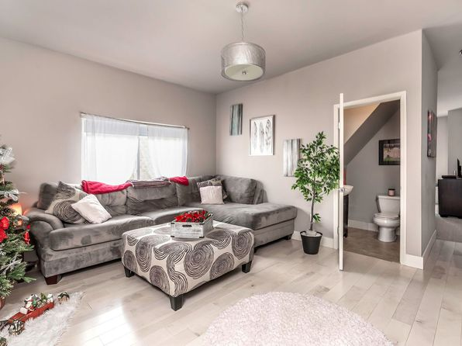](https://www.zillow.com/b/2829-edwards-way-pittsburgh-pa-98N7Yv/)](https://www.zillow.com/b/2829-edwards-way-pittsburgh-pa-98N7Yv/)

*[1655 Beechwood Blvd, Pittsburgh, PA 15217](https://www.zillow.com/homedetails/1655-Beechwood-Blvd-Pittsburgh-PA-15217/11289354_zpid/)*

$2,250/mo

* **3** bds
* **2** ba
* **2,027** sqft

- House for rent

2 days ago

[[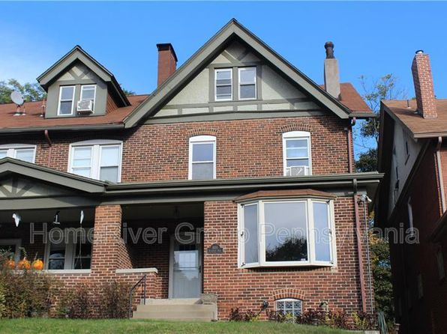](https://www.zillow.com/homedetails/1655-Beechwood-Blvd-Pittsburgh-PA-15217/11289354_zpid/)](https://www.zillow.com/homedetails/1655-Beechwood-Blvd-Pittsburgh-PA-15217/11289354_zpid/)

*[1324 E Carson Street, 1324 E Carson St APT 3, Pittsburgh, PA 15203](https://www.zillow.com/b/1324-e-carson-street-pittsburgh-pa-5Zb2dj/)*

$950/mo

* **1** bd
* **1** ba
* **500** sqft

- Apartment for rent

6 days ago

[[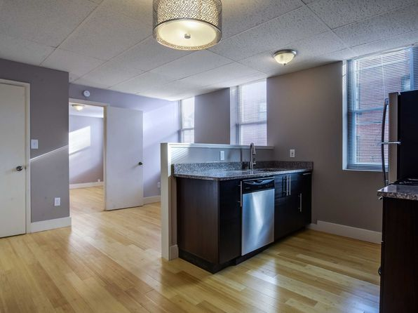](https://www.zillow.com/b/1324-e-carson-street-pittsburgh-pa-5Zb2dj/)](https://www.zillow.com/b/1324-e-carson-street-pittsburgh-pa-5Zb2dj/)

*[746 Bajo St, Pittsburgh, PA 15210](https://www.zillow.com/homedetails/746-Bajo-St-Pittsburgh-PA-15210/11433007_zpid/)*

$2,200/mo

* **3** bds
* **2** ba
* **24,263** sqft

- Apartment for rent

10 days ago

[[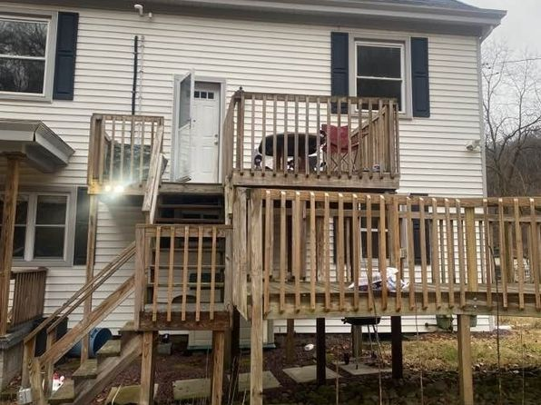](https://www.zillow.com/homedetails/746-Bajo-St-Pittsburgh-PA-15210/11433007_zpid/)](https://www.zillow.com/homedetails/746-Bajo-St-Pittsburgh-PA-15210/11433007_zpid/)

*[371 S Bouquet St, Pittsburgh, PA 15213](https://www.zillow.com/homedetails/371-S-Bouquet-St-Pittsburgh-PA-15213/11412702_zpid/)*

$1,800/mo

* **3** bds
* **1** ba
* **--** sqft

- Townhouse for rent

5 days ago

[[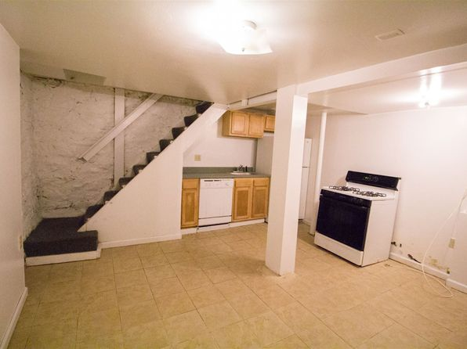](https://www.zillow.com/homedetails/371-S-Bouquet-St-Pittsburgh-PA-15213/11412702_zpid/)](https://www.zillow.com/homedetails/371-S-Bouquet-St-Pittsburgh-PA-15213/11412702_zpid/)

*[1860 Brett St APT 314, Pittsburgh, PA 15205](https://www.zillow.com/homedetails/1860-Brett-St-APT-314-Pittsburgh-PA-15205/2095137580_zpid/)*

$825/mo

* **1** bd
* **1** ba
* **--** sqft

- Apartment for rent

6 days ago

[[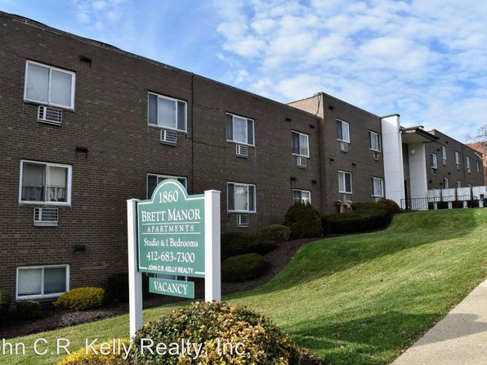](https://www.zillow.com/homedetails/1860-Brett-St-APT-314-Pittsburgh-PA-15205/2095137580_zpid/)](https://www.zillow.com/homedetails/1860-Brett-St-APT-314-Pittsburgh-PA-15205/2095137580_zpid/)

*[518 Griffin St, Pittsburgh, PA 15211](https://www.zillow.com/homedetails/518-Griffin-St-Pittsburgh-PA-15211/11323396_zpid/)*

$1,900/mo

* **3** bds
* **2.5** ba
* **1,400** sqft

- House for rent

10 days ago

[[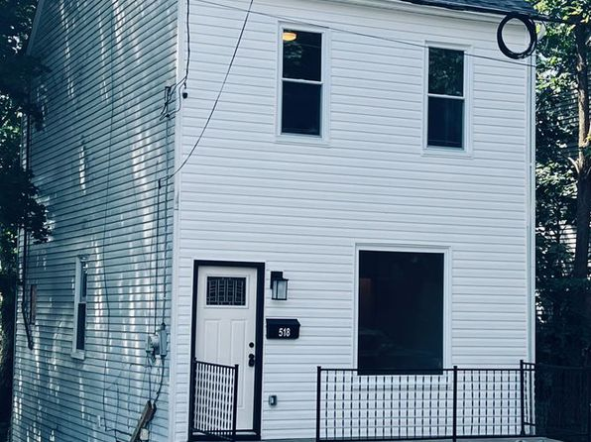](https://www.zillow.com/homedetails/518-Griffin-St-Pittsburgh-PA-15211/11323396_zpid/)](https://www.zillow.com/homedetails/518-Griffin-St-Pittsburgh-PA-15211/11323396_zpid/)

•

*[612 N Saint Clair St, Pittsburgh, PA](https://www.zillow.com/b/612-N-Saint-Clair-St-Pittsburgh-PA/40.46854,-79.92502_ll/)*

$1,399+ 2 bds

* **$1,599+** 3 bds

6 days ago

[[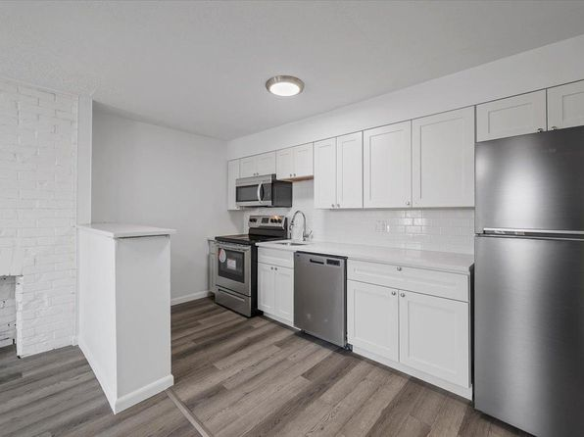](https://www.zillow.com/b/612-N-Saint-Clair-St-Pittsburgh-PA/40.46854,-79.92502_ll/)](https://www.zillow.com/b/612-N-Saint-Clair-St-Pittsburgh-PA/40.46854,-79.92502_ll/)

•

*[5720 Stanton Avenue | 5720 Stanton Ave, Pittsburgh, PA](https://www.zillow.com/b/5720-stanton-avenue-pittsburgh-pa-5Z6hkv/)*

$1,099+ 1 bd

[[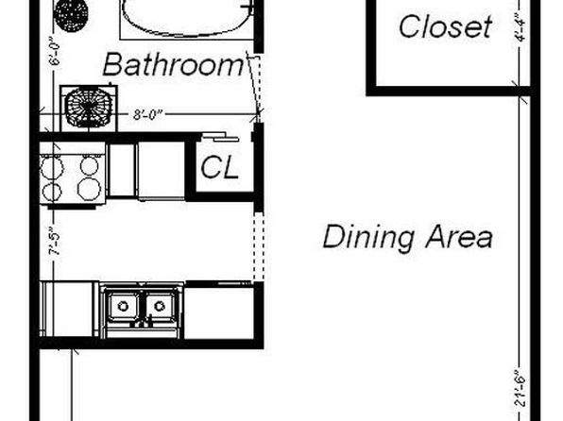](https://www.zillow.com/b/5720-stanton-avenue-pittsburgh-pa-5Z6hkv/)](https://www.zillow.com/b/5720-stanton-avenue-pittsburgh-pa-5Z6hkv/)

*[306 Mount Royal Blvd, Pittsburgh, PA 15223](https://www.zillow.com/homedetails/306-Mount-Royal-Blvd-Pittsburgh-PA-15223/11372326_zpid/)*

$2,000/mo

* **3** bds
* **2** ba
* **2,000** sqft

- House for rent

2 hours ago

[[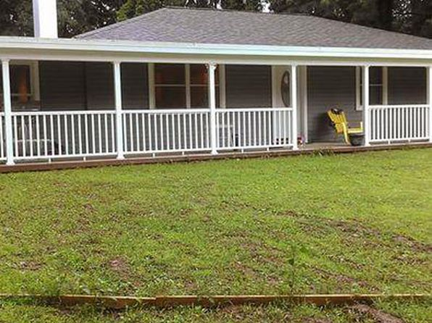](https://www.zillow.com/homedetails/306-Mount-Royal-Blvd-Pittsburgh-PA-15223/11372326_zpid/)](https://www.zillow.com/homedetails/306-Mount-Royal-Blvd-Pittsburgh-PA-15223/11372326_zpid/)

*[1407 Wightman St #1, Pittsburgh, PA 15217](https://www.zillow.com/homedetails/1407-Wightman-St-1-Pittsburgh-PA-15217/2105400465_zpid/)*

$1,459/mo

* **1** bd
* **1** ba
* **--** sqft

- Apartment for rent

11 days ago

[[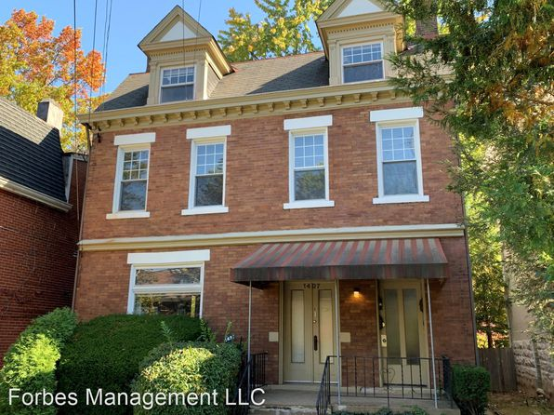](https://www.zillow.com/homedetails/1407-Wightman-St-1-Pittsburgh-PA-15217/2105400465_zpid/)](https://www.zillow.com/homedetails/1407-Wightman-St-1-Pittsburgh-PA-15217/2105400465_zpid/)

*[28 Locust Ln, Pittsburgh, PA 15241](https://www.zillow.com/homedetails/28-Locust-Ln-Pittsburgh-PA-15241/11432485_zpid/)*

$1,650/mo

* **3** bds
* **1** ba
* **1,224** sqft

- House for rent

16 hours ago

[[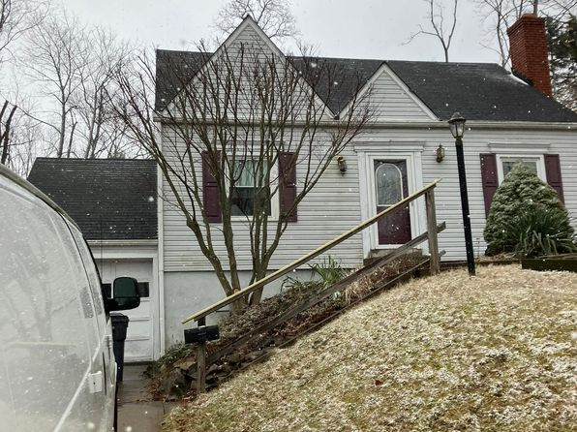](https://www.zillow.com/homedetails/28-Locust-Ln-Pittsburgh-PA-15241/11432485_zpid/)](https://www.zillow.com/homedetails/28-Locust-Ln-Pittsburgh-PA-15241/11432485_zpid/)

*[5491 Penn Ave #A302, Pittsburgh, PA 15206](https://www.zillow.com/homedetails/5491-Penn-Ave-A302-Pittsburgh-PA-15206/123704150_zpid/)*

$2,950/mo

* **1** bd
* **1** ba
* **--** sqft

- Apartment for rent

13 days ago

[[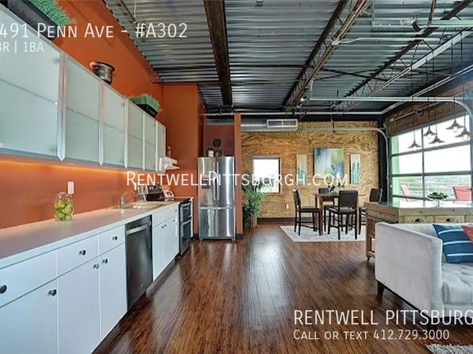](https://www.zillow.com/homedetails/5491-Penn-Ave-A302-Pittsburgh-PA-15206/123704150_zpid/)](https://www.zillow.com/homedetails/5491-Penn-Ave-A302-Pittsburgh-PA-15206/123704150_zpid/)

*[5003 Grand | 5003 Grand Ave, Pittsburgh, PA](https://www.zillow.com/b/5003-grand-pittsburgh-pa-98PPxK/)*

$850+ 1 bd

[[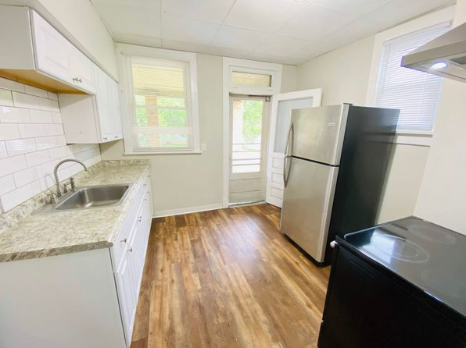](https://www.zillow.com/b/5003-grand-pittsburgh-pa-98PPxK/)](https://www.zillow.com/b/5003-grand-pittsburgh-pa-98PPxK/)

*[222 Park St, Pittsburgh, PA 15209](https://www.zillow.com/homedetails/222-Park-St-Pittsburgh-PA-15209/2077256745_zpid/)*

$975/mo

* **2** bds
* **1** ba
* **--** sqft

- House for rent

2 days ago

[[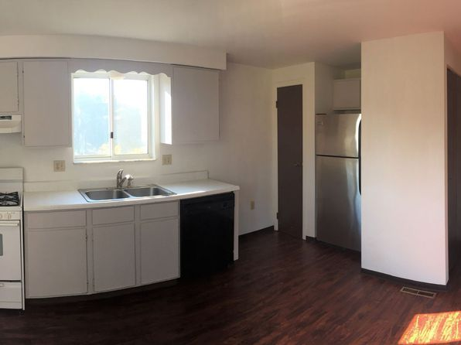](https://www.zillow.com/homedetails/222-Park-St-Pittsburgh-PA-15209/2077256745_zpid/)](https://www.zillow.com/homedetails/222-Park-St-Pittsburgh-PA-15209/2077256745_zpid/)

*[1718 Mary St, Pittsburgh, PA 15203](https://www.zillow.com/homedetails/1718-Mary-St-Pittsburgh-PA-15203/11291915_zpid/)*

$2,500/mo

* **4** bds
* **2** ba
* **1,684** sqft

- House for rent

5 days ago

[[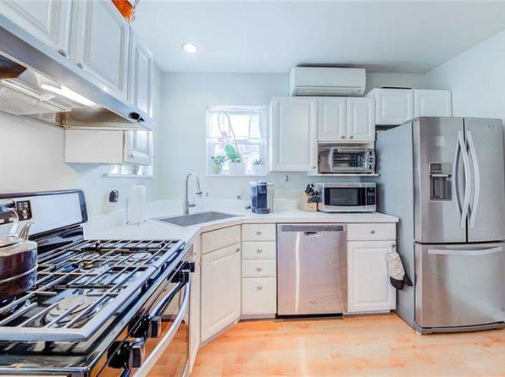](https://www.zillow.com/homedetails/1718-Mary-St-Pittsburgh-PA-15203/11291915_zpid/)](https://www.zillow.com/homedetails/1718-Mary-St-Pittsburgh-PA-15203/11291915_zpid/)

*[411 Hoodridge Dr #D2, Pittsburgh, PA 15234](https://www.zillow.com/homedetails/411-Hoodridge-Dr-D2-Pittsburgh-PA-15234/2060052719_zpid/)*

$835/mo

* **2** bds
* **1** ba
* **640** sqft

- Apartment for rent

12 days ago

[[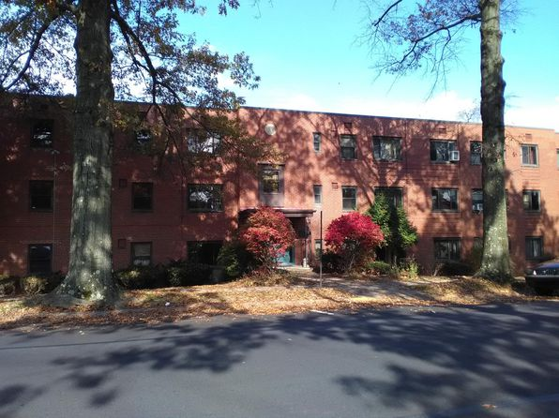](https://www.zillow.com/homedetails/411-Hoodridge-Dr-D2-Pittsburgh-PA-15234/2060052719_zpid/)](https://www.zillow.com/homedetails/411-Hoodridge-Dr-D2-Pittsburgh-PA-15234/2060052719_zpid/)

*[1320 Hazlett Rd, Pittsburgh, PA 15237](https://www.zillow.com/homedetails/1320-Hazlett-Rd-Pittsburgh-PA-15237/11590879_zpid/)*

$1,600/mo

* **3** bds
* **1** ba
* **--** sqft

- House for rent

2 days ago

[[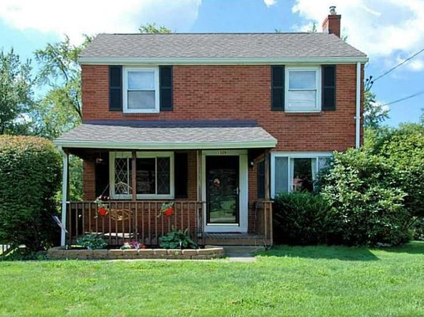](https://www.zillow.com/homedetails/1320-Hazlett-Rd-Pittsburgh-PA-15237/11590879_zpid/)](https://www.zillow.com/homedetails/1320-Hazlett-Rd-Pittsburgh-PA-15237/11590879_zpid/)

*[7310 Church St, Pittsburgh, PA 15218](https://www.zillow.com/homedetails/7310-Church-St-Pittsburgh-PA-15218/11345630_zpid/)*

$825/mo

* **1** bd
* **1** ba
* **--** sqft

- Townhouse for rent

6 days ago

[[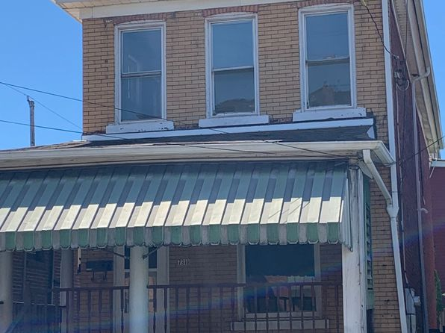](https://www.zillow.com/homedetails/7310-Church-St-Pittsburgh-PA-15218/11345630_zpid/)](https://www.zillow.com/homedetails/7310-Church-St-Pittsburgh-PA-15218/11345630_zpid/)

*[157 S Fairmount St APT 1, Pittsburgh, PA 15206](https://www.zillow.com/homedetails/157-S-Fairmount-St-APT-1-Pittsburgh-PA-15206/2121639352_zpid/)*

$2,180/mo

* **2** bds
* **2** ba
* **1,000** sqft

- Apartment for rent

16 days ago

[[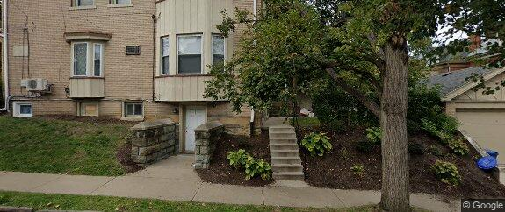](https://www.zillow.com/homedetails/157-S-Fairmount-St-APT-1-Pittsburgh-PA-15206/2121639352_zpid/)](https://www.zillow.com/homedetails/157-S-Fairmount-St-APT-1-Pittsburgh-PA-15206/2121639352_zpid/)

*[2900 Voelkel Ave APT 301, Pittsburgh, PA 15216](https://www.zillow.com/homedetails/2900-Voelkel-Ave-APT-301-Pittsburgh-PA-15216/2083656933_zpid/)*

$640/mo

* **1** bd
* **1** ba
* **350** sqft

- Apartment for rent

5 days ago

[[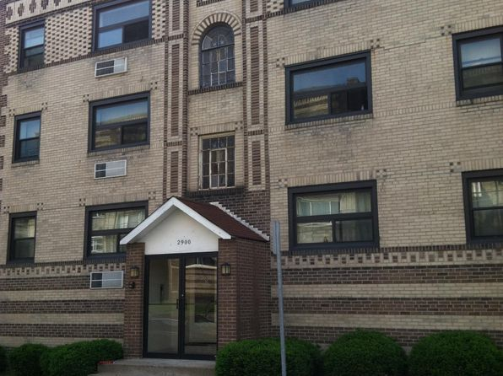](https://www.zillow.com/homedetails/2900-Voelkel-Ave-APT-301-Pittsburgh-PA-15216/2083656933_zpid/)](https://www.zillow.com/homedetails/2900-Voelkel-Ave-APT-301-Pittsburgh-PA-15216/2083656933_zpid/)

*[2132 Sarah St #102, Pittsburgh, PA 15203](https://www.zillow.com/homedetails/2132-Sarah-St-102-Pittsburgh-PA-15203/2094510621_zpid/)*

$3,200/mo

* **2** bds
* **3** ba
* **1,578** sqft

- Apartment for rent

6 days ago

[[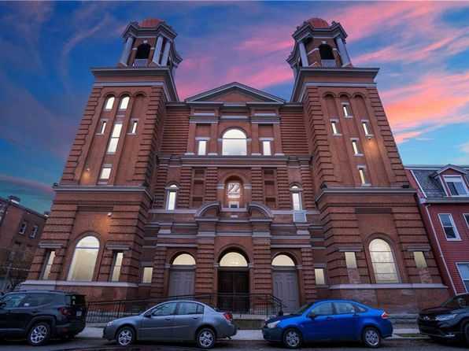](https://www.zillow.com/homedetails/2132-Sarah-St-102-Pittsburgh-PA-15203/2094510621_zpid/)](https://www.zillow.com/homedetails/2132-Sarah-St-102-Pittsburgh-PA-15203/2094510621_zpid/)

*[5454 Pocusset St, Pittsburgh, PA 15217](https://www.zillow.com/homedetails/5454-Pocusset-St-Pittsburgh-PA-15217/11635261_zpid/)*

$3,200/mo

* **4** bds
* **2.5** ba
* **1,650** sqft

- Townhouse for rent

3 days ago

[[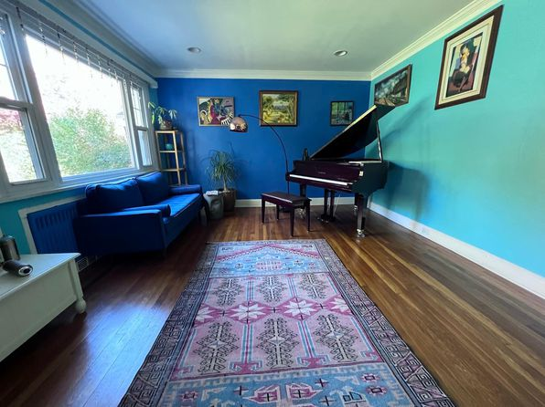](https://www.zillow.com/homedetails/5454-Pocusset-St-Pittsburgh-PA-15217/11635261_zpid/)](https://www.zillow.com/homedetails/5454-Pocusset-St-Pittsburgh-PA-15217/11635261_zpid/)

to get email alerts when listings hit the mark

*[3532 California Ave | 3532 California Ave, Pittsburgh, PA](https://www.zillow.com/b/3532-california-ave-pittsburgh-pa-5fwp5V/)*

$850+ 1 bd

[[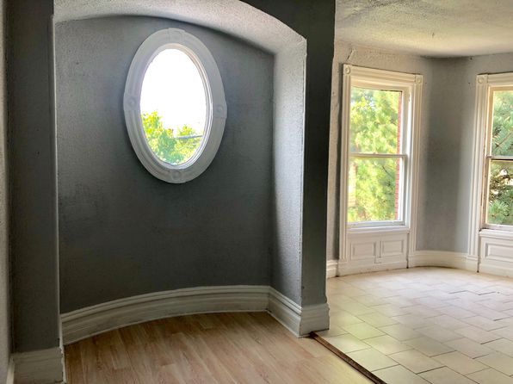](https://www.zillow.com/b/3532-california-ave-pittsburgh-pa-5fwp5V/)](https://www.zillow.com/b/3532-california-ave-pittsburgh-pa-5fwp5V/)

*[5216 Clarwin Ave FLOOR 1, Pittsburgh, PA 15229](https://www.zillow.com/homedetails/5216-Clarwin-Ave-FLOOR-1-Pittsburgh-PA-15229/2060353262_zpid/)*

$1,300/mo

* **2** bds
* **1** ba
* **990** sqft

- Apartment for rent

12 days ago

[[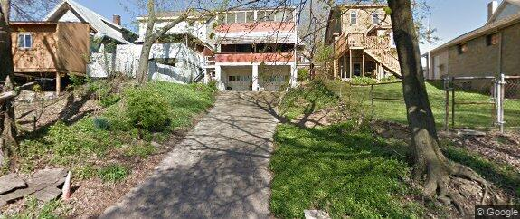](https://www.zillow.com/homedetails/5216-Clarwin-Ave-FLOOR-1-Pittsburgh-PA-15229/2060353262_zpid/)](https://www.zillow.com/homedetails/5216-Clarwin-Ave-FLOOR-1-Pittsburgh-PA-15229/2060353262_zpid/)

•

*[2775 Zephyr Ave, Pittsburgh, PA](https://www.zillow.com/b/Pittsburgh-PA/40.454086,-80.051674_ll/)*

$650+ 1 bd

* **$850+** 3 bds

3 days ago

[[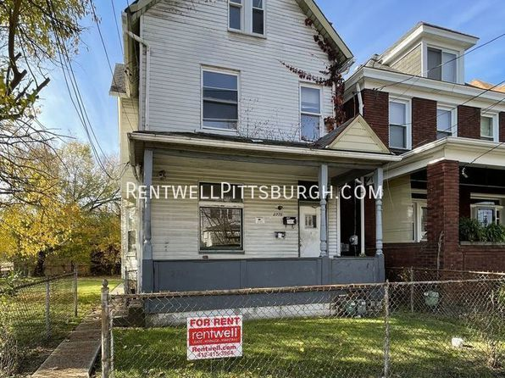](https://www.zillow.com/b/Pittsburgh-PA/40.454086,-80.051674_ll/)](https://www.zillow.com/b/Pittsburgh-PA/40.454086,-80.051674_ll/)

•

*[118 Locust Ridge Dr, Pittsburgh, PA 15209](https://www.zillow.com/homedetails/118-Locust-Ridge-Dr-Pittsburgh-PA-15209/11272462_zpid/)*

$1,075/mo

* **2** bds
* **1** ba
* **--** sqft

- House for rent

2 days ago

[[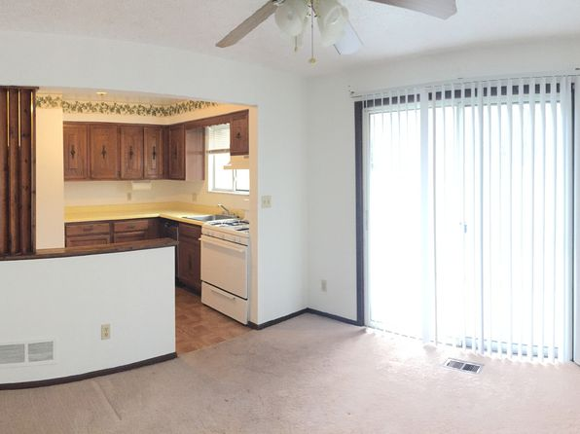](https://www.zillow.com/homedetails/118-Locust-Ridge-Dr-Pittsburgh-PA-15209/11272462_zpid/)](https://www.zillow.com/homedetails/118-Locust-Ridge-Dr-Pittsburgh-PA-15209/11272462_zpid/)

*[642 Griffin St, Pittsburgh, PA 15211](https://www.zillow.com/homedetails/642-Griffin-St-Pittsburgh-PA-15211/11323819_zpid/)*

$1,750/mo

* **5** bds
* **2** ba
* **1,787** sqft

- House for rent

6 days ago

[[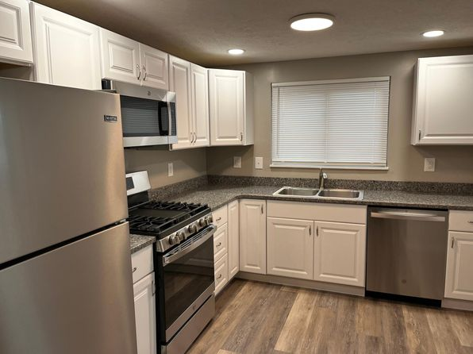](https://www.zillow.com/homedetails/642-Griffin-St-Pittsburgh-PA-15211/11323819_zpid/)](https://www.zillow.com/homedetails/642-Griffin-St-Pittsburgh-PA-15211/11323819_zpid/)

*[2 bed, 1220 sqft, $1,699, 7458 Penfield Ct, Pittsburgh, PA 15208](https://www.zillow.com/b/2-bed,-1220-sqft,-%241,699-pittsburgh-pa-98NQQh/)*

$1,699/mo

* **2** bds
* **1** ba
* **1,220** sqft

- Apartment for rent

18 days ago

[[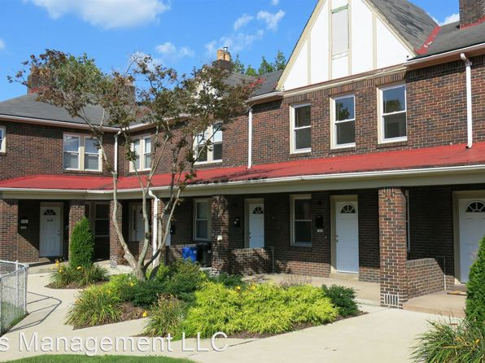](https://www.zillow.com/b/2-bed,-1220-sqft,-%241,699-pittsburgh-pa-98NQQh/)](https://www.zillow.com/b/2-bed,-1220-sqft,-%241,699-pittsburgh-pa-98NQQh/)

*[3258 Niagara Sq, Pittsburgh, PA 15213](https://www.zillow.com/homedetails/3258-Niagara-Sq-Pittsburgh-PA-15213/11413320_zpid/)*

$1,925/mo

* **3** bds
* **1** ba
* **--** sqft

- Townhouse for rent

9 days ago

[[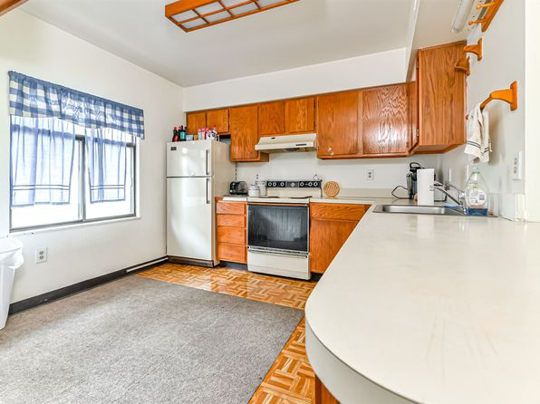](https://www.zillow.com/homedetails/3258-Niagara-Sq-Pittsburgh-PA-15213/11413320_zpid/)](https://www.zillow.com/homedetails/3258-Niagara-Sq-Pittsburgh-PA-15213/11413320_zpid/)

*[3263 Ashlyn St, Pittsburgh, PA 15204](https://www.zillow.com/homedetails/3263-Ashlyn-St-Pittsburgh-PA-15204/11482569_zpid/)*

$1,295/mo

* **3** bds
* **1** ba
* **1,603** sqft

- House for rent

2 days ago

[[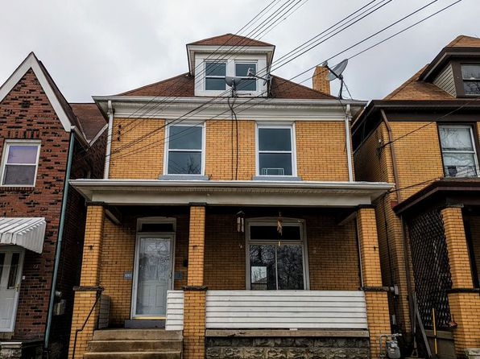](https://www.zillow.com/homedetails/3263-Ashlyn-St-Pittsburgh-PA-15204/11482569_zpid/)](https://www.zillow.com/homedetails/3263-Ashlyn-St-Pittsburgh-PA-15204/11482569_zpid/)

*[417 Hoodridge Dr APT 11, Pittsburgh, PA 15234](https://www.zillow.com/homedetails/417-Hoodridge-Dr-APT-11-Pittsburgh-PA-15234/2084740439_zpid/)*

$822/mo

* **2** bds
* **1** ba
* **607** sqft

- Apartment for rent

12 days ago

[[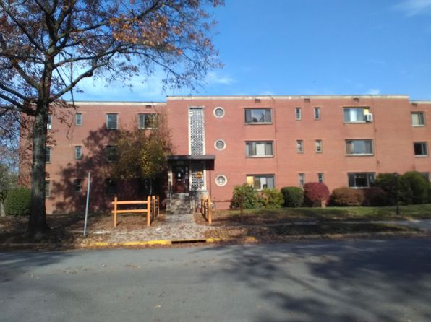](https://www.zillow.com/homedetails/417-Hoodridge-Dr-APT-11-Pittsburgh-PA-15234/2084740439_zpid/)](https://www.zillow.com/homedetails/417-Hoodridge-Dr-APT-11-Pittsburgh-PA-15234/2084740439_zpid/)

*[4008 Woolslayer Way, Pittsburgh, PA 15224](https://www.zillow.com/homedetails/4008-Woolslayer-Way-Pittsburgh-PA-15224/11514773_zpid/)*

$1,895/mo

* **4** bds
* **1** ba
* **1,920** sqft

- House for rent

1 day ago

[[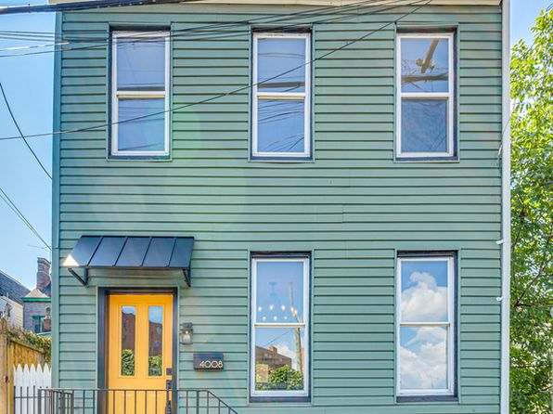](https://www.zillow.com/homedetails/4008-Woolslayer-Way-Pittsburgh-PA-15224/11514773_zpid/)](https://www.zillow.com/homedetails/4008-Woolslayer-Way-Pittsburgh-PA-15224/11514773_zpid/)

*[2 bed, $700, 3592 Brighton Rd APT 3, Pittsburgh, PA 15212](https://www.zillow.com/b/3592-brighton-road-pittsburgh-pa-98Nhk5/)*

$700/mo

* **2** bds
* **1** ba
* **--** sqft

- Apartment for rent

7 days ago

[[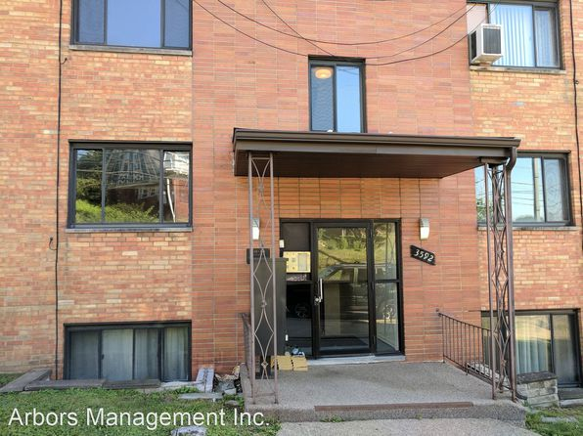](https://www.zillow.com/b/3592-brighton-road-pittsburgh-pa-98Nhk5/)](https://www.zillow.com/b/3592-brighton-road-pittsburgh-pa-98Nhk5/)

*[796 Hazelwood Avenue | 796 Hazelwood Ave, Pittsburgh, PA](https://www.zillow.com/b/796-hazelwood-avenue-pittsburgh-pa-5fwnjT/)*

$1,595+ 2 bds

[[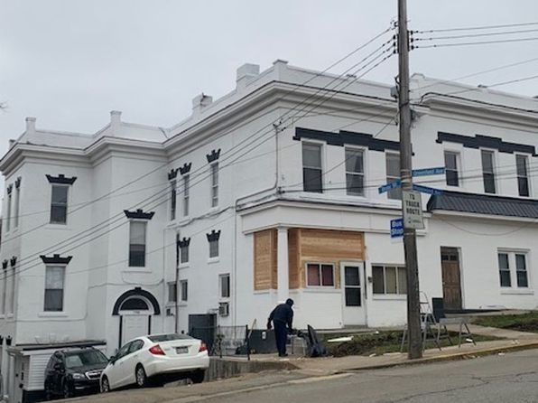](https://www.zillow.com/b/796-hazelwood-avenue-pittsburgh-pa-5fwnjT/)](https://www.zillow.com/b/796-hazelwood-avenue-pittsburgh-pa-5fwnjT/)

*[82 S 14th St, Pittsburgh, PA 15203](https://www.zillow.com/homedetails/82-S-14th-St-Pittsburgh-PA-15203/11474626_zpid/)*

$2,600/mo

* **4** bds
* **2** ba
* **3,222** sqft

- House for rent

6 days ago

[[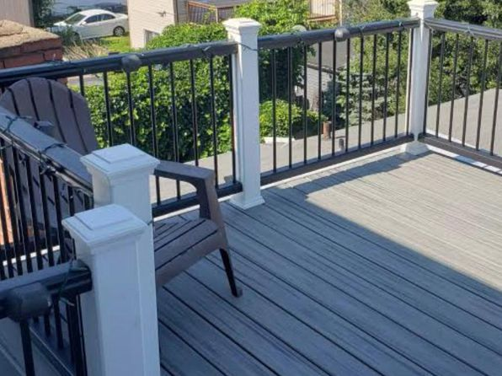](https://www.zillow.com/homedetails/82-S-14th-St-Pittsburgh-PA-15203/11474626_zpid/)](https://www.zillow.com/homedetails/82-S-14th-St-Pittsburgh-PA-15203/11474626_zpid/)

*[08 - 744 Proctor Way, 744 Proctor Way #2, Pittsburgh, PA 15210](https://www.zillow.com/b/08-744-proctor-way-pittsburgh-pa-98NYyg/)*

$1,325/mo

* **3** bds
* **1** ba
* **--** sqft

- Apartment for rent

24 days ago

[[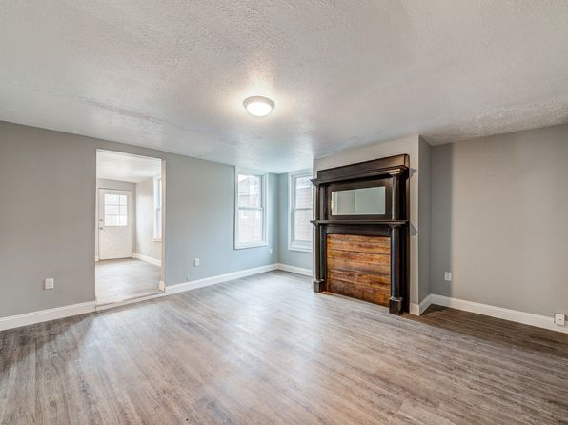](https://www.zillow.com/b/08-744-proctor-way-pittsburgh-pa-98NYyg/)](https://www.zillow.com/b/08-744-proctor-way-pittsburgh-pa-98NYyg/)

*[230 E Elizabeth St, Pittsburgh, PA 15207](https://www.zillow.com/homedetails/230-E-Elizabeth-St-Pittsburgh-PA-15207/11550580_zpid/)*

$1,300/mo

* **3** bds
* **1** ba
* **--** sqft

- House for rent

10 days ago

[[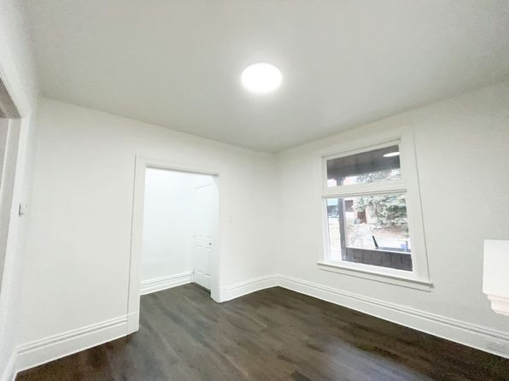](https://www.zillow.com/homedetails/230-E-Elizabeth-St-Pittsburgh-PA-15207/11550580_zpid/)](https://www.zillow.com/homedetails/230-E-Elizabeth-St-Pittsburgh-PA-15207/11550580_zpid/)

•

*[4500 Liberty Avenue | 4500 Liberty Ave, Pittsburgh, PA](https://www.zillow.com/b/4500-liberty-avenue-pittsburgh-pa-98PNmj/)*

$895+ 1 bd

[[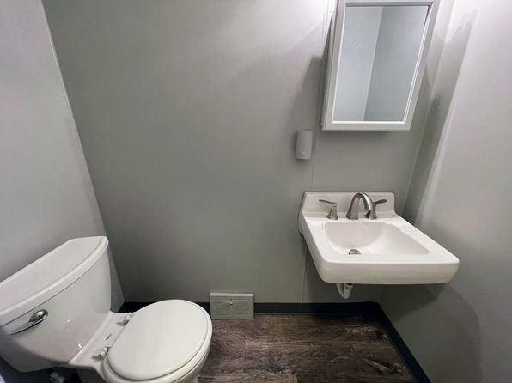](https://www.zillow.com/b/4500-liberty-avenue-pittsburgh-pa-98PNmj/)](https://www.zillow.com/b/4500-liberty-avenue-pittsburgh-pa-98PNmj/)

*[3205 Joe Hammer Sq, Pittsburgh, PA 15213](https://www.zillow.com/homedetails/3205-Joe-Hammer-Sq-Pittsburgh-PA-15213/11413161_zpid/)*

$1,995/mo

* **4** bds
* **1** ba
* **1,877** sqft

- House for rent

6 days ago

[[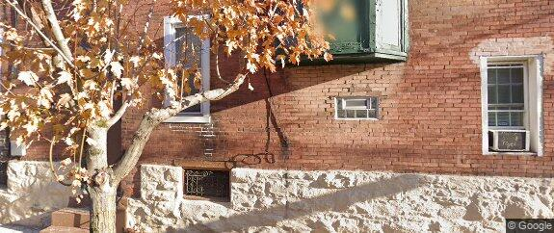](https://www.zillow.com/homedetails/3205-Joe-Hammer-Sq-Pittsburgh-PA-15213/11413161_zpid/)](https://www.zillow.com/homedetails/3205-Joe-Hammer-Sq-Pittsburgh-PA-15213/11413161_zpid/)

*[1324 Merryfield St, Pittsburgh, PA 15204](https://www.zillow.com/homedetails/1324-Merryfield-St-Pittsburgh-PA-15204/11479799_zpid/)*

$1,100/mo

* **2** bds
* **1** ba
* **--** sqft

- Townhouse for rent

2 days ago

[[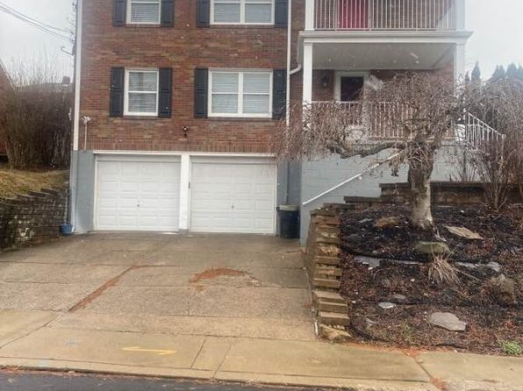](https://www.zillow.com/homedetails/1324-Merryfield-St-Pittsburgh-PA-15204/11479799_zpid/)](https://www.zillow.com/homedetails/1324-Merryfield-St-Pittsburgh-PA-15204/11479799_zpid/)

*[4028 Liberty Ave #1, Pittsburgh, PA 15224](https://www.zillow.com/homedetails/4028-Liberty-Ave-1-Pittsburgh-PA-15224/2076792579_zpid/)*

$1,350/mo

* **1** bd
* **1** ba
* **--** sqft

- Apartment for rent

4 days ago

[[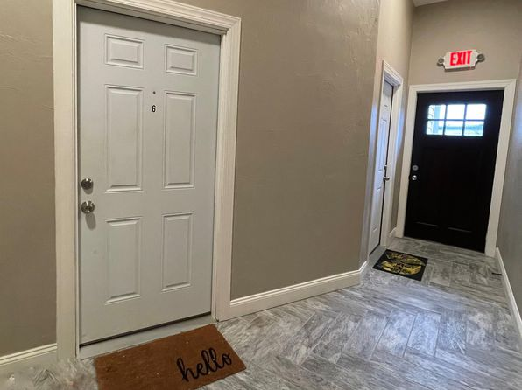](https://www.zillow.com/homedetails/4028-Liberty-Ave-1-Pittsburgh-PA-15224/2076792579_zpid/)](https://www.zillow.com/homedetails/4028-Liberty-Ave-1-Pittsburgh-PA-15224/2076792579_zpid/)

*[128 Jamestown Ct APT C, Pittsburgh, PA 15216](https://www.zillow.com/homedetails/128-Jamestown-Ct-APT-C-Pittsburgh-PA-15216/59836153_zpid/)*

$1,195/mo

* **1** bd
* **1** ba
* **788** sqft

- Apartment for rent

14 days ago

[[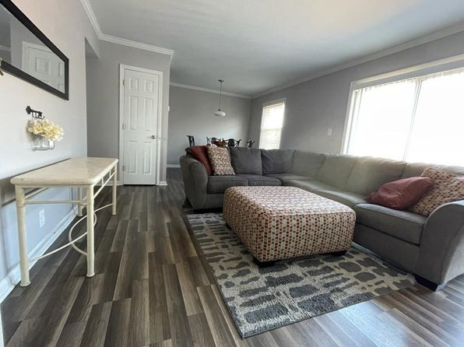](https://www.zillow.com/homedetails/128-Jamestown-Ct-APT-C-Pittsburgh-PA-15216/59836153_zpid/)](https://www.zillow.com/homedetails/128-Jamestown-Ct-APT-C-Pittsburgh-PA-15216/59836153_zpid/)

*[948 E Warrington Ave, Pittsburgh, PA 15210](https://www.zillow.com/homedetails/948-E-Warrington-Ave-Pittsburgh-PA-15210/11315123_zpid/)*

$1,100/mo

* **2** bds
* **1** ba
* **--** sqft

- House for rent

10 days ago

[[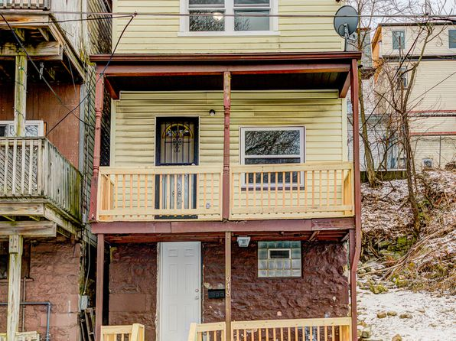](https://www.zillow.com/homedetails/948-E-Warrington-Ave-Pittsburgh-PA-15210/11315123_zpid/)](https://www.zillow.com/homedetails/948-E-Warrington-Ave-Pittsburgh-PA-15210/11315123_zpid/)

*[80 S 24th St, Pittsburgh, PA 15203](https://www.zillow.com/homedetails/80-S-24th-St-Pittsburgh-PA-15203/11290836_zpid/)*

$2,680/mo

* **4** bds
* **2** ba
* **1,800** sqft

- House for rent

6 days ago

[[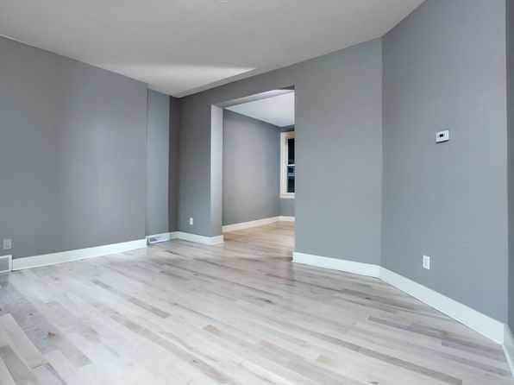](https://www.zillow.com/homedetails/80-S-24th-St-Pittsburgh-PA-15203/11290836_zpid/)](https://www.zillow.com/homedetails/80-S-24th-St-Pittsburgh-PA-15203/11290836_zpid/)

*[1249 Mississippi Ave, Pittsburgh, PA](https://www.zillow.com/b/1249-mississippi-ave-pittsburgh-pa-98Ntfj/)*

$950+ 2 bds

• 3D Tour

[[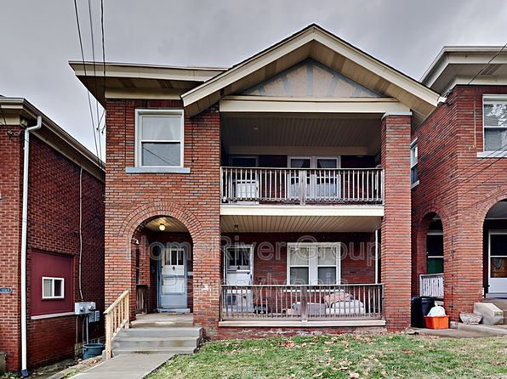](https://www.zillow.com/b/1249-mississippi-ave-pittsburgh-pa-98Ntfj/)](https://www.zillow.com/b/1249-mississippi-ave-pittsburgh-pa-98Ntfj/)

•

*[North Hills - Apartments For Rent In Pittsburgh, 824 Perry Hwy #11326025, Pittsburgh, PA 15229](https://www.zillow.com/b/824-perry-highway-pittsburgh-pa-5fwkrc/)*

$850/mo

* **1** bd
* **1** ba
* **--** sqft

- Apartment for rent

11 days ago

[[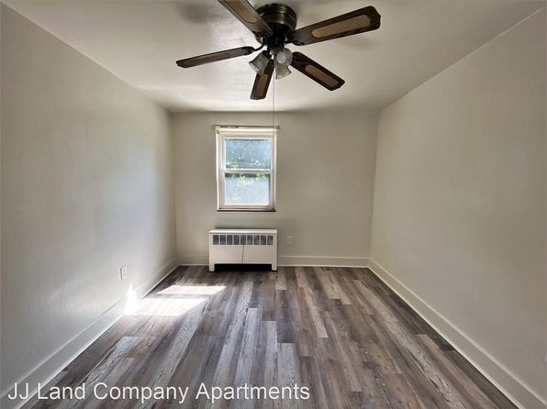](https://www.zillow.com/b/824-perry-highway-pittsburgh-pa-5fwkrc/)](https://www.zillow.com/b/824-perry-highway-pittsburgh-pa-5fwkrc/)

•

*[918 Park Ave, Pittsburgh, PA](https://www.zillow.com/b/918-park-ave-pittsburgh-pa-98PkKV/)*

$1,650+ 2 bds

21 days ago

[[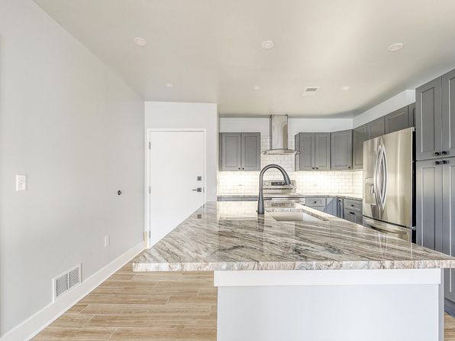](https://www.zillow.com/b/918-park-ave-pittsburgh-pa-98PkKV/)](https://www.zillow.com/b/918-park-ave-pittsburgh-pa-98PkKV/)

•

*[1224 Brookline Blvd #1, Pittsburgh, PA 15226](https://www.zillow.com/homedetails/1224-Brookline-Blvd-1-Pittsburgh-PA-15226/2060147294_zpid/)*

$1,200/mo

* **3** bds
* **1** ba
* **900** sqft

- Apartment for rent

17 days ago

[[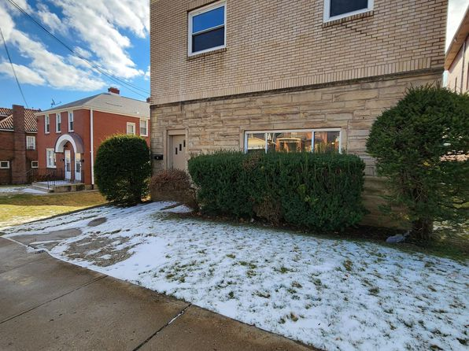](https://www.zillow.com/homedetails/1224-Brookline-Blvd-1-Pittsburgh-PA-15226/2060147294_zpid/)](https://www.zillow.com/homedetails/1224-Brookline-Blvd-1-Pittsburgh-PA-15226/2060147294_zpid/)

*[4036 Perrysville Avenue, 4036 Perrysville Ave FLOOR 2, Pittsburgh, PA 15214](https://www.zillow.com/b/4036-perrysville-avenue-pittsburgh-pa-98NqBX/)*

$1,500/mo

* **4** bds
* **1.5** ba
* **--** sqft

- Apartment for rent

23 days ago

[[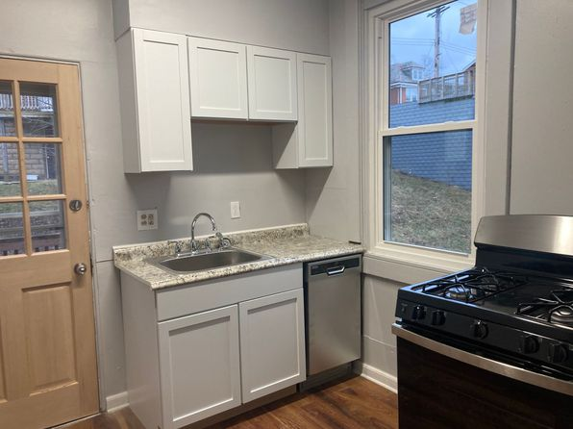](https://www.zillow.com/b/4036-perrysville-avenue-pittsburgh-pa-98NqBX/)](https://www.zillow.com/b/4036-perrysville-avenue-pittsburgh-pa-98NqBX/)

*[318 Kaercher St, Pittsburgh, PA 15207](https://www.zillow.com/homedetails/318-Kaercher-St-Pittsburgh-PA-15207/11544338_zpid/)*

$1,000/mo

* **3** bds
* **1** ba
* **1,300** sqft

- House for rent

5 days ago

[[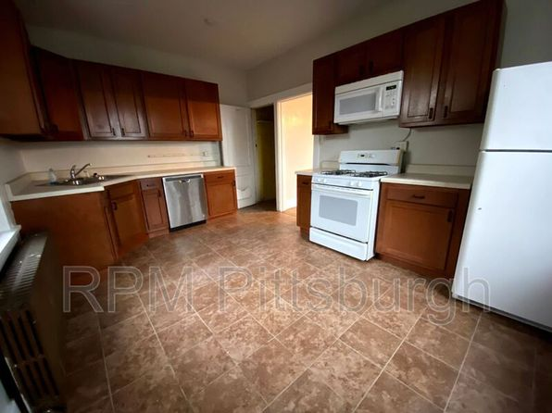](https://www.zillow.com/homedetails/318-Kaercher-St-Pittsburgh-PA-15207/11544338_zpid/)](https://www.zillow.com/homedetails/318-Kaercher-St-Pittsburgh-PA-15207/11544338_zpid/)

*[7220 Meade St #1, Pittsburgh, PA 15208](https://www.zillow.com/homedetails/7220-Meade-St-1-Pittsburgh-PA-15208/2105977357_zpid/)*

$1,400/mo

* **2** bds
* **1** ba
* **1,100** sqft

- Townhouse for rent

3 days ago

[[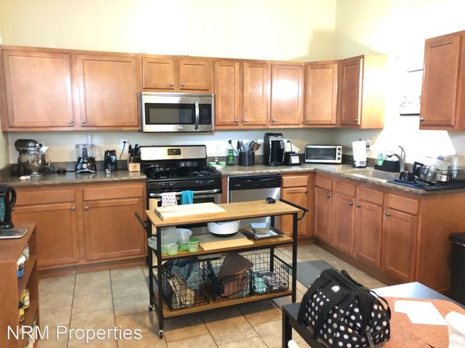](https://www.zillow.com/homedetails/7220-Meade-St-1-Pittsburgh-PA-15208/2105977357_zpid/)](https://www.zillow.com/homedetails/7220-Meade-St-1-Pittsburgh-PA-15208/2105977357_zpid/)

*[5635-5645 Hobart St. | 5635-5645 Hobart St, Pittsburgh, PA](https://www.zillow.com/b/5635-5645-hobart-st.-pittsburgh-pa-C6pQmr/)*

$1,099+ 1 bd

* **$1,949+** 2 bds

[[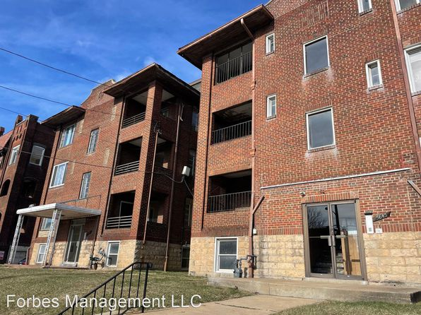](https://www.zillow.com/b/5635-5645-hobart-st.-pittsburgh-pa-C6pQmr/)](https://www.zillow.com/b/5635-5645-hobart-st.-pittsburgh-pa-C6pQmr/)

*[619 Mellon St #2, Pittsburgh, PA 15206](https://www.zillow.com/homedetails/619-Mellon-St-2-Pittsburgh-PA-15206/2117375468_zpid/)*

$1,100/mo

* **2** bds
* **1** ba
* **700** sqft

- Apartment for rent

12 days ago

[[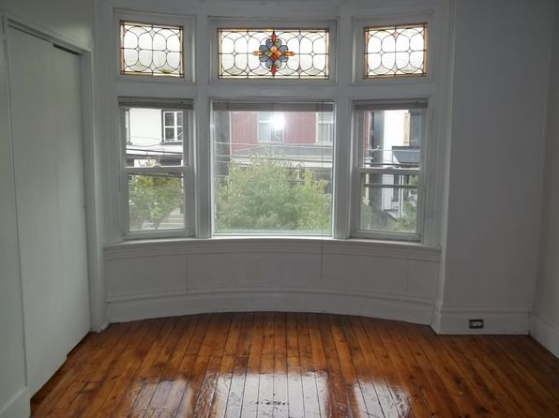](https://www.zillow.com/homedetails/619-Mellon-St-2-Pittsburgh-PA-15206/2117375468_zpid/)](https://www.zillow.com/homedetails/619-Mellon-St-2-Pittsburgh-PA-15206/2117375468_zpid/)

*[1328 Walters Ave, Pittsburgh, PA 15209](https://www.zillow.com/homedetails/1328-Walters-Ave-Pittsburgh-PA-15209/11329200_zpid/)*

$1,350/mo

* **3** bds
* **1** ba
* **1,300** sqft

- House for rent

15 days ago

[[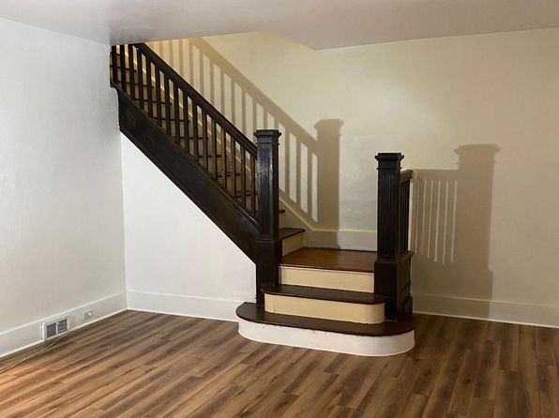](https://www.zillow.com/homedetails/1328-Walters-Ave-Pittsburgh-PA-15209/11329200_zpid/)](https://www.zillow.com/homedetails/1328-Walters-Ave-Pittsburgh-PA-15209/11329200_zpid/)

*[203 Morewood Ave, Pittsburgh, PA 15213](https://www.zillow.com/homedetails/203-Morewood-Ave-Pittsburgh-PA-15213/11525043_zpid/)*

$2,500/mo

* **5** bds
* **2** ba
* **--** sqft

- House for rent

6 days ago

[[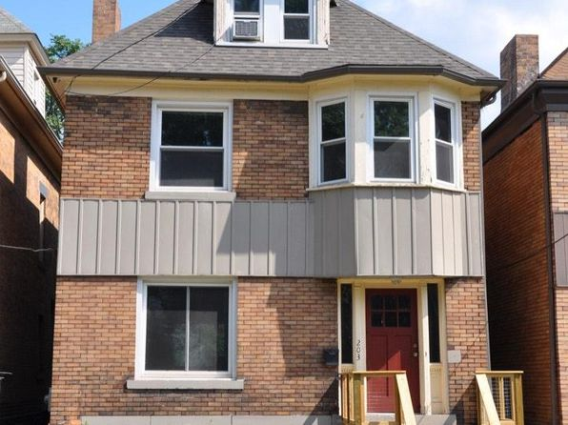](https://www.zillow.com/homedetails/203-Morewood-Ave-Pittsburgh-PA-15213/11525043_zpid/)](https://www.zillow.com/homedetails/203-Morewood-Ave-Pittsburgh-PA-15213/11525043_zpid/)

*[917 Pretense Way #1, Pittsburgh, PA 15203](https://www.zillow.com/homedetails/917-Pretense-Way-1-Pittsburgh-PA-15203/2099750748_zpid/)*

$1,150/mo

* **2** bds
* **1** ba
* **900** sqft

- Apartment for rent

17 days ago

[[](https://www.zillow.com/homedetails/917-Pretense-Way-1-Pittsburgh-PA-15203/2099750748_zpid/)](https://www.zillow.com/homedetails/917-Pretense-Way-1-Pittsburgh-PA-15203/2099750748_zpid/)

*[1532 Buena Vista St #2, Pittsburgh, PA 15212](https://www.zillow.com/homedetails/1532-Buena-Vista-St-2-Pittsburgh-PA-15212/2098475274_zpid/)*

$1,000/mo

* **2** bds
* **1** ba
* **--** sqft

- Apartment for rent

6 days ago

[[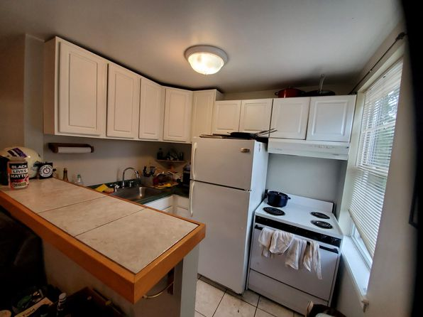](https://www.zillow.com/homedetails/1532-Buena-Vista-St-2-Pittsburgh-PA-15212/2098475274_zpid/)](https://www.zillow.com/homedetails/1532-Buena-Vista-St-2-Pittsburgh-PA-15212/2098475274_zpid/)

*[04 - 986 E Warrington Ave, 986 E Warrington Ave #1, Pittsburgh, PA 15210](https://www.zillow.com/b/04-986-e-warrington-ave-pittsburgh-pa-5yLYvz/)*

$1,250/mo

* **2** bds
* **1** ba
* **--** sqft

- Apartment for rent

10 days ago

[[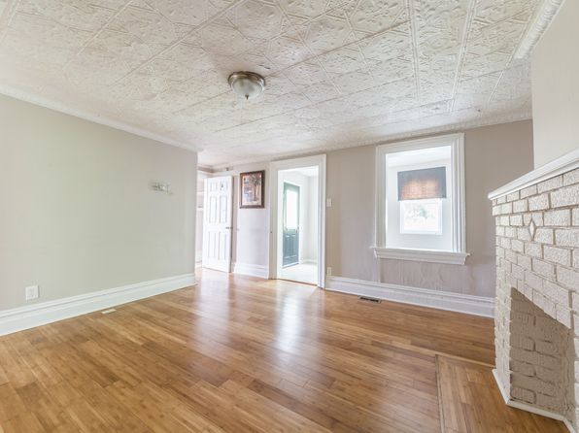](https://www.zillow.com/b/04-986-e-warrington-ave-pittsburgh-pa-5yLYvz/)](https://www.zillow.com/b/04-986-e-warrington-ave-pittsburgh-pa-5yLYvz/)

*[219 Meridan St, Pittsburgh, PA 15211](https://www.zillow.com/homedetails/219-Meridan-St-Pittsburgh-PA-15211/11586354_zpid/)*

$1,550/mo

* **3** bds
* **1** ba
* **1,300** sqft

- Apartment for rent

16 days ago

[[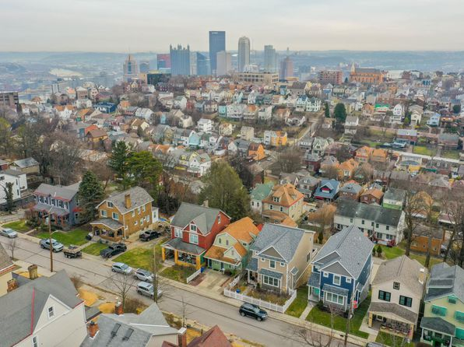](https://www.zillow.com/homedetails/219-Meridan-St-Pittsburgh-PA-15211/11586354_zpid/)](https://www.zillow.com/homedetails/219-Meridan-St-Pittsburgh-PA-15211/11586354_zpid/)

*[1230 Berkshire Ave #1, Pittsburgh, PA 15226](https://www.zillow.com/homedetails/1230-Berkshire-Ave-1-Pittsburgh-PA-15226/2087058694_zpid/)*

$895/mo

* **1** bd
* **1** ba
* **--** sqft

- Townhouse for rent

8 days ago

[[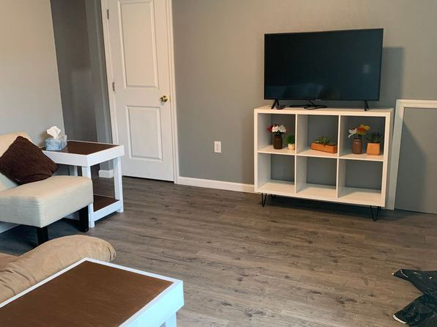](https://www.zillow.com/homedetails/1230-Berkshire-Ave-1-Pittsburgh-PA-15226/2087058694_zpid/)](https://www.zillow.com/homedetails/1230-Berkshire-Ave-1-Pittsburgh-PA-15226/2087058694_zpid/)

*[1220 Sheffield Street, 1220 Sheffield St APT 1B, Pittsburgh, PA 15233](https://www.zillow.com/b/1220-sheffield-street-pittsburgh-pa-5YyDWC/)*

$1,250/mo

* **2** bds
* **1** ba
* **700** sqft

- Apartment for rent

10 days ago

[[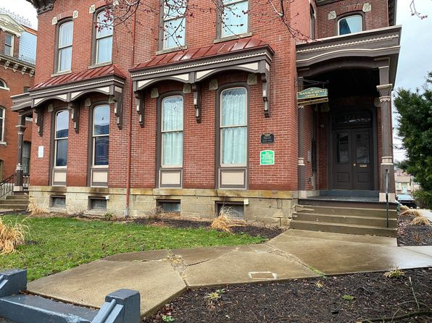](https://www.zillow.com/b/1220-sheffield-street-pittsburgh-pa-5YyDWC/)](https://www.zillow.com/b/1220-sheffield-street-pittsburgh-pa-5YyDWC/)

*[6440 Jackson St, Pittsburgh, PA 15206](https://www.zillow.com/homedetails/6440-Jackson-St-Pittsburgh-PA-15206/2075381849_zpid/)*

$1,385/mo

* **2** bds
* **1** ba
* **--** sqft

- House for rent

4 days ago

[[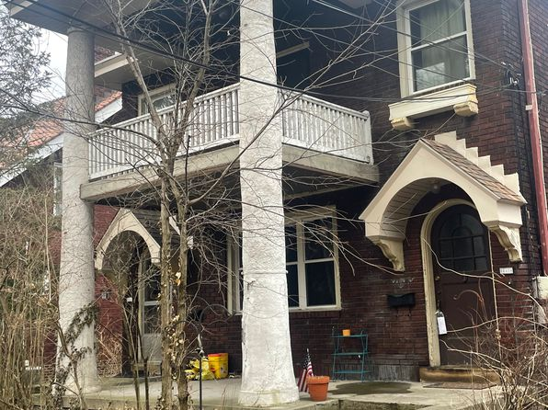](https://www.zillow.com/homedetails/6440-Jackson-St-Pittsburgh-PA-15206/2075381849_zpid/)](https://www.zillow.com/homedetails/6440-Jackson-St-Pittsburgh-PA-15206/2075381849_zpid/)

*[Mt. Nazareth Commons, 250 Nazareth Way, Pittsburgh, PA 15229](https://www.zillow.com/b/mt.-nazareth-commons-pittsburgh-pa-98PdJk/)*

$714+/mo

* + **1** bd
  + **1** ba
  + **--** sqft

- Apartment for rent

10 days ago

[[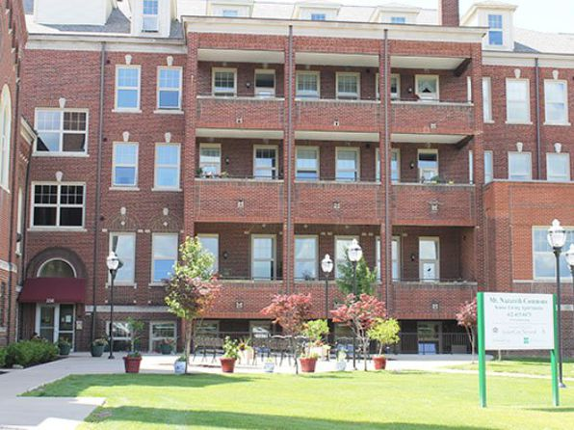](https://www.zillow.com/b/mt.-nazareth-commons-pittsburgh-pa-98PdJk/)](https://www.zillow.com/b/mt.-nazareth-commons-pittsburgh-pa-98PdJk/)

*[1126 Sheffield St #201, Pittsburgh, PA 15233](https://www.zillow.com/homedetails/1126-Sheffield-St-201-Pittsburgh-PA-15233/2079224402_zpid/)*

$1,200/mo

* **2** bds
* **1** ba
* **--** sqft

- Apartment for rent

22 days ago

[[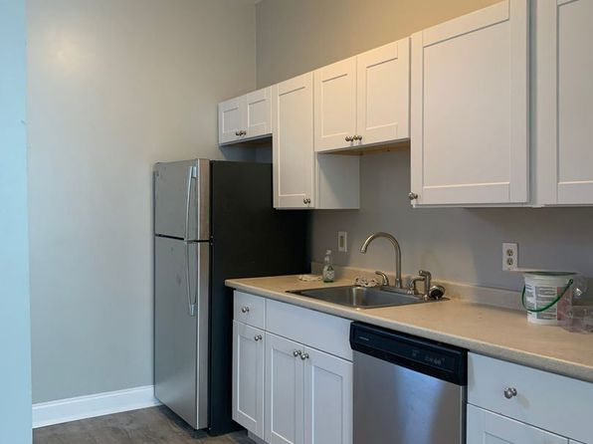](https://www.zillow.com/homedetails/1126-Sheffield-St-201-Pittsburgh-PA-15233/2079224402_zpid/)](https://www.zillow.com/homedetails/1126-Sheffield-St-201-Pittsburgh-PA-15233/2079224402_zpid/)

•

*[3431 Parkview Ave, Pittsburgh, PA 15213](https://www.zillow.com/homedetails/3431-Parkview-Ave-Pittsburgh-PA-15213/11413638_zpid/)*

$3,700/mo

* **5** bds
* **2.5** ba
* **2,650** sqft

- House for rent

10 days ago

[[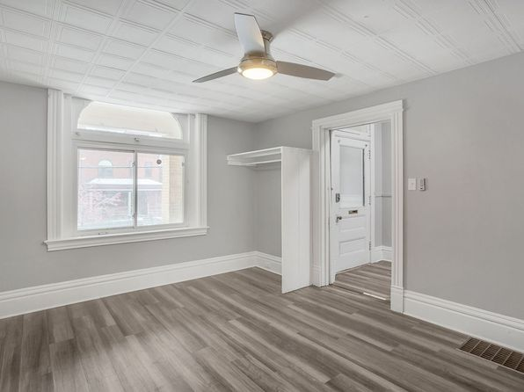](https://www.zillow.com/homedetails/3431-Parkview-Ave-Pittsburgh-PA-15213/11413638_zpid/)](https://www.zillow.com/homedetails/3431-Parkview-Ave-Pittsburgh-PA-15213/11413638_zpid/)

*[127 42nd St, Pittsburgh, PA 15201](https://www.zillow.com/homedetails/127-42nd-St-Pittsburgh-PA-15201/11512709_zpid/)*

$2,600/mo

* **3** bds
* **2** ba
* **1,425** sqft

- House for rent

5 days ago

[[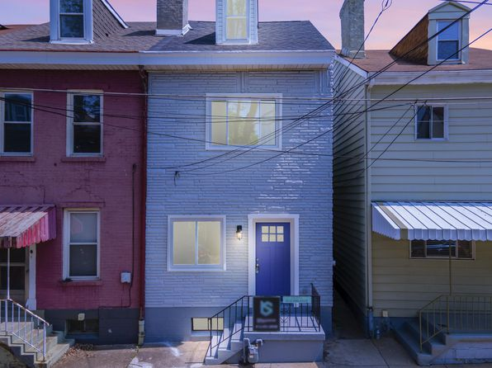](https://www.zillow.com/homedetails/127-42nd-St-Pittsburgh-PA-15201/11512709_zpid/)](https://www.zillow.com/homedetails/127-42nd-St-Pittsburgh-PA-15201/11512709_zpid/)

•

*[873 Boggs Ave, Pittsburgh, PA](https://www.zillow.com/b/873-boggs-ave-pittsburgh-pa-5YCxgh/)*

$825+ 1 bd

29 days ago

[[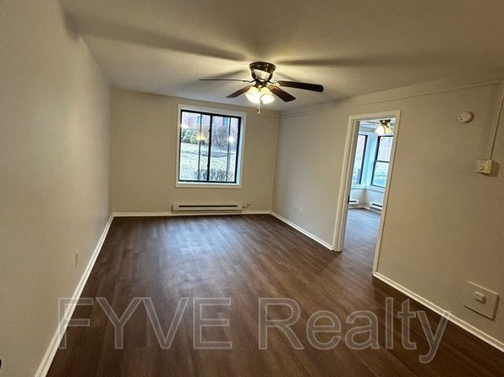](https://www.zillow.com/b/873-boggs-ave-pittsburgh-pa-5YCxgh/)](https://www.zillow.com/b/873-boggs-ave-pittsburgh-pa-5YCxgh/)

•

*[5560 Bartlett St, Pittsburgh, PA 15217](https://www.zillow.com/homedetails/5560-Bartlett-St-Pittsburgh-PA-15217/11631963_zpid/)*

$2,400/mo

* **3** bds
* **1** ba
* **1,440** sqft

- Townhouse for rent

21 days ago

[[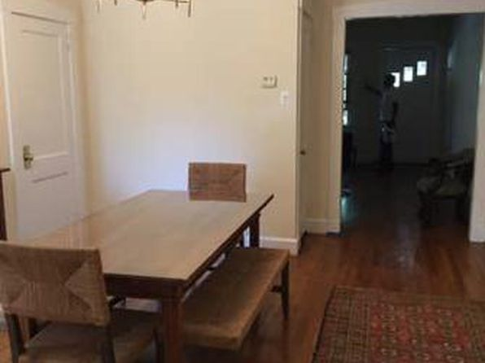](https://www.zillow.com/homedetails/5560-Bartlett-St-Pittsburgh-PA-15217/11631963_zpid/)](https://www.zillow.com/homedetails/5560-Bartlett-St-Pittsburgh-PA-15217/11631963_zpid/)

*[230 S Negley Ave APT 5, Pittsburgh, PA 15206](https://www.zillow.com/homedetails/230-S-Negley-Ave-APT-5-Pittsburgh-PA-15206/2059824107_zpid/)*

$1,200/mo

* **1** bd
* **1** ba
* **--** sqft

- Apartment for rent

3 days ago

[[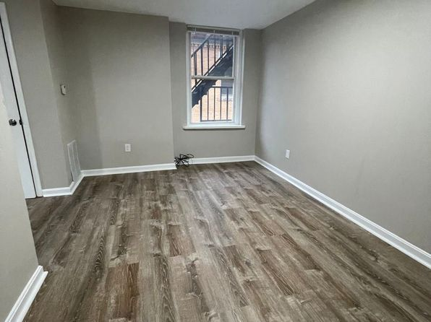](https://www.zillow.com/homedetails/230-S-Negley-Ave-APT-5-Pittsburgh-PA-15206/2059824107_zpid/)](https://www.zillow.com/homedetails/230-S-Negley-Ave-APT-5-Pittsburgh-PA-15206/2059824107_zpid/)

*[636 Hazelwood Ave APT 2, Pittsburgh, PA 15207](https://www.zillow.com/homedetails/636-Hazelwood-Ave-APT-2-Pittsburgh-PA-15207/2060353362_zpid/)*

$1,290/mo

* **2** bds
* **1** ba
* **990** sqft

- Apartment for rent

10 days ago

[[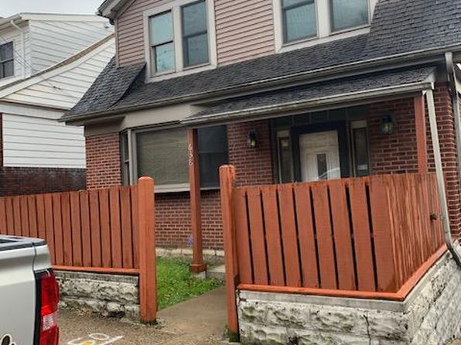](https://www.zillow.com/homedetails/636-Hazelwood-Ave-APT-2-Pittsburgh-PA-15207/2060353362_zpid/)](https://www.zillow.com/homedetails/636-Hazelwood-Ave-APT-2-Pittsburgh-PA-15207/2060353362_zpid/)

*[3433 Parkview Avenue | 3433 Parkview Ave, Pittsburgh, PA](https://www.zillow.com/b/3433-parkview-avenue-pittsburgh-pa-98Nm9B/)*

$1,095+ 1 bd

* **$2,900+** 4 bds

[[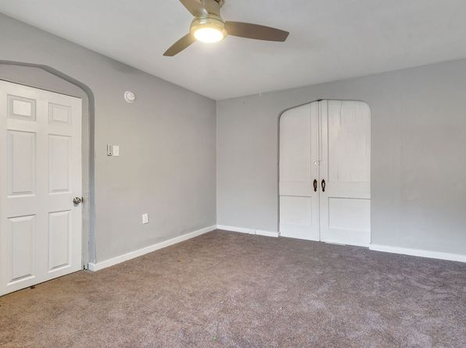](https://www.zillow.com/b/3433-parkview-avenue-pittsburgh-pa-98Nm9B/)](https://www.zillow.com/b/3433-parkview-avenue-pittsburgh-pa-98Nm9B/)

*[3039 W Liberty Ave APT A2, Pittsburgh, PA 15216](https://www.zillow.com/homedetails/3039-W-Liberty-Ave-APT-A2-Pittsburgh-PA-15216/2060117886_zpid/)*

$820/mo

* **Studio**
* **1** ba
* **360** sqft

- Apartment for rent

3D Tour

[[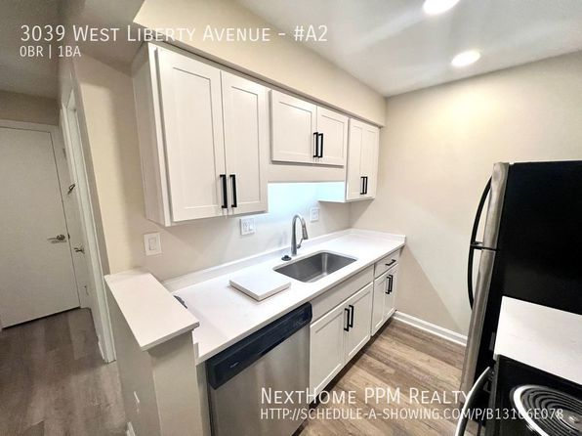](https://www.zillow.com/homedetails/3039-W-Liberty-Ave-APT-A2-Pittsburgh-PA-15216/2060117886_zpid/)](https://www.zillow.com/homedetails/3039-W-Liberty-Ave-APT-A2-Pittsburgh-PA-15216/2060117886_zpid/)

• • •

*[0 Parklyn St, Pittsburgh, PA 15234](https://www.zillow.com/homedetails/0-Parklyn-St-Pittsburgh-PA-15234/2059954368_zpid/)*

$800/mo

* **1** bd
* **1.5** ba
* **--** sqft

- House for rent

6 days ago

[[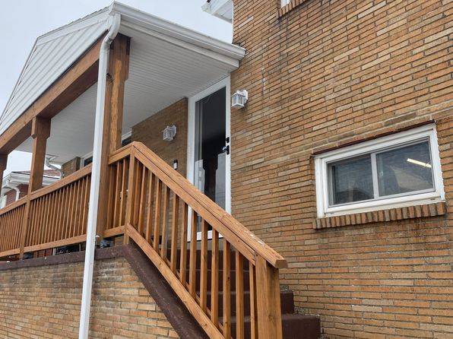](https://www.zillow.com/homedetails/0-Parklyn-St-Pittsburgh-PA-15234/2059954368_zpid/)](https://www.zillow.com/homedetails/0-Parklyn-St-Pittsburgh-PA-15234/2059954368_zpid/)

*[319 Linnview Ave, Pittsburgh, PA 15210](https://www.zillow.com/homedetails/319-Linnview-Ave-Pittsburgh-PA-15210/11437612_zpid/)*

$1,400/mo

* **3** bds
* **1** ba
* **1,050** sqft

- House for rent

13 days ago

[[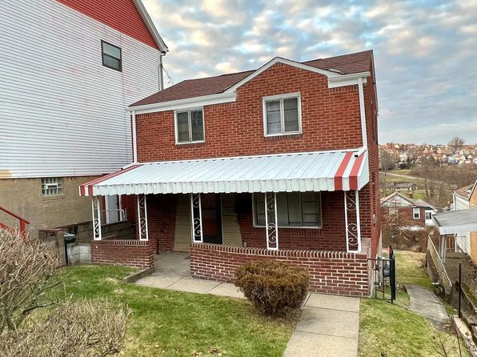](https://www.zillow.com/homedetails/319-Linnview-Ave-Pittsburgh-PA-15210/11437612_zpid/)](https://www.zillow.com/homedetails/319-Linnview-Ave-Pittsburgh-PA-15210/11437612_zpid/)

*[3531 Simen Ave, Pittsburgh, PA 15212](https://www.zillow.com/homedetails/3531-Simen-Ave-Pittsburgh-PA-15212/11603797_zpid/)*

$975/mo

* **2** bds
* **1** ba
* **--** sqft

- House for rent

13 days ago

[[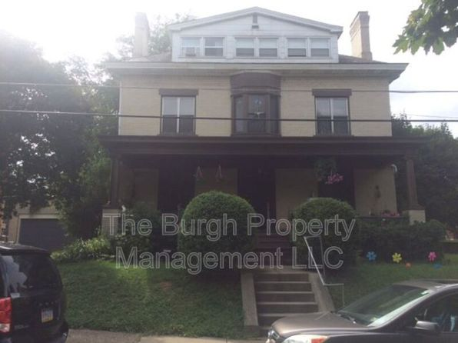](https://www.zillow.com/homedetails/3531-Simen-Ave-Pittsburgh-PA-15212/11603797_zpid/)](https://www.zillow.com/homedetails/3531-Simen-Ave-Pittsburgh-PA-15212/11603797_zpid/)

•

*[2619 Jane St, Pittsburgh, PA 15203](https://www.zillow.com/homedetails/2619-Jane-St-Pittsburgh-PA-15203/11292198_zpid/)*

$2,500/mo

* **4** bds
* **2.5** ba
* **--** sqft

- House for rent

10 days ago

[[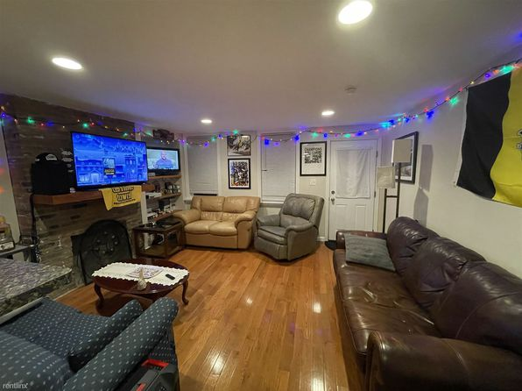](https://www.zillow.com/homedetails/2619-Jane-St-Pittsburgh-PA-15203/11292198_zpid/)](https://www.zillow.com/homedetails/2619-Jane-St-Pittsburgh-PA-15203/11292198_zpid/)

*[510 N Negley Ave APT 4, Pittsburgh, PA 15206](https://www.zillow.com/homedetails/510-N-Negley-Ave-APT-4-Pittsburgh-PA-15206/2081765846_zpid/)*

$1,100/mo

* **2** bds
* **1** ba
* **--** sqft

- Apartment for rent

4 days ago

[[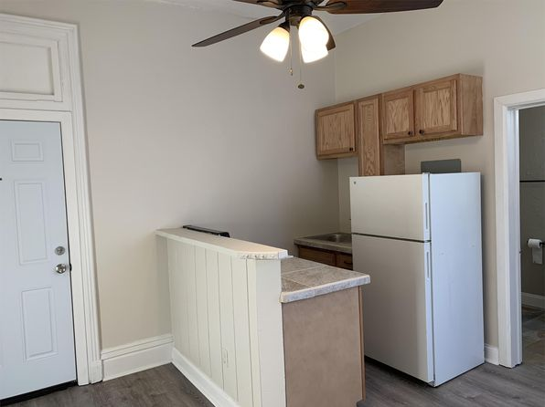](https://www.zillow.com/homedetails/510-N-Negley-Ave-APT-4-Pittsburgh-PA-15206/2081765846_zpid/)](https://www.zillow.com/homedetails/510-N-Negley-Ave-APT-4-Pittsburgh-PA-15206/2081765846_zpid/)

*[5634 Stanton Avenue | 5634 Stanton Ave, Pittsburgh, PA](https://www.zillow.com/b/5634-stanton-avenue-pittsburgh-pa-5Z9WLT/)*

$849+ Studio

* **$1,099+** 1 bd

[[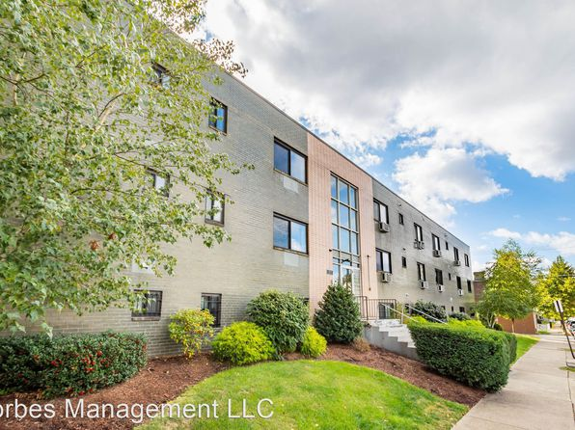](https://www.zillow.com/b/5634-stanton-avenue-pittsburgh-pa-5Z9WLT/)](https://www.zillow.com/b/5634-stanton-avenue-pittsburgh-pa-5Z9WLT/)

*[375 Copperfield Ave, Pittsburgh, PA 15210](https://www.zillow.com/homedetails/375-Copperfield-Ave-Pittsburgh-PA-15210/11557102_zpid/)*

$1,250/mo

* **2** bds
* **1** ba
* **1,152** sqft

- House for rent

Video Walkthrough

[[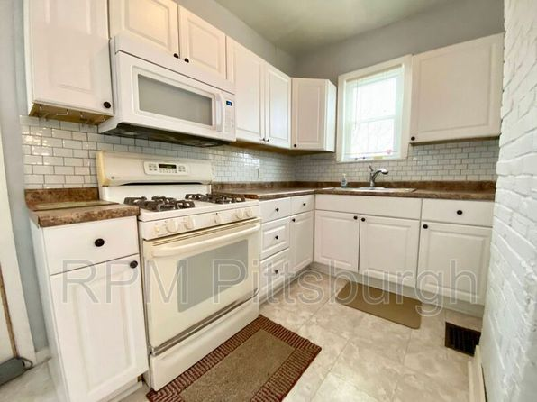](https://www.zillow.com/homedetails/375-Copperfield-Ave-Pittsburgh-PA-15210/11557102_zpid/)](https://www.zillow.com/homedetails/375-Copperfield-Ave-Pittsburgh-PA-15210/11557102_zpid/)

*[195 N Sprague Ave APT 1, Pittsburgh, PA 15202](https://www.zillow.com/homedetails/195-N-Sprague-Ave-APT-1-Pittsburgh-PA-15202/2083507049_zpid/)*

$950/mo

* **1** bd
* **1** ba
* **--** sqft

- Apartment for rent

5 days ago

[[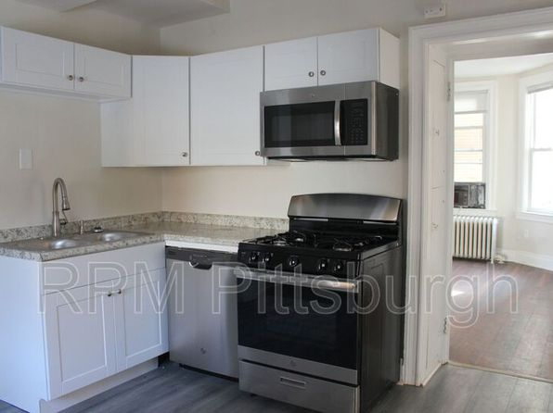](https://www.zillow.com/homedetails/195-N-Sprague-Ave-APT-1-Pittsburgh-PA-15202/2083507049_zpid/)](https://www.zillow.com/homedetails/195-N-Sprague-Ave-APT-1-Pittsburgh-PA-15202/2083507049_zpid/)

*[518 S Graham St APT 1, Pittsburgh, PA 15232](https://www.zillow.com/homedetails/518-S-Graham-St-APT-1-Pittsburgh-PA-15232/2078308440_zpid/)*

$1,650/mo

* **2** bds
* **1** ba
* **980** sqft

- Apartment for rent

6 days ago

[[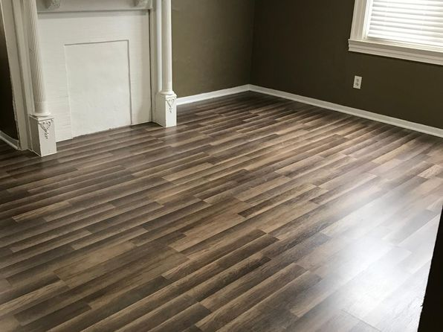](https://www.zillow.com/homedetails/518-S-Graham-St-APT-1-Pittsburgh-PA-15232/2078308440_zpid/)](https://www.zillow.com/homedetails/518-S-Graham-St-APT-1-Pittsburgh-PA-15232/2078308440_zpid/)

*[1112 E Warrington Ave, Pittsburgh, PA 15210](https://www.zillow.com/homedetails/1112-E-Warrington-Ave-Pittsburgh-PA-15210/11315315_zpid/)*

$2,000/mo

* **3** bds
* **2** ba
* **1,238** sqft

- House for rent

14 days ago

[[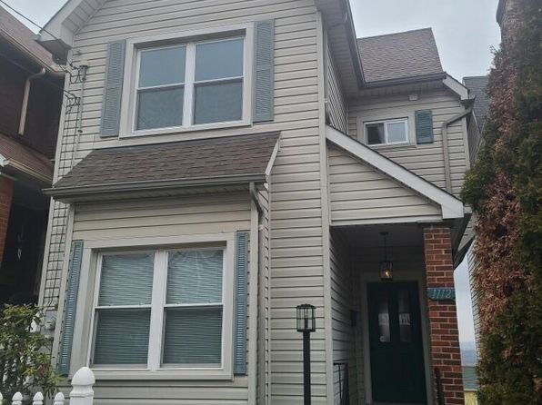](https://www.zillow.com/homedetails/1112-E-Warrington-Ave-Pittsburgh-PA-15210/11315315_zpid/)](https://www.zillow.com/homedetails/1112-E-Warrington-Ave-Pittsburgh-PA-15210/11315315_zpid/)

*[901-905 Bingham St, 901-905 Bingham St APT 105, Pittsburgh, PA 15203](https://www.zillow.com/b/901-905-bingham-st-pittsburgh-pa-BJysqG/)*

$1,500/mo

* **1** bd
* **1** ba
* **--** sqft

- Apartment for rent

25 days ago

[[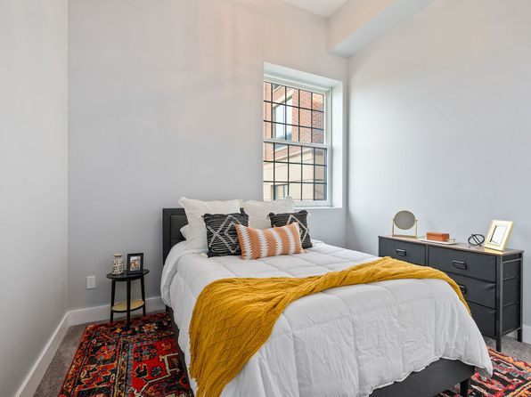](https://www.zillow.com/b/901-905-bingham-st-pittsburgh-pa-BJysqG/)](https://www.zillow.com/b/901-905-bingham-st-pittsburgh-pa-BJysqG/)

*[Saint Clair 517 - 1, 517 N Saint Clair St, Pittsburgh, PA 15206](https://www.zillow.com/b/saint-clair-517-1-pittsburgh-pa-9PRFNQ/)*

$1,900+/mo

* **2** bds
* **1** ba
* **--** sqft

- Apartment for rent

19 days ago

[[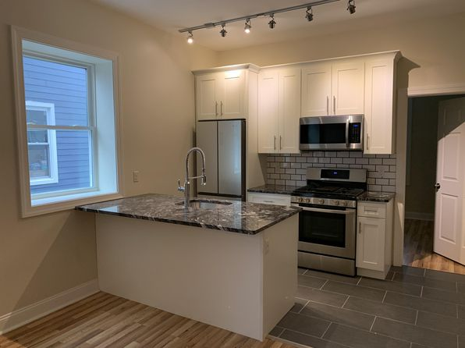](https://www.zillow.com/b/saint-clair-517-1-pittsburgh-pa-9PRFNQ/)](https://www.zillow.com/b/saint-clair-517-1-pittsburgh-pa-9PRFNQ/)

•

*[873 Boggs Ave, Pittsburgh, PA](https://www.zillow.com/b/873-boggs-ave-pittsburgh-pa-5YCxgh/)*

$825+ 1 bd

6 days ago

[[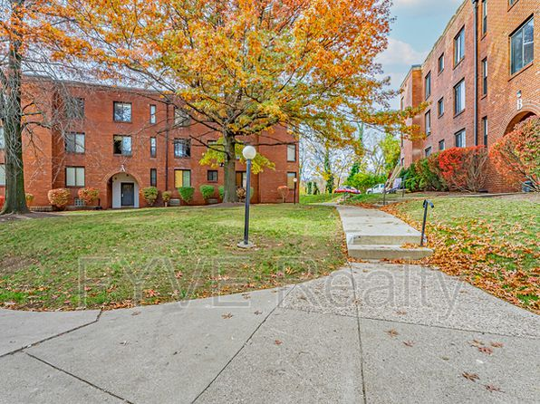](https://www.zillow.com/b/873-boggs-ave-pittsburgh-pa-5YCxgh/)](https://www.zillow.com/b/873-boggs-ave-pittsburgh-pa-5YCxgh/)

•

*[1615 Parkline Dr, Pittsburgh, PA 15227](https://www.zillow.com/homedetails/1615-Parkline-Dr-Pittsburgh-PA-15227/11354700_zpid/)*

$1,375/mo

* **3** bds
* **2** ba
* **1,108** sqft

- Townhouse for rent

29 days ago

[[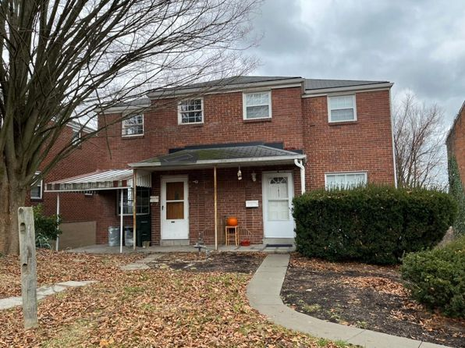](https://www.zillow.com/homedetails/1615-Parkline-Dr-Pittsburgh-PA-15227/11354700_zpid/)](https://www.zillow.com/homedetails/1615-Parkline-Dr-Pittsburgh-PA-15227/11354700_zpid/)

*[4 bed, $2,995, 1728 Wightman St APT 1, Pittsburgh, PA 15217](https://www.zillow.com/b/1728-wightman-street-squirrel-hill-pa-5jBsQ7/)*

$2,995/mo

* **4** bds
* **2** ba
* **--** sqft

- Apartment for rent

11 hours ago

[[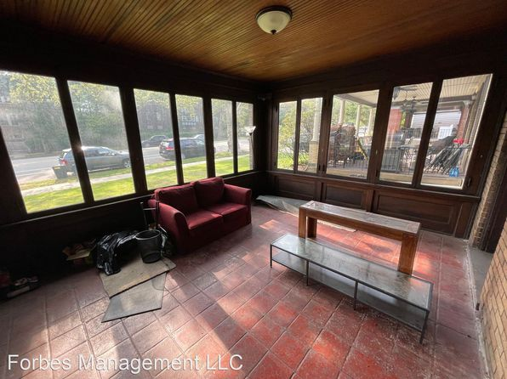](https://www.zillow.com/b/1728-wightman-street-squirrel-hill-pa-5jBsQ7/)](https://www.zillow.com/b/1728-wightman-street-squirrel-hill-pa-5jBsQ7/)

*[1720 Mount Joseph St, Pittsburgh, PA 15210](https://www.zillow.com/homedetails/1720-Mount-Joseph-St-Pittsburgh-PA-15210/11556846_zpid/)*

$1,250/mo

* **3** bds
* **1** ba
* **1,000** sqft

- House for rent

11 days ago

[[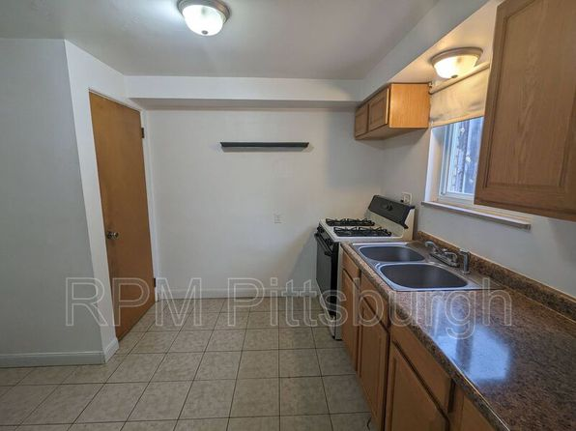](https://www.zillow.com/homedetails/1720-Mount-Joseph-St-Pittsburgh-PA-15210/11556846_zpid/)](https://www.zillow.com/homedetails/1720-Mount-Joseph-St-Pittsburgh-PA-15210/11556846_zpid/)

•

*[1500 Fallowfield Ave, Pittsburgh, PA](https://www.zillow.com/b/1500-fallowfield-ave-pittsburgh-pa-5fwkqf/)*

$849+ Studio

* **$1,099+** 2 bds

5 days ago

[[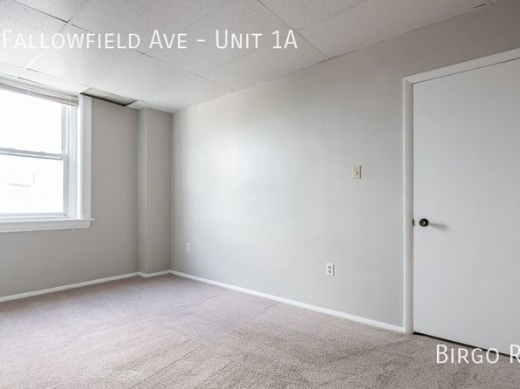](https://www.zillow.com/b/1500-fallowfield-ave-pittsburgh-pa-5fwkqf/)](https://www.zillow.com/b/1500-fallowfield-ave-pittsburgh-pa-5fwkqf/)

•

*[04 - 148 Rinne St, 148 Rinne St, Pittsburgh, PA 15210](https://www.zillow.com/homedetails/148-Rinne-St-Pittsburgh-PA-15210/11309193_zpid/)*

$1,100/mo

* **2** bds
* **1** ba
* **--** sqft

- Apartment for rent

24 days ago

[[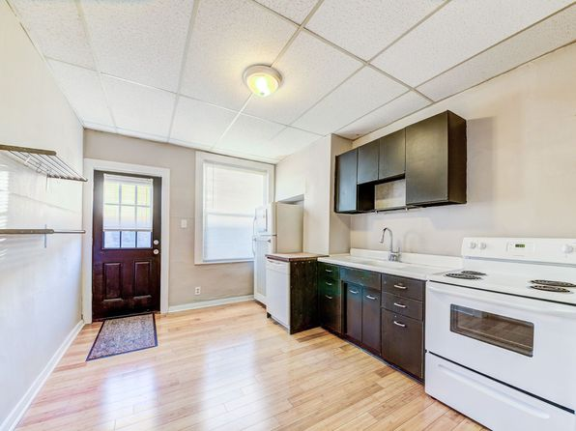](https://www.zillow.com/homedetails/148-Rinne-St-Pittsburgh-PA-15210/11309193_zpid/)](https://www.zillow.com/homedetails/148-Rinne-St-Pittsburgh-PA-15210/11309193_zpid/)

*[14 - 974 Manton Way, 974 Manton Way #1, Pittsburgh, PA 15210](https://www.zillow.com/b/14-974-manton-way-pittsburgh-pa-98NZNp/)*

$1,150/mo

* **2** bds
* **1** ba
* **--** sqft

- Apartment for rent

24 days ago

[[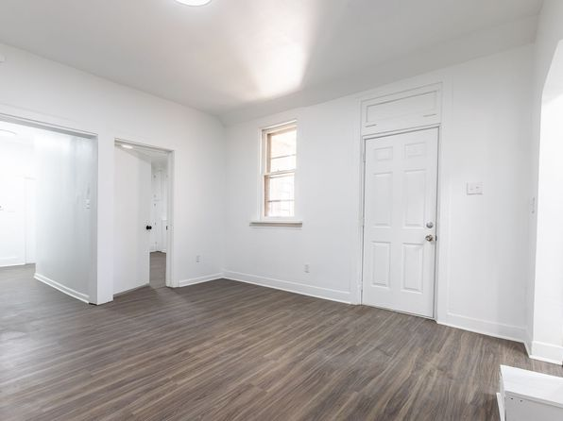](https://www.zillow.com/b/14-974-manton-way-pittsburgh-pa-98NZNp/)](https://www.zillow.com/b/14-974-manton-way-pittsburgh-pa-98NZNp/)

*[2134 S 18th St #1, Pittsburgh, PA 15203](https://www.zillow.com/homedetails/2134-S-18th-St-1-Pittsburgh-PA-15203/2095152033_zpid/)*

$875/mo

* **1** bd
* **1** ba
* **--** sqft

- Apartment for rent

4 days ago

[[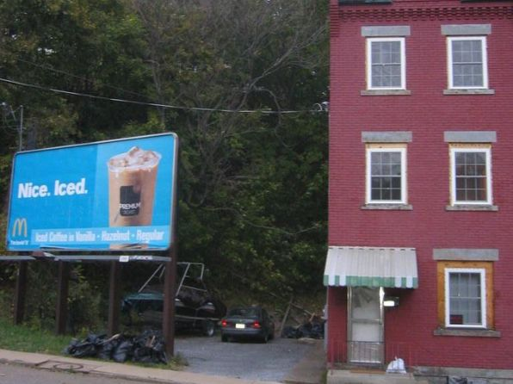](https://www.zillow.com/homedetails/2134-S-18th-St-1-Pittsburgh-PA-15203/2095152033_zpid/)](https://www.zillow.com/homedetails/2134-S-18th-St-1-Pittsburgh-PA-15203/2095152033_zpid/)

*[15 - 2641 S 18th | 2641 S 18th St, Pittsburgh, PA](https://www.zillow.com/b/15-2641-s-18th-pittsburgh-pa-9PRGJN/)*

$1,000+ 2 bds

[[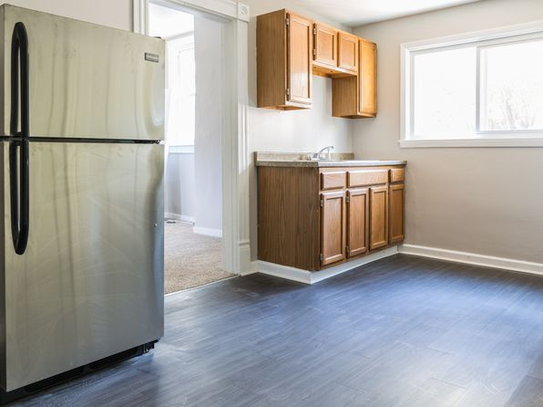](https://www.zillow.com/b/15-2641-s-18th-pittsburgh-pa-9PRGJN/)](https://www.zillow.com/b/15-2641-s-18th-pittsburgh-pa-9PRGJN/)

*[Twin Towers, 314 Washington Rd, Pittsburgh, PA 15216](https://www.zillow.com/b/twin-towers-pittsburgh-pa-5hJ4F2/)*

$658+/mo

* **1** bd
* **1** ba
* **--** sqft

- Apartment for rent

10 days ago

[[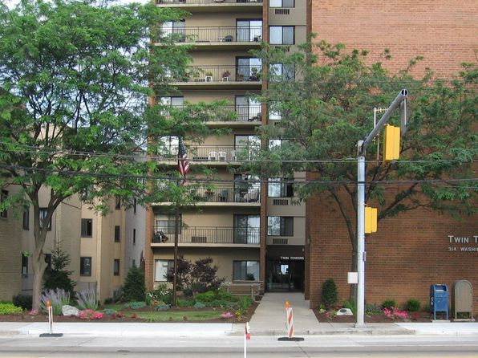](https://www.zillow.com/b/twin-towers-pittsburgh-pa-5hJ4F2/)](https://www.zillow.com/b/twin-towers-pittsburgh-pa-5hJ4F2/)

*[5445-5447 Bartlett St #2, Pittsburgh, PA 15217](https://www.zillow.com/homedetails/5445-5447-Bartlett-St-2-Pittsburgh-PA-15217/2059998747_zpid/)*

$2,000/mo

* **3** bds
* **2** ba
* **1,200** sqft

- Townhouse for rent

11 days ago

[[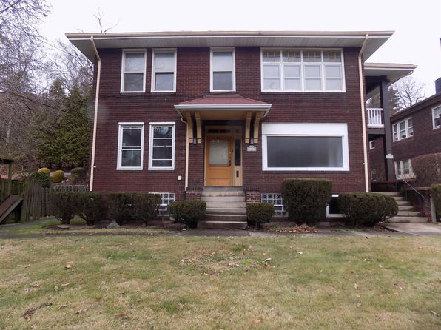](https://www.zillow.com/homedetails/5445-5447-Bartlett-St-2-Pittsburgh-PA-15217/2059998747_zpid/)](https://www.zillow.com/homedetails/5445-5447-Bartlett-St-2-Pittsburgh-PA-15217/2059998747_zpid/)

*[14 Lenox Ave #2, Pittsburgh, PA 15221](https://www.zillow.com/homedetails/14-Lenox-Ave-2-Pittsburgh-PA-15221/2075619217_zpid/)*

$950/mo

* **2** bds
* **1** ba
* **--** sqft

- Apartment for rent

13 days ago

[[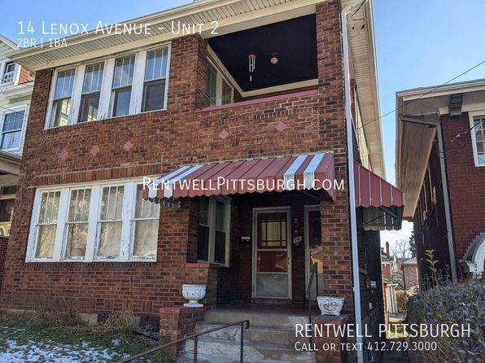](https://www.zillow.com/homedetails/14-Lenox-Ave-2-Pittsburgh-PA-15221/2075619217_zpid/)](https://www.zillow.com/homedetails/14-Lenox-Ave-2-Pittsburgh-PA-15221/2075619217_zpid/)

*[316 S Mathilda Street | 316 S Mathilda St, Pittsburgh, PA](https://www.zillow.com/b/316-s-mathilda-street-pittsburgh-pa-5YCFBS/)*

$1,009+ 1 bd

[[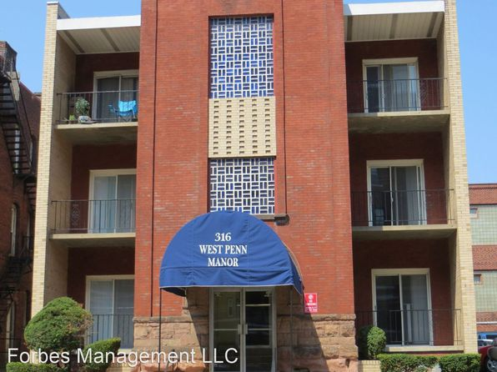](https://www.zillow.com/b/316-s-mathilda-street-pittsburgh-pa-5YCFBS/)](https://www.zillow.com/b/316-s-mathilda-street-pittsburgh-pa-5YCFBS/)

*[(undisclosed Address), Pittsburgh, PA 15229](https://www.zillow.com/homedetails/Pittsburgh-PA-15229/2060128174_zpid/)*

$750/mo

* **1** bd
* **1** ba
* **--** sqft

- Apartment for rent

15 days ago

[[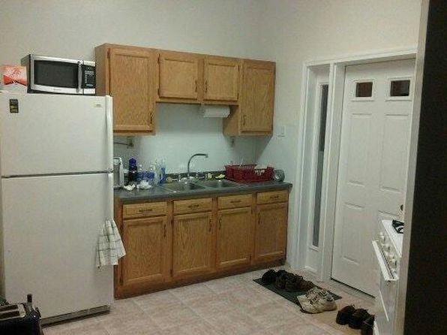](https://www.zillow.com/homedetails/Pittsburgh-PA-15229/2060128174_zpid/)](https://www.zillow.com/homedetails/Pittsburgh-PA-15229/2060128174_zpid/)

*[228 Chesna Dr, Pittsburgh, PA 15236](https://www.zillow.com/homedetails/228-Chesna-Dr-Pittsburgh-PA-15236/2060215986_zpid/)*

$2,500/mo

* **3** bds
* **3** ba
* **2,000** sqft

- Townhouse for rent

6 days ago

[[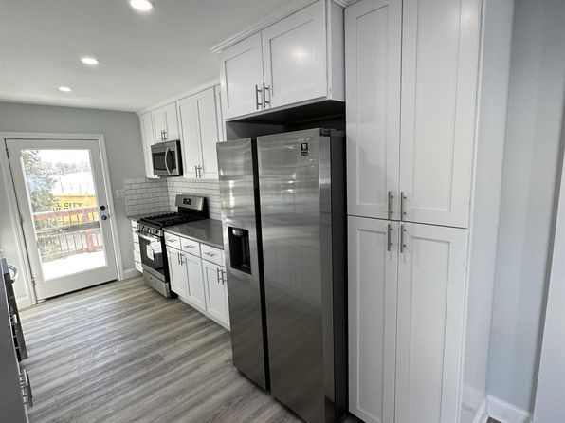](https://www.zillow.com/homedetails/228-Chesna-Dr-Pittsburgh-PA-15236/2060215986_zpid/)](https://www.zillow.com/homedetails/228-Chesna-Dr-Pittsburgh-PA-15236/2060215986_zpid/)

*[5044 Leona Dr, Pittsburgh, PA 15227](https://www.zillow.com/homedetails/5044-Leona-Dr-Pittsburgh-PA-15227/11428506_zpid/)*

$1,625/mo

* **3** bds
* **1** ba
* **1,025** sqft

- House for rent

23 days ago

[[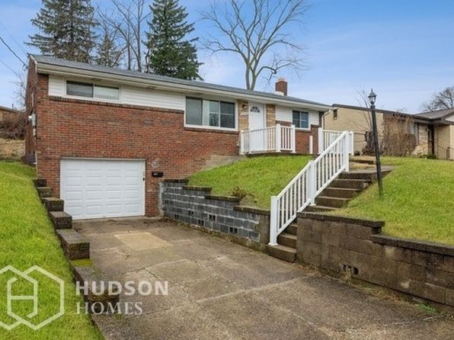](https://www.zillow.com/homedetails/5044-Leona-Dr-Pittsburgh-PA-15227/11428506_zpid/)](https://www.zillow.com/homedetails/5044-Leona-Dr-Pittsburgh-PA-15227/11428506_zpid/)

to get email alerts when listing

*[706-708 Summerlea Street, 706-708 Summerlea St #S4, Pittsburgh, PA 15232](https://www.zillow.com/b/706-708-summerlea-street-pittsburgh-pa-C9sdzD/)*

$1,695/mo

* + **2** bds
  + **2** ba
  + **--** sqft

- Apartment for rent

6 days ago

[[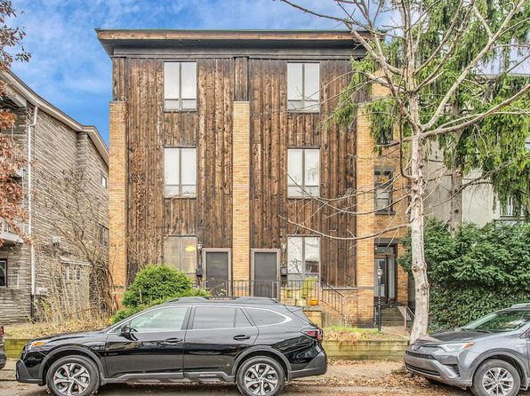](https://www.zillow.com/b/706-708-summerlea-street-pittsburgh-pa-C9sdzD/)](https://www.zillow.com/b/706-708-summerlea-street-pittsburgh-pa-C9sdzD/)

*[5021 Penn Ave APT 2R, Pittsburgh, PA 15224](https://www.zillow.com/homedetails/5021-Penn-Ave-APT-2R-Pittsburgh-PA-15224/2079023488_zpid/)*

$900/mo

* **1** bd
* **1** ba
* **500** sqft

- Apartment for rent

8 days ago

[[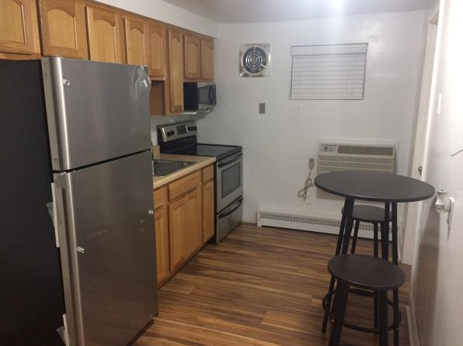](https://www.zillow.com/homedetails/5021-Penn-Ave-APT-2R-Pittsburgh-PA-15224/2079023488_zpid/)](https://www.zillow.com/homedetails/5021-Penn-Ave-APT-2R-Pittsburgh-PA-15224/2079023488_zpid/)

•

*[339 Orin St, Pittsburgh, PA 15235](https://www.zillow.com/homedetails/339-Orin-St-Pittsburgh-PA-15235/11416480_zpid/)*

$1,395/mo

* **3** bds
* **1** ba
* **980** sqft

- House for rent

10 days ago

[[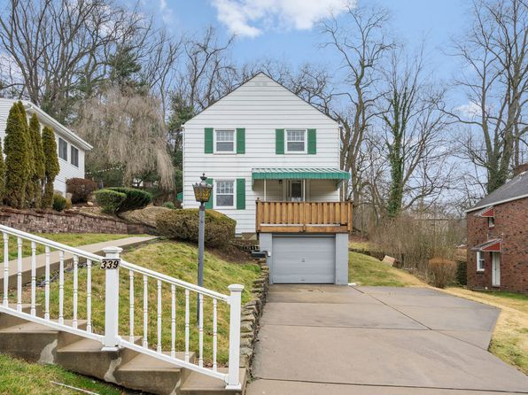](https://www.zillow.com/homedetails/339-Orin-St-Pittsburgh-PA-15235/11416480_zpid/)](https://www.zillow.com/homedetails/339-Orin-St-Pittsburgh-PA-15235/11416480_zpid/)

*[123 Homestead St REAR 1, Pittsburgh, PA 15218](https://www.zillow.com/homedetails/123-Homestead-St-REAR-1-Pittsburgh-PA-15218/2084494663_zpid/)*

$1,050/mo

* **1** bd
* **1** ba
* **850** sqft

- Apartment for rent

32 days ago

[[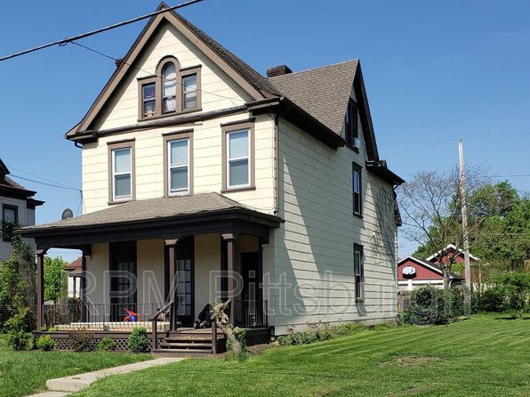](https://www.zillow.com/homedetails/123-Homestead-St-REAR-1-Pittsburgh-PA-15218/2084494663_zpid/)](https://www.zillow.com/homedetails/123-Homestead-St-REAR-1-Pittsburgh-PA-15218/2084494663_zpid/)

*[1015 Gerritt St FLOOR 1, Pittsburgh, PA 15208](https://www.zillow.com/homedetails/1015-Gerritt-St-FLOOR-1-Pittsburgh-PA-15208/2070537478_zpid/)*

$895/mo

* **2** bds
* **1** ba
* **750** sqft

- Apartment for rent

17 days ago

[[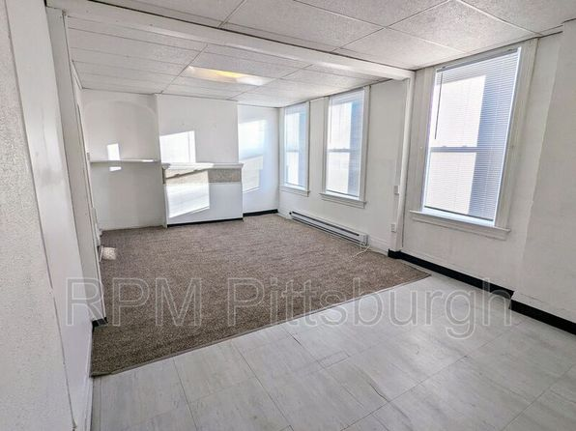](https://www.zillow.com/homedetails/1015-Gerritt-St-FLOOR-1-Pittsburgh-PA-15208/2070537478_zpid/)](https://www.zillow.com/homedetails/1015-Gerritt-St-FLOOR-1-Pittsburgh-PA-15208/2070537478_zpid/)

*[1847 Chislett St, Pittsburgh, PA 15206](https://www.zillow.com/homedetails/1847-Chislett-St-Pittsburgh-PA-15206/2121365741_zpid/)*

$1,299/mo

* **2** bds
* **1** ba
* **825** sqft

- House for rent

11 days ago

[[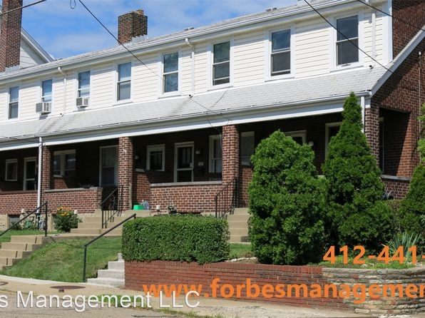](https://www.zillow.com/homedetails/1847-Chislett-St-Pittsburgh-PA-15206/2121365741_zpid/)](https://www.zillow.com/homedetails/1847-Chislett-St-Pittsburgh-PA-15206/2121365741_zpid/)

*[01 - 2400 Mission St | 2400 Mission St, Pittsburgh, PA](https://www.zillow.com/b/01-2400-mission-st-pittsburgh-pa-5jBrv2/)*

$800+ Studio

* **$1,275+** 2 bds

[[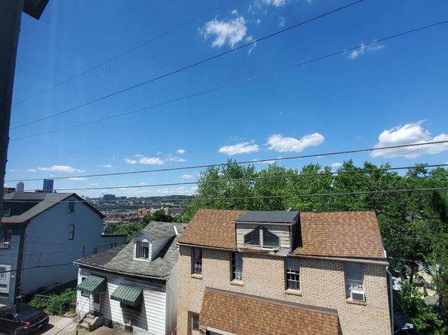](https://www.zillow.com/b/01-2400-mission-st-pittsburgh-pa-5jBrv2/)](https://www.zillow.com/b/01-2400-mission-st-pittsburgh-pa-5jBrv2/)

*[318 Elsdon St, Pittsburgh, PA 15214](https://www.zillow.com/homedetails/318-Elsdon-St-Pittsburgh-PA-15214/11505634_zpid/)*

$1,100/mo

* **4** bds
* **1** ba
* **1,812** sqft

- House for rent

7 days ago

[[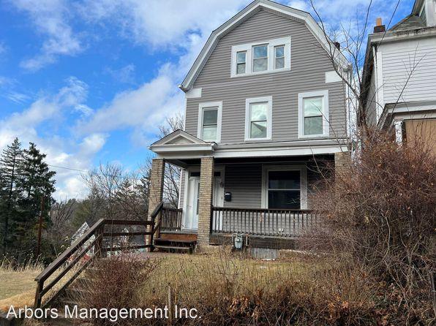](https://www.zillow.com/homedetails/318-Elsdon-St-Pittsburgh-PA-15214/11505634_zpid/)](https://www.zillow.com/homedetails/318-Elsdon-St-Pittsburgh-PA-15214/11505634_zpid/)

*[Studio, 340 sqft, $799, 6017 Stanton Ave APT 1, Pittsburgh, PA 15206](https://www.zillow.com/b/6017-stanton-avenue-pittsburgh-pa-5YC9J2/)*

$799/mo

* **Studio**
* **1** ba
* **340** sqft

- Apartment for rent

10 days ago

[[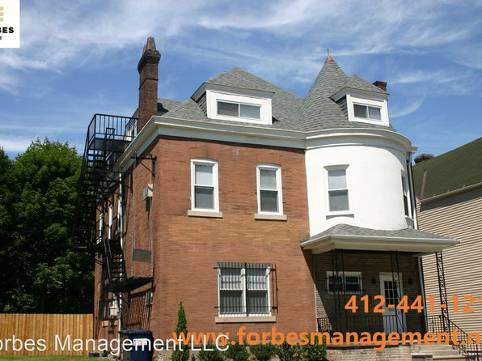](https://www.zillow.com/b/6017-stanton-avenue-pittsburgh-pa-5YC9J2/)](https://www.zillow.com/b/6017-stanton-avenue-pittsburgh-pa-5YC9J2/)

*[219 S Fairmount St APT 1, Pittsburgh, PA 15206](https://www.zillow.com/homedetails/219-S-Fairmount-St-APT-1-Pittsburgh-PA-15206/2095130670_zpid/)*

$1,395/mo

* **1** bd
* **1** ba
* **--** sqft

- Apartment for rent

3 days ago

[[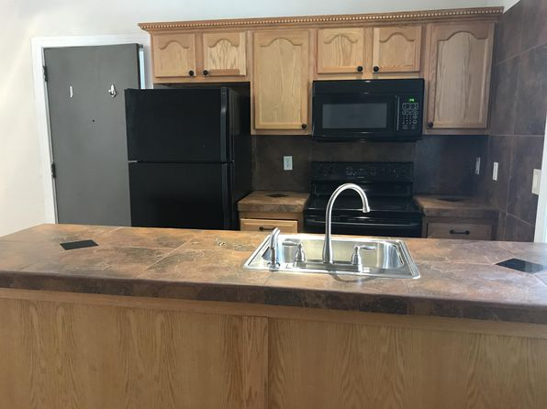](https://www.zillow.com/homedetails/219-S-Fairmount-St-APT-1-Pittsburgh-PA-15206/2095130670_zpid/)](https://www.zillow.com/homedetails/219-S-Fairmount-St-APT-1-Pittsburgh-PA-15206/2095130670_zpid/)

*[955 E Warrington Ave, Pittsburgh, PA 15210](https://www.zillow.com/homedetails/955-E-Warrington-Ave-Pittsburgh-PA-15210/11315101_zpid/)*

$1,600/mo

* **5** bds
* **2** ba
* **--** sqft

- House for rent

6 days ago

[[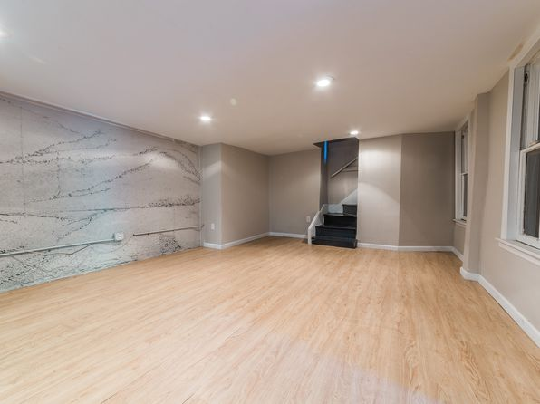](https://www.zillow.com/homedetails/955-E-Warrington-Ave-Pittsburgh-PA-15210/11315101_zpid/)](https://www.zillow.com/homedetails/955-E-Warrington-Ave-Pittsburgh-PA-15210/11315101_zpid/)

*[150 Saint Paul St, Pittsburgh, PA 15203](https://www.zillow.com/homedetails/150-Saint-Paul-St-Pittsburgh-PA-15203/11315268_zpid/)*

$1,900/mo

* **4** bds
* **1** ba
* **--** sqft

- House for rent

30 days ago

[[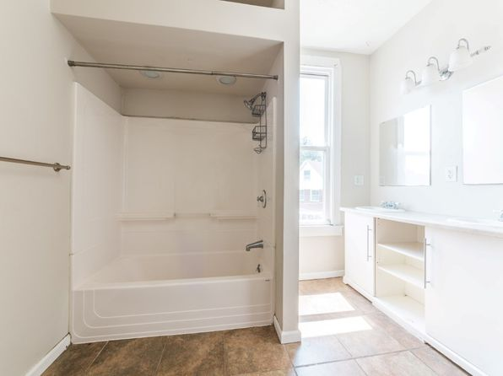](https://www.zillow.com/homedetails/150-Saint-Paul-St-Pittsburgh-PA-15203/11315268_zpid/)](https://www.zillow.com/homedetails/150-Saint-Paul-St-Pittsburgh-PA-15203/11315268_zpid/)

*[10156 Clair Ave, Pittsburgh, PA 15235](https://www.zillow.com/homedetails/10156-Clair-Ave-Pittsburgh-PA-15235/11415414_zpid/)*

$1,350/mo

* **3** bds
* **1** ba
* **1,237** sqft

- House for rent

13 days ago

[[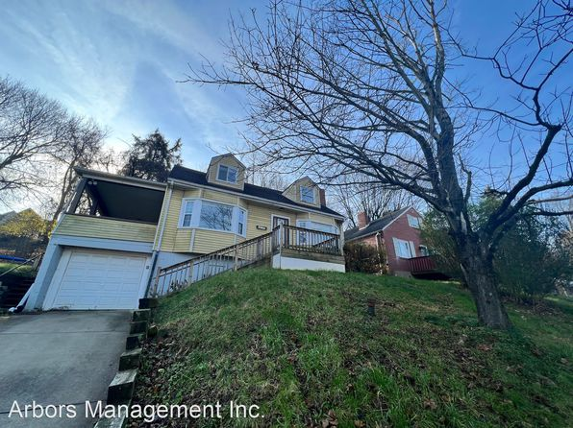](https://www.zillow.com/homedetails/10156-Clair-Ave-Pittsburgh-PA-15235/11415414_zpid/)](https://www.zillow.com/homedetails/10156-Clair-Ave-Pittsburgh-PA-15235/11415414_zpid/)

*[5551 Beacon St, Pittsburgh, PA 15217](https://www.zillow.com/homedetails/5551-Beacon-St-Pittsburgh-PA-15217/2093210930_zpid/)*

$1,895/mo

* **3** bds
* **2** ba
* **--** sqft

- House for rent

11 days ago

[[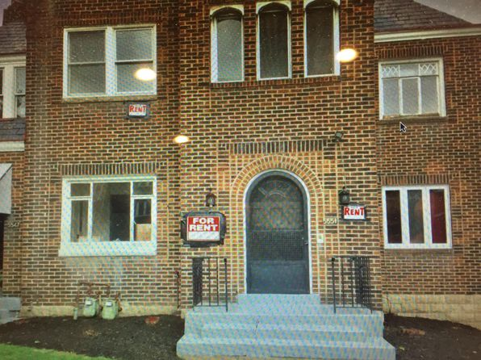](https://www.zillow.com/homedetails/5551-Beacon-St-Pittsburgh-PA-15217/2093210930_zpid/)](https://www.zillow.com/homedetails/5551-Beacon-St-Pittsburgh-PA-15217/2093210930_zpid/)

*[01 - 129 Fitler St, 129 Fitler St, Pittsburgh, PA 15210](https://www.zillow.com/homedetails/129-Fitler-St-Pittsburgh-PA-15210/11308681_zpid/)*

$1,375/mo

* **3** bds
* **2** ba
* **--** sqft

- Apartment for rent

24 days ago

[[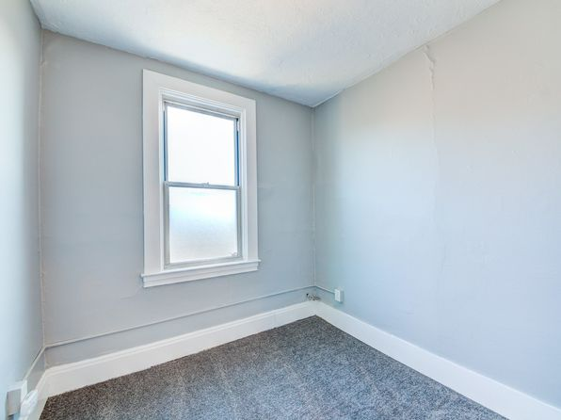](https://www.zillow.com/homedetails/129-Fitler-St-Pittsburgh-PA-15210/11308681_zpid/)](https://www.zillow.com/homedetails/129-Fitler-St-Pittsburgh-PA-15210/11308681_zpid/)

•

*[235 Edgewood Ave APT B08, Pittsburgh, PA 15218](https://www.zillow.com/homedetails/235-Edgewood-Ave-APT-B08-Pittsburgh-PA-15218/2059972074_zpid/)*

$925/mo

* **1** bd
* **1** ba
* **712** sqft

- Apartment for rent

9 days ago

[[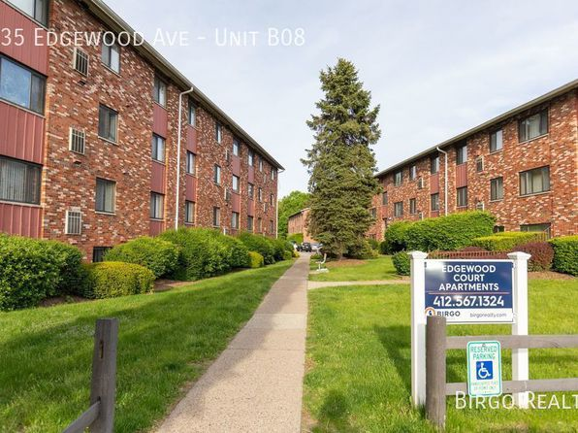](https://www.zillow.com/homedetails/235-Edgewood-Ave-APT-B08-Pittsburgh-PA-15218/2059972074_zpid/)](https://www.zillow.com/homedetails/235-Edgewood-Ave-APT-B08-Pittsburgh-PA-15218/2059972074_zpid/)

*[383 Dorothy Dr, Pittsburgh, PA 15235](https://www.zillow.com/homedetails/383-Dorothy-Dr-Pittsburgh-PA-15235/11450696_zpid/)*

$1,500/mo

* **3** bds
* **1** ba
* **1,144** sqft

- House for rent

16 days ago

[[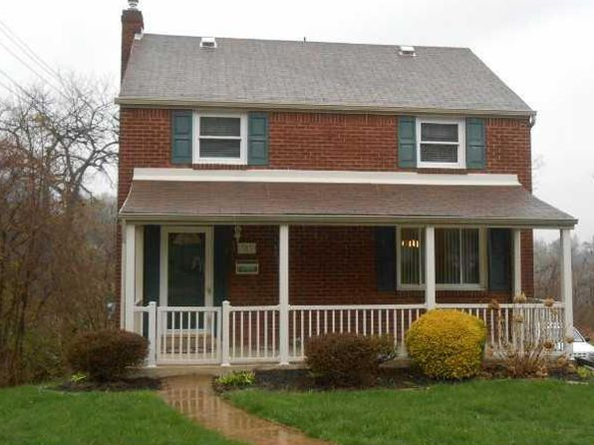](https://www.zillow.com/homedetails/383-Dorothy-Dr-Pittsburgh-PA-15235/11450696_zpid/)](https://www.zillow.com/homedetails/383-Dorothy-Dr-Pittsburgh-PA-15235/11450696_zpid/)

•

*[6900 Riverside Place | 6900 Riverside Pl, Pittsburgh, PA](https://www.zillow.com/b/6900-riverside-place-pittsburgh-pa-5XmQ26/)*

$850+ 2 bds

[[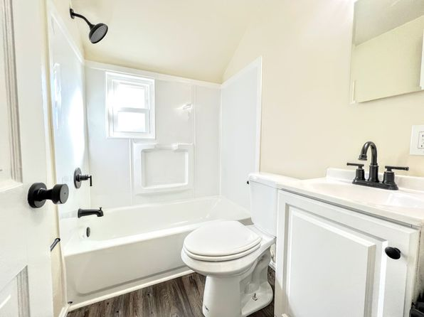](https://www.zillow.com/b/6900-riverside-place-pittsburgh-pa-5XmQ26/)](https://www.zillow.com/b/6900-riverside-place-pittsburgh-pa-5XmQ26/)

•

*[1414 Bellaire Pl, Pittsburgh, PA 15226](https://www.zillow.com/homedetails/1414-Bellaire-Pl-Pittsburgh-PA-15226/11649045_zpid/)*

$1,400/mo

* **3** bds
* **1** ba
* **1,320** sqft

- House for rent

16 days ago

[[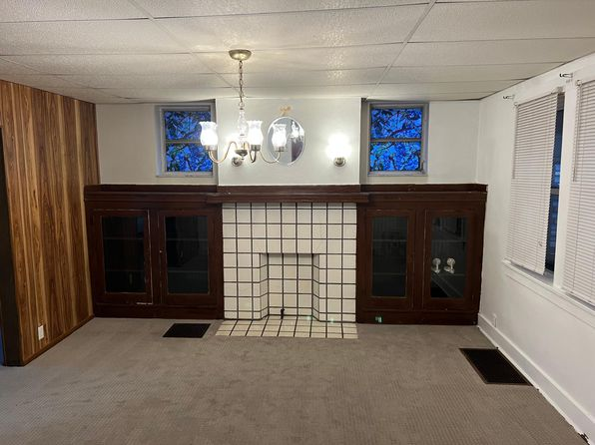](https://www.zillow.com/homedetails/1414-Bellaire-Pl-Pittsburgh-PA-15226/11649045_zpid/)](https://www.zillow.com/homedetails/1414-Bellaire-Pl-Pittsburgh-PA-15226/11649045_zpid/)

*[4767 1/2 Cypress St, Pittsburgh, PA 15224](https://www.zillow.com/homedetails/4767-1-2-Cypress-St-Pittsburgh-PA-15224/11524746_zpid/)*

$1,450/mo

* **2** bds
* **1** ba
* **--** sqft

- House for rent

20 days ago

[[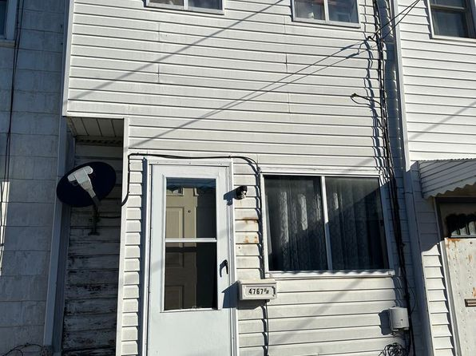](https://www.zillow.com/homedetails/4767-1-2-Cypress-St-Pittsburgh-PA-15224/11524746_zpid/)](https://www.zillow.com/homedetails/4767-1-2-Cypress-St-Pittsburgh-PA-15224/11524746_zpid/)

*[East Liberty - Apartments For Rent In Pittsburgh, 621 Collins Ave APT 3, Pittsburgh, PA 15206](https://www.zillow.com/b/east-liberty-apartments-for-rent-in-pittsburgh-pittsburgh-pa-5bcKnL/)*

$695/mo

* **Studio**
* **1** ba
* **--** sqft

- Apartment for rent

21 days ago

[[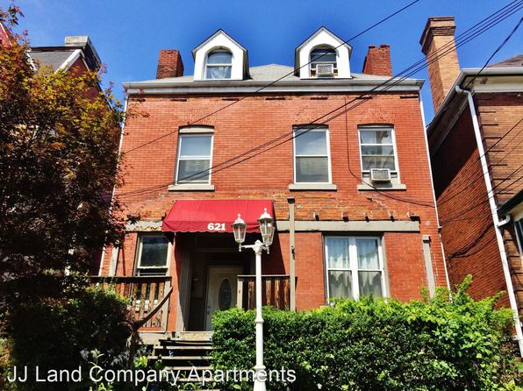](https://www.zillow.com/b/east-liberty-apartments-for-rent-in-pittsburgh-pittsburgh-pa-5bcKnL/)](https://www.zillow.com/b/east-liberty-apartments-for-rent-in-pittsburgh-pittsburgh-pa-5bcKnL/)

*[1740 Yorktown Pl, Pittsburgh, PA 15235](https://www.zillow.com/homedetails/1740-Yorktown-Pl-Pittsburgh-PA-15235/11417295_zpid/)*

$1,695/mo

* **3** bds
* **2** ba
* **1,320** sqft

- House for rent

10 days ago

[[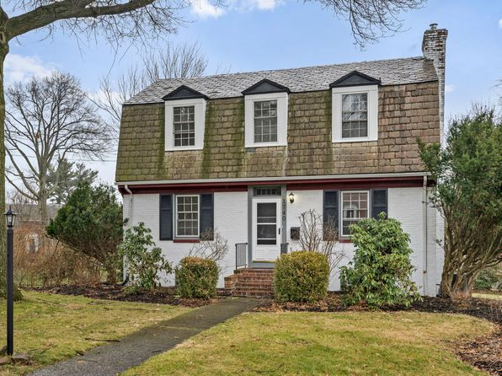](https://www.zillow.com/homedetails/1740-Yorktown-Pl-Pittsburgh-PA-15235/11417295_zpid/)](https://www.zillow.com/homedetails/1740-Yorktown-Pl-Pittsburgh-PA-15235/11417295_zpid/)

*[125 Wilson Dr, Pittsburgh, PA 15235](https://www.zillow.com/homedetails/125-Wilson-Dr-Pittsburgh-PA-15235/11451205_zpid/)*

$1,470/mo

* **3** bds
* **1** ba
* **1,163** sqft

- House for rent

11 days ago

[[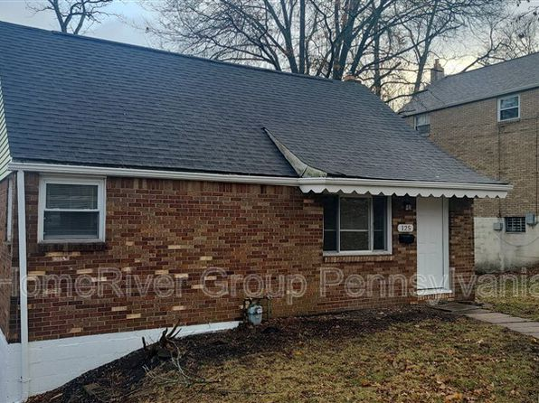](https://www.zillow.com/homedetails/125-Wilson-Dr-Pittsburgh-PA-15235/11451205_zpid/)](https://www.zillow.com/homedetails/125-Wilson-Dr-Pittsburgh-PA-15235/11451205_zpid/)

*[615 Southern Ave, Mount Washington, PA 15211](https://www.zillow.com/homedetails/615-Southern-Ave-Mount-Washington-PA-15211/11323198_zpid/)*

$1,995/mo

* **3** bds
* **2** ba
* **1,372** sqft

- House for rent

10 days ago

[[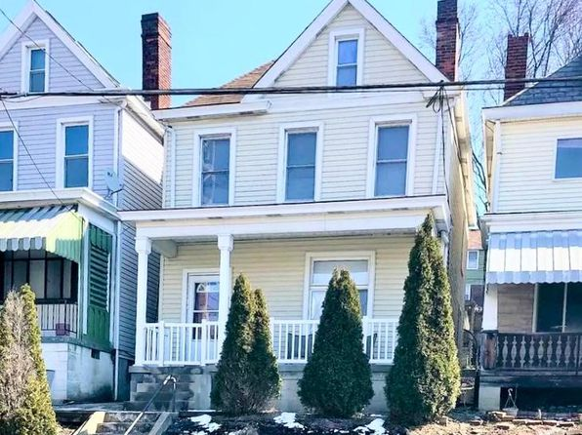](https://www.zillow.com/homedetails/615-Southern-Ave-Mount-Washington-PA-15211/11323198_zpid/)](https://www.zillow.com/homedetails/615-Southern-Ave-Mount-Washington-PA-15211/11323198_zpid/)

*[2334 Spring St, Pittsburgh, PA 15210](https://www.zillow.com/homedetails/2334-Spring-St-Pittsburgh-PA-15210/11309071_zpid/)*

$1,600/mo

* **4** bds
* **2** ba
* **--** sqft

- House for rent

17 days ago

[[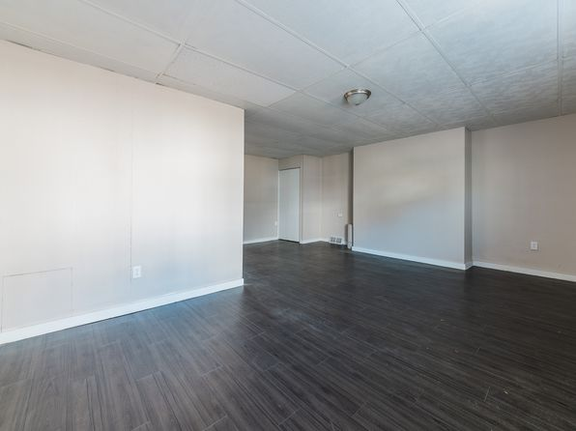](https://www.zillow.com/homedetails/2334-Spring-St-Pittsburgh-PA-15210/11309071_zpid/)](https://www.zillow.com/homedetails/2334-Spring-St-Pittsburgh-PA-15210/11309071_zpid/)

*[East Liberty - Apartments For Rent In Pittsburgh, 719 N Negley Ave APT 4, Pittsburgh, PA 15206](https://www.zillow.com/b/east-liberty-apartments-for-rent-in-pittsburgh-pittsburgh-pa-5fwmF5/)*

$795/mo

* **1** bd
* **1** ba
* **--** sqft

- Apartment for rent

12 days ago

[[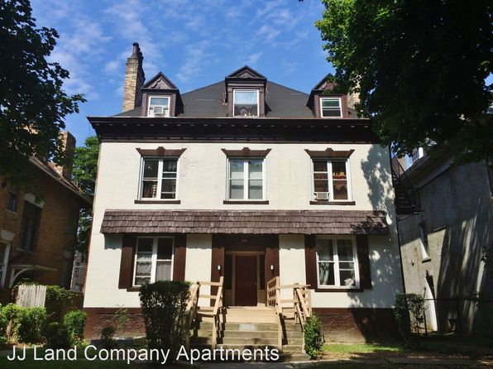](https://www.zillow.com/b/east-liberty-apartments-for-rent-in-pittsburgh-pittsburgh-pa-5fwmF5/)](https://www.zillow.com/b/east-liberty-apartments-for-rent-in-pittsburgh-pittsburgh-pa-5fwmF5/)

*[192 43rd St, Pittsburgh, PA 15201](https://www.zillow.com/homedetails/192-43rd-St-Pittsburgh-PA-15201/11512974_zpid/)*

$2,500/mo

* **3** bds
* **1.5** ba
* **1,824** sqft

- House for rent

8 days ago

[[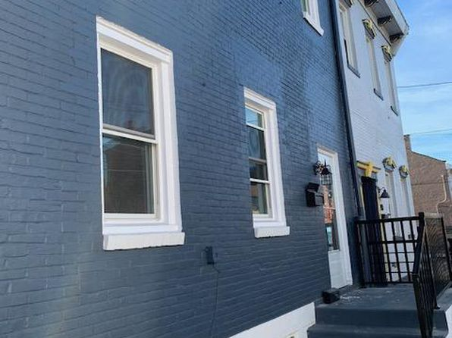](https://www.zillow.com/homedetails/192-43rd-St-Pittsburgh-PA-15201/11512974_zpid/)](https://www.zillow.com/homedetails/192-43rd-St-Pittsburgh-PA-15201/11512974_zpid/)

*[13 Maytide St, Pittsburgh, PA 15227](https://www.zillow.com/homedetails/13-Maytide-St-Pittsburgh-PA-15227/11303933_zpid/)*

$1,300/mo

* **3** bds
* **1** ba
* **1,709** sqft

- House for rent

23 days ago

[[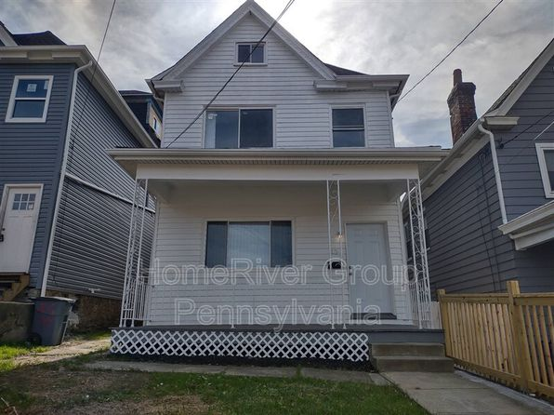](https://www.zillow.com/homedetails/13-Maytide-St-Pittsburgh-PA-15227/11303933_zpid/)](https://www.zillow.com/homedetails/13-Maytide-St-Pittsburgh-PA-15227/11303933_zpid/)

*[5800 Stanton Avenue | 5800 Stanton Ave, Pittsburgh, PA](https://www.zillow.com/b/5800-stanton-avenue-pittsburgh-pa-5Z6hkj/)*

$1,019+ 1 bd

[[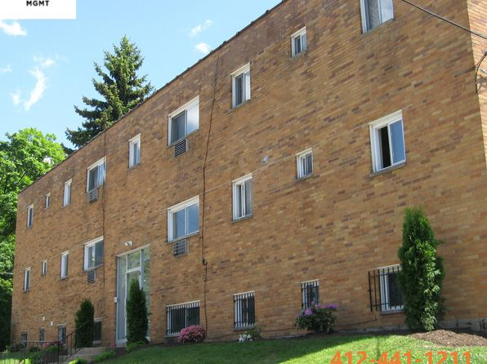](https://www.zillow.com/b/5800-stanton-avenue-pittsburgh-pa-5Z6hkj/)](https://www.zillow.com/b/5800-stanton-avenue-pittsburgh-pa-5Z6hkj/)

*[538 Halsey Ave #2, Pittsburgh, PA 15221](https://www.zillow.com/homedetails/538-Halsey-Ave-2-Pittsburgh-PA-15221/2106648208_zpid/)*

$1,000/mo

* **2** bds
* **1** ba
* **900** sqft

- Townhouse for rent

30 days ago

[[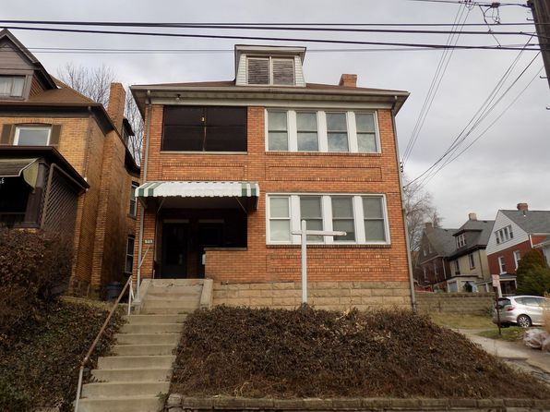](https://www.zillow.com/homedetails/538-Halsey-Ave-2-Pittsburgh-PA-15221/2106648208_zpid/)](https://www.zillow.com/homedetails/538-Halsey-Ave-2-Pittsburgh-PA-15221/2106648208_zpid/)

*[1815 Niggel St, Pittsburgh, PA 15212](https://www.zillow.com/homedetails/1815-Niggel-St-Pittsburgh-PA-15212/2060127651_zpid/)*

$1,000/mo

* **2** bds
* **1** ba
* **1,150** sqft

- House for rent

15 days ago

[[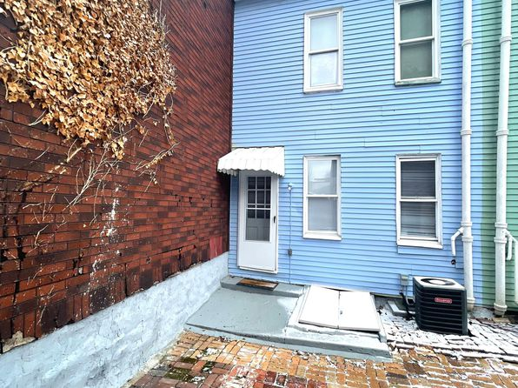](https://www.zillow.com/homedetails/1815-Niggel-St-Pittsburgh-PA-15212/2060127651_zpid/)](https://www.zillow.com/homedetails/1815-Niggel-St-Pittsburgh-PA-15212/2060127651_zpid/)

*[1725 Realty Ave, 1725 Realty Ave APT 2, Pittsburgh, PA 15216](https://www.zillow.com/b/1725-realty-ave-pittsburgh-pa-5b4ZNx/)*

$925/mo

* **2** bds
* **1** ba
* **1,000** sqft

- Apartment for rent

25 days ago

[[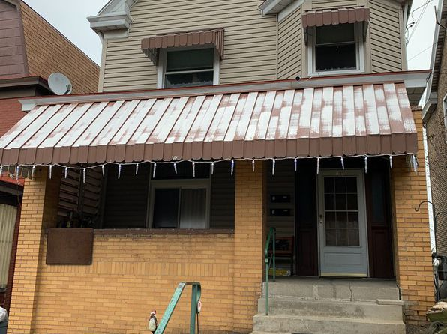](https://www.zillow.com/b/1725-realty-ave-pittsburgh-pa-5b4ZNx/)](https://www.zillow.com/b/1725-realty-ave-pittsburgh-pa-5b4ZNx/)

*[2 Blaine St FLOOR 3, Pittsburgh, PA 15226](https://www.zillow.com/homedetails/2-Blaine-St-FLOOR-3-Pittsburgh-PA-15226/2076796584_zpid/)*

$850/mo

* **1** bd
* **1** ba
* **--** sqft

- Apartment for rent

13 days ago

[[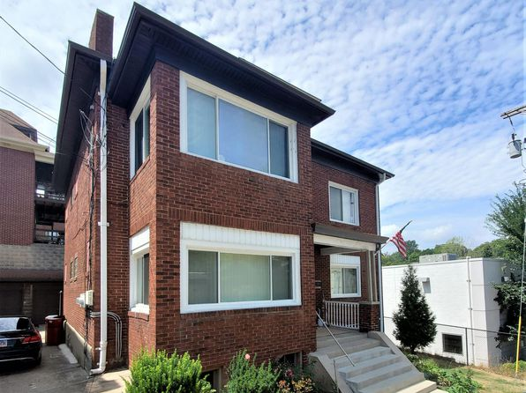](https://www.zillow.com/homedetails/2-Blaine-St-FLOOR-3-Pittsburgh-PA-15226/2076796584_zpid/)](https://www.zillow.com/homedetails/2-Blaine-St-FLOOR-3-Pittsburgh-PA-15226/2076796584_zpid/)

*[1613 Belasco Ave, Pittsburgh, PA 15216](https://www.zillow.com/homedetails/1613-Belasco-Ave-Pittsburgh-PA-15216/11445207_zpid/)*

$1,450/mo

* **3** bds
* **1** ba
* **1,550** sqft

- House for rent

11 days ago

[[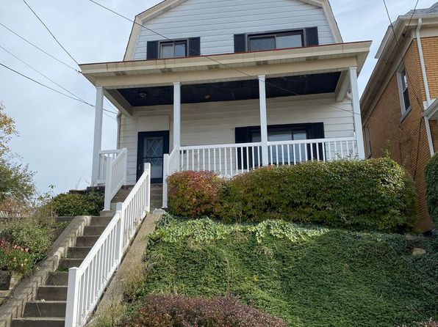](https://www.zillow.com/homedetails/1613-Belasco-Ave-Pittsburgh-PA-15216/11445207_zpid/)](https://www.zillow.com/homedetails/1613-Belasco-Ave-Pittsburgh-PA-15216/11445207_zpid/)

*[2320 Spring St, Pittsburgh, PA 15210](https://www.zillow.com/homedetails/2320-Spring-St-Pittsburgh-PA-15210/11309076_zpid/)*

$1,400/mo

* **3** bds
* **1** ba
* **--** sqft

- House for rent

11 days ago

[[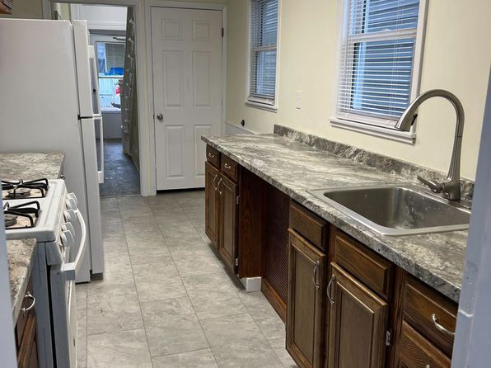](https://www.zillow.com/homedetails/2320-Spring-St-Pittsburgh-PA-15210/11309076_zpid/)](https://www.zillow.com/homedetails/2320-Spring-St-Pittsburgh-PA-15210/11309076_zpid/)

*[2607 Voelkel Ave, Pittsburgh, PA 15216](https://www.zillow.com/homedetails/2607-Voelkel-Ave-Pittsburgh-PA-15216/11565557_zpid/)*

$1,295/mo

* **3** bds
* **1** ba
* **1,000** sqft

- Apartment for rent

4 days ago

[[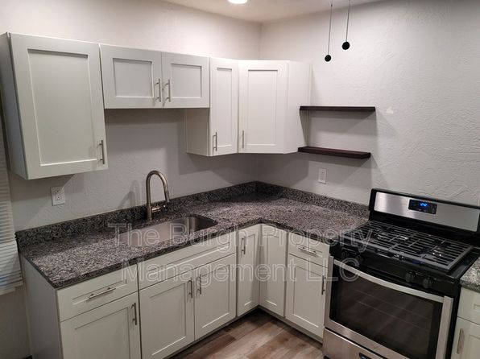](https://www.zillow.com/homedetails/2607-Voelkel-Ave-Pittsburgh-PA-15216/11565557_zpid/)](https://www.zillow.com/homedetails/2607-Voelkel-Ave-Pittsburgh-PA-15216/11565557_zpid/)

*[216 Oneida St #2, Pittsburgh, PA 15211](https://www.zillow.com/homedetails/216-Oneida-St-2-Pittsburgh-PA-15211/2119142687_zpid/)*

$1,200/mo

* **2** bds
* **1** ba
* **880** sqft

- Apartment for rent

13 days ago

[[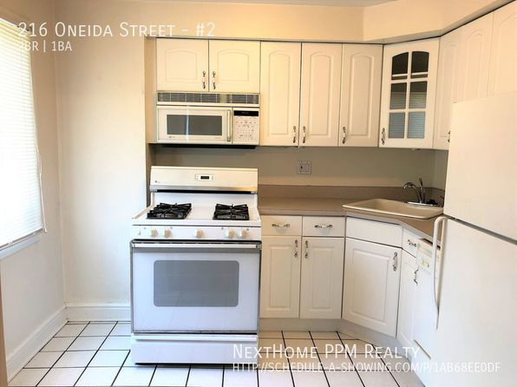](https://www.zillow.com/homedetails/216-Oneida-St-2-Pittsburgh-PA-15211/2119142687_zpid/)](https://www.zillow.com/homedetails/216-Oneida-St-2-Pittsburgh-PA-15211/2119142687_zpid/)

*[1503 Princess Ave #3, Pittsburgh, PA 15216](https://www.zillow.com/homedetails/1503-Princess-Ave-3-Pittsburgh-PA-15216/2060169070_zpid/)*

$1,400/mo

* **3** bds
* **1** ba
* **--** sqft

- Apartment for rent

19 days ago

[[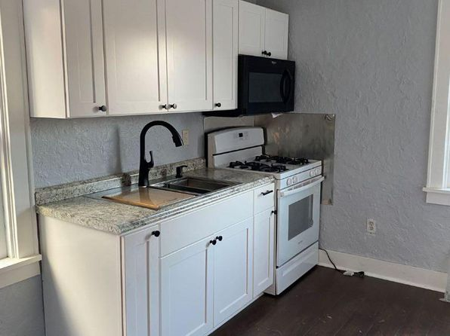](https://www.zillow.com/homedetails/1503-Princess-Ave-3-Pittsburgh-PA-15216/2060169070_zpid/)](https://www.zillow.com/homedetails/1503-Princess-Ave-3-Pittsburgh-PA-15216/2060169070_zpid/)

*[1213 Ocala St, Pittsburgh, PA 15212](https://www.zillow.com/homedetails/1213-Ocala-St-Pittsburgh-PA-15212/2102971119_zpid/)*

$1,300/mo

* **3** bds
* **1** ba
* **1,300** sqft

- House for rent

6 days ago

[[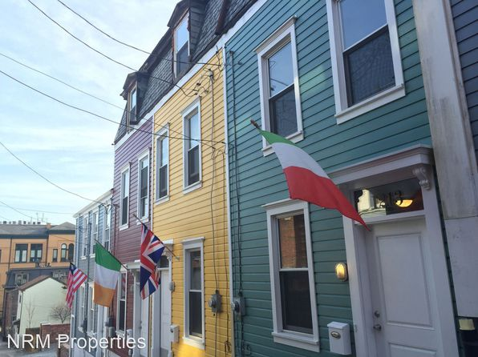](https://www.zillow.com/homedetails/1213-Ocala-St-Pittsburgh-PA-15212/2102971119_zpid/)](https://www.zillow.com/homedetails/1213-Ocala-St-Pittsburgh-PA-15212/2102971119_zpid/)

*[2738 Glenmawr Ave | 2738 Glenmawr St, Pittsburgh, PA](https://www.zillow.com/b/2738-glenmawr-ave-pittsburgh-pa-98N8Z2/)*

$930+ 1 bd

* **$1,250+** 3 bds

[[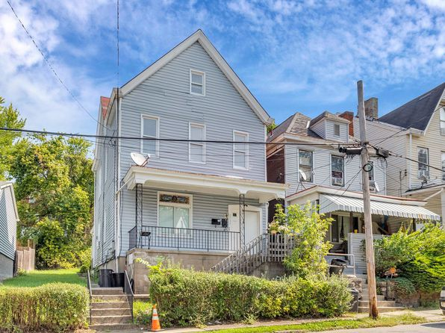](https://www.zillow.com/b/2738-glenmawr-ave-pittsburgh-pa-98N8Z2/)](https://www.zillow.com/b/2738-glenmawr-ave-pittsburgh-pa-98N8Z2/)

to get email alerts when listings hit the market.

*[1710 Creedmoor Ave, Pittsburgh, PA 15226](https://www.zillow.com/homedetails/1710-Creedmoor-Ave-Pittsburgh-PA-15226/11650400_zpid/)*

$1,375/mo

* + **3** bds
  + **2** ba
  + **900** sqft

- House for rent

14 days ago

[[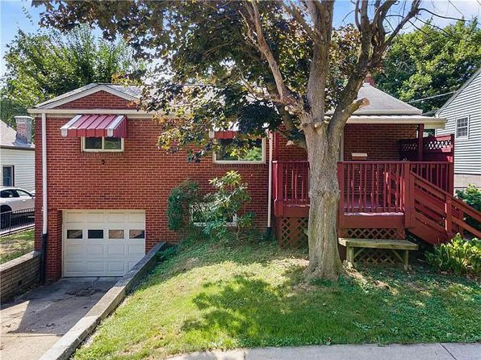](https://www.zillow.com/homedetails/1710-Creedmoor-Ave-Pittsburgh-PA-15226/11650400_zpid/)](https://www.zillow.com/homedetails/1710-Creedmoor-Ave-Pittsburgh-PA-15226/11650400_zpid/)

*[20 Edith Pl, Pittsburgh, PA 15213](https://www.zillow.com/homedetails/20-Edith-Pl-Pittsburgh-PA-15213/11419972_zpid/)*

$1,350/mo

* **3** bds
* **1** ba
* **--** sqft

- House for rent

10 days ago

[[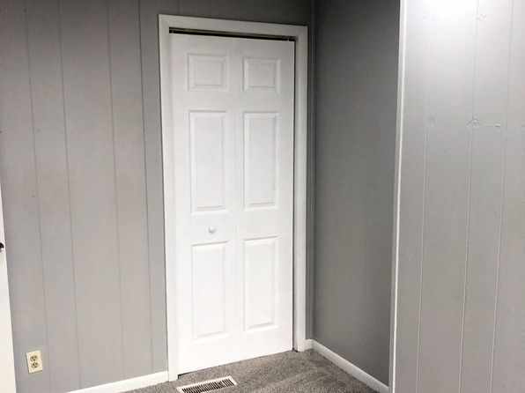](https://www.zillow.com/homedetails/20-Edith-Pl-Pittsburgh-PA-15213/11419972_zpid/)](https://www.zillow.com/homedetails/20-Edith-Pl-Pittsburgh-PA-15213/11419972_zpid/)

•

*[06 - 2013.5 Gregory St, 2013.5 Gregory St #1, Pittsburgh, PA 15203](https://www.zillow.com/b/06-2013.5-gregory-st-pittsburgh-pa-C6bznw/)*

$1,200/mo

* **2** bds
* **1** ba
* **--** sqft

- Apartment for rent

24 days ago

[[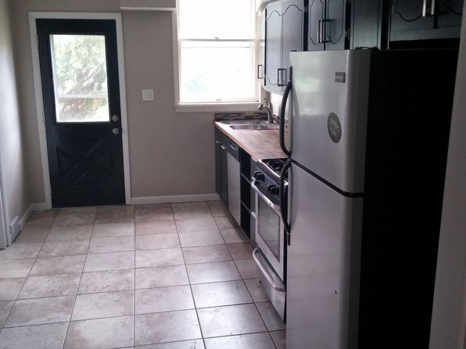](https://www.zillow.com/b/06-2013.5-gregory-st-pittsburgh-pa-C6bznw/)](https://www.zillow.com/b/06-2013.5-gregory-st-pittsburgh-pa-C6bznw/)

*[1146 Woods Run Ave, Pittsburgh, PA 15212](https://www.zillow.com/homedetails/1146-Woods-Run-Ave-Pittsburgh-PA-15212/11605805_zpid/)*

$1,195/mo

* **2** bds
* **1** ba
* **1,382** sqft

- House for rent

13 days ago

[[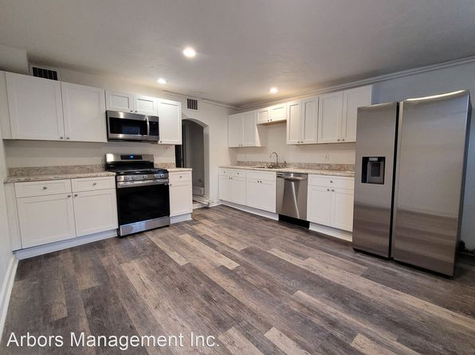](https://www.zillow.com/homedetails/1146-Woods-Run-Ave-Pittsburgh-PA-15212/11605805_zpid/)](https://www.zillow.com/homedetails/1146-Woods-Run-Ave-Pittsburgh-PA-15212/11605805_zpid/)

*[Available August 1, 5631 Phillips Ave #6E0FBE3A4, Pittsburgh, PA 15217](https://www.zillow.com/b/available-august-1-squirrel-hill-pa-5fwkfn/)*

$1,000/mo

* **1** bd
* **1** ba
* **--** sqft

- Apartment for rent

6 days ago

[[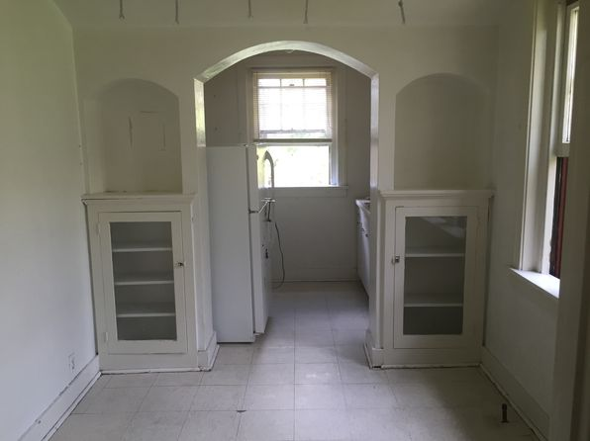](https://www.zillow.com/b/available-august-1-squirrel-hill-pa-5fwkfn/)](https://www.zillow.com/b/available-august-1-squirrel-hill-pa-5fwkfn/)

*[3123 Phelan Way FLOOR 2, Pittsburgh, PA 15219](https://www.zillow.com/homedetails/3123-Phelan-Way-FLOOR-2-Pittsburgh-PA-15219/2059959484_zpid/)*

$1,700/mo

* **2** bds
* **2** ba
* **950** sqft

- Apartment for rent

8 days ago

[[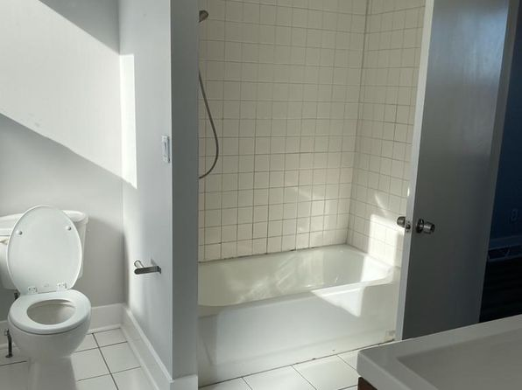](https://www.zillow.com/homedetails/3123-Phelan-Way-FLOOR-2-Pittsburgh-PA-15219/2059959484_zpid/)](https://www.zillow.com/homedetails/3123-Phelan-Way-FLOOR-2-Pittsburgh-PA-15219/2059959484_zpid/)

*[28 - 275 Lelia, 275 Lelia St #2, Pittsburgh, PA 15211](https://www.zillow.com/b/28-275-lelia-pittsburgh-pa-5jPKMt/)*

$1,050/mo

* **2** bds
* **1** ba
* **--** sqft

- Apartment for rent

25 days ago

[[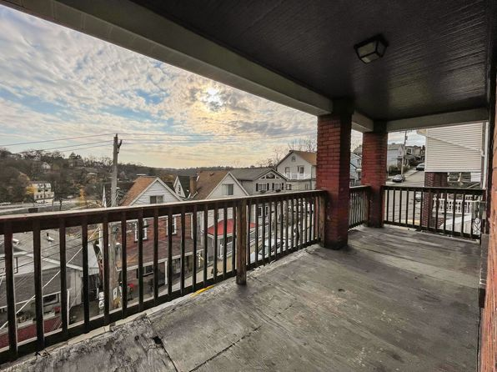](https://www.zillow.com/b/28-275-lelia-pittsburgh-pa-5jPKMt/)](https://www.zillow.com/b/28-275-lelia-pittsburgh-pa-5jPKMt/)

*[604 Perrilyn St, Pittsburgh, PA 15226](https://www.zillow.com/homedetails/604-Perrilyn-St-Pittsburgh-PA-15226/11565916_zpid/)*

$1,399/mo

* **3** bds
* **1.5** ba
* **950** sqft

- House for rent

8 days ago

[[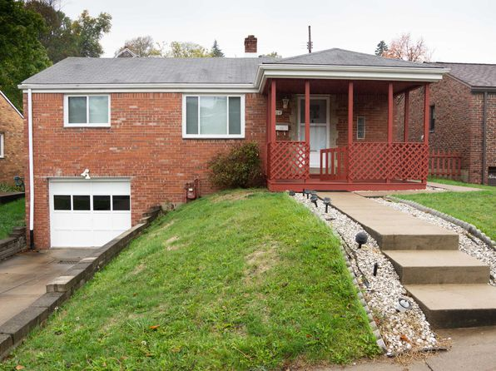](https://www.zillow.com/homedetails/604-Perrilyn-St-Pittsburgh-PA-15226/11565916_zpid/)](https://www.zillow.com/homedetails/604-Perrilyn-St-Pittsburgh-PA-15226/11565916_zpid/)

*[215 Grant Ave APT 1, Pittsburgh, PA 15202](https://www.zillow.com/homedetails/215-Grant-Ave-APT-1-Pittsburgh-PA-15202/2060110106_zpid/)*

$1,295/mo

* **2** bds
* **1** ba
* **1,000** sqft

- Townhouse for rent

12 days ago

[[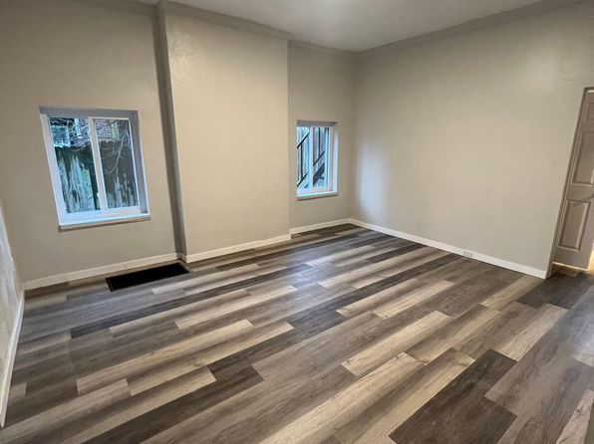](https://www.zillow.com/homedetails/215-Grant-Ave-APT-1-Pittsburgh-PA-15202/2060110106_zpid/)](https://www.zillow.com/homedetails/215-Grant-Ave-APT-1-Pittsburgh-PA-15202/2060110106_zpid/)

*[113 Wabash St, Pittsburgh, PA 15220](https://www.zillow.com/homedetails/113-Wabash-St-Pittsburgh-PA-15220/11362679_zpid/)*

$2,195/mo

* **4** bds
* **2.5** ba
* **2,000** sqft

- House for rent

17 days ago

[[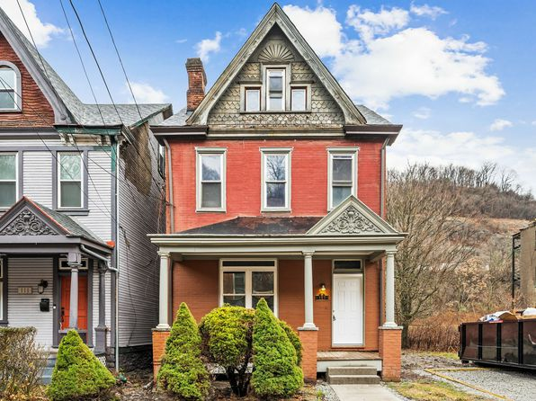](https://www.zillow.com/homedetails/113-Wabash-St-Pittsburgh-PA-15220/11362679_zpid/)](https://www.zillow.com/homedetails/113-Wabash-St-Pittsburgh-PA-15220/11362679_zpid/)

*[4380 Coleridge St, Pittsburgh, PA 15201](https://www.zillow.com/homedetails/4380-Coleridge-St-Pittsburgh-PA-15201/11615010_zpid/)*

$895/mo

* **2** bds
* **1** ba
* **--** sqft

- House for rent

9 days ago

[[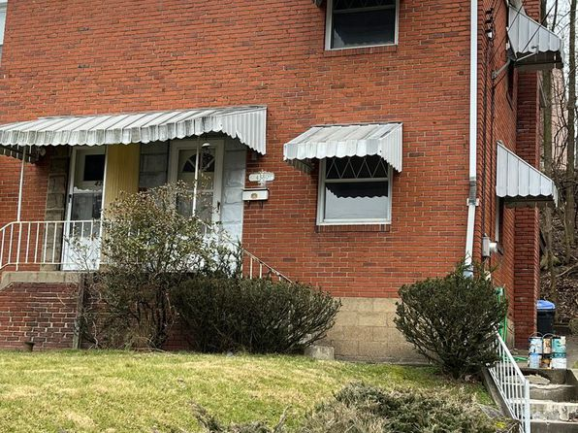](https://www.zillow.com/homedetails/4380-Coleridge-St-Pittsburgh-PA-15201/11615010_zpid/)](https://www.zillow.com/homedetails/4380-Coleridge-St-Pittsburgh-PA-15201/11615010_zpid/)

*[318 S Main St #A, Pittsburgh, PA 15220](https://www.zillow.com/homedetails/318-S-Main-St-A-Pittsburgh-PA-15220/2060179966_zpid/)*

$1,300/mo

* **2** bds
* **1** ba
* **--** sqft

- Apartment for rent

19 days ago

[[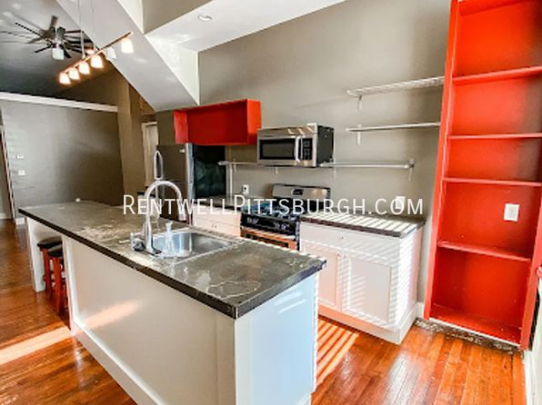](https://www.zillow.com/homedetails/318-S-Main-St-A-Pittsburgh-PA-15220/2060179966_zpid/)](https://www.zillow.com/homedetails/318-S-Main-St-A-Pittsburgh-PA-15220/2060179966_zpid/)

*[2475 Woodward Ave, Pittsburgh, PA 15226](https://www.zillow.com/homedetails/2475-Woodward-Ave-Pittsburgh-PA-15226/11566278_zpid/)*

$1,350/mo

* **3** bds
* **1** ba
* **--** sqft

- House for rent

10 days ago

[[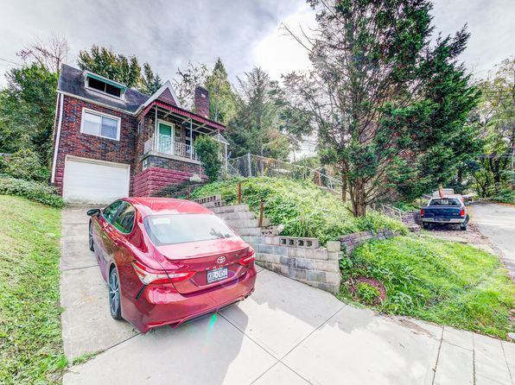](https://www.zillow.com/homedetails/2475-Woodward-Ave-Pittsburgh-PA-15226/11566278_zpid/)](https://www.zillow.com/homedetails/2475-Woodward-Ave-Pittsburgh-PA-15226/11566278_zpid/)

*[3555 California Ave APT 101, Pittsburgh, PA 15212](https://www.zillow.com/homedetails/3555-California-Ave-APT-101-Pittsburgh-PA-15212/2099987100_zpid/)*

$895/mo

* **1** bd
* **1** ba
* **--** sqft

- Apartment for rent

22 days ago

[[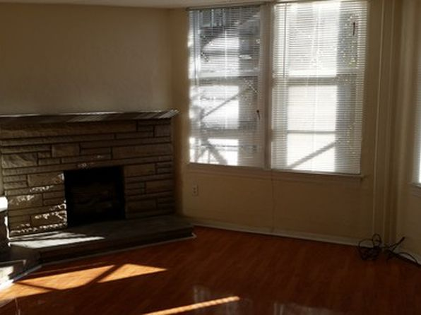](https://www.zillow.com/homedetails/3555-California-Ave-APT-101-Pittsburgh-PA-15212/2099987100_zpid/)](https://www.zillow.com/homedetails/3555-California-Ave-APT-101-Pittsburgh-PA-15212/2099987100_zpid/)

*[239 Edgewood Ave UNIT D04, Pittsburgh, PA 15218](https://www.zillow.com/homedetails/239-Edgewood-Ave-UNIT-D04-Pittsburgh-PA-15218/2068954531_zpid/)*

$925/mo

* **1** bd
* **1** ba
* **712** sqft

- Apartment for rent

9 days ago

[[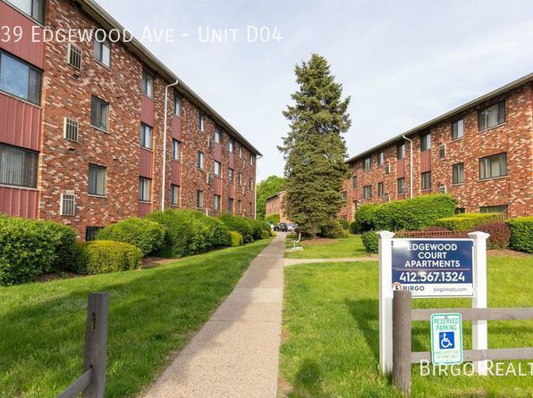](https://www.zillow.com/homedetails/239-Edgewood-Ave-UNIT-D04-Pittsburgh-PA-15218/2068954531_zpid/)](https://www.zillow.com/homedetails/239-Edgewood-Ave-UNIT-D04-Pittsburgh-PA-15218/2068954531_zpid/)

•

*[2013 Gregory St, Pittsburgh, PA 15203](https://www.zillow.com/homedetails/2013-Gregory-St-Pittsburgh-PA-15203/11291976_zpid/)*

$1,200/mo

* **2** bds
* **1** ba
* **--** sqft

- House for rent

10 days ago

[[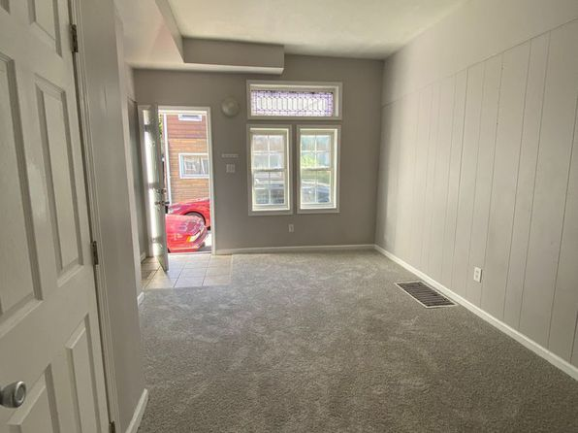](https://www.zillow.com/homedetails/2013-Gregory-St-Pittsburgh-PA-15203/11291976_zpid/)](https://www.zillow.com/homedetails/2013-Gregory-St-Pittsburgh-PA-15203/11291976_zpid/)

*[5721 Stanton Avenue | 5721 Stanton Ave, Pittsburgh, PA](https://www.zillow.com/b/5721-stanton-avenue-pittsburgh-pa-5YCGRn/)*

$1,195+ 2 bds

[[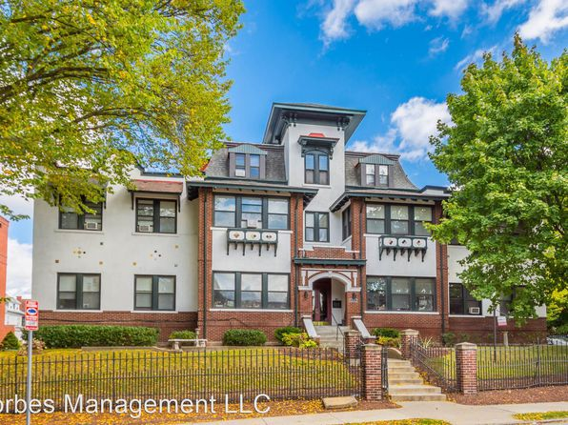](https://www.zillow.com/b/5721-stanton-avenue-pittsburgh-pa-5YCGRn/)](https://www.zillow.com/b/5721-stanton-avenue-pittsburgh-pa-5YCGRn/)

*[6927 McPherson Blvd, Pittsburgh, PA 15208](https://www.zillow.com/homedetails/6927-McPherson-Blvd-Pittsburgh-PA-15208/2059932519_zpid/)*

$1,900/mo

* **3** bds
* **2** ba
* **1,410** sqft

- House for rent

6 days ago

[[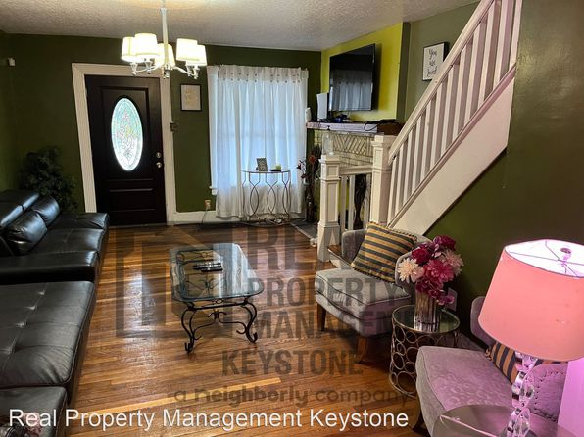](https://www.zillow.com/homedetails/6927-McPherson-Blvd-Pittsburgh-PA-15208/2059932519_zpid/)](https://www.zillow.com/homedetails/6927-McPherson-Blvd-Pittsburgh-PA-15208/2059932519_zpid/)

*[2306 Hill St, Pittsburgh, PA 15235](https://www.zillow.com/homedetails/2306-Hill-St-Pittsburgh-PA-15235/11569245_zpid/)*

$1,195/mo

* **3** bds
* **1.5** ba
* **1,848** sqft

- House for rent

10 days ago

[[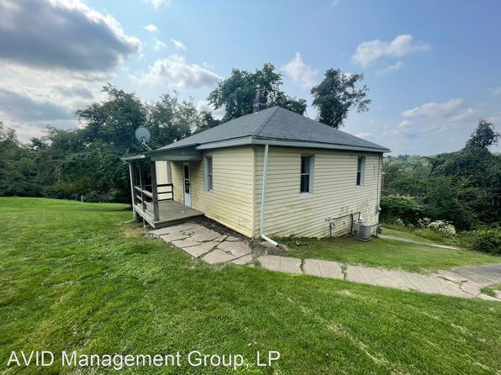](https://www.zillow.com/homedetails/2306-Hill-St-Pittsburgh-PA-15235/11569245_zpid/)](https://www.zillow.com/homedetails/2306-Hill-St-Pittsburgh-PA-15235/11569245_zpid/)

*[115 Banner Way, Pittsburgh, PA 15201](https://www.zillow.com/homedetails/115-Banner-Way-Pittsburgh-PA-15201/11512759_zpid/)*

$2,000/mo

* **2** bds
* **1** ba
* **1,200** sqft

- House for rent

4 days ago

[[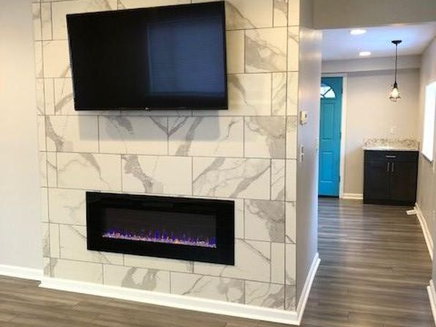](https://www.zillow.com/homedetails/115-Banner-Way-Pittsburgh-PA-15201/11512759_zpid/)](https://www.zillow.com/homedetails/115-Banner-Way-Pittsburgh-PA-15201/11512759_zpid/)

*[290 McMurray Rd, Pittsburgh, PA 15241](https://www.zillow.com/homedetails/290-McMurray-Rd-Pittsburgh-PA-15241/11549626_zpid/)*

$2,100/mo

* **4** bds
* **2** ba
* **1,296** sqft

- House for rent

10 days ago

[[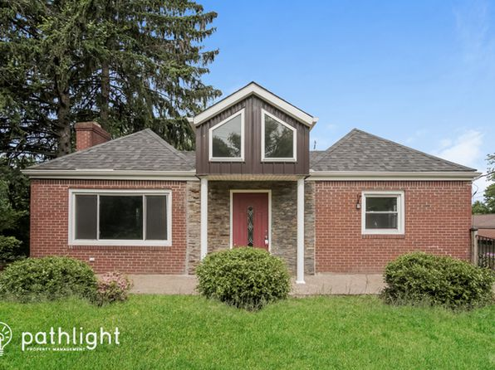](https://www.zillow.com/homedetails/290-McMurray-Rd-Pittsburgh-PA-15241/11549626_zpid/)](https://www.zillow.com/homedetails/290-McMurray-Rd-Pittsburgh-PA-15241/11549626_zpid/)

*[160 Lincoln Ave #4, Pittsburgh, PA 15202](https://www.zillow.com/homedetails/160-Lincoln-Ave-4-Pittsburgh-PA-15202/2080432192_zpid/)*

$795/mo

* **1** bd
* **1** ba
* **750** sqft

- Apartment for rent

9 days ago

[[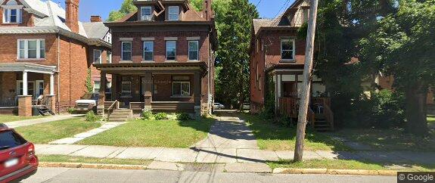](https://www.zillow.com/homedetails/160-Lincoln-Ave-4-Pittsburgh-PA-15202/2080432192_zpid/)](https://www.zillow.com/homedetails/160-Lincoln-Ave-4-Pittsburgh-PA-15202/2080432192_zpid/)

*[62 Lakewood Ave, Pittsburgh, PA 15229](https://www.zillow.com/homedetails/62-Lakewood-Ave-Pittsburgh-PA-15229/11406482_zpid/)*

$1,595/mo

* **2** bds
* **1** ba
* **1,061** sqft

- House for rent

25 days ago

[[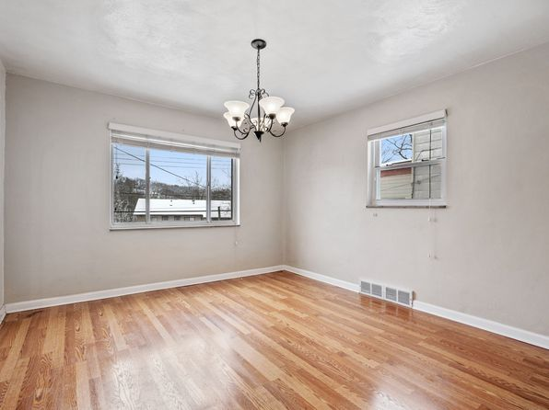](https://www.zillow.com/homedetails/62-Lakewood-Ave-Pittsburgh-PA-15229/11406482_zpid/)](https://www.zillow.com/homedetails/62-Lakewood-Ave-Pittsburgh-PA-15229/11406482_zpid/)

*[18 Holt St, Pittsburgh, PA 15203](https://www.zillow.com/homedetails/18-Holt-St-Pittsburgh-PA-15203/11307572_zpid/)*

$1,199/mo

* **2** bds
* **2** ba
* **910** sqft

- House for rent

20 days ago

[[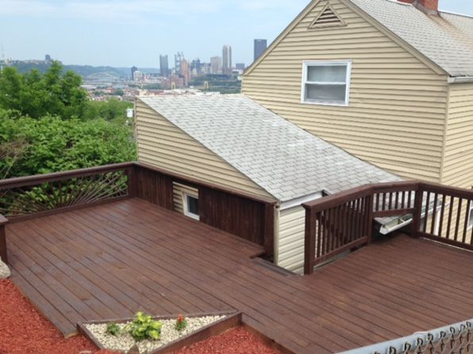](https://www.zillow.com/homedetails/18-Holt-St-Pittsburgh-PA-15203/11307572_zpid/)](https://www.zillow.com/homedetails/18-Holt-St-Pittsburgh-PA-15203/11307572_zpid/)

*[321 Seward St, Pittsburgh, PA 15211](https://www.zillow.com/homedetails/321-Seward-St-Pittsburgh-PA-15211/11585471_zpid/)*

$1,200/mo

* **2** bds
* **1** ba
* **--** sqft

- House for rent

24 days ago

[[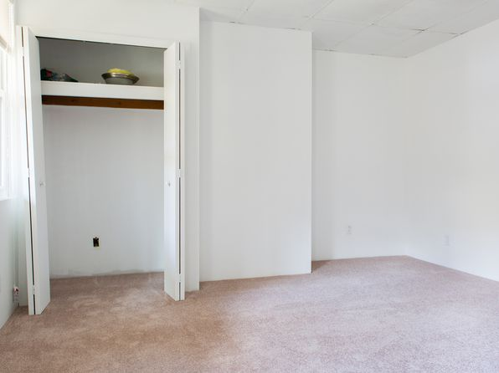](https://www.zillow.com/homedetails/321-Seward-St-Pittsburgh-PA-15211/11585471_zpid/)](https://www.zillow.com/homedetails/321-Seward-St-Pittsburgh-PA-15211/11585471_zpid/)

*[724 Ceres Way, Pittsburgh, PA 15210](https://www.zillow.com/homedetails/724-Ceres-Way-Pittsburgh-PA-15210/11315038_zpid/)*

$1,150/mo

* **2** bds
* **1** ba
* **--** sqft

- House for rent

17 days ago

[[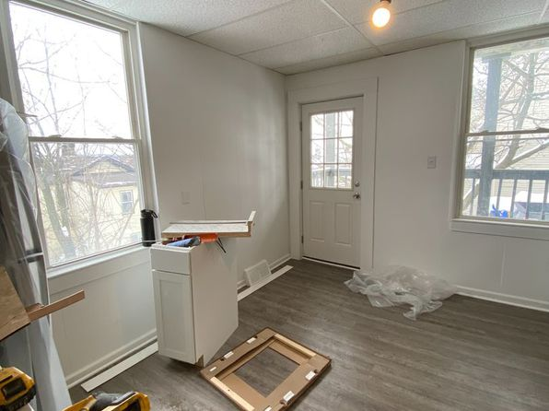](https://www.zillow.com/homedetails/724-Ceres-Way-Pittsburgh-PA-15210/11315038_zpid/)](https://www.zillow.com/homedetails/724-Ceres-Way-Pittsburgh-PA-15210/11315038_zpid/)

*[1018 E Warrington Ave S, Pittsburgh, PA 15210](https://www.zillow.com/homedetails/1018-E-Warrington-Ave-S-Pittsburgh-PA-15210/2065758997_zpid/)*

$1,750/mo

* **4** bds
* **1.5** ba
* **2,010** sqft

- House for rent

30 days ago

[[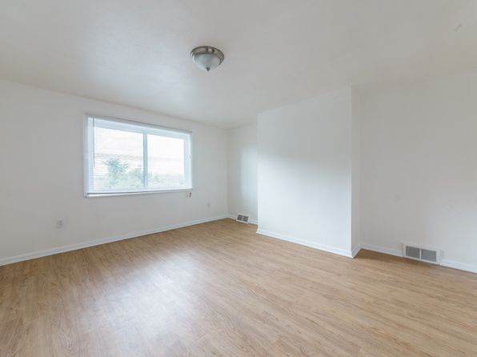](https://www.zillow.com/homedetails/1018-E-Warrington-Ave-S-Pittsburgh-PA-15210/2065758997_zpid/)](https://www.zillow.com/homedetails/1018-E-Warrington-Ave-S-Pittsburgh-PA-15210/2065758997_zpid/)

*[2 bed, $875, 313 W Burgess St #2, Pittsburgh, PA 15214](https://www.zillow.com/b/2-bed,-%24875-pittsburgh-pa-B7kkrp/)*

$875/mo

* **2** bds
* **1** ba
* **--** sqft

- Apartment for rent

21 days ago

[[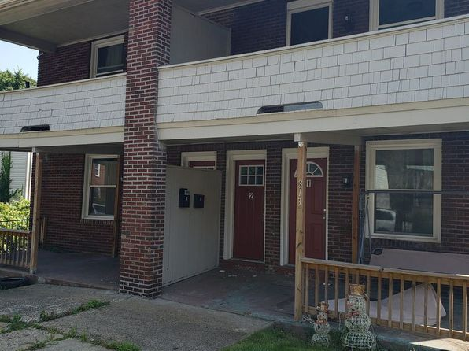](https://www.zillow.com/b/2-bed,-%24875-pittsburgh-pa-B7kkrp/)](https://www.zillow.com/b/2-bed,-%24875-pittsburgh-pa-B7kkrp/)

*[2916 Stromberg St, Pittsburgh, PA 15203](https://www.zillow.com/homedetails/2916-Stromberg-St-Pittsburgh-PA-15203/11308199_zpid/)*

$1,550/mo

* **3** bds
* **2** ba
* **1,188** sqft

- House for rent

3D Tour

[[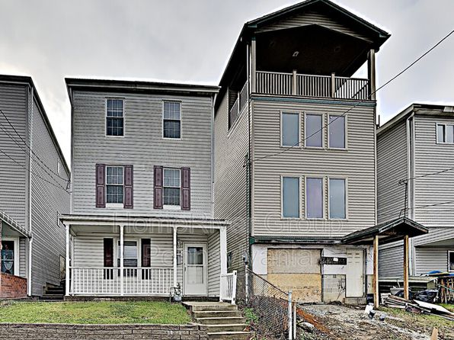](https://www.zillow.com/homedetails/2916-Stromberg-St-Pittsburgh-PA-15203/11308199_zpid/)](https://www.zillow.com/homedetails/2916-Stromberg-St-Pittsburgh-PA-15203/11308199_zpid/)

*[122 Maple Ter #2, Pittsburgh, PA 15211](https://www.zillow.com/homedetails/122-Maple-Ter-2-Pittsburgh-PA-15211/2089740383_zpid/)*

$1,395/mo

* **2** bds
* **1** ba
* **1,000** sqft

- Apartment for rent

40 days ago

[[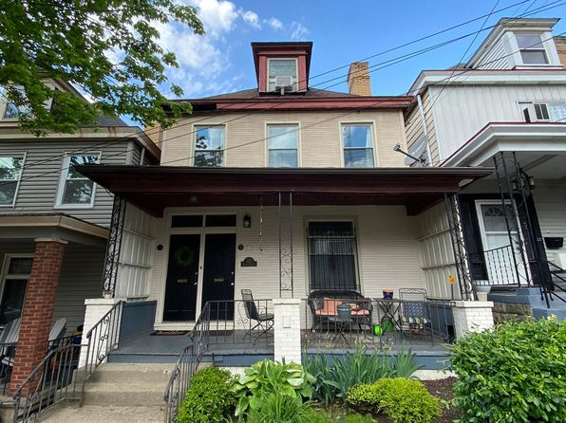](https://www.zillow.com/homedetails/122-Maple-Ter-2-Pittsburgh-PA-15211/2089740383_zpid/)](https://www.zillow.com/homedetails/122-Maple-Ter-2-Pittsburgh-PA-15211/2089740383_zpid/)

*[68 S 22nd St, Pittsburgh, PA 15203](https://www.zillow.com/homedetails/68-S-22nd-St-Pittsburgh-PA-15203/11290783_zpid/)*

$2,300/mo

* **5** bds
* **3** ba
* **1,950** sqft

- House for rent

19 days ago

[[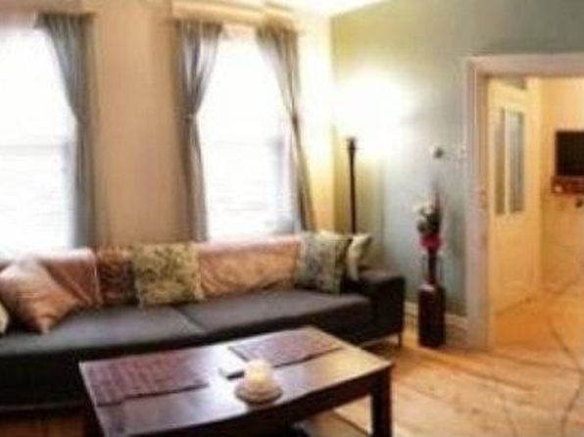](https://www.zillow.com/homedetails/68-S-22nd-St-Pittsburgh-PA-15203/11290783_zpid/)](https://www.zillow.com/homedetails/68-S-22nd-St-Pittsburgh-PA-15203/11290783_zpid/)

*[320 Fernhill Ave, Pittsburgh, PA 15226](https://www.zillow.com/homedetails/320-Fernhill-Ave-Pittsburgh-PA-15226/11565809_zpid/)*

$1,790/mo

* **3** bds
* **1.5** ba
* **1,384** sqft

- House for rent

7 days ago

[[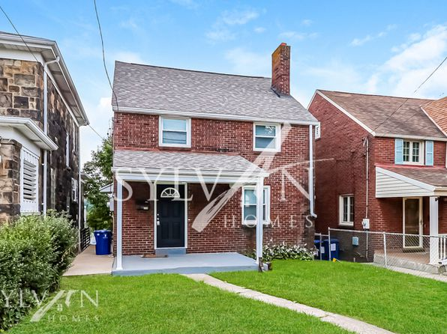](https://www.zillow.com/homedetails/320-Fernhill-Ave-Pittsburgh-PA-15226/11565809_zpid/)](https://www.zillow.com/homedetails/320-Fernhill-Ave-Pittsburgh-PA-15226/11565809_zpid/)

*[111 Clover St, Pittsburgh, PA 15210](https://www.zillow.com/homedetails/111-Clover-St-Pittsburgh-PA-15210/11308540_zpid/)*

$1,475/mo

* **4** bds
* **1.5** ba
* **--** sqft

- House for rent

30 days ago

[[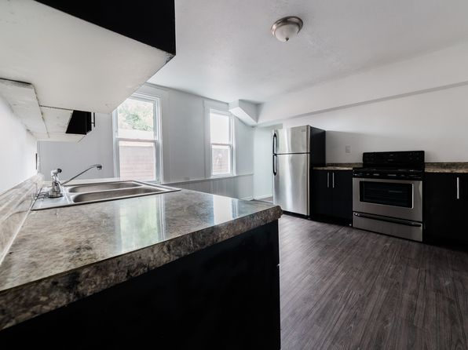](https://www.zillow.com/homedetails/111-Clover-St-Pittsburgh-PA-15210/11308540_zpid/)](https://www.zillow.com/homedetails/111-Clover-St-Pittsburgh-PA-15210/11308540_zpid/)

*[419 Parklow St, Pittsburgh, PA 15210](https://www.zillow.com/homedetails/419-Parklow-St-Pittsburgh-PA-15210/11435520_zpid/)*

$1,350/mo

* **3** bds
* **1** ba
* **1,500** sqft

- House for rent

39 days ago

[[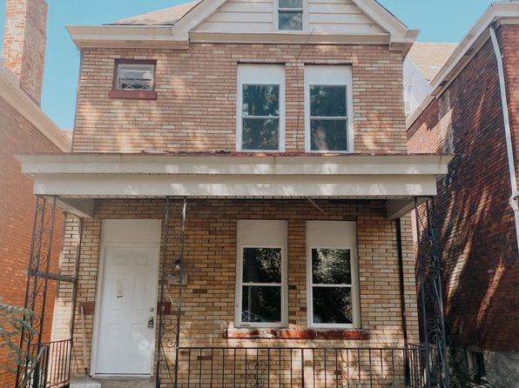](https://www.zillow.com/homedetails/419-Parklow-St-Pittsburgh-PA-15210/11435520_zpid/)](https://www.zillow.com/homedetails/419-Parklow-St-Pittsburgh-PA-15210/11435520_zpid/)

*[4703 Maripoe St, Pittsburgh, PA 15213](https://www.zillow.com/homedetails/4703-Maripoe-St-Pittsburgh-PA-15213/11403273_zpid/)*

$1,430/mo

* **2** bds
* **1** ba
* **925** sqft

- House for rent

10 days ago

[[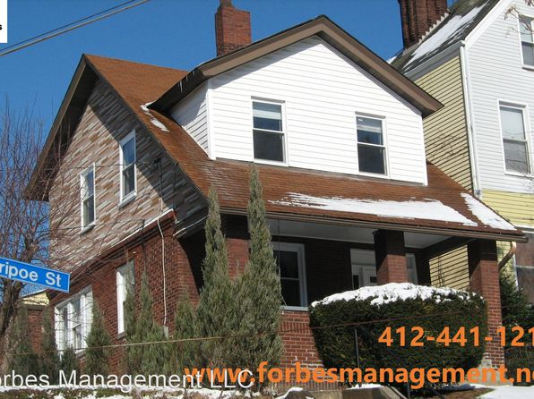](https://www.zillow.com/homedetails/4703-Maripoe-St-Pittsburgh-PA-15213/11403273_zpid/)](https://www.zillow.com/homedetails/4703-Maripoe-St-Pittsburgh-PA-15213/11403273_zpid/)

*[510 Kathleen St, Pittsburgh, PA 15211](https://www.zillow.com/homedetails/510-Kathleen-St-Pittsburgh-PA-15211/11474827_zpid/)*

$1,595/mo

* **2** bds
* **1.5** ba
* **1,188** sqft

- House for rent

15 days ago

[[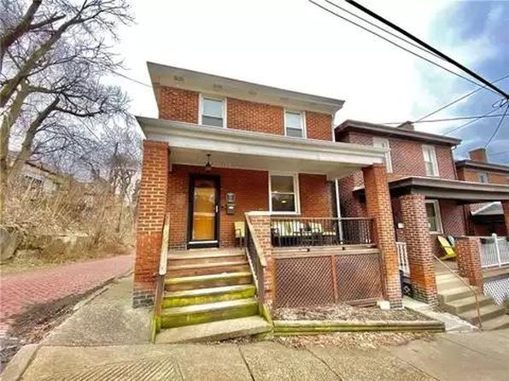](https://www.zillow.com/homedetails/510-Kathleen-St-Pittsburgh-PA-15211/11474827_zpid/)](https://www.zillow.com/homedetails/510-Kathleen-St-Pittsburgh-PA-15211/11474827_zpid/)

*[5900 Hobart St, Pittsburgh, PA 15217](https://www.zillow.com/homedetails/5900-Hobart-St-Pittsburgh-PA-15217/2089530755_zpid/)*

$1,495/mo

* **2** bds
* **1** ba
* **--** sqft

- Apartment for rent

24 days ago

[[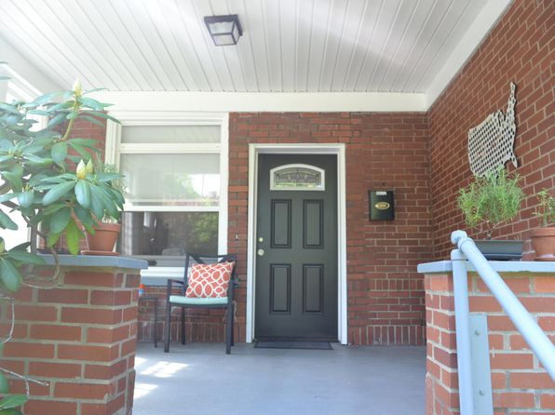](https://www.zillow.com/homedetails/5900-Hobart-St-Pittsburgh-PA-15217/2089530755_zpid/)](https://www.zillow.com/homedetails/5900-Hobart-St-Pittsburgh-PA-15217/2089530755_zpid/)

*[147 S Negley Ave APT 1, Pittsburgh, PA 15206](https://www.zillow.com/homedetails/147-S-Negley-Ave-APT-1-Pittsburgh-PA-15206/2121821675_zpid/)*

$1,099/mo

* **1** bd
* **1** ba
* **525** sqft

- Apartment for rent

7 days ago

[[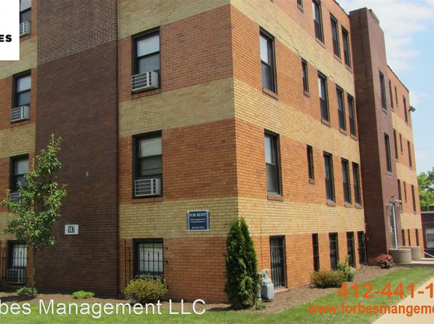](https://www.zillow.com/homedetails/147-S-Negley-Ave-APT-1-Pittsburgh-PA-15206/2121821675_zpid/)](https://www.zillow.com/homedetails/147-S-Negley-Ave-APT-1-Pittsburgh-PA-15206/2121821675_zpid/)

*[1432 McFarland Rd, Pittsburgh, PA 15216](https://www.zillow.com/homedetails/1432-McFarland-Rd-Pittsburgh-PA-15216/11655649_zpid/)*

$2,100/mo

* **4** bds
* **2** ba
* **2,160** sqft

- House for rent

16 days ago

[[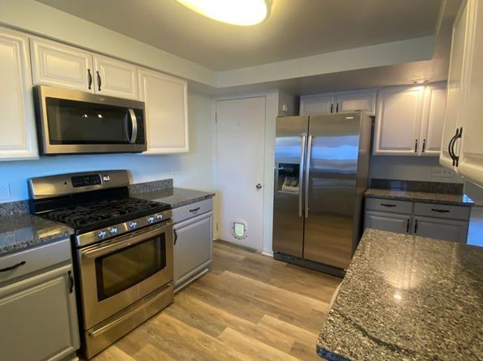](https://www.zillow.com/homedetails/1432-McFarland-Rd-Pittsburgh-PA-15216/11655649_zpid/)](https://www.zillow.com/homedetails/1432-McFarland-Rd-Pittsburgh-PA-15216/11655649_zpid/)

*[608 Edgemont St, Pittsburgh, PA 15210](https://www.zillow.com/homedetails/608-Edgemont-St-Pittsburgh-PA-15210/11314759_zpid/)*

$1,500/mo

* **2** bds
* **1.5** ba
* **--** sqft

- House for rent

30 days ago

[[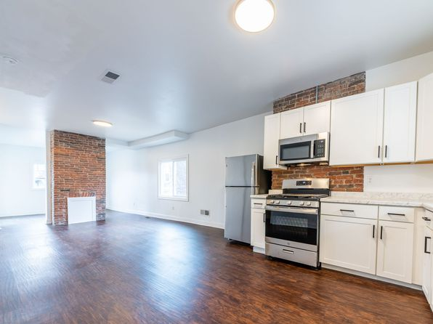](https://www.zillow.com/homedetails/608-Edgemont-St-Pittsburgh-PA-15210/11314759_zpid/)](https://www.zillow.com/homedetails/608-Edgemont-St-Pittsburgh-PA-15210/11314759_zpid/)

to get email alerts when listings hit the market.

*[1504 Fernleaf St, Pittsburgh, PA 15210](https://www.zillow.com/homedetails/1504-Fernleaf-St-Pittsburgh-PA-15210/2110864931_zpid/)*

$1,200/mo

* + **2** bds
  + **1** ba
  + **1,400** sqft

- House for rent

25 days ago

[[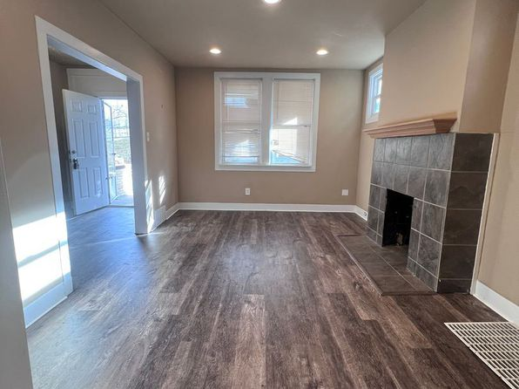](https://www.zillow.com/homedetails/1504-Fernleaf-St-Pittsburgh-PA-15210/2110864931_zpid/)](https://www.zillow.com/homedetails/1504-Fernleaf-St-Pittsburgh-PA-15210/2110864931_zpid/)

*[936 Industry St FLOOR 2, Pittsburgh, PA 15210](https://www.zillow.com/homedetails/936-Industry-St-FLOOR-2-Pittsburgh-PA-15210/2060167881_zpid/)*

$1,149/mo

* **3** bds
* **1** ba
* **1,200** sqft

- Apartment for rent

19 days ago

[[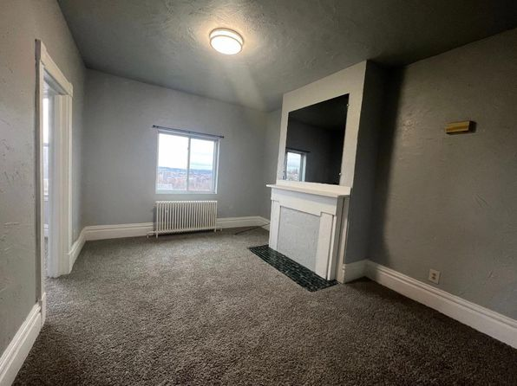](https://www.zillow.com/homedetails/936-Industry-St-FLOOR-2-Pittsburgh-PA-15210/2060167881_zpid/)](https://www.zillow.com/homedetails/936-Industry-St-FLOOR-2-Pittsburgh-PA-15210/2060167881_zpid/)

•

*[836 Industry St, Pittsburgh, PA 15210](https://www.zillow.com/homedetails/836-Industry-St-Pittsburgh-PA-15210/11315551_zpid/)*

$1,650/mo

* **4** bds
* **2** ba
* **--** sqft

- House for rent

30 days ago

[[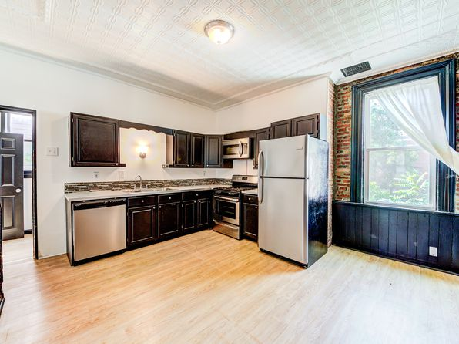](https://www.zillow.com/homedetails/836-Industry-St-Pittsburgh-PA-15210/11315551_zpid/)](https://www.zillow.com/homedetails/836-Industry-St-Pittsburgh-PA-15210/11315551_zpid/)

*[1 bed, 480 sqft, $850, 54 Hawley Ave APT 9, Pittsburgh, PA 15202](https://www.zillow.com/b/52-54-hawley-avenue-hw-9-bellevue-pa-98N5b9/)*

$850/mo

* **1** bd
* **1** ba
* **480** sqft

- Apartment for rent

16 days ago

[[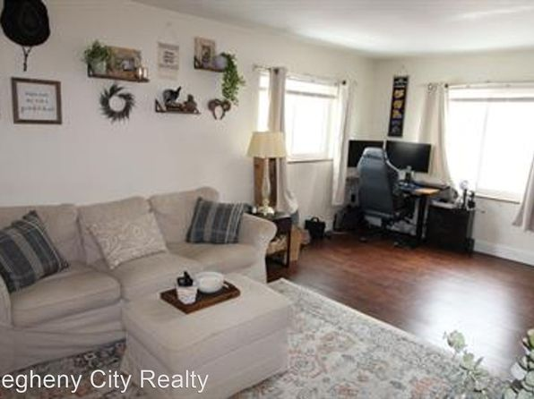](https://www.zillow.com/b/52-54-hawley-avenue-hw-9-bellevue-pa-98N5b9/)](https://www.zillow.com/b/52-54-hawley-avenue-hw-9-bellevue-pa-98N5b9/)

*[5106 Baum Blvd #1, Pittsburgh, PA 15224](https://www.zillow.com/homedetails/5106-Baum-Blvd-1-Pittsburgh-PA-15224/2098558771_zpid/)*

$929/mo

* **1** bd
* **1** ba
* **550** sqft

- Apartment for rent

10 days ago

[[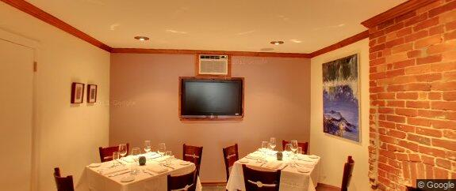](https://www.zillow.com/homedetails/5106-Baum-Blvd-1-Pittsburgh-PA-15224/2098558771_zpid/)](https://www.zillow.com/homedetails/5106-Baum-Blvd-1-Pittsburgh-PA-15224/2098558771_zpid/)

*[91 Westwood St, Pittsburgh, PA 15211](https://www.zillow.com/homedetails/91-Westwood-St-Pittsburgh-PA-15211/11323455_zpid/)*

$2,000/mo

* **4** bds
* **1.5** ba
* **1,354** sqft

- House for rent

3 days ago

[[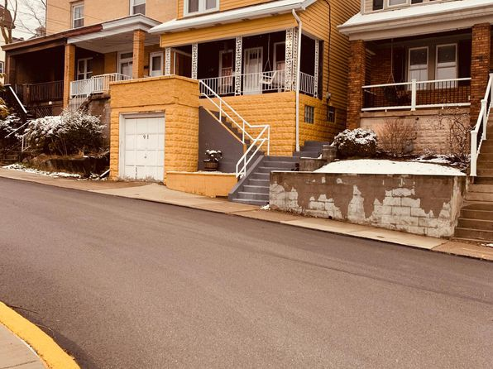](https://www.zillow.com/homedetails/91-Westwood-St-Pittsburgh-PA-15211/11323455_zpid/)](https://www.zillow.com/homedetails/91-Westwood-St-Pittsburgh-PA-15211/11323455_zpid/)

*[17 Caesar Way, Pittsburgh, PA 15203](https://www.zillow.com/homedetails/17-Caesar-Way-Pittsburgh-PA-15203/11307584_zpid/)*

$975/mo

* **2** bds
* **1** ba
* **--** sqft

- House for rent

30 days ago

[[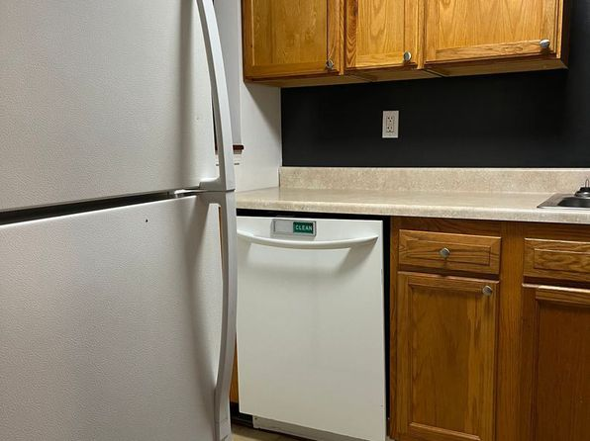](https://www.zillow.com/homedetails/17-Caesar-Way-Pittsburgh-PA-15203/11307584_zpid/)](https://www.zillow.com/homedetails/17-Caesar-Way-Pittsburgh-PA-15203/11307584_zpid/)

*[116 Lansing Ave, Pittsburgh, PA 15229](https://www.zillow.com/homedetails/116-Lansing-Ave-Pittsburgh-PA-15229/11408523_zpid/)*

$1,695/mo

* **3** bds
* **2** ba
* **--** sqft

- House for rent

23 days ago

[[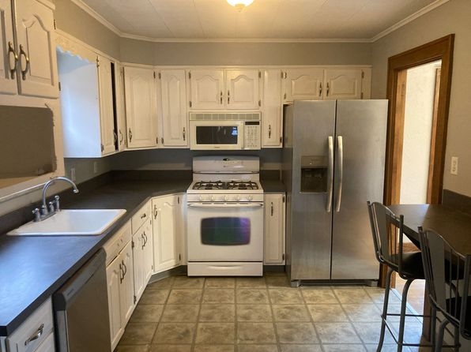](https://www.zillow.com/homedetails/116-Lansing-Ave-Pittsburgh-PA-15229/11408523_zpid/)](https://www.zillow.com/homedetails/116-Lansing-Ave-Pittsburgh-PA-15229/11408523_zpid/)

*[1190 Brook View Ct, Pittsburgh, PA 15237](https://www.zillow.com/homedetails/1190-Brook-View-Ct-Pittsburgh-PA-15237/2059972127_zpid/)*

$4,999/mo

* **4** bds
* **2.5** ba
* **3,668** sqft

- House for rent

9 days ago

[[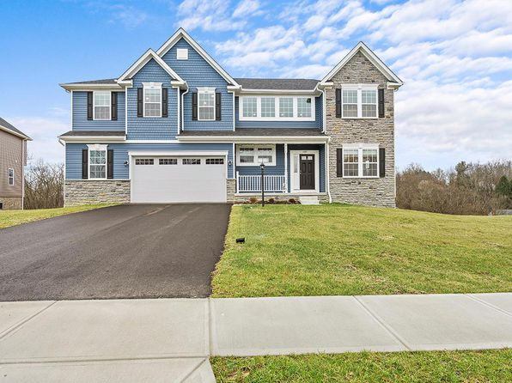](https://www.zillow.com/homedetails/1190-Brook-View-Ct-Pittsburgh-PA-15237/2059972127_zpid/)](https://www.zillow.com/homedetails/1190-Brook-View-Ct-Pittsburgh-PA-15237/2059972127_zpid/)

*[512 Edmond St #2, Pittsburgh, PA 15224](https://www.zillow.com/homedetails/512-Edmond-St-2-Pittsburgh-PA-15224/2121349529_zpid/)*

$1,359/mo

* **2** bds
* **1** ba
* **929** sqft

- Apartment for rent

12 days ago

[[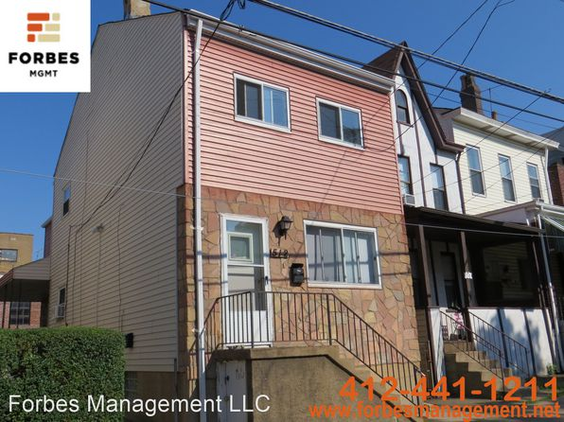](https://www.zillow.com/homedetails/512-Edmond-St-2-Pittsburgh-PA-15224/2121349529_zpid/)](https://www.zillow.com/homedetails/512-Edmond-St-2-Pittsburgh-PA-15224/2121349529_zpid/)

*[2128 E. Carson Street, 2128 E Carson St, Pittsburgh, PA 15203](https://www.zillow.com/homedetails/2128-E-Carson-St-Pittsburgh-PA-15203/304678538_zpid/)*

$2,500/mo

* **4** bds
* **2** ba
* **2,000** sqft

- Apartment for rent

12 days ago

[[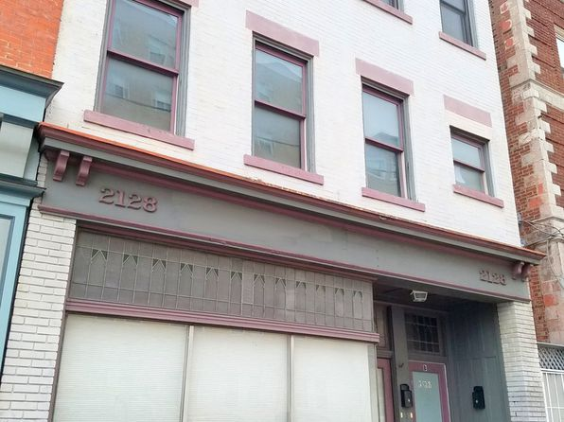](https://www.zillow.com/homedetails/2128-E-Carson-St-Pittsburgh-PA-15203/304678538_zpid/)](https://www.zillow.com/homedetails/2128-E-Carson-St-Pittsburgh-PA-15203/304678538_zpid/)

*[835 Dounton Way, Pittsburgh, PA 15233](https://www.zillow.com/homedetails/835-Dounton-Way-Pittsburgh-PA-15233/11640265_zpid/)*

$2,200/mo

* **2** bds
* **1** ba
* **1,044** sqft

- House for rent

93 days ago

[[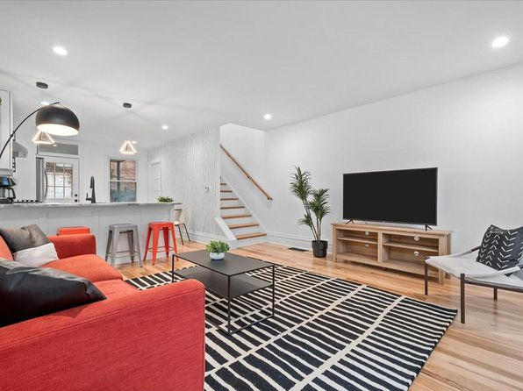](https://www.zillow.com/homedetails/835-Dounton-Way-Pittsburgh-PA-15233/11640265_zpid/)](https://www.zillow.com/homedetails/835-Dounton-Way-Pittsburgh-PA-15233/11640265_zpid/)

•

*[120 North Ave, Pittsburgh, PA](https://www.zillow.com/b/120-north-ave-pittsburgh-pa-98N4CV/)*

$850+ 1 bd

* **$1,100+** 2 bds

52 days ago

[[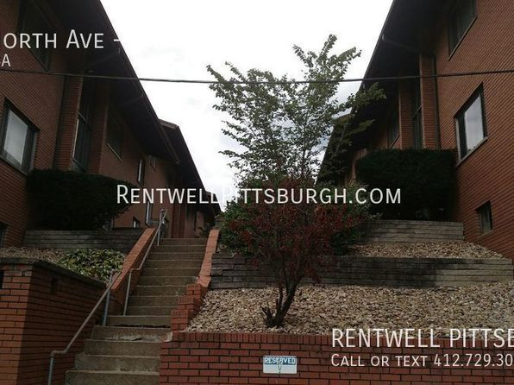](https://www.zillow.com/b/120-north-ave-pittsburgh-pa-98N4CV/)](https://www.zillow.com/b/120-north-ave-pittsburgh-pa-98N4CV/)

•

*[9 Marie Ave #2, Avalon, PA 15202](https://www.zillow.com/homedetails/9-Marie-Ave-2-Avalon-PA-15202/2094014742_zpid/)*

$1,025/mo

* **2** bds
* **1** ba
* **900** sqft

- Apartment for rent

24 days ago

[[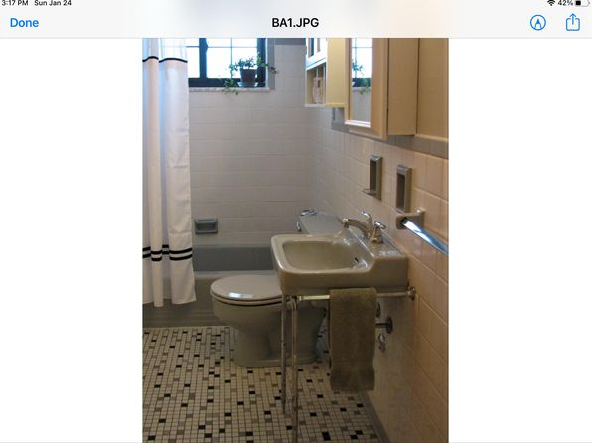](https://www.zillow.com/homedetails/9-Marie-Ave-2-Avalon-PA-15202/2094014742_zpid/)](https://www.zillow.com/homedetails/9-Marie-Ave-2-Avalon-PA-15202/2094014742_zpid/)

*[226 E End Ave, Pittsburgh, PA 15221](https://www.zillow.com/homedetails/226-E-End-Ave-Pittsburgh-PA-15221/2091446345_zpid/)*

$999/mo

* **2** bds
* **1** ba
* **1,494** sqft

- House for rent

17 days ago

[[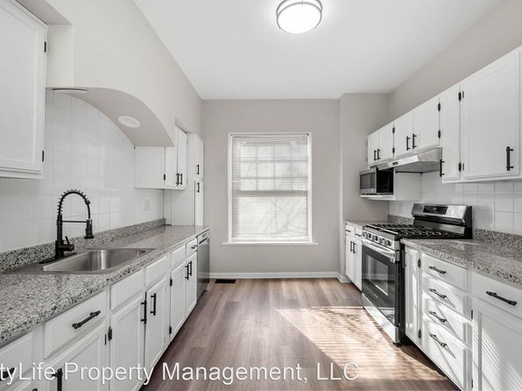](https://www.zillow.com/homedetails/226-E-End-Ave-Pittsburgh-PA-15221/2091446345_zpid/)](https://www.zillow.com/homedetails/226-E-End-Ave-Pittsburgh-PA-15221/2091446345_zpid/)

•

*[923 Manton Way, Pittsburgh, PA 15210](https://www.zillow.com/homedetails/923-Manton-Way-Pittsburgh-PA-15210/11315118_zpid/)*

$1,350/mo

* **3** bds
* **1** ba
* **--** sqft

- House for rent

24 days ago

[[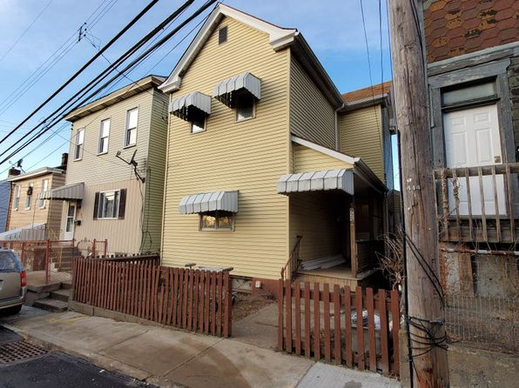](https://www.zillow.com/homedetails/923-Manton-Way-Pittsburgh-PA-15210/11315118_zpid/)](https://www.zillow.com/homedetails/923-Manton-Way-Pittsburgh-PA-15210/11315118_zpid/)

*[89 Westwood St, Pittsburgh, PA 15211](https://www.zillow.com/homedetails/89-Westwood-St-Pittsburgh-PA-15211/11323454_zpid/)*

$1,075/mo

* **2** bds
* **1** ba
* **--** sqft

- House for rent

17 days ago

[[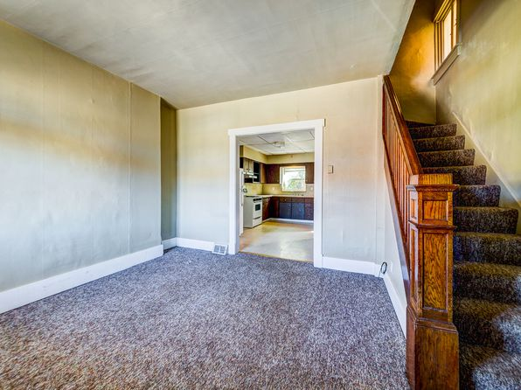](https://www.zillow.com/homedetails/89-Westwood-St-Pittsburgh-PA-15211/11323454_zpid/)](https://www.zillow.com/homedetails/89-Westwood-St-Pittsburgh-PA-15211/11323454_zpid/)

*[260 Berringer Pl, Pittsburgh, PA 15202](https://www.zillow.com/homedetails/260-Berringer-Pl-Pittsburgh-PA-15202/11368316_zpid/)*

$1,445/mo

* **3** bds
* **1** ba
* **1,400** sqft

- House for rent

25 days ago

[[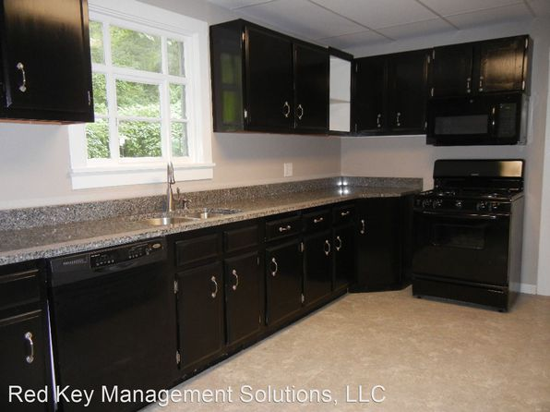](https://www.zillow.com/homedetails/260-Berringer-Pl-Pittsburgh-PA-15202/11368316_zpid/)](https://www.zillow.com/homedetails/260-Berringer-Pl-Pittsburgh-PA-15202/11368316_zpid/)

*[5014 Friendship Ave FLOOR 1, Pittsburgh, PA 15224](https://www.zillow.com/homedetails/5014-Friendship-Ave-FLOOR-1-Pittsburgh-PA-15224/2060126375_zpid/)*

$1,500/mo

* **1** bd
* **1.5** ba
* **1,300** sqft

- Apartment for rent

15 days ago

[[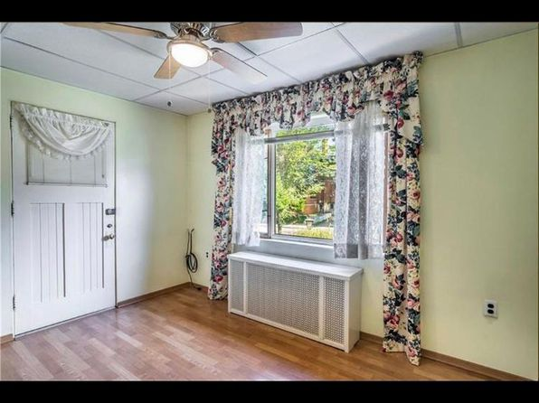](https://www.zillow.com/homedetails/5014-Friendship-Ave-FLOOR-1-Pittsburgh-PA-15224/2060126375_zpid/)](https://www.zillow.com/homedetails/5014-Friendship-Ave-FLOOR-1-Pittsburgh-PA-15224/2060126375_zpid/)

*[6370 Forward Ave, Pittsburgh, PA 15217](https://www.zillow.com/homedetails/6370-Forward-Ave-Pittsburgh-PA-15217/2101422775_zpid/)*

$1,125/mo

* **2** bds
* **1** ba
* **--** sqft

- Apartment for rent

2 days ago

[[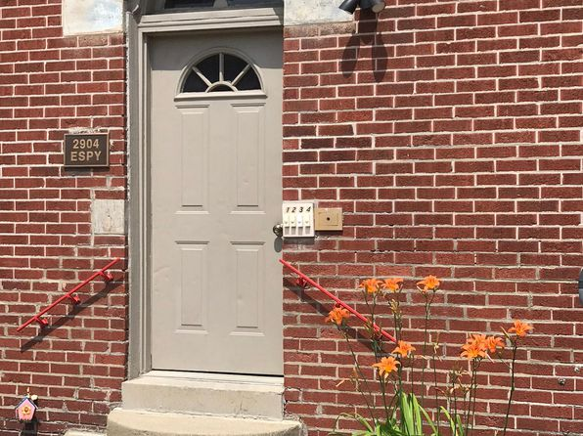](https://www.zillow.com/homedetails/6370-Forward-Ave-Pittsburgh-PA-15217/2101422775_zpid/)](https://www.zillow.com/homedetails/6370-Forward-Ave-Pittsburgh-PA-15217/2101422775_zpid/)

*[31 - 601 E Warrington, 601 E Warrington Ave APT 2, Pittsburgh, PA 15210](https://www.zillow.com/b/31-601-e-warrington-pittsburgh-pa-5jBsMx/)*

$1,050/mo

* **1** bd
* **1** ba
* **--** sqft

- Apartment for rent

25 days ago

[[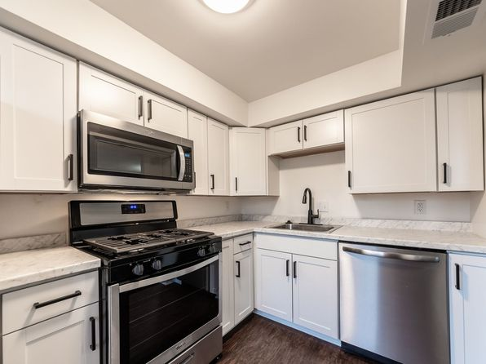](https://www.zillow.com/b/31-601-e-warrington-pittsburgh-pa-5jBsMx/)](https://www.zillow.com/b/31-601-e-warrington-pittsburgh-pa-5jBsMx/)

*[1837 Greenleaf St, Pittsburgh, PA 15211](https://www.zillow.com/homedetails/1837-Greenleaf-St-Pittsburgh-PA-15211/11585200_zpid/)*

$1,895/mo

* **3** bds
* **1.5** ba
* **1,250** sqft

- House for rent

15 days ago

[[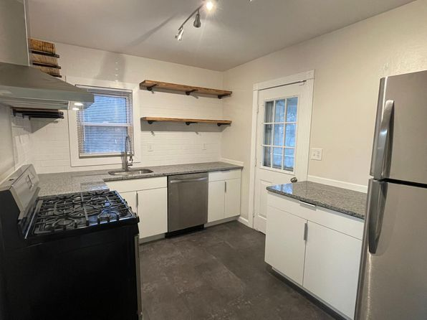](https://www.zillow.com/homedetails/1837-Greenleaf-St-Pittsburgh-PA-15211/11585200_zpid/)](https://www.zillow.com/homedetails/1837-Greenleaf-St-Pittsburgh-PA-15211/11585200_zpid/)

*[5708 Phillips Ave, Pittsburgh, PA 15217](https://www.zillow.com/homedetails/5708-Phillips-Ave-Pittsburgh-PA-15217/11634998_zpid/)*

$2,800/mo

* **3** bds
* **2** ba
* **1,500** sqft

- House for rent

18 days ago

[[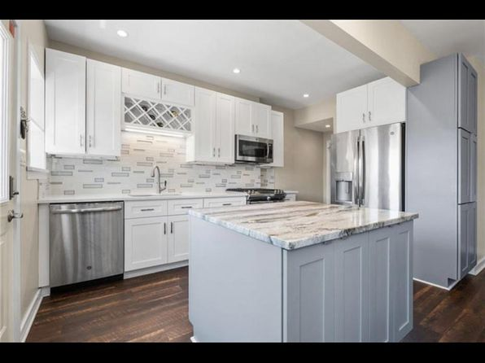](https://www.zillow.com/homedetails/5708-Phillips-Ave-Pittsburgh-PA-15217/11634998_zpid/)](https://www.zillow.com/homedetails/5708-Phillips-Ave-Pittsburgh-PA-15217/11634998_zpid/)

*[131 Ulysses St, Pittsburgh, PA 15211](https://www.zillow.com/homedetails/131-Ulysses-St-Pittsburgh-PA-15211/11363514_zpid/)*

$1,598/mo

* **3** bds
* **1** ba
* **1,000** sqft

- Townhouse for rent

31 days ago

[[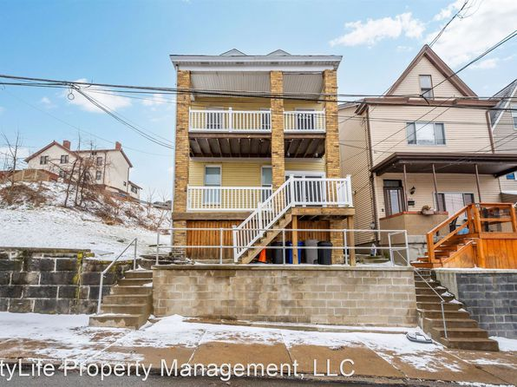](https://www.zillow.com/homedetails/131-Ulysses-St-Pittsburgh-PA-15211/11363514_zpid/)](https://www.zillow.com/homedetails/131-Ulysses-St-Pittsburgh-PA-15211/11363514_zpid/)

*[336 Perry Highway | 336 Perry Hwy, Pittsburgh, PA](https://www.zillow.com/b/336-perry-highway-pittsburgh-pa-9nyH7x/)*

$845+ 1 bd

[[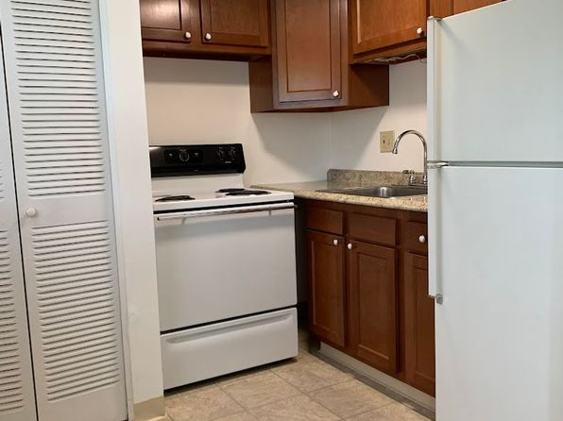](https://www.zillow.com/b/336-perry-highway-pittsburgh-pa-9nyH7x/)](https://www.zillow.com/b/336-perry-highway-pittsburgh-pa-9nyH7x/)

*[4708 Hatfield Street, 4708 Hatfield St, Pittsburgh, PA 15201](https://www.zillow.com/homedetails/4708-Hatfield-St-Pittsburgh-PA-15201/11613097_zpid/)*

$1,395/mo

* **3** bds
* **1.5** ba
* **--** sqft

- Apartment for rent

18 days ago

[[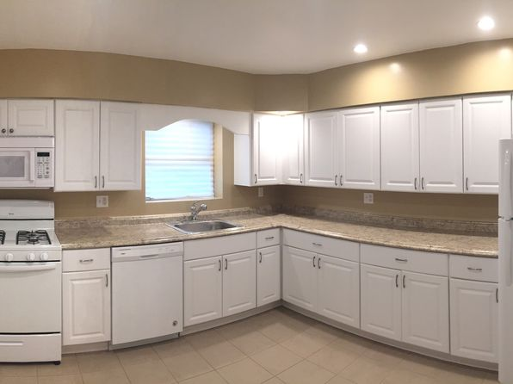](https://www.zillow.com/homedetails/4708-Hatfield-St-Pittsburgh-PA-15201/11613097_zpid/)](https://www.zillow.com/homedetails/4708-Hatfield-St-Pittsburgh-PA-15201/11613097_zpid/)

*[425 Edgemont St, Mt Washington, PA 15211](https://www.zillow.com/homedetails/425-Edgemont-St-Mt-Washington-PA-15211/11323641_zpid/)*

$1,600/mo

* **5** bds
* **1.5** ba
* **--** sqft

- House for rent

30 days ago

[[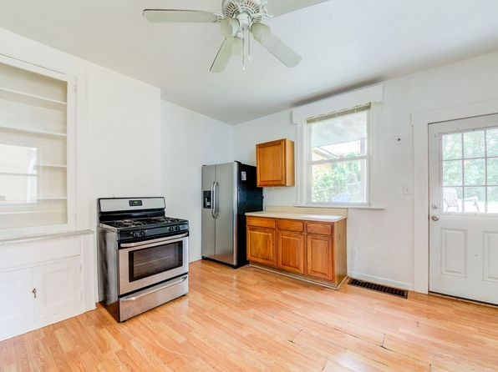](https://www.zillow.com/homedetails/425-Edgemont-St-Mt-Washington-PA-15211/11323641_zpid/)](https://www.zillow.com/homedetails/425-Edgemont-St-Mt-Washington-PA-15211/11323641_zpid/)

*[301 Rochelle Street | 301 Rochelle St, Pittsburgh, PA](https://www.zillow.com/b/301-rochelle-street-pittsburgh-pa-98NXDw/)*

$1,200+ 2 bds

[[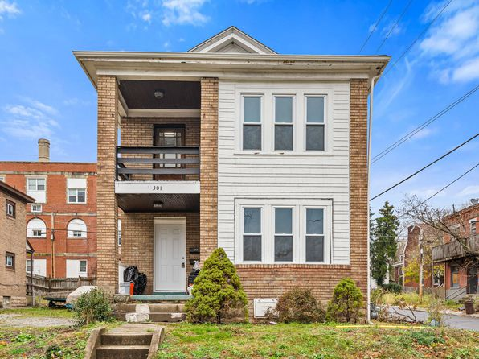](https://www.zillow.com/b/301-rochelle-street-pittsburgh-pa-98NXDw/)](https://www.zillow.com/b/301-rochelle-street-pittsburgh-pa-98NXDw/)

*[5407 Halchess St, Pittsburgh, PA 15207](https://www.zillow.com/homedetails/5407-Halchess-St-Pittsburgh-PA-15207/11352008_zpid/)*

$1,200/mo

* **3** bds
* **1** ba
* **1,242** sqft

- House for rent

16 days ago

[[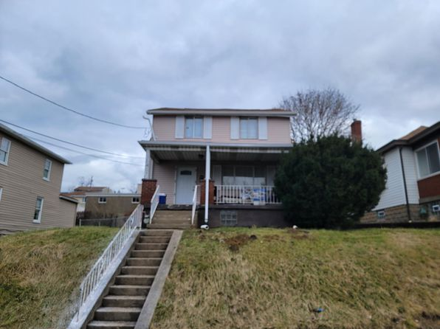](https://www.zillow.com/homedetails/5407-Halchess-St-Pittsburgh-PA-15207/11352008_zpid/)](https://www.zillow.com/homedetails/5407-Halchess-St-Pittsburgh-PA-15207/11352008_zpid/)

*[12 - 2642 Quarry, 2642 Quarry St APT 2, Pittsburgh, PA 15210](https://www.zillow.com/b/12-2642-quarry-pittsburgh-pa-98NX6R/)*

$1,300/mo

* **3** bds
* **1** ba
* **--** sqft

- Apartment for rent

24 days ago

[[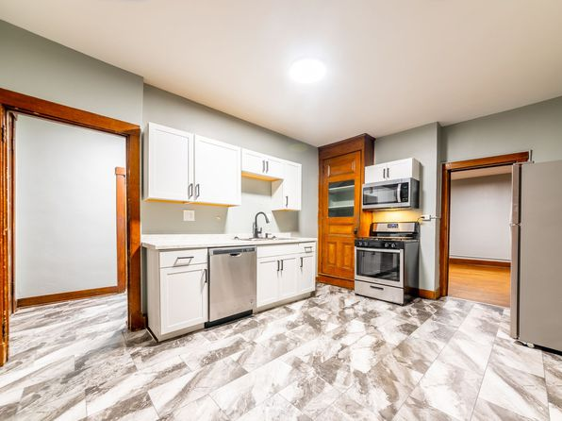](https://www.zillow.com/b/12-2642-quarry-pittsburgh-pa-98NX6R/)](https://www.zillow.com/b/12-2642-quarry-pittsburgh-pa-98NX6R/)

*[2217 Vodeli St, Pittsburgh, PA 15216](https://www.zillow.com/homedetails/2217-Vodeli-St-Pittsburgh-PA-15216/11565209_zpid/)*

$1,450/mo

* **3** bds
* **1.5** ba
* **1,326** sqft

- House for rent

9 days ago

[[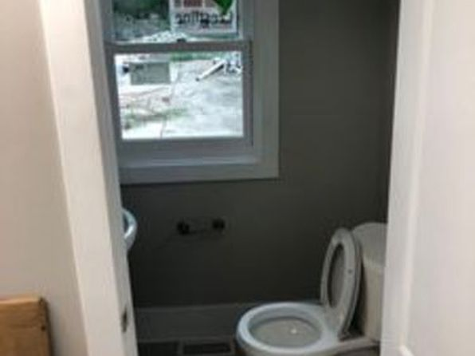](https://www.zillow.com/homedetails/2217-Vodeli-St-Pittsburgh-PA-15216/11565209_zpid/)](https://www.zillow.com/homedetails/2217-Vodeli-St-Pittsburgh-PA-15216/11565209_zpid/)

*[205 Maple Ter #A, Pittsburgh, PA 15211](https://www.zillow.com/homedetails/205-Maple-Ter-A-Pittsburgh-PA-15211/2107175889_zpid/)*

$1,460/mo

* **2** bds
* **1** ba
* **1,100** sqft

- Apartment for rent

13 days ago

[[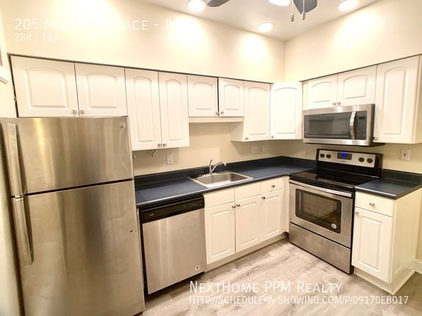](https://www.zillow.com/homedetails/205-Maple-Ter-A-Pittsburgh-PA-15211/2107175889_zpid/)](https://www.zillow.com/homedetails/205-Maple-Ter-A-Pittsburgh-PA-15211/2107175889_zpid/)

*[434 42nd St, Pittsburgh, PA 15201](https://www.zillow.com/homedetails/434-42nd-St-Pittsburgh-PA-15201/11513966_zpid/)*

$2,400/mo

* **2** bds
* **1.5** ba
* **--** sqft

- House for rent

8 days ago

[[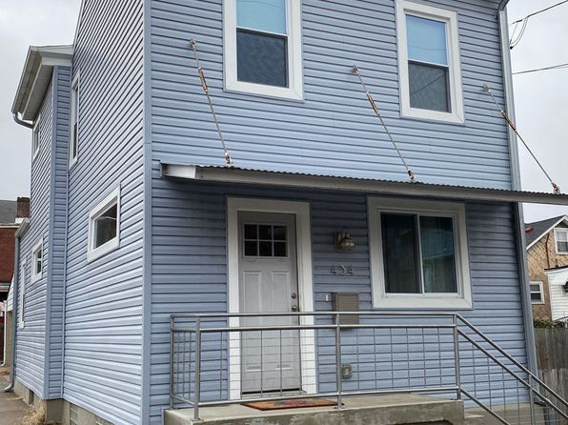](https://www.zillow.com/homedetails/434-42nd-St-Pittsburgh-PA-15201/11513966_zpid/)](https://www.zillow.com/homedetails/434-42nd-St-Pittsburgh-PA-15201/11513966_zpid/)

*[02 - 184 Pius St, 184 Pius St, Pittsburgh, PA 15203](https://www.zillow.com/homedetails/184-Pius-St-Pittsburgh-PA-15203/11291983_zpid/)*

$1,500/mo

* **2** bds
* **1** ba
* **--** sqft

- Apartment for rent

24 days ago

[[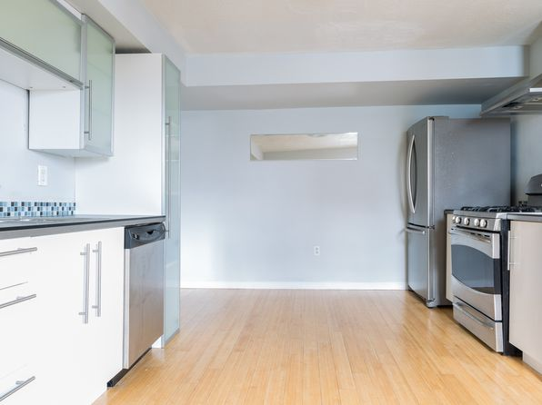](https://www.zillow.com/homedetails/184-Pius-St-Pittsburgh-PA-15203/11291983_zpid/)](https://www.zillow.com/homedetails/184-Pius-St-Pittsburgh-PA-15203/11291983_zpid/)

*[227 Maytide St #2, Pittsburgh, PA 15227](https://www.zillow.com/homedetails/227-Maytide-St-2-Pittsburgh-PA-15227/2083212538_zpid/)*

$950/mo

* **1** bd
* **1** ba
* **1,032** sqft

- Apartment for rent

26 days ago

[[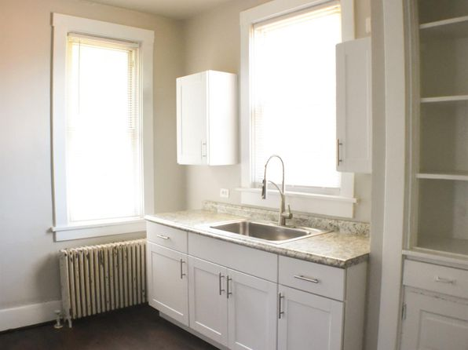](https://www.zillow.com/homedetails/227-Maytide-St-2-Pittsburgh-PA-15227/2083212538_zpid/)](https://www.zillow.com/homedetails/227-Maytide-St-2-Pittsburgh-PA-15227/2083212538_zpid/)

*[1136 High St, Pittsburgh, PA 15212](https://www.zillow.com/homedetails/1136-High-St-Pittsburgh-PA-15212/11394408_zpid/)*

$1,650/mo

* **3** bds
* **1** ba
* **1,600** sqft

- House for rent

18 days ago

[[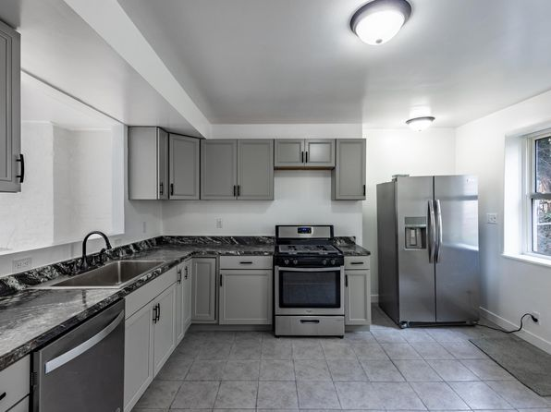](https://www.zillow.com/homedetails/1136-High-St-Pittsburgh-PA-15212/11394408_zpid/)](https://www.zillow.com/homedetails/1136-High-St-Pittsburgh-PA-15212/11394408_zpid/)

*[1509 Kenberma Ave, Pittsburgh, PA 15216](https://www.zillow.com/homedetails/1509-Kenberma-Ave-Pittsburgh-PA-15216/11444877_zpid/)*

$1,325/mo

* **3** bds
* **1** ba
* **1,357** sqft

- House for rent

19 days ago

[[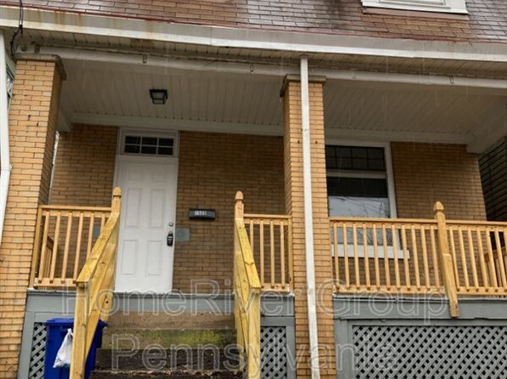](https://www.zillow.com/homedetails/1509-Kenberma-Ave-Pittsburgh-PA-15216/11444877_zpid/)](https://www.zillow.com/homedetails/1509-Kenberma-Ave-Pittsburgh-PA-15216/11444877_zpid/)

*[5731 Ellsworth Avenue | 5731 Ellsworth Ave, Pittsburgh, PA](https://www.zillow.com/b/5731-ellsworth-avenue-pittsburgh-pa-5YC96P/)*

$1,159+ 1 bd

[[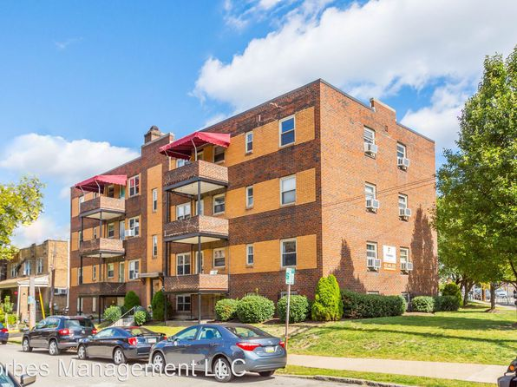](https://www.zillow.com/b/5731-ellsworth-avenue-pittsburgh-pa-5YC96P/)](https://www.zillow.com/b/5731-ellsworth-avenue-pittsburgh-pa-5YC96P/)

*[2703 Voelkel Ave APT B, Pittsburgh, PA 15216](https://www.zillow.com/homedetails/2703-Voelkel-Ave-APT-B-Pittsburgh-PA-15216/2111488034_zpid/)*

$910/mo

* **1** bd
* **1** ba
* **525** sqft

- Apartment for rent

3D Tour

[[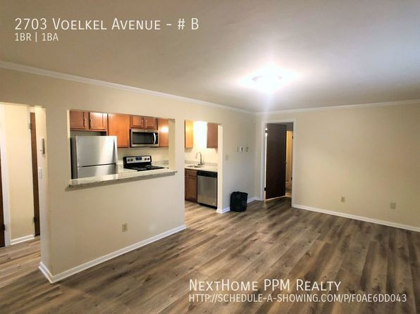](https://www.zillow.com/homedetails/2703-Voelkel-Ave-APT-B-Pittsburgh-PA-15216/2111488034_zpid/)](https://www.zillow.com/homedetails/2703-Voelkel-Ave-APT-B-Pittsburgh-PA-15216/2111488034_zpid/)

*[516 W North Ave UNIT B, Pittsburgh, PA 15212](https://www.zillow.com/homedetails/516-W-North-Ave-UNIT-B-Pittsburgh-PA-15212/2069185766_zpid/)*

$1,295/mo

* **1** bd
* **1** ba
* **--** sqft

- Apartment for rent

18 days ago

[[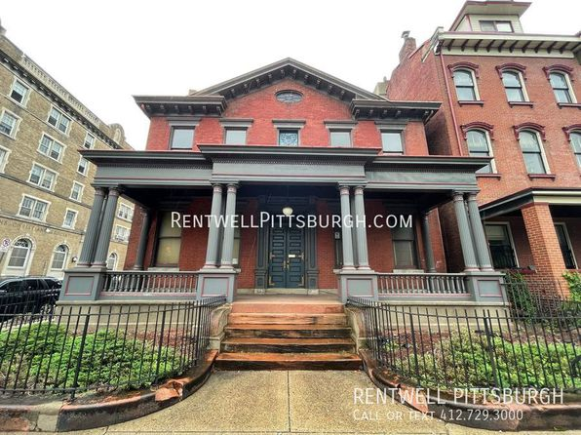](https://www.zillow.com/homedetails/516-W-North-Ave-UNIT-B-Pittsburgh-PA-15212/2069185766_zpid/)](https://www.zillow.com/homedetails/516-W-North-Ave-UNIT-B-Pittsburgh-PA-15212/2069185766_zpid/)

to get email alerts when listings hit the market.

* For Rent
* [Pennsylvania](https://www.zillow.com/pa/rentals/)
* [Allegheny County](https://www.zillow.com/allegheny-county-pa/rentals/)
* **Pittsburgh**

*[Highland Park - Apartments For Rent In Pittsburgh, 5506 Stanton Ave APT 1, Pittsburgh, PA 15206](https://www.zillow.com/b/5506-stanton-avenue-pittsburgh-pa-5fwkzR/)*

$850/mo

* + **1** bd
  + **1** ba
  + **--** sqft

- Apartment for rent

3 days ago

[[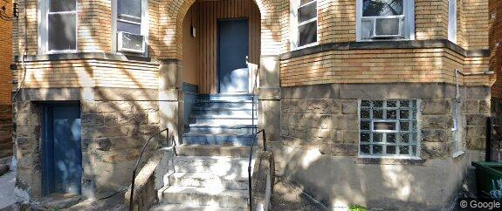](https://www.zillow.com/b/5506-stanton-avenue-pittsburgh-pa-5fwkzR/)](https://www.zillow.com/b/5506-stanton-avenue-pittsburgh-pa-5fwkzR/)

*[6821 Penn Ave FLOOR 1, Pittsburgh, PA 15208](https://www.zillow.com/homedetails/6821-Penn-Ave-FLOOR-1-Pittsburgh-PA-15208/2059816618_zpid/)*

$1,250/mo

* **1** bd
* **1** ba
* **--** sqft

- Townhouse for rent

3 days ago

[[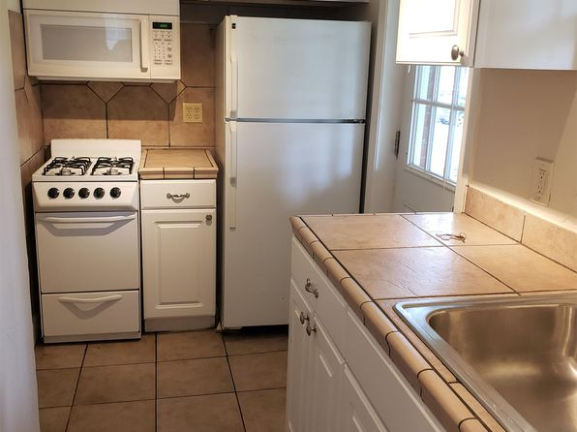](https://www.zillow.com/homedetails/6821-Penn-Ave-FLOOR-1-Pittsburgh-PA-15208/2059816618_zpid/)](https://www.zillow.com/homedetails/6821-Penn-Ave-FLOOR-1-Pittsburgh-PA-15208/2059816618_zpid/)

•

*[236 Plymouth St, Pittsburgh, PA 15211](https://www.zillow.com/homedetails/236-Plymouth-St-Pittsburgh-PA-15211/11586136_zpid/)*

$1,200/mo

* **2** bds
* **1** ba
* **--** sqft

- House for rent

10 days ago

[[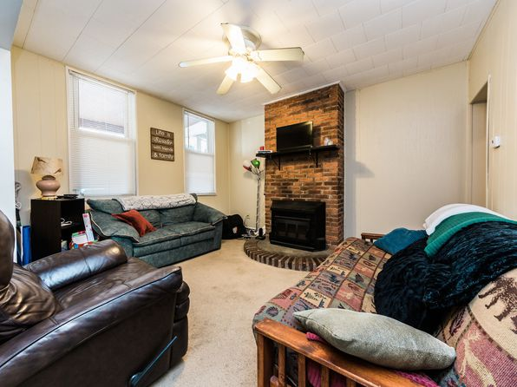](https://www.zillow.com/homedetails/236-Plymouth-St-Pittsburgh-PA-15211/11586136_zpid/)](https://www.zillow.com/homedetails/236-Plymouth-St-Pittsburgh-PA-15211/11586136_zpid/)

*[150 North Ave APT 61, Pittsburgh, PA 15202](https://www.zillow.com/homedetails/150-North-Ave-APT-61-Pittsburgh-PA-15202/11405253_zpid/)*

$850/mo

* **1** bd
* **1** ba
* **--** sqft

- Apartment for rent

26 days ago

[[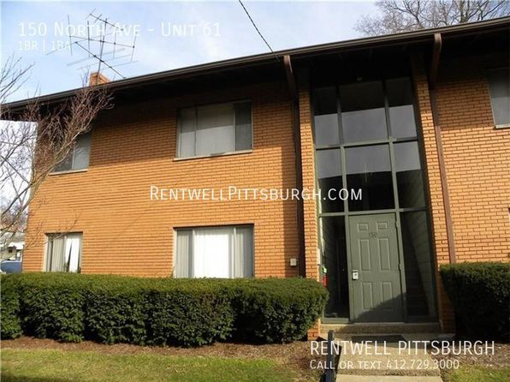](https://www.zillow.com/homedetails/150-North-Ave-APT-61-Pittsburgh-PA-15202/11405253_zpid/)](https://www.zillow.com/homedetails/150-North-Ave-APT-61-Pittsburgh-PA-15202/11405253_zpid/)

*[Studio, 323 sqft, $1,099, 347 S Fairmount St APT 1, Pittsburgh, PA 15232](https://www.zillow.com/b/studio,-323-sqft,-%241,099-pittsburgh-pa-5Z6hk4/)*

$1,099/mo

* **Studio**
* **1** ba
* **323** sqft

- Apartment for rent

12 days ago

[[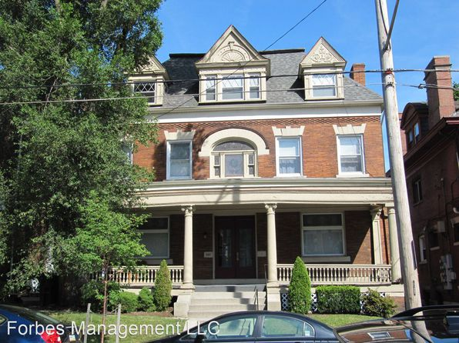](https://www.zillow.com/b/studio,-323-sqft,-%241,099-pittsburgh-pa-5Z6hk4/)](https://www.zillow.com/b/studio,-323-sqft,-%241,099-pittsburgh-pa-5Z6hk4/)

*[Swissvale Towers, 1826 Monongahela Ave, Pittsburgh, PA 15218](https://www.zillow.com/b/swissvale-towers-pittsburgh-pa-5Yy8ST/)*

$650+/mo

* **1** bd
* **1** ba
* **--** sqft

- Apartment for rent

10 days ago

[[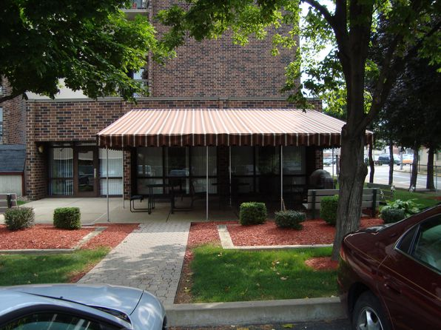](https://www.zillow.com/b/swissvale-towers-pittsburgh-pa-5Yy8ST/)](https://www.zillow.com/b/swissvale-towers-pittsburgh-pa-5Yy8ST/)

*[22 - 52 Ruth, 52 Ruth St #1, Pittsburgh, PA 15211](https://www.zillow.com/b/22-52-ruth-pittsburgh-pa-98NcCV/)*

$850/mo

* **1** bd
* **1** ba
* **--** sqft

- Apartment for rent

24 days ago

[[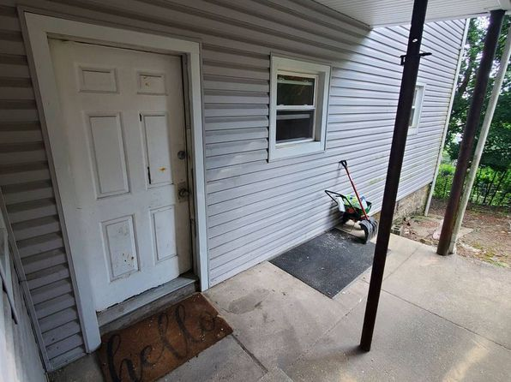](https://www.zillow.com/b/22-52-ruth-pittsburgh-pa-98NcCV/)](https://www.zillow.com/b/22-52-ruth-pittsburgh-pa-98NcCV/)

*[41 - 1126 Arlington Ave, 1126 Arlington Ave #2, Pittsburgh, PA 15203](https://www.zillow.com/b/41-1126-arlington-ave-pittsburgh-pa-5XwGd4/)*

$1,000/mo

* **2** bds
* **1** ba
* **--** sqft

- Apartment for rent

10 days ago

[[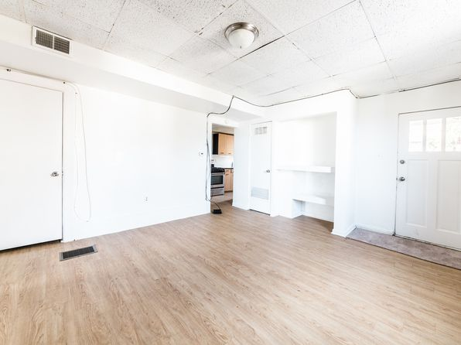](https://www.zillow.com/b/41-1126-arlington-ave-pittsburgh-pa-5XwGd4/)](https://www.zillow.com/b/41-1126-arlington-ave-pittsburgh-pa-5XwGd4/)

*[103 Harwood St, Pittsburgh, PA 15211](https://www.zillow.com/homedetails/103-Harwood-St-Pittsburgh-PA-15211/11323653_zpid/)*

$1,800/mo

* **3** bds
* **2** ba
* **--** sqft

- House for rent

24 days ago

[[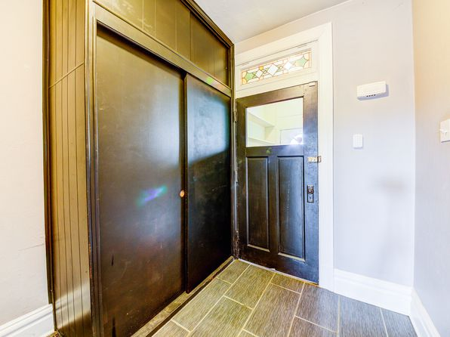](https://www.zillow.com/homedetails/103-Harwood-St-Pittsburgh-PA-15211/11323653_zpid/)](https://www.zillow.com/homedetails/103-Harwood-St-Pittsburgh-PA-15211/11323653_zpid/)

*[2310 Sarah St, Pittsburgh, PA 15203](https://www.zillow.com/homedetails/2310-Sarah-St-Pittsburgh-PA-15203/11291485_zpid/)*

$2,000/mo

* **3** bds
* **3** ba
* **2,000** sqft

- House for rent

11 days ago

[[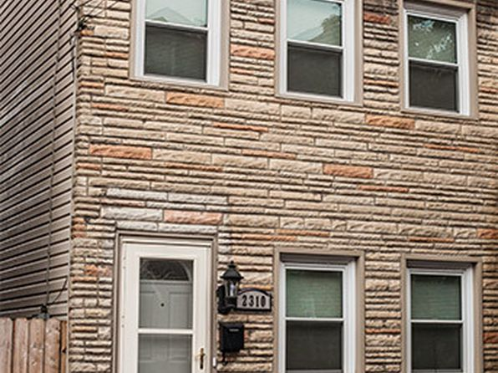](https://www.zillow.com/homedetails/2310-Sarah-St-Pittsburgh-PA-15203/11291485_zpid/)](https://www.zillow.com/homedetails/2310-Sarah-St-Pittsburgh-PA-15203/11291485_zpid/)

*[30 - 316 Belonda, 316 Belonda St #1, Pittsburgh, PA 15211](https://www.zillow.com/b/30-316-belonda-pittsburgh-pa-5xyJWY/)*

$875/mo

* **Studio**
* **1** ba
* **--** sqft

- Apartment for rent

24 days ago

[[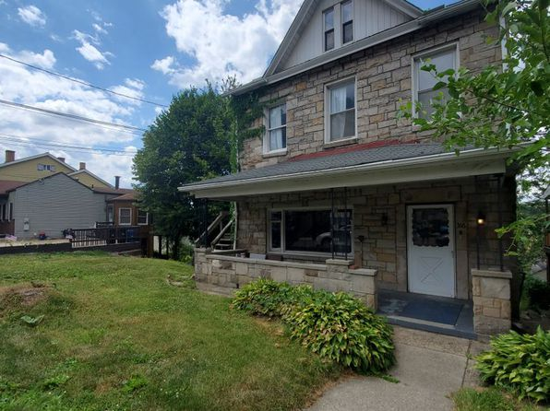](https://www.zillow.com/b/30-316-belonda-pittsburgh-pa-5xyJWY/)](https://www.zillow.com/b/30-316-belonda-pittsburgh-pa-5xyJWY/)

*[2416 Mount Troy Rd., 2416 Mount Troy Rd #1, Pittsburgh, PA 15212](https://www.zillow.com/b/2416-mount-troy-rd.-pittsburgh-pa-98NgmP/)*

$1,295/mo

* **2** bds
* **1** ba
* **--** sqft

- Apartment for rent

24 days ago

[[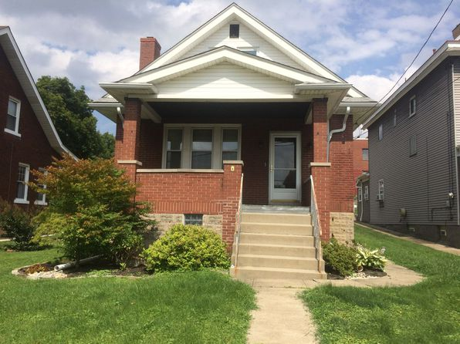](https://www.zillow.com/b/2416-mount-troy-rd.-pittsburgh-pa-98NgmP/)](https://www.zillow.com/b/2416-mount-troy-rd.-pittsburgh-pa-98NgmP/)

*[1732 Duffield St, Pittsburgh, PA 15206](https://www.zillow.com/homedetails/1732-Duffield-St-Pittsburgh-PA-15206/2095741840_zpid/)*

$1,499/mo

* **2** bds
* **1** ba
* **970** sqft

- House for rent

17 days ago

[[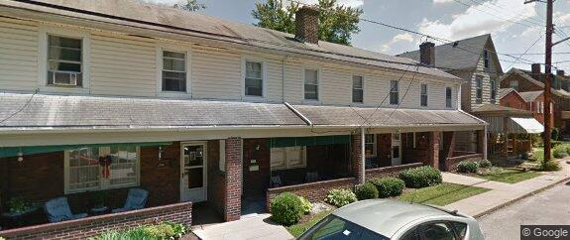](https://www.zillow.com/homedetails/1732-Duffield-St-Pittsburgh-PA-15206/2095741840_zpid/)](https://www.zillow.com/homedetails/1732-Duffield-St-Pittsburgh-PA-15206/2095741840_zpid/)

*[1008 E Warrington Ave, Pittsburgh, PA 15210](https://www.zillow.com/homedetails/1008-E-Warrington-Ave-Pittsburgh-PA-15210/11315135_zpid/)*

$1,400/mo

* **4** bds
* **1** ba
* **--** sqft

- House for rent

30 days ago

[[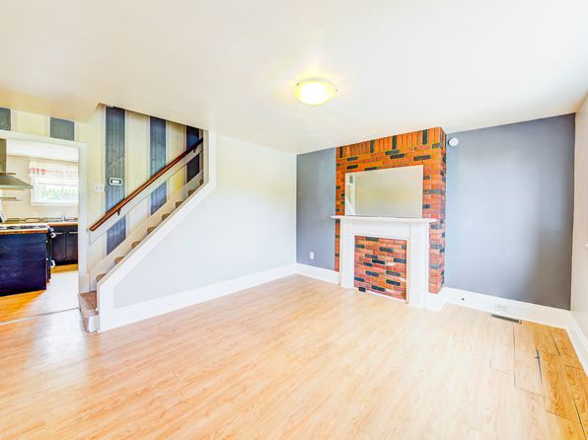](https://www.zillow.com/homedetails/1008-E-Warrington-Ave-Pittsburgh-PA-15210/11315135_zpid/)](https://www.zillow.com/homedetails/1008-E-Warrington-Ave-Pittsburgh-PA-15210/11315135_zpid/)

*[10 E Sycamore St, Pittsburgh, PA 15211](https://www.zillow.com/homedetails/10-E-Sycamore-St-Pittsburgh-PA-15211/11515850_zpid/)*

$1,400/mo

* **3** bds
* **1** ba
* **--** sqft

- House for rent

6 days ago

[[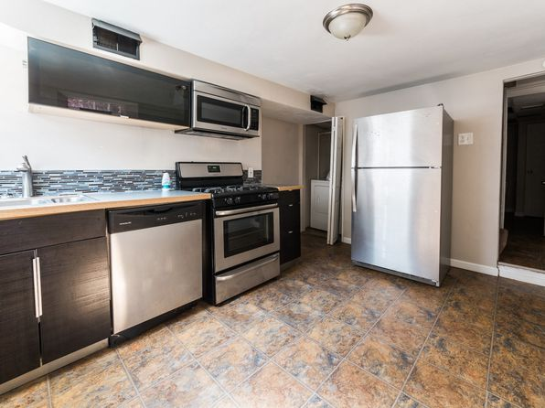](https://www.zillow.com/homedetails/10-E-Sycamore-St-Pittsburgh-PA-15211/11515850_zpid/)](https://www.zillow.com/homedetails/10-E-Sycamore-St-Pittsburgh-PA-15211/11515850_zpid/)

•

*[83 Beltzhoover Ave, Pittsburgh, PA 15210](https://www.zillow.com/homedetails/83-Beltzhoover-Ave-Pittsburgh-PA-15210/11314793_zpid/)*

$1,750/mo

* **3** bds
* **3.5** ba
* **--** sqft

- House for rent

17 days ago

[[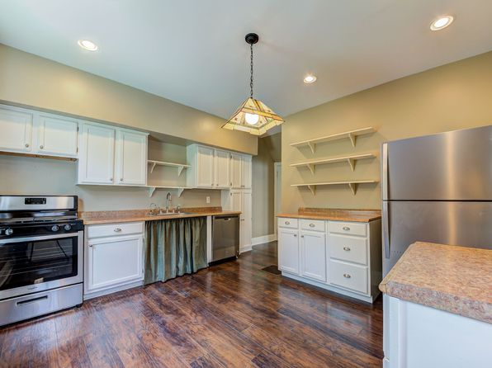](https://www.zillow.com/homedetails/83-Beltzhoover-Ave-Pittsburgh-PA-15210/11314793_zpid/)](https://www.zillow.com/homedetails/83-Beltzhoover-Ave-Pittsburgh-PA-15210/11314793_zpid/)

*[330 Ohiopyle Dr, Pittsburgh, PA 15239](https://www.zillow.com/homedetails/330-Ohiopyle-Dr-Pittsburgh-PA-15239/11261690_zpid/)*

$1,700/mo

* **3** bds
* **2** ba
* **1,275** sqft

- House for rent

10 hours ago

[[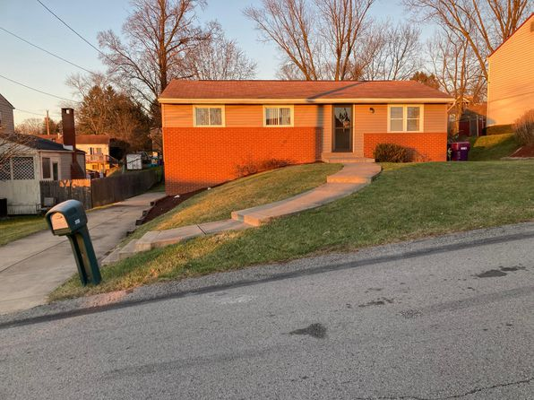](https://www.zillow.com/homedetails/330-Ohiopyle-Dr-Pittsburgh-PA-15239/11261690_zpid/)](https://www.zillow.com/homedetails/330-Ohiopyle-Dr-Pittsburgh-PA-15239/11261690_zpid/)

*[203 Millbridge St, Pittsburgh, PA 15210](https://www.zillow.com/homedetails/203-Millbridge-St-Pittsburgh-PA-15210/11315465_zpid/)*

$1,550/mo

* **4** bds
* **2** ba
* **2,850** sqft

- House for rent

30 days ago

[[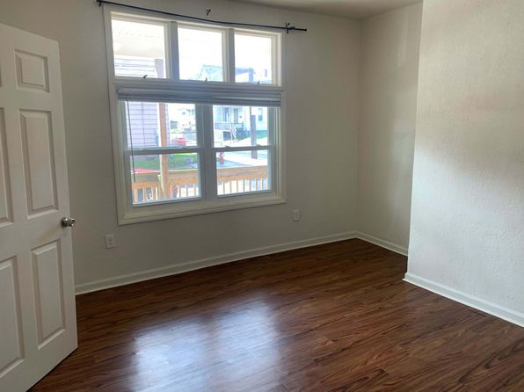](https://www.zillow.com/homedetails/203-Millbridge-St-Pittsburgh-PA-15210/11315465_zpid/)](https://www.zillow.com/homedetails/203-Millbridge-St-Pittsburgh-PA-15210/11315465_zpid/)

*[109 Brightwood Ave, Pittsburgh, PA 15229](https://www.zillow.com/homedetails/109-Brightwood-Ave-Pittsburgh-PA-15229/11408763_zpid/)*

$1,650/mo

* **3** bds
* **1** ba
* **1,040** sqft

- House for rent

26 days ago

[[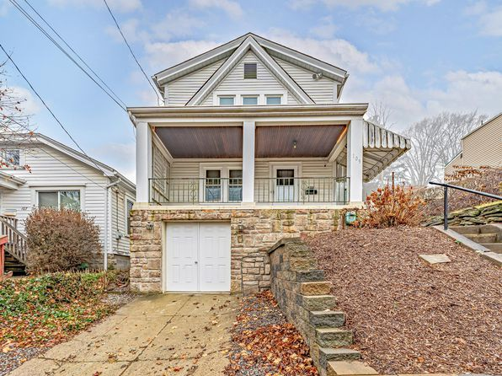](https://www.zillow.com/homedetails/109-Brightwood-Ave-Pittsburgh-PA-15229/11408763_zpid/)](https://www.zillow.com/homedetails/109-Brightwood-Ave-Pittsburgh-PA-15229/11408763_zpid/)

*[434 Katherine St, Pittsburgh, PA 15214](https://www.zillow.com/homedetails/434-Katherine-St-Pittsburgh-PA-15214/11327496_zpid/)*

$1,295/mo

* **3** bds
* **1.5** ba
* **1,344** sqft

- House for rent

20 days ago

[[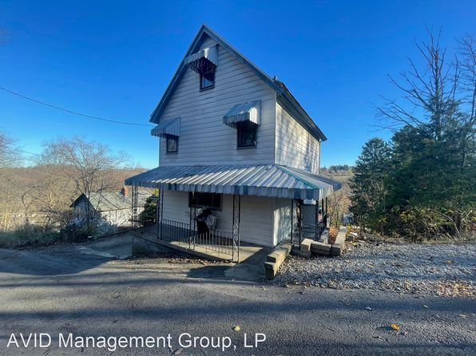](https://www.zillow.com/homedetails/434-Katherine-St-Pittsburgh-PA-15214/11327496_zpid/)](https://www.zillow.com/homedetails/434-Katherine-St-Pittsburgh-PA-15214/11327496_zpid/)

*[2013 Wightman St, Pittsburgh, PA 15217](https://www.zillow.com/homedetails/2013-Wightman-St-Pittsburgh-PA-15217/11631991_zpid/)*

$2,420/mo

* **3** bds
* **1.5** ba
* **1,450** sqft

- House for rent

11 days ago

[[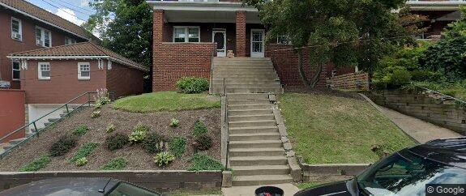](https://www.zillow.com/homedetails/2013-Wightman-St-Pittsburgh-PA-15217/11631991_zpid/)](https://www.zillow.com/homedetails/2013-Wightman-St-Pittsburgh-PA-15217/11631991_zpid/)

*[1629 Alplaus St, Pittsburgh, PA 15210](https://www.zillow.com/homedetails/1629-Alplaus-St-Pittsburgh-PA-15210/11553999_zpid/)*

$1,450/mo

* **4** bds
* **1** ba
* **2,005** sqft

- House for rent

45 days ago

[[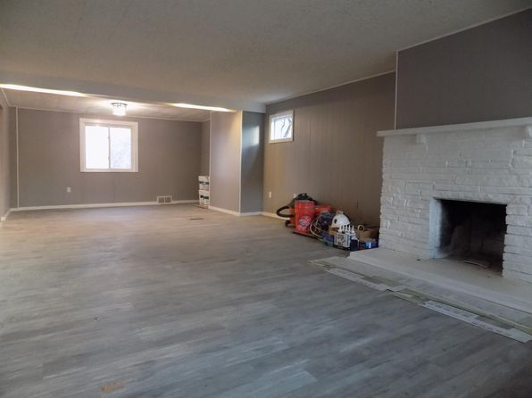](https://www.zillow.com/homedetails/1629-Alplaus-St-Pittsburgh-PA-15210/11553999_zpid/)](https://www.zillow.com/homedetails/1629-Alplaus-St-Pittsburgh-PA-15210/11553999_zpid/)

*[226 Seward St, Pittsburgh, PA 15211](https://www.zillow.com/homedetails/226-Seward-St-Pittsburgh-PA-15211/11585267_zpid/)*

$1,500/mo

* **4** bds
* **1** ba
* **--** sqft

- House for rent

30 days ago

[[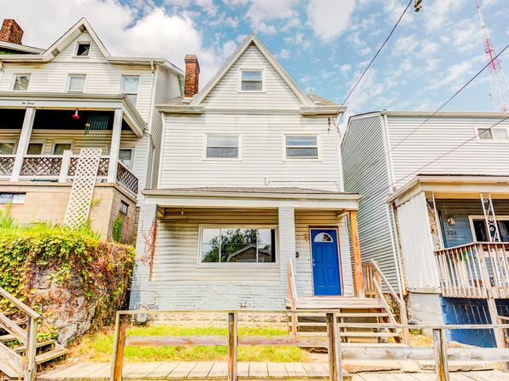](https://www.zillow.com/homedetails/226-Seward-St-Pittsburgh-PA-15211/11585267_zpid/)](https://www.zillow.com/homedetails/226-Seward-St-Pittsburgh-PA-15211/11585267_zpid/)

*[2232 Wightman St APT 203, Pittsburgh, PA 15217](https://www.zillow.com/homedetails/2232-Wightman-St-APT-203-Pittsburgh-PA-15217/2094872009_zpid/)*

$875/mo

* **Studio**
* **1** ba
* **396** sqft

- Apartment for rent

5 days ago

[[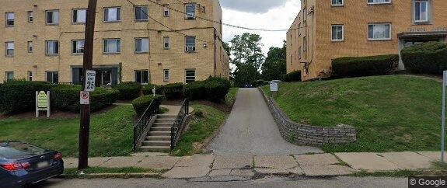](https://www.zillow.com/homedetails/2232-Wightman-St-APT-203-Pittsburgh-PA-15217/2094872009_zpid/)](https://www.zillow.com/homedetails/2232-Wightman-St-APT-203-Pittsburgh-PA-15217/2094872009_zpid/)

*[1521 Dormont Ave FLOOR 1, Pittsburgh, PA 15216](https://www.zillow.com/homedetails/1521-Dormont-Ave-FLOOR-1-Pittsburgh-PA-15216/2060178636_zpid/)*

$1,250/mo

* **2** bds
* **1** ba
* **1,120** sqft

- Apartment for rent

19 days ago

[[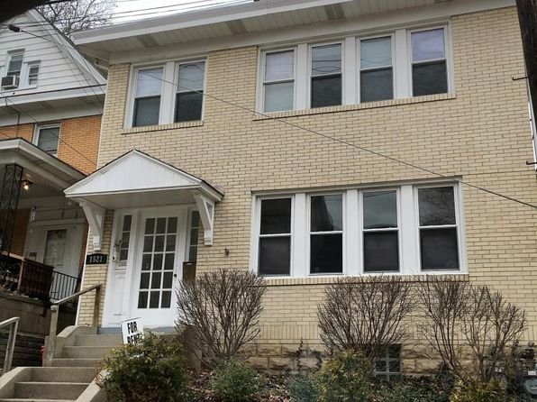](https://www.zillow.com/homedetails/1521-Dormont-Ave-FLOOR-1-Pittsburgh-PA-15216/2060178636_zpid/)](https://www.zillow.com/homedetails/1521-Dormont-Ave-FLOOR-1-Pittsburgh-PA-15216/2060178636_zpid/)

*[114 Millbridge St, Pittsburgh, PA 15210](https://www.zillow.com/homedetails/114-Millbridge-St-Pittsburgh-PA-15210/2072305833_zpid/)*

$1,425/mo

* **3** bds
* **1** ba
* **--** sqft

- House for rent

12 days ago

[[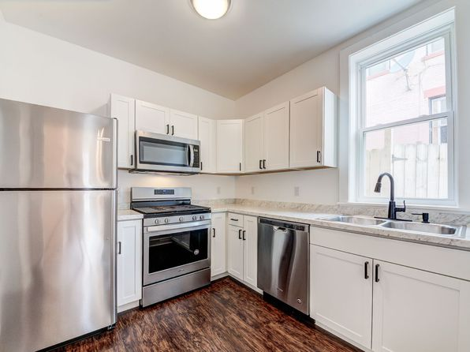](https://www.zillow.com/homedetails/114-Millbridge-St-Pittsburgh-PA-15210/2072305833_zpid/)](https://www.zillow.com/homedetails/114-Millbridge-St-Pittsburgh-PA-15210/2072305833_zpid/)

*[7332 Brighton Rd, Pittsburgh, PA 15202](https://www.zillow.com/homedetails/7332-Brighton-Rd-Pittsburgh-PA-15202/2061228085_zpid/)*

$1,950/mo

* **2** bds
* **1** ba
* **1,450** sqft

- Townhouse for rent

26 days ago

[[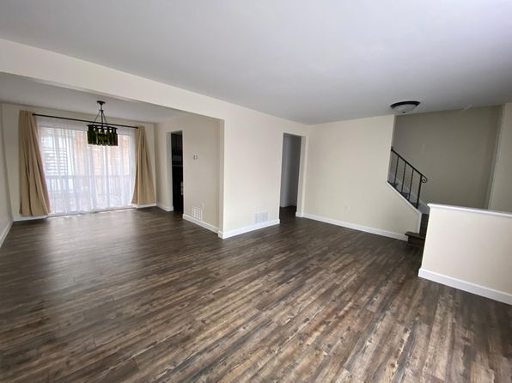](https://www.zillow.com/homedetails/7332-Brighton-Rd-Pittsburgh-PA-15202/2061228085_zpid/)](https://www.zillow.com/homedetails/7332-Brighton-Rd-Pittsburgh-PA-15202/2061228085_zpid/)

*[2619 Burham St, Pittsburgh, PA 15203](https://www.zillow.com/homedetails/2619-Burham-St-Pittsburgh-PA-15203/11308213_zpid/)*

$1,150/mo

* **2** bds
* **1.5** ba
* **--** sqft

- House for rent

24 days ago

[[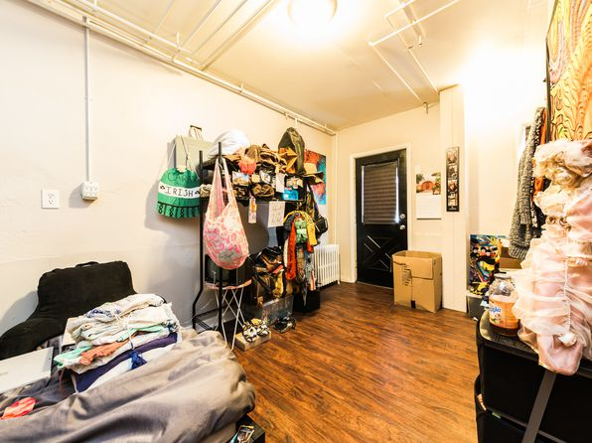](https://www.zillow.com/homedetails/2619-Burham-St-Pittsburgh-PA-15203/11308213_zpid/)](https://www.zillow.com/homedetails/2619-Burham-St-Pittsburgh-PA-15203/11308213_zpid/)

*[2408 Jane St #2, Pittsburgh, PA 15203](https://www.zillow.com/homedetails/2408-Jane-St-2-Pittsburgh-PA-15203/2108808722_zpid/)*

$1,800/mo

* **3** bds
* **2** ba
* **1,000** sqft

- Apartment for rent

17 days ago

[[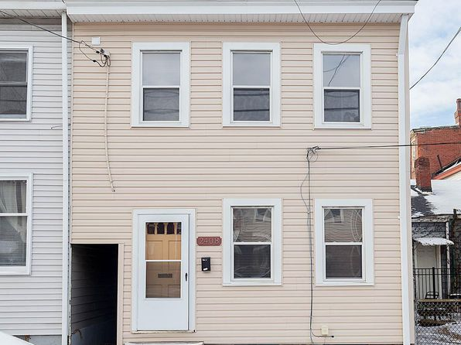](https://www.zillow.com/homedetails/2408-Jane-St-2-Pittsburgh-PA-15203/2108808722_zpid/)](https://www.zillow.com/homedetails/2408-Jane-St-2-Pittsburgh-PA-15203/2108808722_zpid/)

*[3543 California Ave #D, Pittsburgh, PA 15212](https://www.zillow.com/homedetails/3543-California-Ave-D-Pittsburgh-PA-15212/2110302942_zpid/)*

$1,190/mo

* **2** bds
* **1** ba
* **800** sqft

- Apartment for rent

27 days ago

[[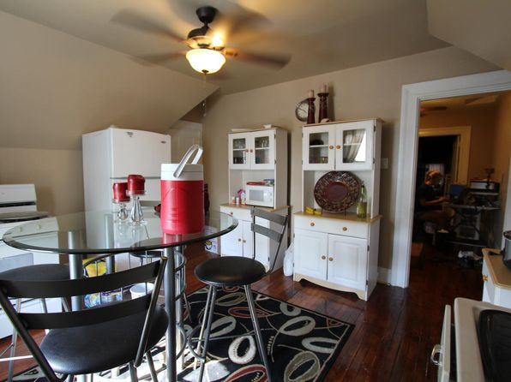](https://www.zillow.com/homedetails/3543-California-Ave-D-Pittsburgh-PA-15212/2110302942_zpid/)](https://www.zillow.com/homedetails/3543-California-Ave-D-Pittsburgh-PA-15212/2110302942_zpid/)

*[5643 Wilkins Ave, Pittsburgh, PA 15217](https://www.zillow.com/homedetails/5643-Wilkins-Ave-Pittsburgh-PA-15217/2077819825_zpid/)*

$3,750/mo

* **6** bds
* **2** ba
* **2,000** sqft

- House for rent

16 days ago

[[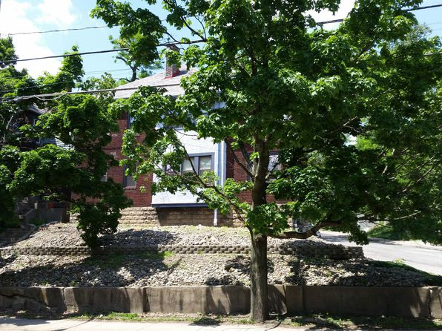](https://www.zillow.com/homedetails/5643-Wilkins-Ave-Pittsburgh-PA-15217/2077819825_zpid/)](https://www.zillow.com/homedetails/5643-Wilkins-Ave-Pittsburgh-PA-15217/2077819825_zpid/)

*[1376 Herman St, Pittsburgh, PA 15212](https://www.zillow.com/homedetails/1376-Herman-St-Pittsburgh-PA-15212/11394702_zpid/)*

$1,395/mo

* **2** bds
* **1** ba
* **--** sqft

- House for rent

24 days ago

[[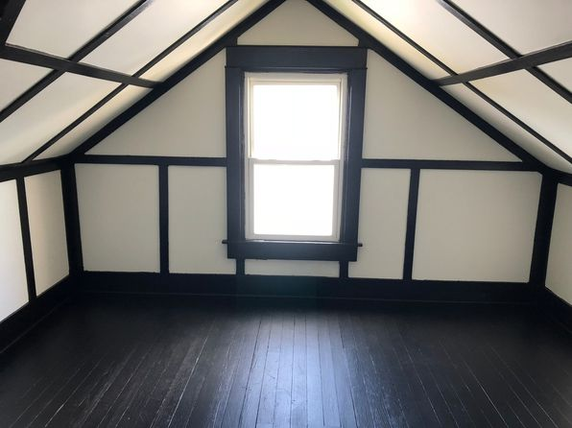](https://www.zillow.com/homedetails/1376-Herman-St-Pittsburgh-PA-15212/11394702_zpid/)](https://www.zillow.com/homedetails/1376-Herman-St-Pittsburgh-PA-15212/11394702_zpid/)

*[323 Nelbon Ave, Pittsburgh, PA 15235](https://www.zillow.com/homedetails/323-Nelbon-Ave-Pittsburgh-PA-15235/11452109_zpid/)*

$1,395/mo

* **3** bds
* **2** ba
* **1,318** sqft

- House for rent

20 days ago

[[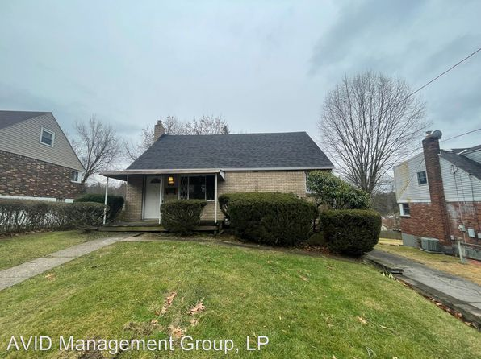](https://www.zillow.com/homedetails/323-Nelbon-Ave-Pittsburgh-PA-15235/11452109_zpid/)](https://www.zillow.com/homedetails/323-Nelbon-Ave-Pittsburgh-PA-15235/11452109_zpid/)

*[67 Haberman Ave, Pittsburgh, PA 15211](https://www.zillow.com/homedetails/67-Haberman-Ave-Pittsburgh-PA-15211/11517106_zpid/)*

$1,400/mo

* **3** bds
* **1** ba
* **1,212** sqft

- House for rent

24 days ago

[[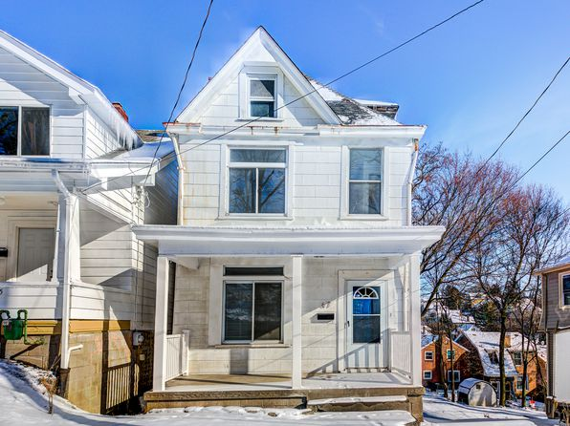](https://www.zillow.com/homedetails/67-Haberman-Ave-Pittsburgh-PA-15211/11517106_zpid/)](https://www.zillow.com/homedetails/67-Haberman-Ave-Pittsburgh-PA-15211/11517106_zpid/)

*[149 Hilands Pl, Pittsburgh, PA 15237](https://www.zillow.com/homedetails/149-Hilands-Pl-Pittsburgh-PA-15237/2059993945_zpid/)*

$1,350/mo

* **2** bds
* **1** ba
* **995** sqft

- House for rent

11 days ago

[[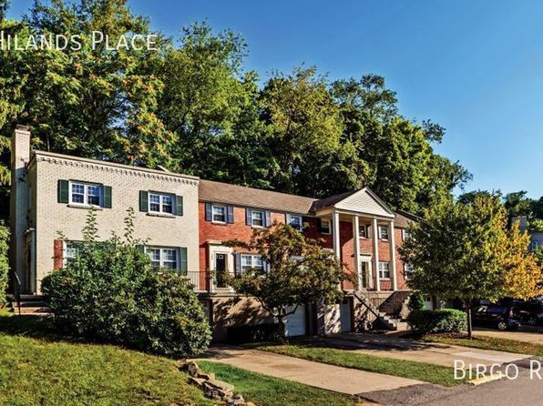](https://www.zillow.com/homedetails/149-Hilands-Pl-Pittsburgh-PA-15237/2059993945_zpid/)](https://www.zillow.com/homedetails/149-Hilands-Pl-Pittsburgh-PA-15237/2059993945_zpid/)

*[5261 Natrona Way, Pittsburgh, PA 15201](https://www.zillow.com/homedetails/5261-Natrona-Way-Pittsburgh-PA-15201/2067814256_zpid/)*

$1,450/mo

* **2** bds
* **1.5** ba
* **--** sqft

- House for rent

13 days ago

[[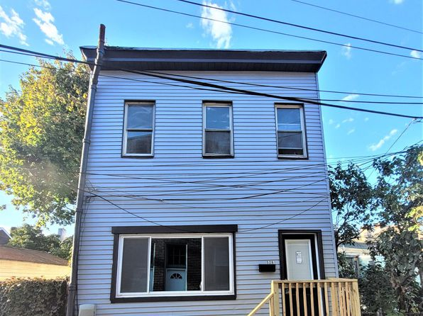](https://www.zillow.com/homedetails/5261-Natrona-Way-Pittsburgh-PA-15201/2067814256_zpid/)](https://www.zillow.com/homedetails/5261-Natrona-Way-Pittsburgh-PA-15201/2067814256_zpid/)

*[7716 Brashear Street, 7716 Brashear St #2, Pittsburgh, PA 15221](https://www.zillow.com/b/7716-brashear-street-pittsburgh-pa-5dk8Nj/)*

$1,250/mo

* **3** bds
* **1** ba
* **--** sqft

- Apartment for rent

39 days ago

[[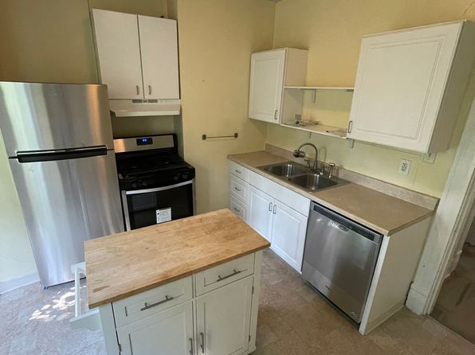](https://www.zillow.com/b/7716-brashear-street-pittsburgh-pa-5dk8Nj/)](https://www.zillow.com/b/7716-brashear-street-pittsburgh-pa-5dk8Nj/)

*[1801 Elmdale Rd APT 3, Pittsburgh, PA 15205](https://www.zillow.com/homedetails/1801-Elmdale-Rd-APT-3-Pittsburgh-PA-15205/2060182266_zpid/)*

$750/mo

* **1** bd
* **1** ba
* **--** sqft

- Apartment for rent

20 days ago

[[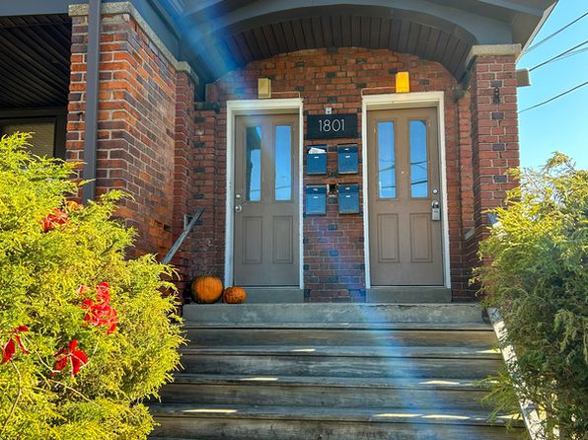](https://www.zillow.com/homedetails/1801-Elmdale-Rd-APT-3-Pittsburgh-PA-15205/2060182266_zpid/)](https://www.zillow.com/homedetails/1801-Elmdale-Rd-APT-3-Pittsburgh-PA-15205/2060182266_zpid/)

*[1021 Crucible St, Pittsburgh, PA 15220](https://www.zillow.com/homedetails/1021-Crucible-St-Pittsburgh-PA-15220/11366978_zpid/)*

$1,050/mo

* **3** bds
* **1** ba
* **--** sqft

- House for rent

1 day ago

[[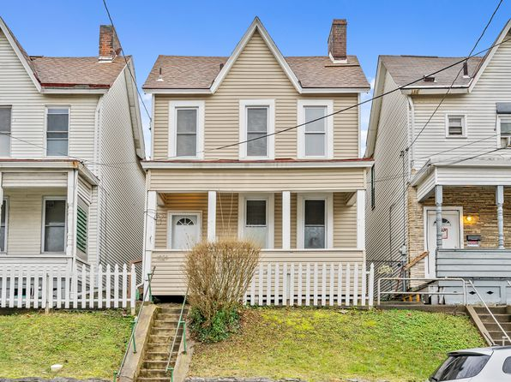](https://www.zillow.com/homedetails/1021-Crucible-St-Pittsburgh-PA-15220/11366978_zpid/)](https://www.zillow.com/homedetails/1021-Crucible-St-Pittsburgh-PA-15220/11366978_zpid/)

*[5113 Duncan St #2, Pittsburgh, PA 15201](https://www.zillow.com/homedetails/5113-Duncan-St-2-Pittsburgh-PA-15201/2083097975_zpid/)*

$1,500/mo

* **2** bds
* **1** ba
* **1,425** sqft

- Apartment for rent

22 days ago

[[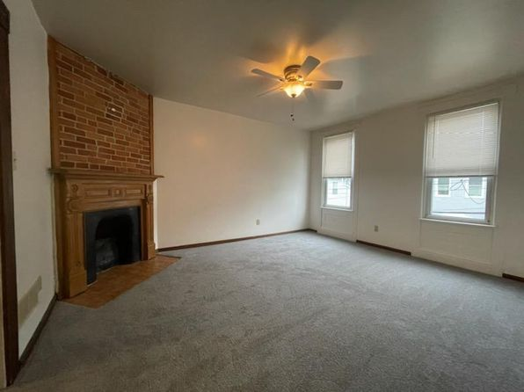](https://www.zillow.com/homedetails/5113-Duncan-St-2-Pittsburgh-PA-15201/2083097975_zpid/)](https://www.zillow.com/homedetails/5113-Duncan-St-2-Pittsburgh-PA-15201/2083097975_zpid/)

to get email alerts when listings hit the market.

*[07 - 70 Millbridge | 70 Millbridge St, Pittsburgh, PA](https://www.zillow.com/b/07-70-millbridge-pittsburgh-pa-98NYsr/)*

$1,050+ 1 bd

* + **$1,600+** 4 bds

[[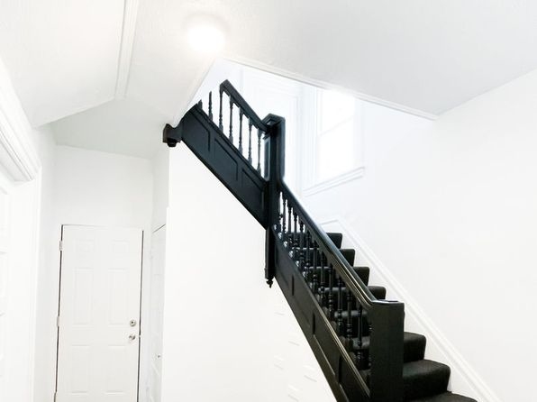](https://www.zillow.com/b/07-70-millbridge-pittsburgh-pa-98NYsr/)](https://www.zillow.com/b/07-70-millbridge-pittsburgh-pa-98NYsr/)

*[8 Gregory St, Pittsburgh, PA 15203](https://www.zillow.com/homedetails/8-Gregory-St-Pittsburgh-PA-15203/11291898_zpid/)*

$1,480/mo

* **4** bds
* **2** ba
* **1,440** sqft

- House for rent

19 days ago

[[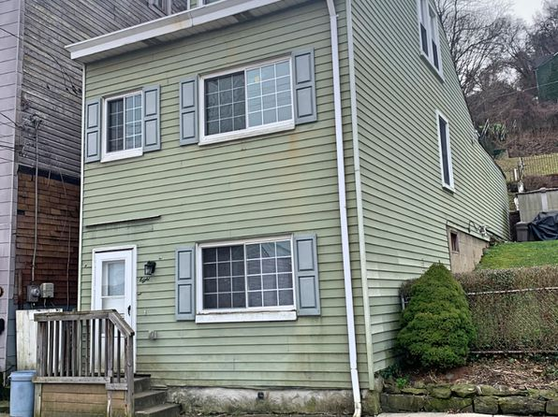](https://www.zillow.com/homedetails/8-Gregory-St-Pittsburgh-PA-15203/11291898_zpid/)](https://www.zillow.com/homedetails/8-Gregory-St-Pittsburgh-PA-15203/11291898_zpid/)

•

*[1335 Leaside Dr, Pittsburgh, PA 15207](https://www.zillow.com/homedetails/1335-Leaside-Dr-Pittsburgh-PA-15207/11351794_zpid/)*

$895/mo

* **2** bds
* **1** ba
* **840** sqft

- House for rent

20 days ago

[[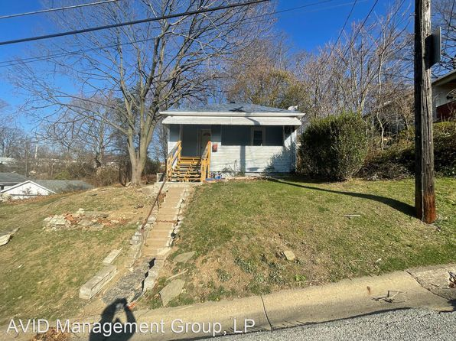](https://www.zillow.com/homedetails/1335-Leaside-Dr-Pittsburgh-PA-15207/11351794_zpid/)](https://www.zillow.com/homedetails/1335-Leaside-Dr-Pittsburgh-PA-15207/11351794_zpid/)

*[5231 Wickliff St, Pittsburgh, PA 15201](https://www.zillow.com/homedetails/5231-Wickliff-St-Pittsburgh-PA-15201/11612938_zpid/)*

$1,840/mo

* **3** bds
* **1** ba
* **1,479** sqft

- House for rent

3D Tour

[[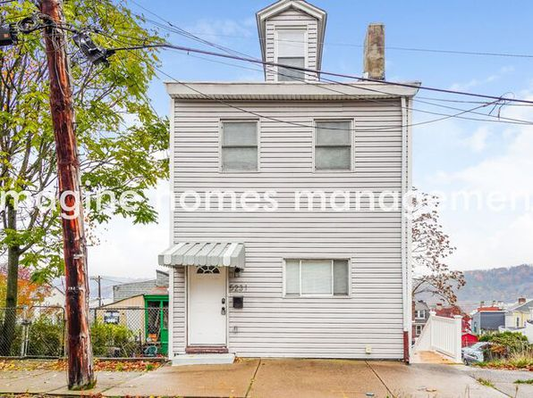](https://www.zillow.com/homedetails/5231-Wickliff-St-Pittsburgh-PA-15201/11612938_zpid/)](https://www.zillow.com/homedetails/5231-Wickliff-St-Pittsburgh-PA-15201/11612938_zpid/)

*[15 - 2216 Arlington, 2216 Arlington Ave, Pittsburgh, PA 15210](https://www.zillow.com/homedetails/2216-Arlington-Ave-Pittsburgh-PA-15210/11308416_zpid/)*

$900/mo

* **1** bd
* **1** ba
* **--** sqft

- Apartment for rent

24 days ago

[[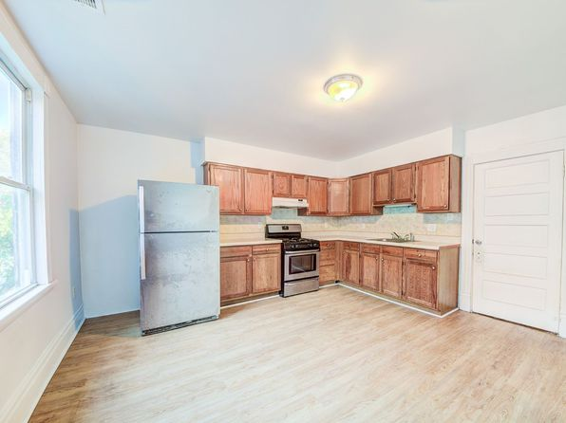](https://www.zillow.com/homedetails/2216-Arlington-Ave-Pittsburgh-PA-15210/11308416_zpid/)](https://www.zillow.com/homedetails/2216-Arlington-Ave-Pittsburgh-PA-15210/11308416_zpid/)

*[610 Ceres Way, Pittsburgh, PA 15210](https://www.zillow.com/homedetails/610-Ceres-Way-Pittsburgh-PA-15210/11314806_zpid/)*

$1,050/mo

* **2** bds
* **1.5** ba
* **--** sqft

- House for rent

24 days ago

[[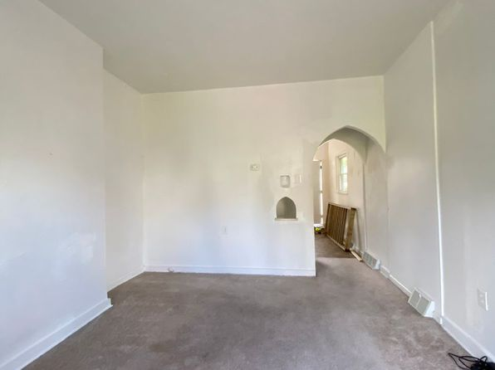](https://www.zillow.com/homedetails/610-Ceres-Way-Pittsburgh-PA-15210/11314806_zpid/)](https://www.zillow.com/homedetails/610-Ceres-Way-Pittsburgh-PA-15210/11314806_zpid/)

*[1505 Bingham St FLOOR 3, Pittsburgh, PA 15203](https://www.zillow.com/homedetails/1505-Bingham-St-FLOOR-3-Pittsburgh-PA-15203/2060271518_zpid/)*

$950/mo

* **1** bd
* **1** ba
* **750** sqft

- Apartment for rent

28 days ago

[[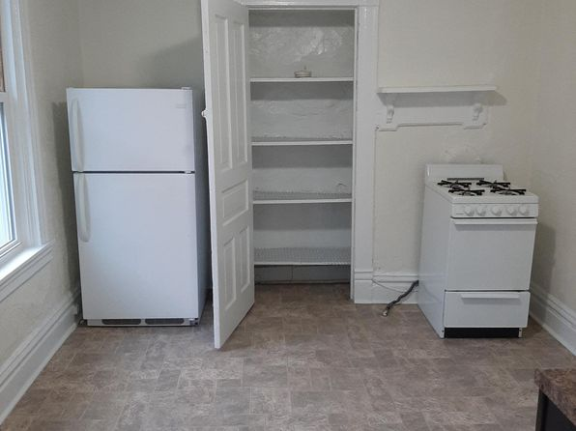](https://www.zillow.com/homedetails/1505-Bingham-St-FLOOR-3-Pittsburgh-PA-15203/2060271518_zpid/)](https://www.zillow.com/homedetails/1505-Bingham-St-FLOOR-3-Pittsburgh-PA-15203/2060271518_zpid/)

*[5635 Rippey St APT 6, Pittsburgh, PA 15206](https://www.zillow.com/homedetails/5635-Rippey-St-APT-6-Pittsburgh-PA-15206/2098699060_zpid/)*

$989/mo

* **Studio**
* **1** ba
* **405** sqft

- Apartment for rent

11 days ago

[[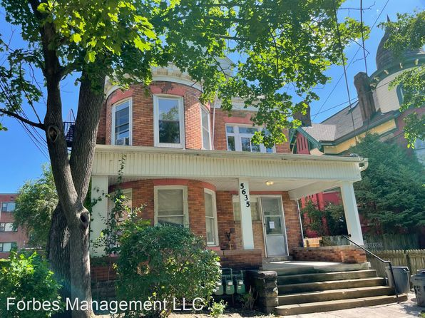](https://www.zillow.com/homedetails/5635-Rippey-St-APT-6-Pittsburgh-PA-15206/2098699060_zpid/)](https://www.zillow.com/homedetails/5635-Rippey-St-APT-6-Pittsburgh-PA-15206/2098699060_zpid/)

*[713 Excelsior St, Pittsburgh, PA 15210](https://www.zillow.com/homedetails/713-Excelsior-St-Pittsburgh-PA-15210/11315043_zpid/)*

$1,600/mo

* **4** bds
* **1** ba
* **--** sqft

- House for rent

10 days ago

[[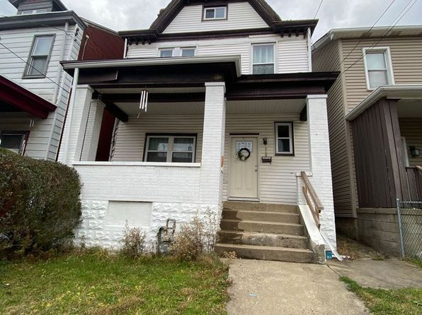](https://www.zillow.com/homedetails/713-Excelsior-St-Pittsburgh-PA-15210/11315043_zpid/)](https://www.zillow.com/homedetails/713-Excelsior-St-Pittsburgh-PA-15210/11315043_zpid/)

*[351 S Negley Ave APT 5, Pittsburgh, PA 15232](https://www.zillow.com/homedetails/351-S-Negley-Ave-APT-5-Pittsburgh-PA-15232/2091140528_zpid/)*

$895/mo

* **1** bd
* **1** ba
* **--** sqft

- Apartment for rent

2 days ago

[[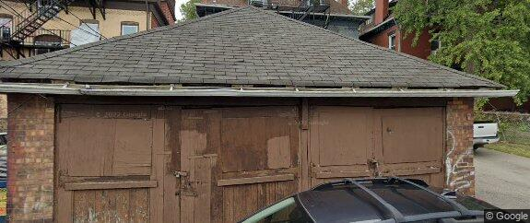](https://www.zillow.com/homedetails/351-S-Negley-Ave-APT-5-Pittsburgh-PA-15232/2091140528_zpid/)](https://www.zillow.com/homedetails/351-S-Negley-Ave-APT-5-Pittsburgh-PA-15232/2091140528_zpid/)

*[59 Barry St, Pittsburgh, PA 15203](https://www.zillow.com/homedetails/59-Barry-St-Pittsburgh-PA-15203/11307751_zpid/)*

$2,050/mo

* **4** bds
* **1** ba
* **--** sqft

- House for rent

30 days ago

[[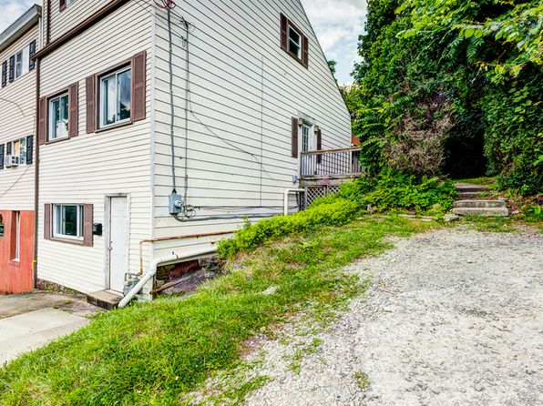](https://www.zillow.com/homedetails/59-Barry-St-Pittsburgh-PA-15203/11307751_zpid/)](https://www.zillow.com/homedetails/59-Barry-St-Pittsburgh-PA-15203/11307751_zpid/)

*[220 Park Ave, West View, PA 15229](https://www.zillow.com/homedetails/220-Park-Ave-West-View-PA-15229/11408914_zpid/)*

$1,395/mo

* **4** bds
* **1** ba
* **1,282** sqft

- House for rent

20 days ago

[[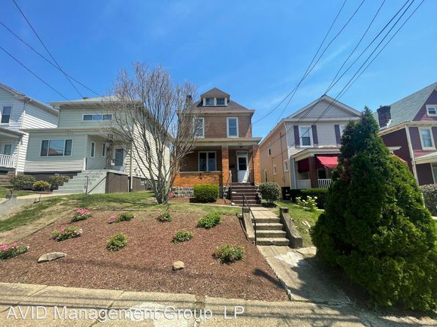](https://www.zillow.com/homedetails/220-Park-Ave-West-View-PA-15229/11408914_zpid/)](https://www.zillow.com/homedetails/220-Park-Ave-West-View-PA-15229/11408914_zpid/)

*[306 54th St, Pittsburgh, PA 15201](https://www.zillow.com/homedetails/306-54th-St-Pittsburgh-PA-15201/11272828_zpid/)*

$2,300/mo

* **2** bds
* **1.5** ba
* **1,500** sqft

- House for rent

13 days ago

[[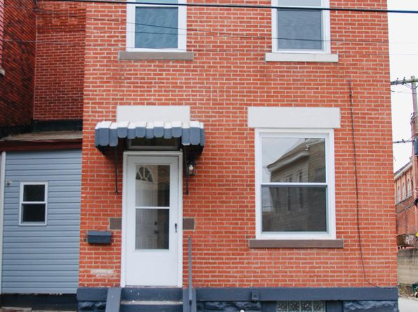](https://www.zillow.com/homedetails/306-54th-St-Pittsburgh-PA-15201/11272828_zpid/)](https://www.zillow.com/homedetails/306-54th-St-Pittsburgh-PA-15201/11272828_zpid/)

*[902-908 McCandless Avenue, 902-908 McCandless Ave #906, Pittsburgh, PA 15201](https://www.zillow.com/b/902-908-mccandless-avenue-pittsburgh-pa-BMgxwN/)*

$1,500/mo

* **2** bds
* **1** ba
* **--** sqft

- Apartment for rent

23 days ago

[[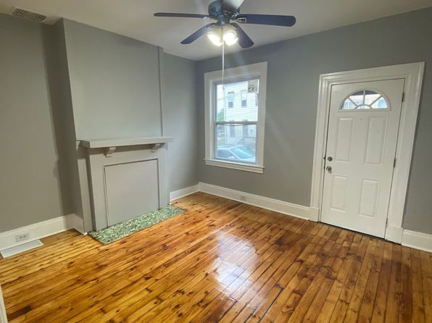](https://www.zillow.com/b/902-908-mccandless-avenue-pittsburgh-pa-BMgxwN/)](https://www.zillow.com/b/902-908-mccandless-avenue-pittsburgh-pa-BMgxwN/)

• • •

*[27 S 14th St #2, Pittsburgh, PA 15203](https://www.zillow.com/homedetails/27-S-14th-St-2-Pittsburgh-PA-15203/2075584434_zpid/)*

$1,595/mo

* **3** bds
* **1** ba
* **1,100** sqft

- Apartment for rent

10 days ago

[[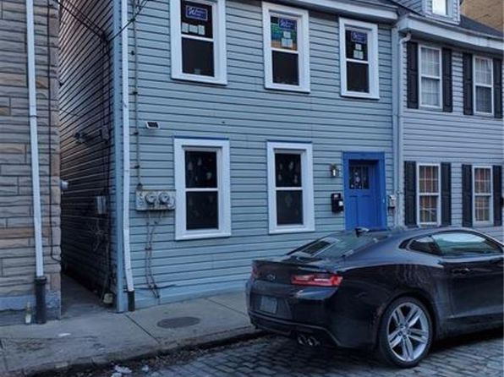](https://www.zillow.com/homedetails/27-S-14th-St-2-Pittsburgh-PA-15203/2075584434_zpid/)](https://www.zillow.com/homedetails/27-S-14th-St-2-Pittsburgh-PA-15203/2075584434_zpid/)

*[201 Allen St, Pittsburgh, PA 15210](https://www.zillow.com/homedetails/201-Allen-St-Pittsburgh-PA-15210/11315570_zpid/)*

$1,450/mo

* **3** bds
* **1** ba
* **--** sqft

- House for rent

24 days ago

[[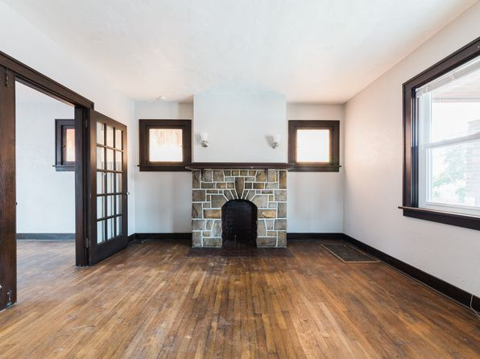](https://www.zillow.com/homedetails/201-Allen-St-Pittsburgh-PA-15210/11315570_zpid/)](https://www.zillow.com/homedetails/201-Allen-St-Pittsburgh-PA-15210/11315570_zpid/)

*[1901 Woodward Ave, Pittsburgh, PA 15226](https://www.zillow.com/homedetails/1901-Woodward-Ave-Pittsburgh-PA-15226/11446330_zpid/)*

$1,300/mo

* **3** bds
* **1** ba
* **1,364** sqft

- House for rent

23 days ago

[[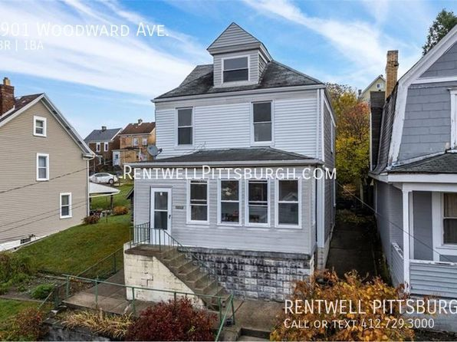](https://www.zillow.com/homedetails/1901-Woodward-Ave-Pittsburgh-PA-15226/11446330_zpid/)](https://www.zillow.com/homedetails/1901-Woodward-Ave-Pittsburgh-PA-15226/11446330_zpid/)

*[119 S Fairmount St #2, Pittsburgh, PA 15206](https://www.zillow.com/homedetails/119-S-Fairmount-St-2-Pittsburgh-PA-15206/2095184642_zpid/)*

$1,999/mo

* **2** bds
* **1.5** ba
* **1,350** sqft

- Apartment for rent

25 days ago

[[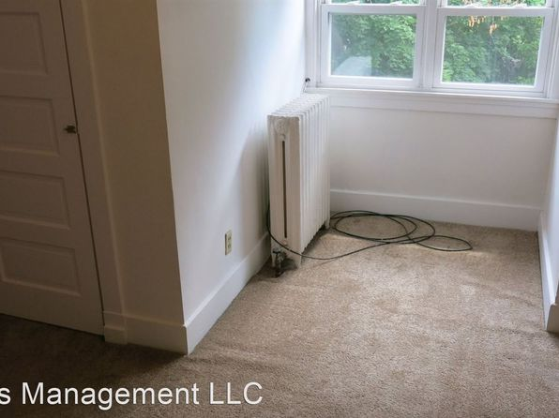](https://www.zillow.com/homedetails/119-S-Fairmount-St-2-Pittsburgh-PA-15206/2095184642_zpid/)](https://www.zillow.com/homedetails/119-S-Fairmount-St-2-Pittsburgh-PA-15206/2095184642_zpid/)

*[5539 Camelia St, Pittsburgh, PA 15201](https://www.zillow.com/homedetails/5539-Camelia-St-Pittsburgh-PA-15201/11615023_zpid/)*

$2,399/mo

* **2** bds
* **2** ba
* **970** sqft

- House for rent

11 days ago

[[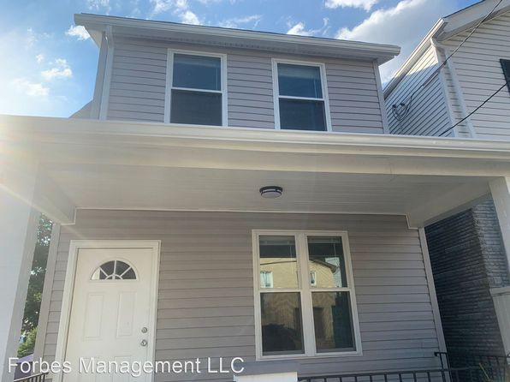](https://www.zillow.com/homedetails/5539-Camelia-St-Pittsburgh-PA-15201/11615023_zpid/)](https://www.zillow.com/homedetails/5539-Camelia-St-Pittsburgh-PA-15201/11615023_zpid/)

*[3217-3223 Brereton Street | 3217-3223 Brereton St, Pittsburgh, PA](https://www.zillow.com/b/3217-3223-brereton-street-pittsburgh-pa-BMh2fp/)*

$869+ 1 bd

* **$1,499+** 2 bds

[[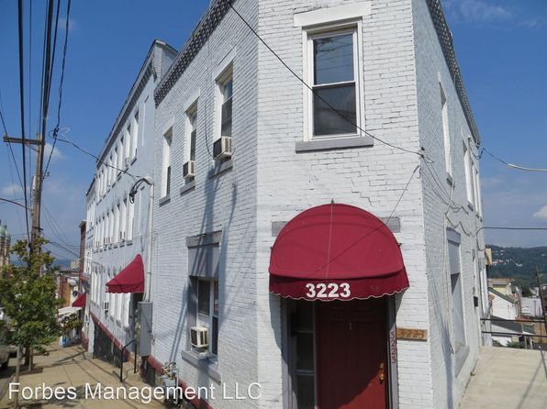](https://www.zillow.com/b/3217-3223-brereton-street-pittsburgh-pa-BMh2fp/)](https://www.zillow.com/b/3217-3223-brereton-street-pittsburgh-pa-BMh2fp/)

*[1464 Tolma Ave, Pittsburgh, PA 15216](https://www.zillow.com/homedetails/1464-Tolma-Ave-Pittsburgh-PA-15216/11655576_zpid/)*

$1,195/mo

* **2** bds
* **1** ba
* **952** sqft

- House for rent

18 days ago

[[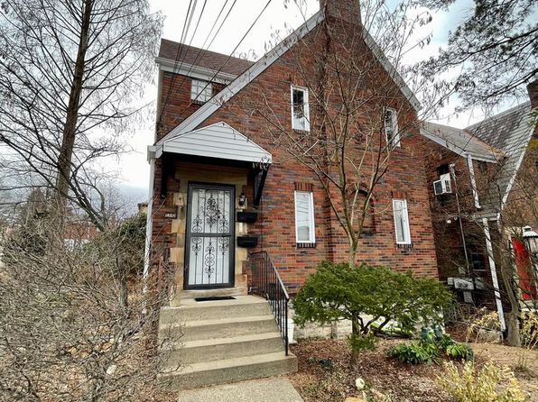](https://www.zillow.com/homedetails/1464-Tolma-Ave-Pittsburgh-PA-15216/11655576_zpid/)](https://www.zillow.com/homedetails/1464-Tolma-Ave-Pittsburgh-PA-15216/11655576_zpid/)

*[4503 Corday Way, Pittsburgh, PA 15224](https://www.zillow.com/homedetails/4503-Corday-Way-Pittsburgh-PA-15224/11515098_zpid/)*

$1,500/mo

* **2** bds
* **2** ba
* **952** sqft

- Townhouse for rent

15 days ago

[[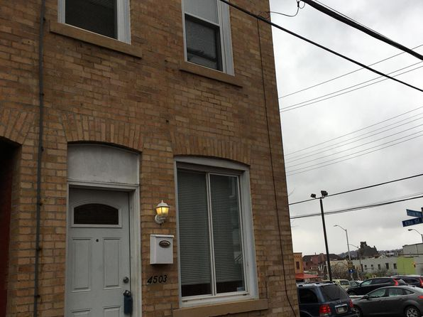](https://www.zillow.com/homedetails/4503-Corday-Way-Pittsburgh-PA-15224/11515098_zpid/)](https://www.zillow.com/homedetails/4503-Corday-Way-Pittsburgh-PA-15224/11515098_zpid/)

*[7616 Kelly St APT 4, Pittsburgh, PA 15208](https://www.zillow.com/homedetails/7616-Kelly-St-APT-4-Pittsburgh-PA-15208/2090056225_zpid/)*

$850/mo

* **2** bds
* **1** ba
* **--** sqft

- Apartment for rent

3D Tour

[[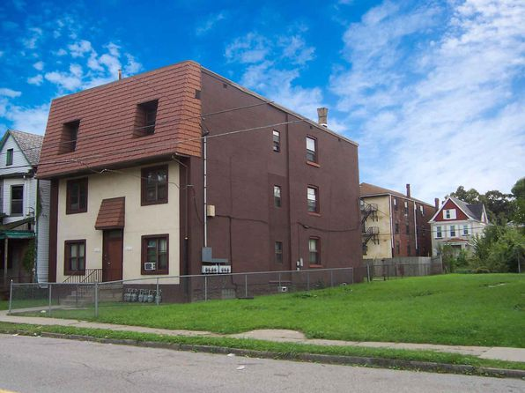](https://www.zillow.com/homedetails/7616-Kelly-St-APT-4-Pittsburgh-PA-15208/2090056225_zpid/)](https://www.zillow.com/homedetails/7616-Kelly-St-APT-4-Pittsburgh-PA-15208/2090056225_zpid/)

*[1874 Greenleaf St, Pittsburgh, PA 15211](https://www.zillow.com/homedetails/1874-Greenleaf-St-Pittsburgh-PA-15211/11585194_zpid/)*

$1,000/mo

* **2** bds
* **1** ba
* **--** sqft

- House for rent

24 days ago

[[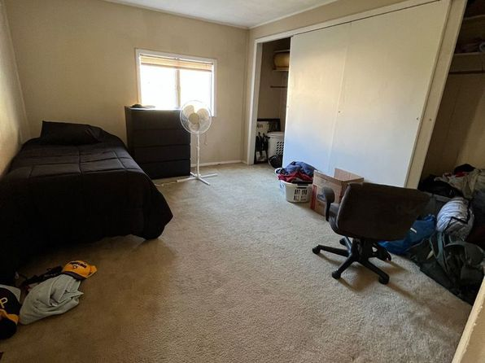](https://www.zillow.com/homedetails/1874-Greenleaf-St-Pittsburgh-PA-15211/11585194_zpid/)](https://www.zillow.com/homedetails/1874-Greenleaf-St-Pittsburgh-PA-15211/11585194_zpid/)

*[1409 Brookline Blvd, Pittsburgh, PA 15226](https://www.zillow.com/homedetails/1409-Brookline-Blvd-Pittsburgh-PA-15226/11649102_zpid/)*

$1,295/mo

* **3** bds
* **1.5** ba
* **1,392** sqft

- House for rent

20 days ago

[[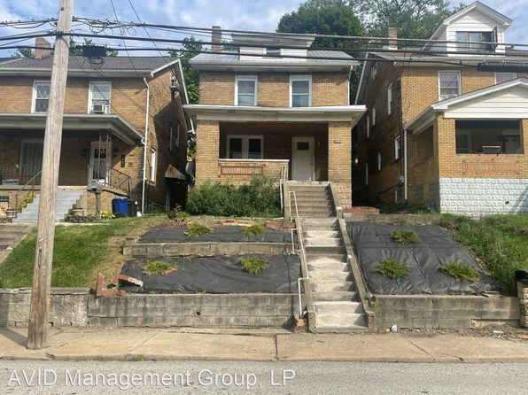](https://www.zillow.com/homedetails/1409-Brookline-Blvd-Pittsburgh-PA-15226/11649102_zpid/)](https://www.zillow.com/homedetails/1409-Brookline-Blvd-Pittsburgh-PA-15226/11649102_zpid/)

*[415 Edgemont St, Mt Washington, PA 15211](https://www.zillow.com/homedetails/415-Edgemont-St-Mt-Washington-PA-15211/11323645_zpid/)*

$1,575/mo

* **4** bds
* **1** ba
* **--** sqft

- House for rent

30 days ago

[[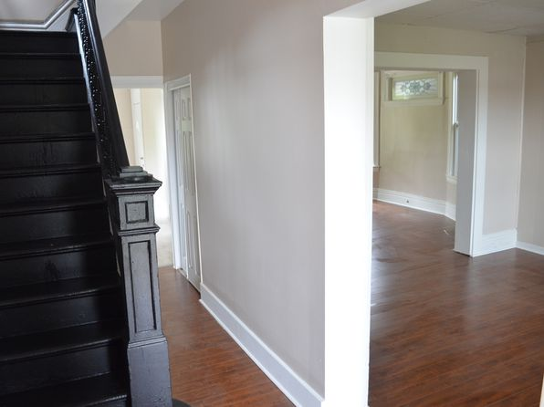](https://www.zillow.com/homedetails/415-Edgemont-St-Mt-Washington-PA-15211/11323645_zpid/)](https://www.zillow.com/homedetails/415-Edgemont-St-Mt-Washington-PA-15211/11323645_zpid/)

*[1646 Longmore Ave, Pittsburgh, PA 15216](https://www.zillow.com/homedetails/1646-Longmore-Ave-Pittsburgh-PA-15216/11445425_zpid/)*

$1,149/mo

* **3** bds
* **1** ba
* **1,232** sqft

- House for rent

20 days ago

[[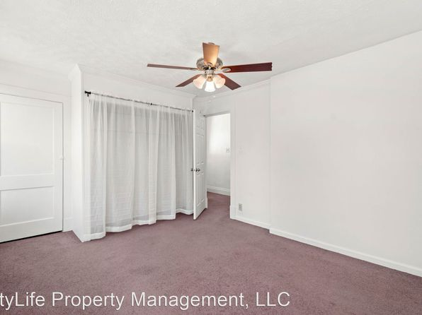](https://www.zillow.com/homedetails/1646-Longmore-Ave-Pittsburgh-PA-15216/11445425_zpid/)](https://www.zillow.com/homedetails/1646-Longmore-Ave-Pittsburgh-PA-15216/11445425_zpid/)

*[904 E Warrington Ave, Pittsburgh, PA 15210](https://www.zillow.com/homedetails/904-E-Warrington-Ave-Pittsburgh-PA-15210/11315004_zpid/)*

$1,375/mo

* **3** bds
* **1** ba
* **1,080** sqft

- House for rent

52 days ago

[[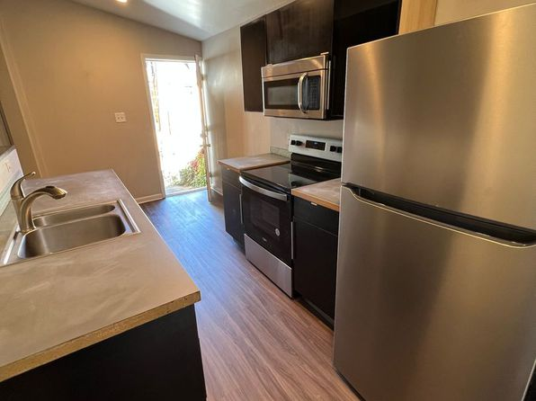](https://www.zillow.com/homedetails/904-E-Warrington-Ave-Pittsburgh-PA-15210/11315004_zpid/)](https://www.zillow.com/homedetails/904-E-Warrington-Ave-Pittsburgh-PA-15210/11315004_zpid/)

*[123 S 13th St, Pittsburgh, PA 15203](https://www.zillow.com/homedetails/123-S-13th-St-Pittsburgh-PA-15203/11474673_zpid/)*

$1,990/mo

* **3** bds
* **2** ba
* **1,440** sqft

- House for rent

3D Tour

[[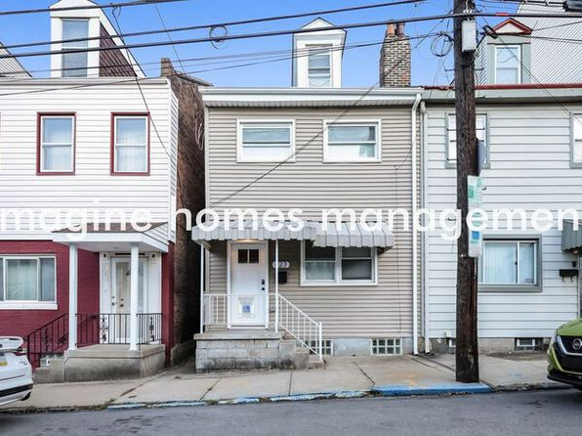](https://www.zillow.com/homedetails/123-S-13th-St-Pittsburgh-PA-15203/11474673_zpid/)](https://www.zillow.com/homedetails/123-S-13th-St-Pittsburgh-PA-15203/11474673_zpid/)

*[115 Varney St, Pittsburgh, PA 15202](https://www.zillow.com/homedetails/115-Varney-St-Pittsburgh-PA-15202/11326872_zpid/)*

$1,195/mo

* **3** bds
* **1.5** ba
* **1,226** sqft

- House for rent

20 days ago

[[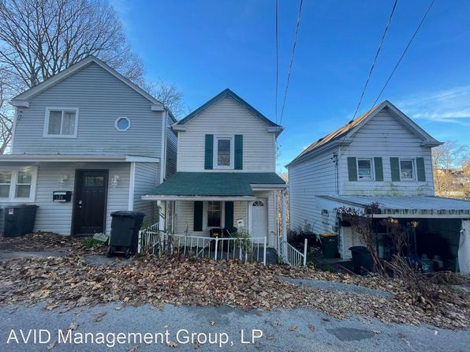](https://www.zillow.com/homedetails/115-Varney-St-Pittsburgh-PA-15202/11326872_zpid/)](https://www.zillow.com/homedetails/115-Varney-St-Pittsburgh-PA-15202/11326872_zpid/)

*[1734 Leolyn St, Pittsburgh, PA 15210](https://www.zillow.com/homedetails/1734-Leolyn-St-Pittsburgh-PA-15210/11557058_zpid/)*

$1,175/mo

* **3** bds
* **1** ba
* **1,088** sqft

- House for rent

31 days ago

[[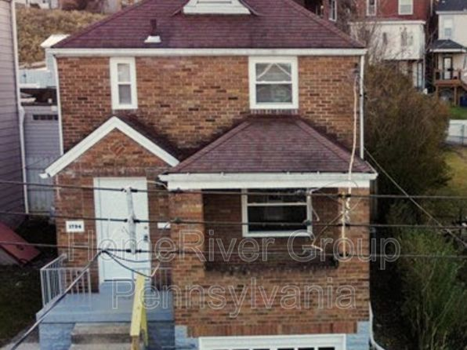](https://www.zillow.com/homedetails/1734-Leolyn-St-Pittsburgh-PA-15210/11557058_zpid/)](https://www.zillow.com/homedetails/1734-Leolyn-St-Pittsburgh-PA-15210/11557058_zpid/)

*[26 Academy Ave APT B4, Mt Lebanon, PA 15228](https://www.zillow.com/homedetails/26-Academy-Ave-APT-B4-Mt-Lebanon-PA-15228/2122137887_zpid/)*

$1,700/mo

* **2** bds
* **1** ba
* **1,150** sqft

- Apartment for rent

13 days ago

[[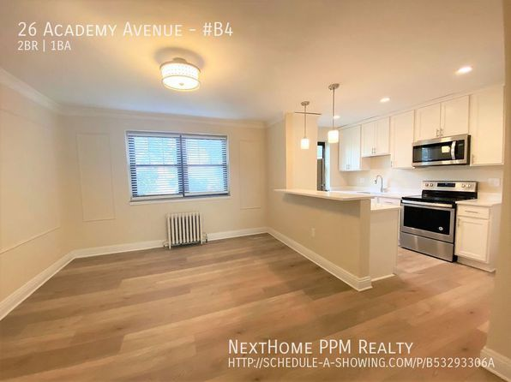](https://www.zillow.com/homedetails/26-Academy-Ave-APT-B4-Mt-Lebanon-PA-15228/2122137887_zpid/)](https://www.zillow.com/homedetails/26-Academy-Ave-APT-B4-Mt-Lebanon-PA-15228/2122137887_zpid/)

*[24 Monastery St, Pittsburgh, PA 15203](https://www.zillow.com/homedetails/24-Monastery-St-Pittsburgh-PA-15203/11315245_zpid/)*

$1,695/mo

* **3** bds
* **2** ba
* **1,500** sqft

- House for rent

9 days ago

[[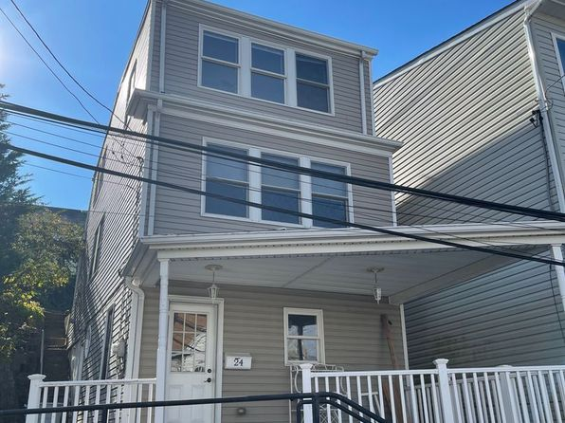](https://www.zillow.com/homedetails/24-Monastery-St-Pittsburgh-PA-15203/11315245_zpid/)](https://www.zillow.com/homedetails/24-Monastery-St-Pittsburgh-PA-15203/11315245_zpid/)

*[51 Hawley Ave, Pittsburgh, PA 15202](https://www.zillow.com/homedetails/51-Hawley-Ave-Pittsburgh-PA-15202/11325669_zpid/)*

$1,750/mo

* **3** bds
* **2** ba
* **1,324** sqft

- House for rent

11 days ago

[[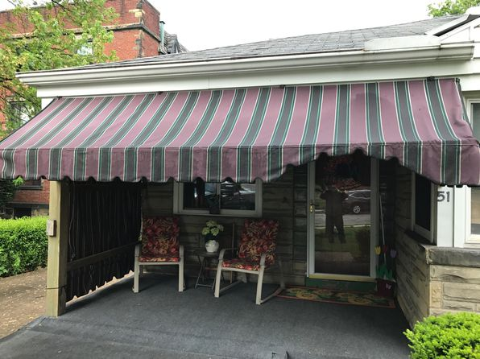](https://www.zillow.com/homedetails/51-Hawley-Ave-Pittsburgh-PA-15202/11325669_zpid/)](https://www.zillow.com/homedetails/51-Hawley-Ave-Pittsburgh-PA-15202/11325669_zpid/)

*[2034 Swallow Hill Ct UNIT 332, Pittsburgh, PA 15220](https://www.zillow.com/homedetails/2034-Swallow-Hill-Ct-UNIT-332-Pittsburgh-PA-15220/2079550365_zpid/)*

$1,100/mo

* **2** bds
* **1** ba
* **1,000** sqft

- House for rent

26 days ago

[[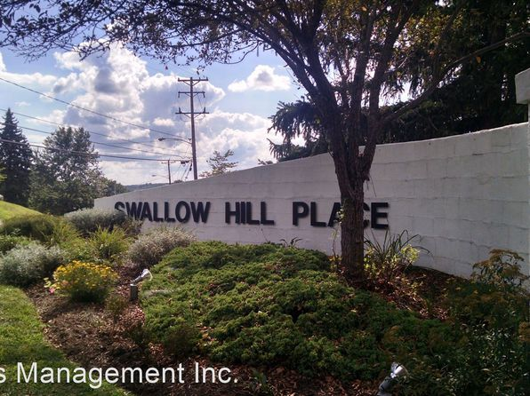](https://www.zillow.com/homedetails/2034-Swallow-Hill-Ct-UNIT-332-Pittsburgh-PA-15220/2079550365_zpid/)](https://www.zillow.com/homedetails/2034-Swallow-Hill-Ct-UNIT-332-Pittsburgh-PA-15220/2079550365_zpid/)

*[4620 Davison St, Pittsburgh, PA 15201](https://www.zillow.com/homedetails/4620-Davison-St-Pittsburgh-PA-15201/11513035_zpid/)*

$2,150/mo

* **2** bds
* **1** ba
* **--** sqft

- House for rent

8 days ago

[[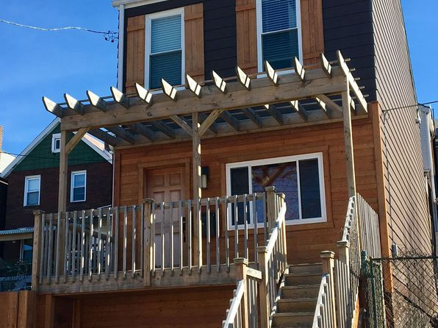](https://www.zillow.com/homedetails/4620-Davison-St-Pittsburgh-PA-15201/11513035_zpid/)](https://www.zillow.com/homedetails/4620-Davison-St-Pittsburgh-PA-15201/11513035_zpid/)

*[155 Merrimac St, Pittsburgh, PA 15211](https://www.zillow.com/homedetails/155-Merrimac-St-Pittsburgh-PA-15211/2068454638_zpid/)*

$1,695/mo

* **4** bds
* **2** ba
* **2,000** sqft

- House for rent

39 days ago

[[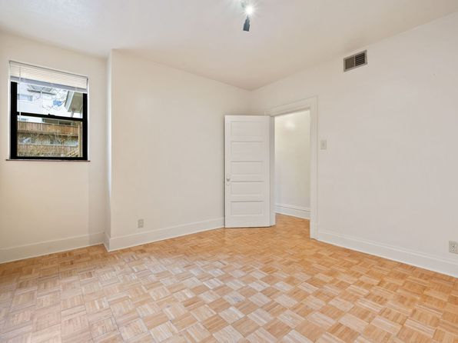](https://www.zillow.com/homedetails/155-Merrimac-St-Pittsburgh-PA-15211/2068454638_zpid/)](https://www.zillow.com/homedetails/155-Merrimac-St-Pittsburgh-PA-15211/2068454638_zpid/)

*[927 Brookline Blvd, 927 Brookline Blvd APT 2, Pittsburgh, PA 15226](https://www.zillow.com/b/927-brookline-blvd-pittsburgh-pa-98PSYk/)*

$995/mo

* **2** bds
* **1** ba
* **--** sqft

- Apartment for rent

34 days ago

[[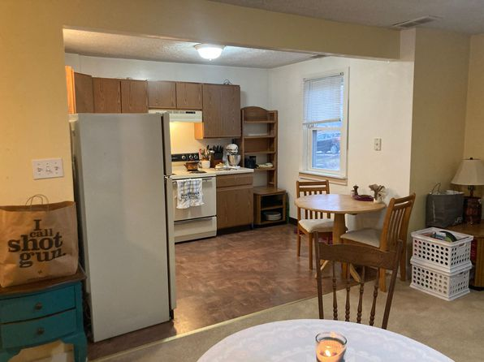](https://www.zillow.com/b/927-brookline-blvd-pittsburgh-pa-98PSYk/)](https://www.zillow.com/b/927-brookline-blvd-pittsburgh-pa-98PSYk/)

to get email alerts when listings hit the market.

*[516 S Highland Ave APT 11, Pittsburgh, PA 15206](https://www.zillow.com/homedetails/516-S-Highland-Ave-APT-11-Pittsburgh-PA-15206/2096039160_zpid/)*

$1,580/mo

* + **1** bd
  + **1** ba
  + **--** sqft

- Apartment for rent

13 days ago

[[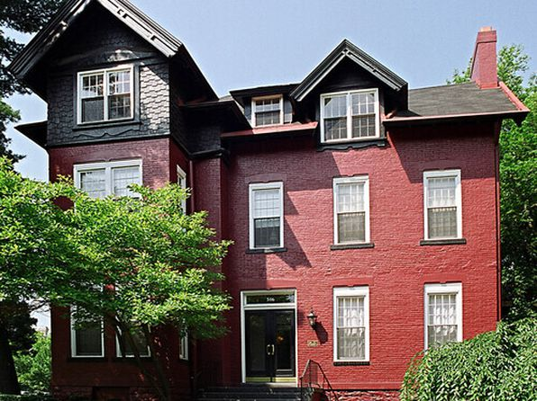](https://www.zillow.com/homedetails/516-S-Highland-Ave-APT-11-Pittsburgh-PA-15206/2096039160_zpid/)](https://www.zillow.com/homedetails/516-S-Highland-Ave-APT-11-Pittsburgh-PA-15206/2096039160_zpid/)

*[248 S Atlantic Ave #2, Pittsburgh, PA 15224](https://www.zillow.com/homedetails/248-S-Atlantic-Ave-2-Pittsburgh-PA-15224/2121969026_zpid/)*

$2,870/mo

* **4** bds
* **2** ba
* **2,392** sqft

- Townhouse for rent

16 days ago

[[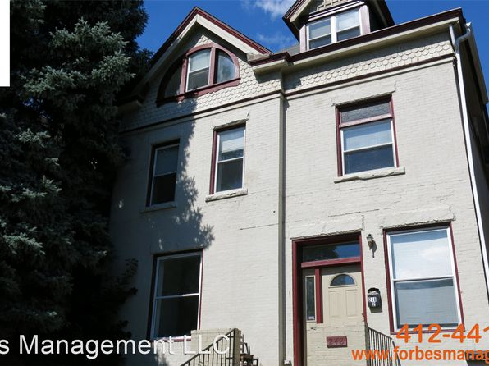](https://www.zillow.com/homedetails/248-S-Atlantic-Ave-2-Pittsburgh-PA-15224/2121969026_zpid/)](https://www.zillow.com/homedetails/248-S-Atlantic-Ave-2-Pittsburgh-PA-15224/2121969026_zpid/)

•

*[1190 Forest Ave APT 3, Pittsburgh, PA 15236](https://www.zillow.com/homedetails/1190-Forest-Ave-APT-3-Pittsburgh-PA-15236/2098204606_zpid/)*

$1,100/mo

* **2** bds
* **2** ba
* **1,100** sqft

- Apartment for rent

20 days ago

[[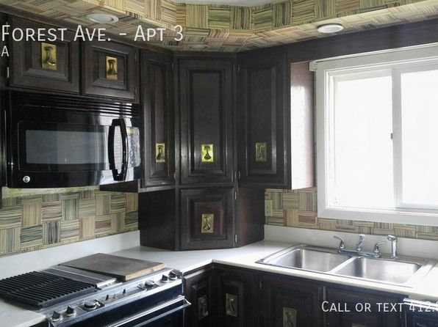](https://www.zillow.com/homedetails/1190-Forest-Ave-APT-3-Pittsburgh-PA-15236/2098204606_zpid/)](https://www.zillow.com/homedetails/1190-Forest-Ave-APT-3-Pittsburgh-PA-15236/2098204606_zpid/)

*[15 Saint Thomas St, Pittsburgh, PA 15203](https://www.zillow.com/homedetails/15-Saint-Thomas-St-Pittsburgh-PA-15203/11315229_zpid/)*

$1,875/mo

* **4** bds
* **1.5** ba
* **--** sqft

- House for rent

30 days ago

[[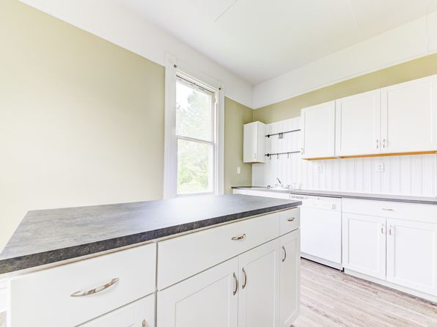](https://www.zillow.com/homedetails/15-Saint-Thomas-St-Pittsburgh-PA-15203/11315229_zpid/)](https://www.zillow.com/homedetails/15-Saint-Thomas-St-Pittsburgh-PA-15203/11315229_zpid/)

*[315 Grace St, Mount Washington, PA 15211](https://www.zillow.com/homedetails/315-Grace-St-Mount-Washington-PA-15211/11515738_zpid/)*

$3,000/mo

* **4** bds
* **2** ba
* **2,500** sqft

- House for rent

18 days ago

[[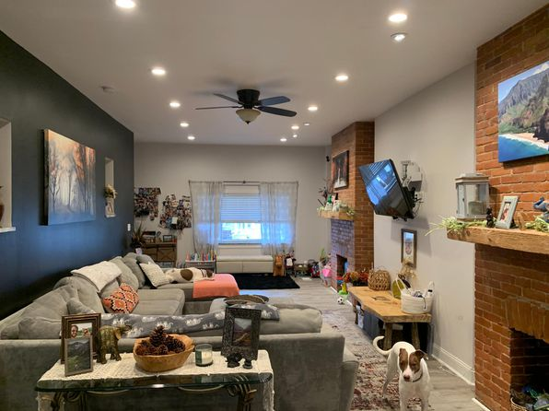](https://www.zillow.com/homedetails/315-Grace-St-Mount-Washington-PA-15211/11515738_zpid/)](https://www.zillow.com/homedetails/315-Grace-St-Mount-Washington-PA-15211/11515738_zpid/)

*[2816 Spring St, Pittsburgh, PA 15210](https://www.zillow.com/homedetails/2816-Spring-St-Pittsburgh-PA-15210/11309186_zpid/)*

$2,649/mo

* **6** bds
* **3** ba
* **--** sqft

- House for rent

45 days ago

[[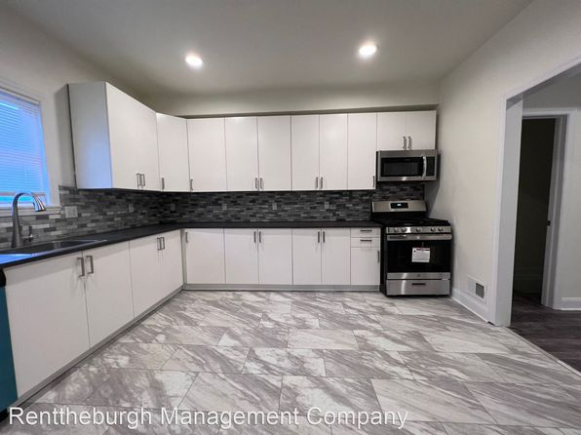](https://www.zillow.com/homedetails/2816-Spring-St-Pittsburgh-PA-15210/11309186_zpid/)](https://www.zillow.com/homedetails/2816-Spring-St-Pittsburgh-PA-15210/11309186_zpid/)

*[2105 Wharton Street, 2105 Wharton St APT 5, Pittsburgh, PA 15203](https://www.zillow.com/b/2105-wharton-street-pittsburgh-pa-5XrpCd/)*

$1,425/mo

* **2** bds
* **1** ba
* **800** sqft

- Apartment for rent

3 days ago

[[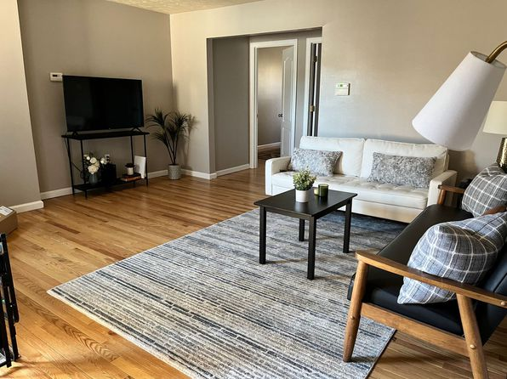](https://www.zillow.com/b/2105-wharton-street-pittsburgh-pa-5XrpCd/)](https://www.zillow.com/b/2105-wharton-street-pittsburgh-pa-5XrpCd/)

*[Rosecrest Drive, 94-96 Rosecrest Dr, Pittsburgh, PA 15229](https://www.zillow.com/b/rosecrest-drive-pittsburgh-pa-5bH3G7/)*

$1,495/mo

* **3** bds
* **1** ba
* **--** sqft

- Apartment for rent

24 days ago

[[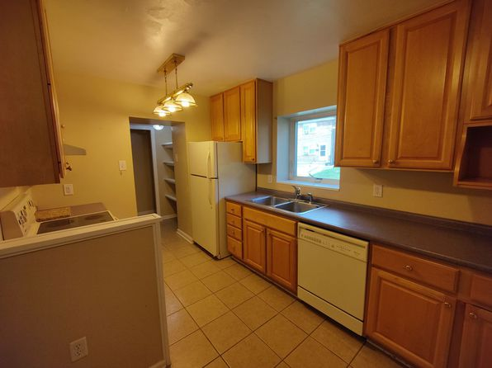](https://www.zillow.com/b/rosecrest-drive-pittsburgh-pa-5bH3G7/)](https://www.zillow.com/b/rosecrest-drive-pittsburgh-pa-5bH3G7/)

*[5519 Hays St #1B, Pittsburgh, PA 15206](https://www.zillow.com/homedetails/5519-Hays-St-1B-Pittsburgh-PA-15206/2060365275_zpid/)*

$1,795/mo

* **2** bds
* **1** ba
* **--** sqft

- Apartment for rent

1 day ago

[[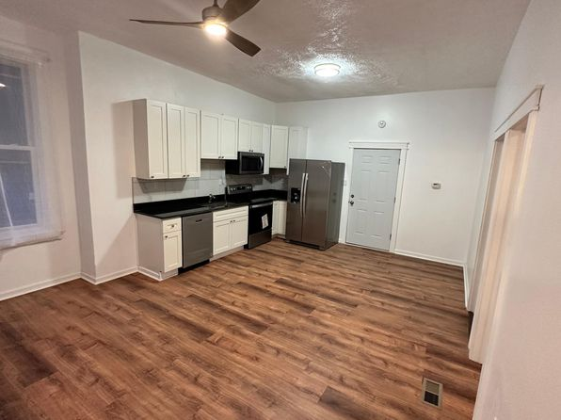](https://www.zillow.com/homedetails/5519-Hays-St-1B-Pittsburgh-PA-15206/2060365275_zpid/)](https://www.zillow.com/homedetails/5519-Hays-St-1B-Pittsburgh-PA-15206/2060365275_zpid/)

*[116 Laughlin Ave, Pittsburgh, PA 15210](https://www.zillow.com/homedetails/116-Laughlin-Ave-Pittsburgh-PA-15210/11556251_zpid/)*

$1,200/mo

* **3** bds
* **1.5** ba
* **1,728** sqft

- House for rent

33 days ago

[[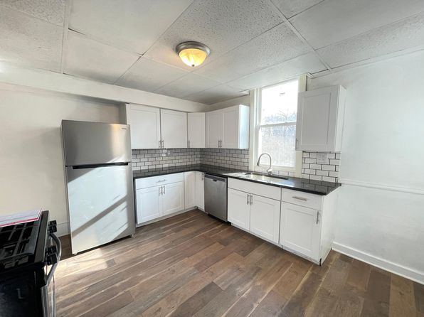](https://www.zillow.com/homedetails/116-Laughlin-Ave-Pittsburgh-PA-15210/11556251_zpid/)](https://www.zillow.com/homedetails/116-Laughlin-Ave-Pittsburgh-PA-15210/11556251_zpid/)

*[125 Roup Ave., 125 Roup Ave APT 2, Pittsburgh, PA 15206](https://www.zillow.com/b/125-roup-ave.-pittsburgh-pa-5jBsBS/)*

$1,395/mo

* **2** bds
* **2** ba
* **--** sqft

- Apartment for rent

24 days ago

[[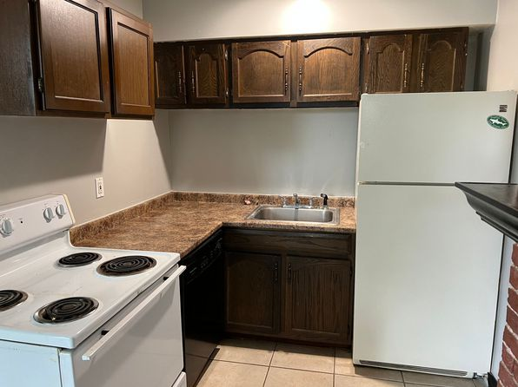](https://www.zillow.com/b/125-roup-ave.-pittsburgh-pa-5jBsBS/)](https://www.zillow.com/b/125-roup-ave.-pittsburgh-pa-5jBsBS/)

*[219 Thompson Run Road, 219 Thompson Run Rd FLOOR 1, Pittsburgh, PA 15237](https://www.zillow.com/b/219-thompson-run-road-pittsburgh-pa-98Q4NL/)*

$975/mo

* **1** bd
* **1** ba
* **--** sqft

- Apartment for rent

39 days ago

[[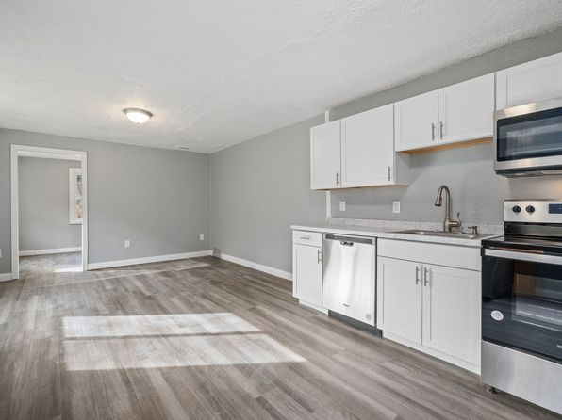](https://www.zillow.com/b/219-thompson-run-road-pittsburgh-pa-98Q4NL/)](https://www.zillow.com/b/219-thompson-run-road-pittsburgh-pa-98Q4NL/)

*[1312 Complete St, Pittsburgh, PA 15212](https://www.zillow.com/homedetails/1312-Complete-St-Pittsburgh-PA-15212/11606343_zpid/)*

$895/mo

* **2** bds
* **1** ba
* **1,184** sqft

- House for rent

20 days ago

[[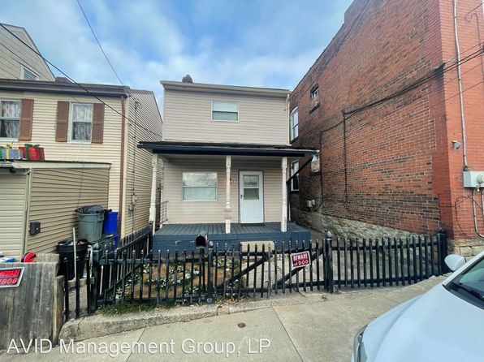](https://www.zillow.com/homedetails/1312-Complete-St-Pittsburgh-PA-15212/11606343_zpid/)](https://www.zillow.com/homedetails/1312-Complete-St-Pittsburgh-PA-15212/11606343_zpid/)

*[44 S 11th St, Pittsburgh, PA 15203](https://www.zillow.com/homedetails/44-S-11th-St-Pittsburgh-PA-15203/11474273_zpid/)*

$2,940/mo

* **4** bds
* **3** ba
* **1,200** sqft

- House for rent

26 days ago

[[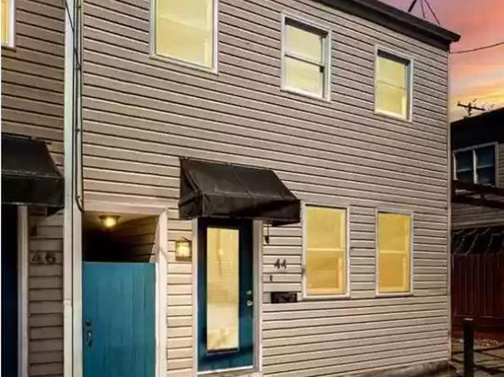](https://www.zillow.com/homedetails/44-S-11th-St-Pittsburgh-PA-15203/11474273_zpid/)](https://www.zillow.com/homedetails/44-S-11th-St-Pittsburgh-PA-15203/11474273_zpid/)

*[12 E Sycamore St, Pittsburgh, PA 15211](https://www.zillow.com/homedetails/12-E-Sycamore-St-Pittsburgh-PA-15211/11515849_zpid/)*

$1,250/mo

* **2** bds
* **1** ba
* **--** sqft

- House for rent

24 days ago

[[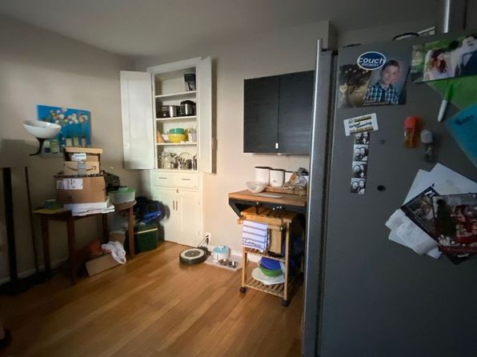](https://www.zillow.com/homedetails/12-E-Sycamore-St-Pittsburgh-PA-15211/11515849_zpid/)](https://www.zillow.com/homedetails/12-E-Sycamore-St-Pittsburgh-PA-15211/11515849_zpid/)

•

*[410 S Atlantic Ave APT A, Pittsburgh, PA 15224](https://www.zillow.com/homedetails/410-S-Atlantic-Ave-APT-A-Pittsburgh-PA-15224/2102863576_zpid/)*

$879/mo

* **1** bd
* **1** ba
* **485** sqft

- Apartment for rent

12 days ago

[[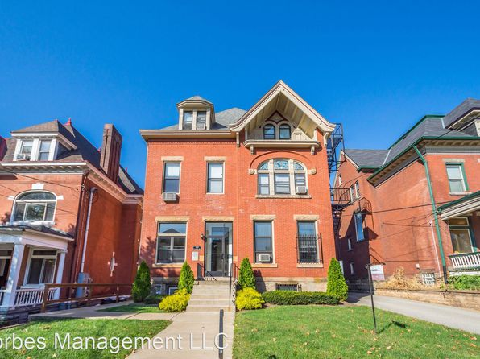](https://www.zillow.com/homedetails/410-S-Atlantic-Ave-APT-A-Pittsburgh-PA-15224/2102863576_zpid/)](https://www.zillow.com/homedetails/410-S-Atlantic-Ave-APT-A-Pittsburgh-PA-15224/2102863576_zpid/)

*[823 Proctor Way, Pittsburgh, PA 15210](https://www.zillow.com/homedetails/823-Proctor-Way-Pittsburgh-PA-15210/11315559_zpid/)*

$1,400/mo

* **2** bds
* **1** ba
* **--** sqft

- House for rent

10 days ago

[[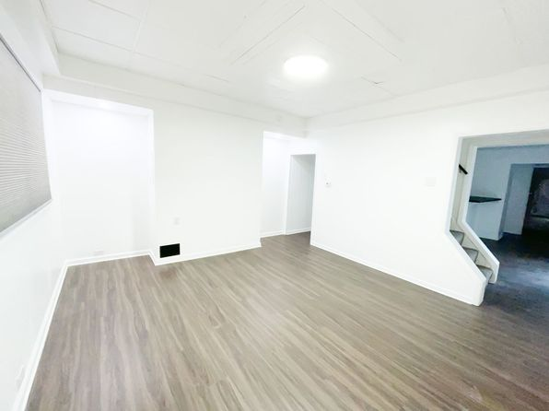](https://www.zillow.com/homedetails/823-Proctor-Way-Pittsburgh-PA-15210/11315559_zpid/)](https://www.zillow.com/homedetails/823-Proctor-Way-Pittsburgh-PA-15210/11315559_zpid/)

*[2120 Merriman Way, Pittsburgh, PA 15203](https://www.zillow.com/homedetails/2120-Merriman-Way-Pittsburgh-PA-15203/11290733_zpid/)*

$1,550/mo

* **2** bds
* **1** ba
* **950** sqft

- House for rent

39 days ago

[[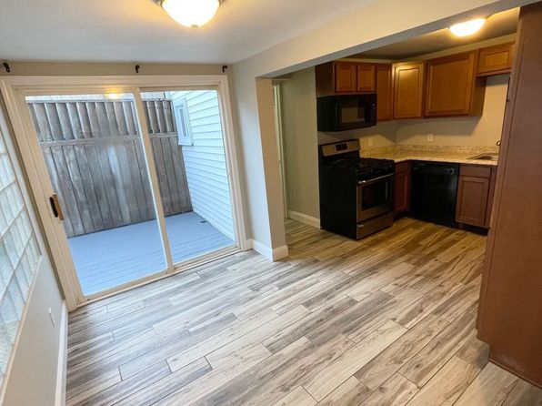](https://www.zillow.com/homedetails/2120-Merriman-Way-Pittsburgh-PA-15203/11290733_zpid/)](https://www.zillow.com/homedetails/2120-Merriman-Way-Pittsburgh-PA-15203/11290733_zpid/)

*[96 Jeremias Street, 96 Jeremias St APT 4, Swissvale, PA 15218](https://www.zillow.com/b/96-jeremias-street-pittsburgh-pa-98P6BK/)*

$795/mo

* **1** bd
* **1** ba
* **--** sqft

- Apartment for rent

39 days ago

[[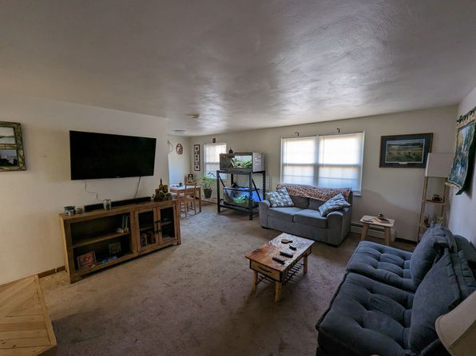](https://www.zillow.com/b/96-jeremias-street-pittsburgh-pa-98P6BK/)](https://www.zillow.com/b/96-jeremias-street-pittsburgh-pa-98P6BK/)

*[Robinson 151 - 27, 151 Robinson St, Pittsburgh, PA 15213](https://www.zillow.com/b/robinson-151-27-pittsburgh-pa-5fwkqK/)*

$1,225+/mo

* **1** bd
* **1** ba
* **--** sqft

- Apartment for rent

40 days ago

[[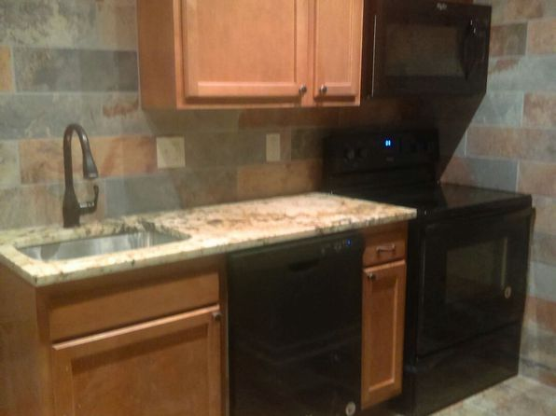](https://www.zillow.com/b/robinson-151-27-pittsburgh-pa-5fwkqK/)](https://www.zillow.com/b/robinson-151-27-pittsburgh-pa-5fwkqK/)

*[132 Westfield Ave, Pittsburgh, PA 15229](https://www.zillow.com/homedetails/132-Westfield-Ave-Pittsburgh-PA-15229/11408159_zpid/)*

$1,295/mo

* **3** bds
* **1** ba
* **1,726** sqft

- House for rent

20 days ago

[[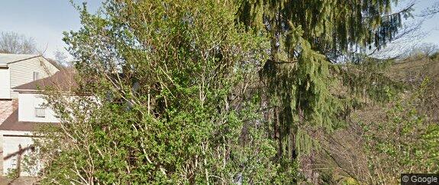](https://www.zillow.com/homedetails/132-Westfield-Ave-Pittsburgh-PA-15229/11408159_zpid/)](https://www.zillow.com/homedetails/132-Westfield-Ave-Pittsburgh-PA-15229/11408159_zpid/)

*[734 Franklin Ave APT 2, Pittsburgh, PA 15221](https://www.zillow.com/homedetails/734-Franklin-Ave-APT-2-Pittsburgh-PA-15221/2060359060_zpid/)*

$1,050/mo

* **3** bds
* **1** ba
* **--** sqft

- Apartment for rent

41 days ago

[[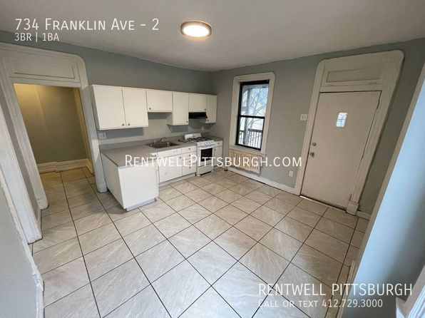](https://www.zillow.com/homedetails/734-Franklin-Ave-APT-2-Pittsburgh-PA-15221/2060359060_zpid/)](https://www.zillow.com/homedetails/734-Franklin-Ave-APT-2-Pittsburgh-PA-15221/2060359060_zpid/)

*[Robinson 205 - 18, 205 Robinson St, Pittsburgh, PA 15213](https://www.zillow.com/b/robinson-205-18-pittsburgh-pa-5jBs9X/)*

$1,195+/mo

* **1** bd
* **1** ba
* **--** sqft

- Apartment for rent

19 days ago

[[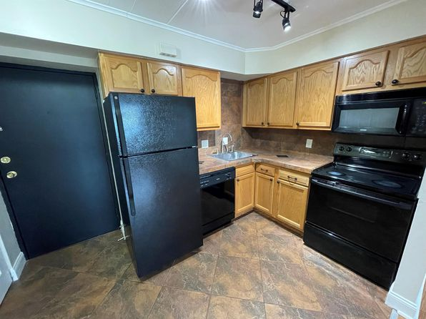](https://www.zillow.com/b/robinson-205-18-pittsburgh-pa-5jBs9X/)](https://www.zillow.com/b/robinson-205-18-pittsburgh-pa-5jBs9X/)

*[211 Southern Ave, Pittsburgh, PA 15211](https://www.zillow.com/homedetails/211-Southern-Ave-Pittsburgh-PA-15211/11516604_zpid/)*

$1,250/mo

* **2** bds
* **1** ba
* **--** sqft

- House for rent

16 days ago

[[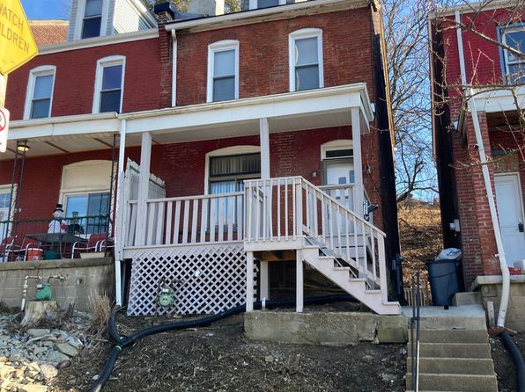](https://www.zillow.com/homedetails/211-Southern-Ave-Pittsburgh-PA-15211/11516604_zpid/)](https://www.zillow.com/homedetails/211-Southern-Ave-Pittsburgh-PA-15211/11516604_zpid/)

*[560 E End Ave APT 2, Pittsburgh, PA 15221](https://www.zillow.com/homedetails/560-E-End-Ave-APT-2-Pittsburgh-PA-15221/2060269045_zpid/)*

$1,850/mo

* **3** bds
* **2** ba
* **1,476** sqft

- Apartment for rent

27 days ago

[[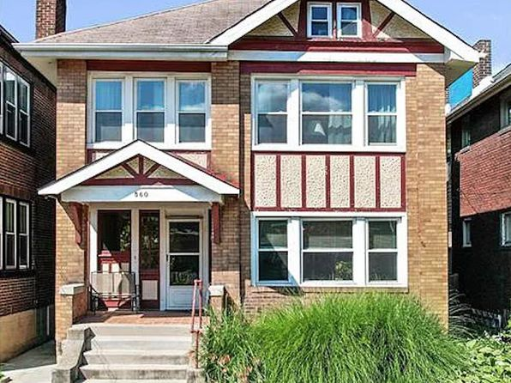](https://www.zillow.com/homedetails/560-E-End-Ave-APT-2-Pittsburgh-PA-15221/2060269045_zpid/)](https://www.zillow.com/homedetails/560-E-End-Ave-APT-2-Pittsburgh-PA-15221/2060269045_zpid/)

*[532 Mellon St #1, Pittsburgh, PA 15206](https://www.zillow.com/homedetails/532-Mellon-St-1-Pittsburgh-PA-15206/2103745746_zpid/)*

$2,900/mo

* **4** bds
* **2** ba
* **2,000** sqft

- Apartment for rent

12 days ago

[[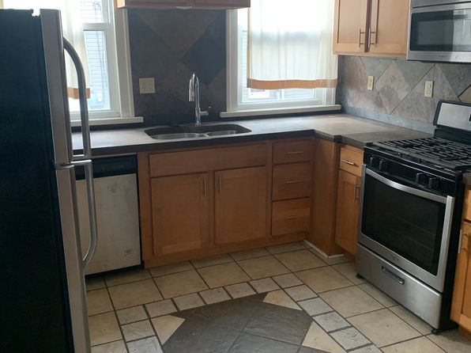](https://www.zillow.com/homedetails/532-Mellon-St-1-Pittsburgh-PA-15206/2103745746_zpid/)](https://www.zillow.com/homedetails/532-Mellon-St-1-Pittsburgh-PA-15206/2103745746_zpid/)

*[613 Boggs Ave #6, Pittsburgh, PA 15211](https://www.zillow.com/homedetails/613-Boggs-Ave-6-Pittsburgh-PA-15211/2093509993_zpid/)*

$925/mo

* **2** bds
* **1** ba
* **--** sqft

- Apartment for rent

11 days ago

[[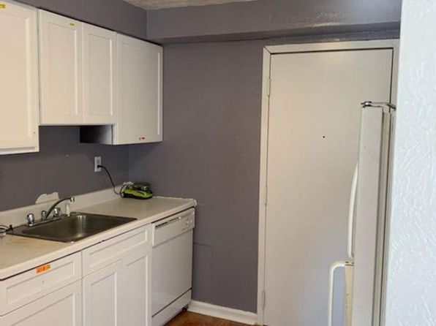](https://www.zillow.com/homedetails/613-Boggs-Ave-6-Pittsburgh-PA-15211/2093509993_zpid/)](https://www.zillow.com/homedetails/613-Boggs-Ave-6-Pittsburgh-PA-15211/2093509993_zpid/)

*[1413 Bingham St, Pittsburgh, PA 15203](https://www.zillow.com/homedetails/1413-Bingham-St-Pittsburgh-PA-15203/11474346_zpid/)*

$1,975/mo

* **3** bds
* **2** ba
* **2,000** sqft

- House for rent

6 days ago

[[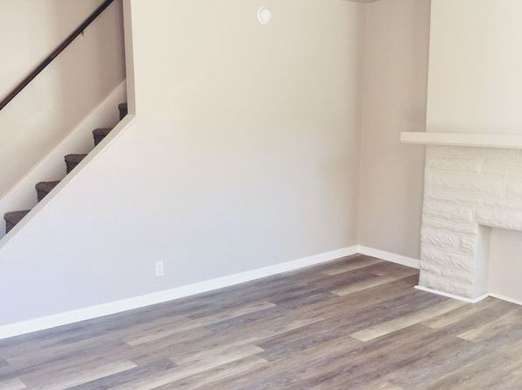](https://www.zillow.com/homedetails/1413-Bingham-St-Pittsburgh-PA-15203/11474346_zpid/)](https://www.zillow.com/homedetails/1413-Bingham-St-Pittsburgh-PA-15203/11474346_zpid/)

*[5627-5631 Rippey Street | 5627-5631 Rippey St, Pittsburgh, PA](https://www.zillow.com/b/5627-5631-rippey-street-pittsburgh-pa-Bt47bY/)*

$989+ 1 bd

[[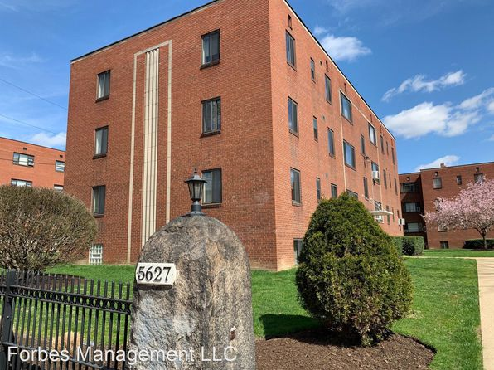](https://www.zillow.com/b/5627-5631-rippey-street-pittsburgh-pa-Bt47bY/)](https://www.zillow.com/b/5627-5631-rippey-street-pittsburgh-pa-Bt47bY/)

*[327 Rodi Rd, Pittsburgh, PA 15235](https://www.zillow.com/homedetails/327-Rodi-Rd-Pittsburgh-PA-15235/11493179_zpid/)*

$1,475/mo

* **3** bds
* **2** ba
* **1,368** sqft

- House for rent

22 days ago

[[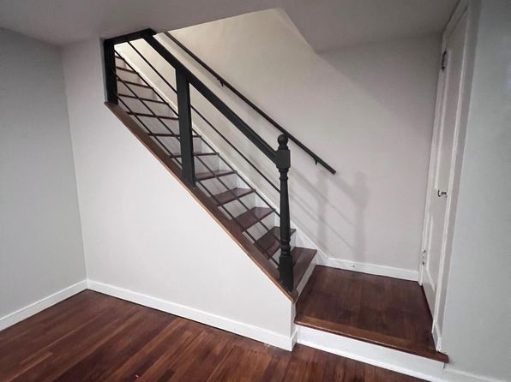](https://www.zillow.com/homedetails/327-Rodi-Rd-Pittsburgh-PA-15235/11493179_zpid/)](https://www.zillow.com/homedetails/327-Rodi-Rd-Pittsburgh-PA-15235/11493179_zpid/)

*[117 Crawford Avenue, 117 Crawford Ave APT 3, Pittsburgh, PA 15202](https://www.zillow.com/b/117-crawford-avenue-pittsburgh-pa-98N49s/)*

$1,145/mo

* **3** bds
* **2** ba
* **1,400** sqft

- Apartment for rent

39 days ago

[[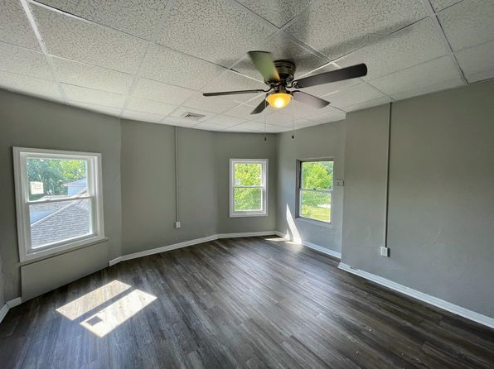](https://www.zillow.com/b/117-crawford-avenue-pittsburgh-pa-98N49s/)](https://www.zillow.com/b/117-crawford-avenue-pittsburgh-pa-98N49s/)

*[1963-1965 Pittview Ave, 1963-1965 Pittview Ave #1, Pittsburgh, PA 15212](https://www.zillow.com/b/1963-1965-pittview-ave-pittsburgh-pa-BK3pXC/)*

$825/mo

* **1** bd
* **1** ba
* **--** sqft

- Apartment for rent

16 days ago

[[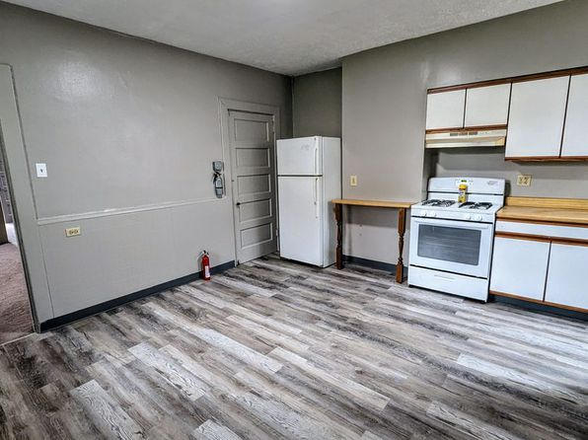](https://www.zillow.com/b/1963-1965-pittview-ave-pittsburgh-pa-BK3pXC/)](https://www.zillow.com/b/1963-1965-pittview-ave-pittsburgh-pa-BK3pXC/)

*[81 S Harrison Ave FLOOR 1, Pittsburgh, PA 15202](https://www.zillow.com/homedetails/81-S-Harrison-Ave-FLOOR-1-Pittsburgh-PA-15202/2067020954_zpid/)*

$1,145/mo

* **2** bds
* **1** ba
* **850** sqft

- Apartment for rent

54 days ago

[[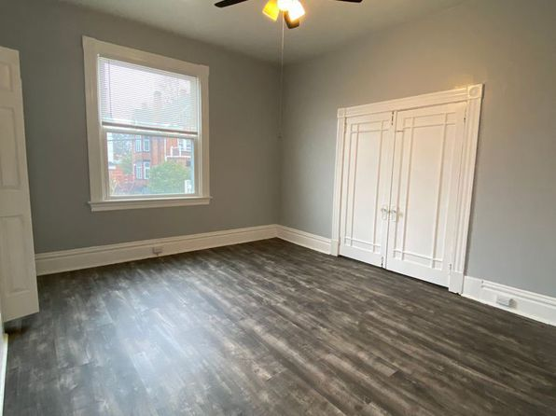](https://www.zillow.com/homedetails/81-S-Harrison-Ave-FLOOR-1-Pittsburgh-PA-15202/2067020954_zpid/)](https://www.zillow.com/homedetails/81-S-Harrison-Ave-FLOOR-1-Pittsburgh-PA-15202/2067020954_zpid/)

*[1350 Evers Dr APT 23, Pittsburgh, PA 15206](https://www.zillow.com/homedetails/1350-Evers-Dr-APT-23-Pittsburgh-PA-15206/2060525997_zpid/)*

$933/mo

* **2** bds
* **1** ba
* **--** sqft

- Apartment for rent

3D Tour

[[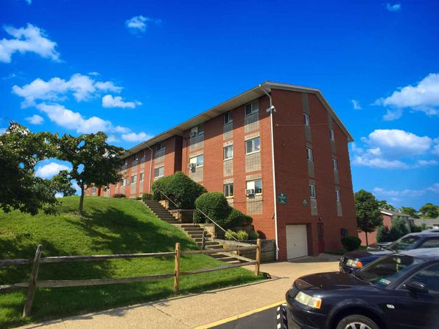](https://www.zillow.com/homedetails/1350-Evers-Dr-APT-23-Pittsburgh-PA-15206/2060525997_zpid/)](https://www.zillow.com/homedetails/1350-Evers-Dr-APT-23-Pittsburgh-PA-15206/2060525997_zpid/)

*[1962 Waite St, Pittsburgh, PA 15210](https://www.zillow.com/homedetails/1962-Waite-St-Pittsburgh-PA-15210/2068420476_zpid/)*

$995/mo

* **2** bds
* **1** ba
* **--** sqft

- House for rent

39 days ago

[[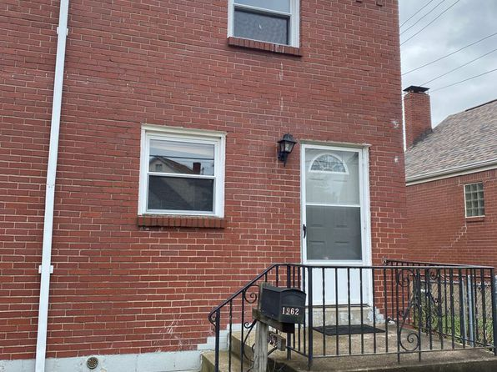](https://www.zillow.com/homedetails/1962-Waite-St-Pittsburgh-PA-15210/2068420476_zpid/)](https://www.zillow.com/homedetails/1962-Waite-St-Pittsburgh-PA-15210/2068420476_zpid/)

*[4933 Butler St FLOOR 1, Pittsburgh, PA 15201](https://www.zillow.com/homedetails/4933-Butler-St-FLOOR-1-Pittsburgh-PA-15201/2069545097_zpid/)*

$1,000/mo

* **Studio**
* **1** ba
* **--** sqft

- Townhouse for rent

28 days ago

[[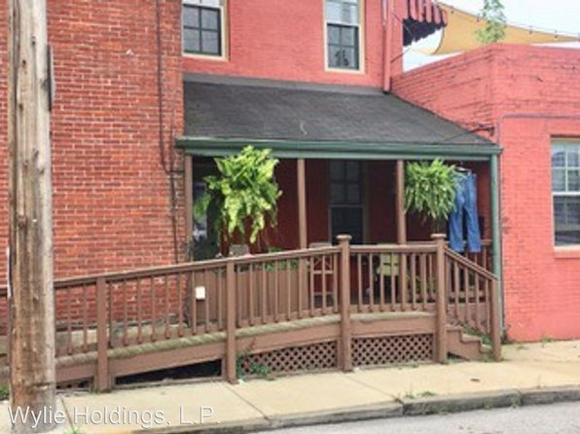](https://www.zillow.com/homedetails/4933-Butler-St-FLOOR-1-Pittsburgh-PA-15201/2069545097_zpid/)](https://www.zillow.com/homedetails/4933-Butler-St-FLOOR-1-Pittsburgh-PA-15201/2069545097_zpid/)

*[4103 Allequippa St APT 3, Pittsburgh, PA 15219](https://www.zillow.com/homedetails/4103-Allequippa-St-APT-3-Pittsburgh-PA-15219/2091921109_zpid/)*

$1,495/mo

* **2** bds
* **1** ba
* **--** sqft

- Apartment for rent

39 days ago

[[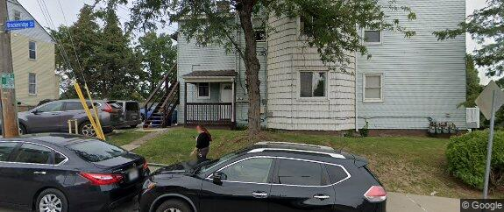](https://www.zillow.com/homedetails/4103-Allequippa-St-APT-3-Pittsburgh-PA-15219/2091921109_zpid/)](https://www.zillow.com/homedetails/4103-Allequippa-St-APT-3-Pittsburgh-PA-15219/2091921109_zpid/)

*[8 Regina St S, Pittsburgh, PA 15203](https://www.zillow.com/homedetails/8-Regina-St-S-Pittsburgh-PA-15203/2064332423_zpid/)*

$1,400/mo

* **3** bds
* **1** ba
* **--** sqft

- House for rent

24 days ago

[[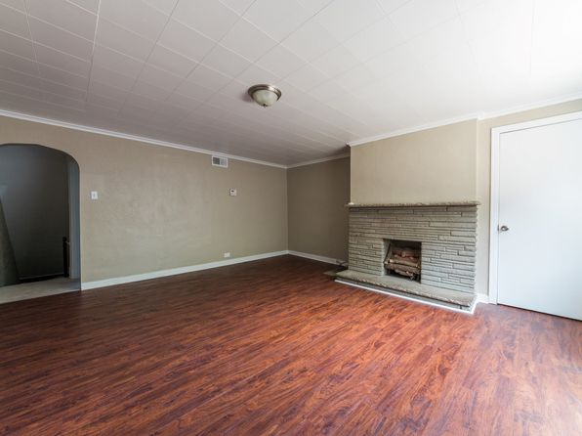](https://www.zillow.com/homedetails/8-Regina-St-S-Pittsburgh-PA-15203/2064332423_zpid/)](https://www.zillow.com/homedetails/8-Regina-St-S-Pittsburgh-PA-15203/2064332423_zpid/)

*[127 Elmont Street, 127 Elmont St FLOOR 2, Pittsburgh, PA 15205](https://www.zillow.com/b/127-elmont-street-pittsburgh-pa-98NBJc/)*

$1,050/mo

* **2** bds
* **1** ba
* **--** sqft

- Apartment for rent

39 days ago

[[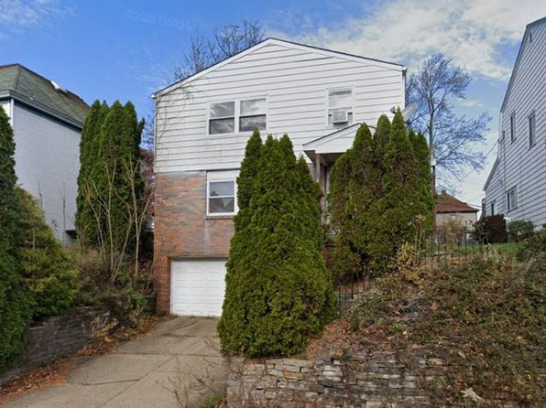](https://www.zillow.com/b/127-elmont-street-pittsburgh-pa-98NBJc/)](https://www.zillow.com/b/127-elmont-street-pittsburgh-pa-98NBJc/)

*[2619 Stella St, Pittsburgh, PA 15203](https://www.zillow.com/homedetails/2619-Stella-St-Pittsburgh-PA-15203/11307812_zpid/)*

$1,400/mo

* **3** bds
* **1** ba
* **1,650** sqft

- House for rent

45 days ago

[[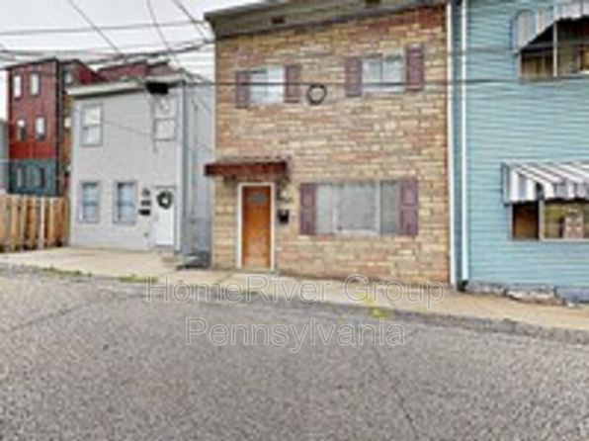](https://www.zillow.com/homedetails/2619-Stella-St-Pittsburgh-PA-15203/11307812_zpid/)](https://www.zillow.com/homedetails/2619-Stella-St-Pittsburgh-PA-15203/11307812_zpid/)

to get email alerts when listings hit the market.

*[3351 Maple Dr, Pittsburgh, PA 15237](https://www.zillow.com/homedetails/3351-Maple-Dr-Pittsburgh-PA-15237/11484260_zpid/)*

$1,980/mo

* + **3** bds
  + **2** ba
  + **1,431** sqft

- House for rent

10 days ago

[[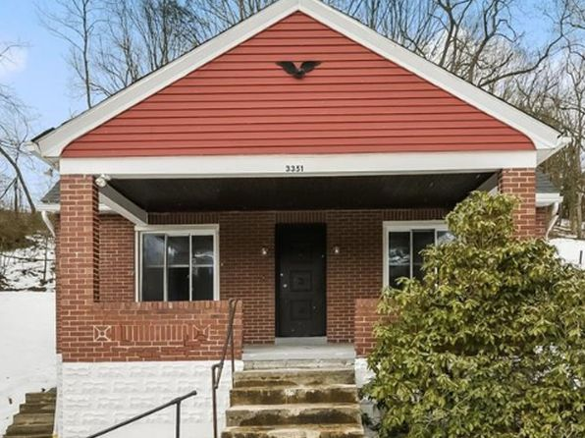](https://www.zillow.com/homedetails/3351-Maple-Dr-Pittsburgh-PA-15237/11484260_zpid/)](https://www.zillow.com/homedetails/3351-Maple-Dr-Pittsburgh-PA-15237/11484260_zpid/)

*[127 Hilands Pl, Pittsburgh, PA 15237](https://www.zillow.com/homedetails/127-Hilands-Pl-Pittsburgh-PA-15237/2059969410_zpid/)*

$1,450/mo

* **3** bds
* **1** ba
* **1,170** sqft

- House for rent

9 days ago

[[](https://www.zillow.com/homedetails/127-Hilands-Pl-Pittsburgh-PA-15237/2059969410_zpid/)](https://www.zillow.com/homedetails/127-Hilands-Pl-Pittsburgh-PA-15237/2059969410_zpid/)

•

*[3712 Parviss St, Pittsburgh, PA 15212](https://www.zillow.com/homedetails/3712-Parviss-St-Pittsburgh-PA-15212/11269367_zpid/)*

$2,150/mo

* **4** bds
* **1.5** ba
* **2,100** sqft

- House for rent

5 days ago

[[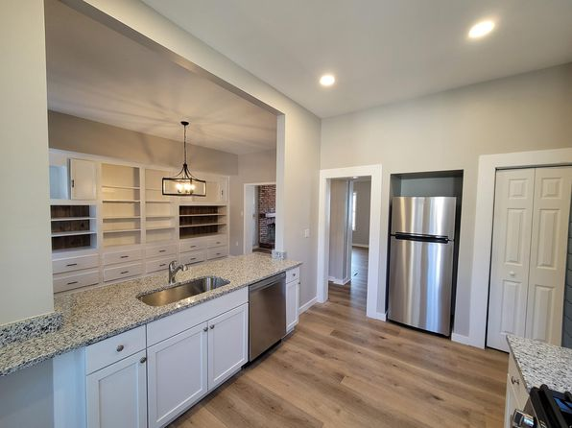](https://www.zillow.com/homedetails/3712-Parviss-St-Pittsburgh-PA-15212/11269367_zpid/)](https://www.zillow.com/homedetails/3712-Parviss-St-Pittsburgh-PA-15212/11269367_zpid/)

*[1335 Cedar Blvd, 1335 Cedar Blvd APT G, Pittsburgh, PA 15228](https://www.zillow.com/b/1335-cedar-blvd-pittsburgh-pa-98PYbb/)*

$1,195/mo

* **1** bd
* **1** ba
* **--** sqft

- Apartment for rent

39 days ago

[[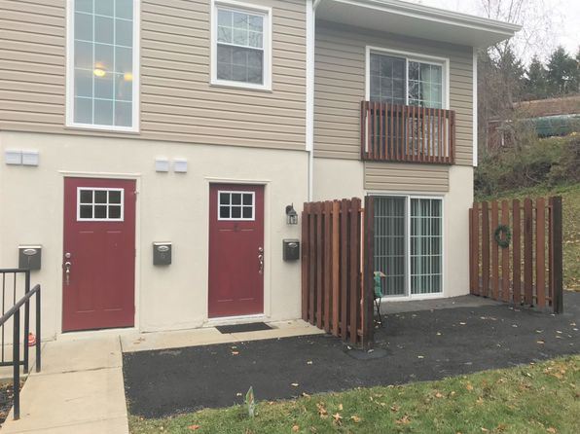](https://www.zillow.com/b/1335-cedar-blvd-pittsburgh-pa-98PYbb/)](https://www.zillow.com/b/1335-cedar-blvd-pittsburgh-pa-98PYbb/)

*[4415 Garwood Way UNIT 1, Pittsburgh, PA 15201](https://www.zillow.com/homedetails/4415-Garwood-Way-UNIT-1-Pittsburgh-PA-15201/2060179773_zpid/)*

$1,525/mo

* **2** bds
* **1** ba
* **--** sqft

- Apartment for rent

20 days ago

[[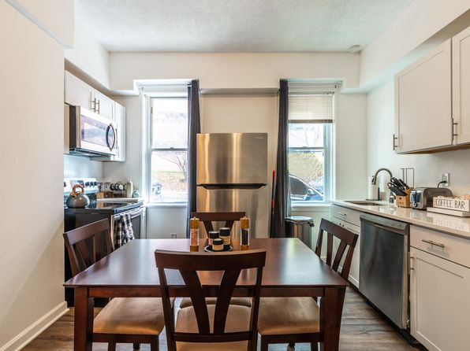](https://www.zillow.com/homedetails/4415-Garwood-Way-UNIT-1-Pittsburgh-PA-15201/2060179773_zpid/)](https://www.zillow.com/homedetails/4415-Garwood-Way-UNIT-1-Pittsburgh-PA-15201/2060179773_zpid/)

*[Bartlett St Commons, 5825 Bartlett St APT 1M, Pittsburgh, PA 15217](https://www.zillow.com/b/bartlett-st-commons-squirrel-hill-pa-5fwkZK/)*

$2,434/mo

* **3** bds
* **2** ba
* **--** sqft

- Apartment for rent

32 days ago

[[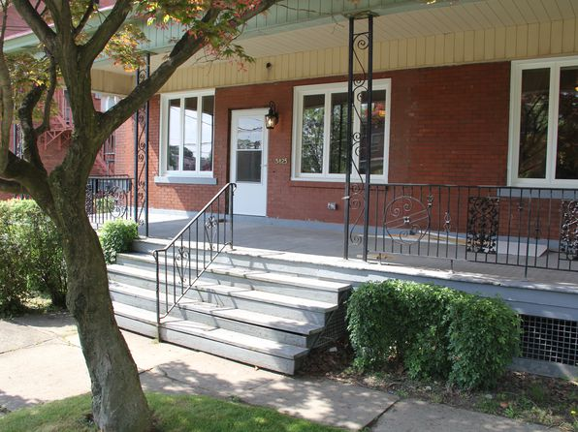](https://www.zillow.com/b/bartlett-st-commons-squirrel-hill-pa-5fwkZK/)](https://www.zillow.com/b/bartlett-st-commons-squirrel-hill-pa-5fwkZK/)

•

*[5832 Beacon St, Pittsburgh, PA](https://www.zillow.com/b/5832-beacon-st-pittsburgh-pa-98P2cV/)*

$2,385+ 3 bds

* **$3,500+** 4 bds

27 days ago

[[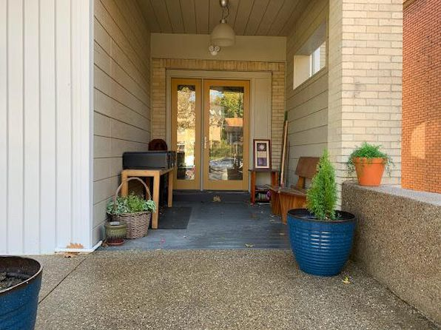](https://www.zillow.com/b/5832-beacon-st-pittsburgh-pa-98P2cV/)](https://www.zillow.com/b/5832-beacon-st-pittsburgh-pa-98P2cV/)

•

*[918 Ivy St #3, Pittsburgh, PA 15232](https://www.zillow.com/homedetails/918-Ivy-St-3-Pittsburgh-PA-15232/2082783603_zpid/)*

$1,300/mo

* **2** bds
* **1** ba
* **--** sqft

- Apartment for rent

3D Tour

[[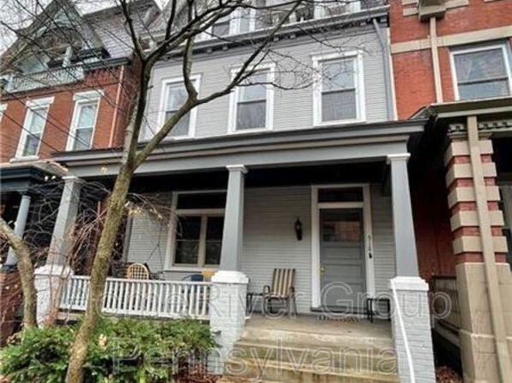](https://www.zillow.com/homedetails/918-Ivy-St-3-Pittsburgh-PA-15232/2082783603_zpid/)](https://www.zillow.com/homedetails/918-Ivy-St-3-Pittsburgh-PA-15232/2082783603_zpid/)

*[1036 Steuben St FLOOR 2, Pittsburgh, PA 15220](https://www.zillow.com/homedetails/1036-Steuben-St-FLOOR-2-Pittsburgh-PA-15220/2060707634_zpid/)*

$1,200/mo

* **2** bds
* **1** ba
* **--** sqft

- Townhouse for rent

23 days ago

[[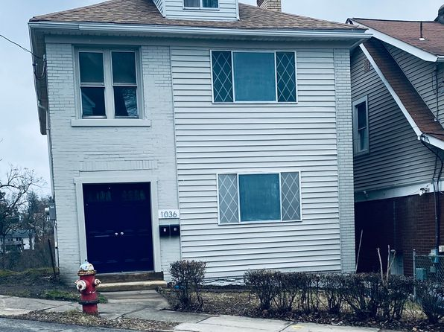](https://www.zillow.com/homedetails/1036-Steuben-St-FLOOR-2-Pittsburgh-PA-15220/2060707634_zpid/)](https://www.zillow.com/homedetails/1036-Steuben-St-FLOOR-2-Pittsburgh-PA-15220/2060707634_zpid/)

*[116 Dauntless Dr, Pittsburgh, PA 15235](https://www.zillow.com/homedetails/116-Dauntless-Dr-Pittsburgh-PA-15235/11451615_zpid/)*

$1,350/mo

* **3** bds
* **1** ba
* **1,040** sqft

- House for rent

24 days ago

[[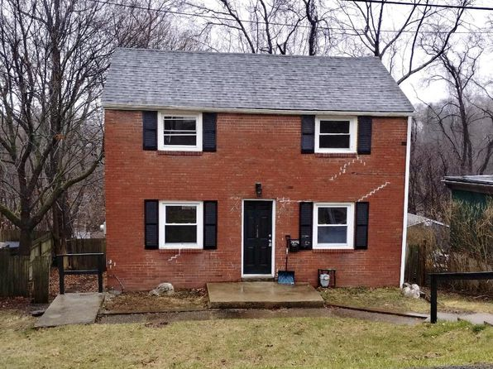](https://www.zillow.com/homedetails/116-Dauntless-Dr-Pittsburgh-PA-15235/11451615_zpid/)](https://www.zillow.com/homedetails/116-Dauntless-Dr-Pittsburgh-PA-15235/11451615_zpid/)

*[5567 Hobart St APT 2, Pittsburgh, PA 15217](https://www.zillow.com/homedetails/5567-Hobart-St-APT-2-Pittsburgh-PA-15217/2060517361_zpid/)*

$1,550/mo

* **2** bds
* **1** ba
* **1,225** sqft

- Townhouse for rent

14 days ago

[[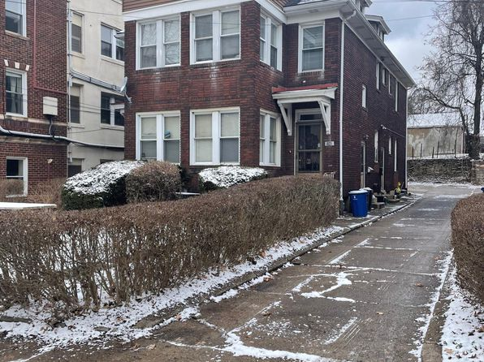](https://www.zillow.com/homedetails/5567-Hobart-St-APT-2-Pittsburgh-PA-15217/2060517361_zpid/)](https://www.zillow.com/homedetails/5567-Hobart-St-APT-2-Pittsburgh-PA-15217/2060517361_zpid/)

*[7227-7239 Penn Avenue | 7227-7239 Penn Ave, Pittsburgh, PA](https://www.zillow.com/b/7227-7239-penn-avenue-pittsburgh-pa-BtrtyB/)*

$1,139+ 1 bd

* **$1,099+** 2 bds

[[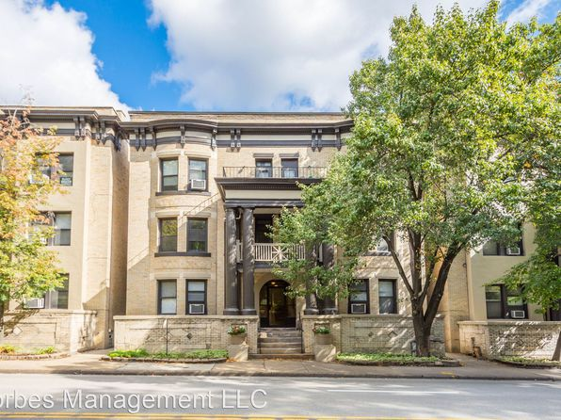](https://www.zillow.com/b/7227-7239-penn-avenue-pittsburgh-pa-BtrtyB/)](https://www.zillow.com/b/7227-7239-penn-avenue-pittsburgh-pa-BtrtyB/)

*[Lacrosse 124 - 102, 124 Lacrosse St, Pittsburgh, PA 15218](https://www.zillow.com/b/lacrosse-124-102-pittsburgh-pa-5jBrhh/)*

$950+/mo

* **1** bd
* **1** ba
* **--** sqft

- Apartment for rent

16 days ago

[[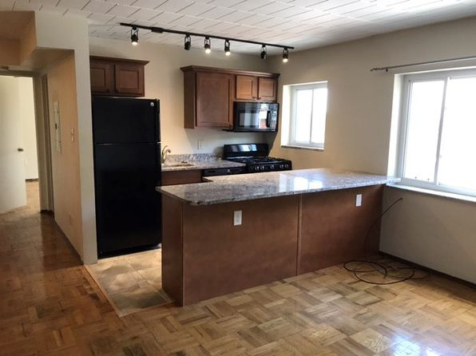](https://www.zillow.com/b/lacrosse-124-102-pittsburgh-pa-5jBrhh/)](https://www.zillow.com/b/lacrosse-124-102-pittsburgh-pa-5jBrhh/)

*[165 Erin St, Pittsburgh, PA 15219](https://www.zillow.com/homedetails/165-Erin-St-Pittsburgh-PA-15219/116178924_zpid/)*

$1,800/mo

* **3** bds
* **1.5** ba
* **--** sqft

- House for rent

38 days ago

[[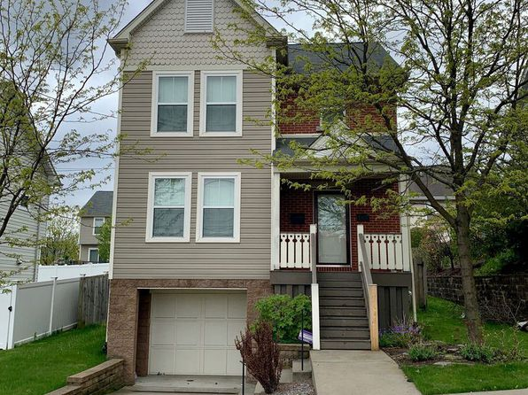](https://www.zillow.com/homedetails/165-Erin-St-Pittsburgh-PA-15219/116178924_zpid/)](https://www.zillow.com/homedetails/165-Erin-St-Pittsburgh-PA-15219/116178924_zpid/)

*[151 Merrimac St, Pittsburgh, PA 15211](https://www.zillow.com/homedetails/151-Merrimac-St-Pittsburgh-PA-15211/11363409_zpid/)*

$1,595/mo

* **3** bds
* **2.5** ba
* **2,000** sqft

- House for rent

39 days ago

[[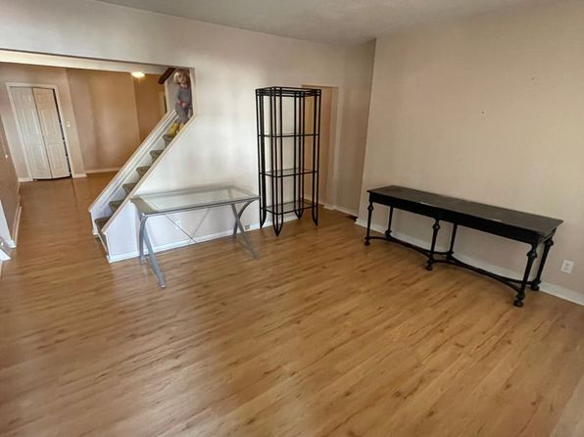](https://www.zillow.com/homedetails/151-Merrimac-St-Pittsburgh-PA-15211/11363409_zpid/)](https://www.zillow.com/homedetails/151-Merrimac-St-Pittsburgh-PA-15211/11363409_zpid/)

•

*[1604 Clinton St, Pittsburgh, PA 15203](https://www.zillow.com/homedetails/1604-Clinton-St-Pittsburgh-PA-15203/11475196_zpid/)*

$2,250/mo

* **3** bds
* **2.5** ba
* **2,200** sqft

- House for rent

12 days ago

[[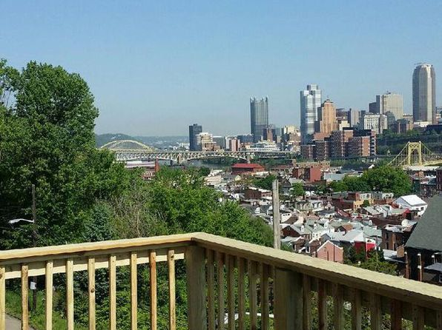](https://www.zillow.com/homedetails/1604-Clinton-St-Pittsburgh-PA-15203/11475196_zpid/)](https://www.zillow.com/homedetails/1604-Clinton-St-Pittsburgh-PA-15203/11475196_zpid/)

*[5205 Stanton Ave FLOOR 1, Pittsburgh, PA 15201](https://www.zillow.com/homedetails/5205-Stanton-Ave-FLOOR-1-Pittsburgh-PA-15201/2065742961_zpid/)*

$1,250/mo

* **1** bd
* **1** ba
* **--** sqft

- Apartment for rent

7 days ago

[[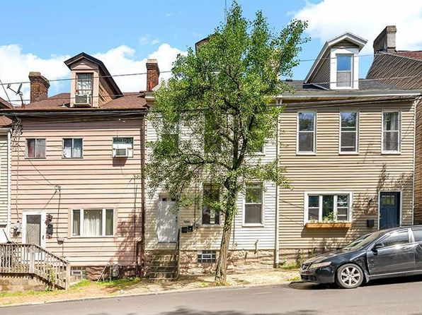](https://www.zillow.com/homedetails/5205-Stanton-Ave-FLOOR-1-Pittsburgh-PA-15201/2065742961_zpid/)](https://www.zillow.com/homedetails/5205-Stanton-Ave-FLOOR-1-Pittsburgh-PA-15201/2065742961_zpid/)

*[2915 Homehurst Ave, Pittsburgh, PA 15234](https://www.zillow.com/homedetails/2915-Homehurst-Ave-Pittsburgh-PA-15234/11356701_zpid/)*

$1,200/mo

* **3** bds
* **1** ba
* **1,300** sqft

- House for rent

39 days ago

[[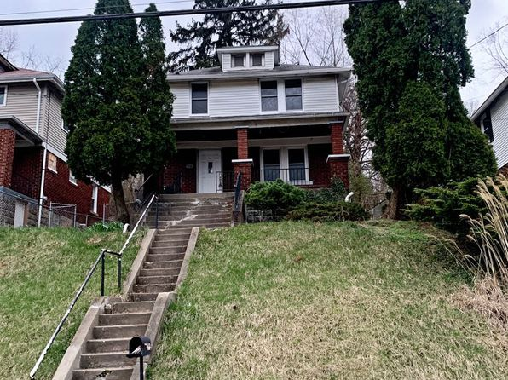](https://www.zillow.com/homedetails/2915-Homehurst-Ave-Pittsburgh-PA-15234/11356701_zpid/)](https://www.zillow.com/homedetails/2915-Homehurst-Ave-Pittsburgh-PA-15234/11356701_zpid/)

*[1872 Morningside Ave, Pittsburgh, PA 15206](https://www.zillow.com/homedetails/1872-Morningside-Ave-Pittsburgh-PA-15206/2121732846_zpid/)*

$1,339/mo

* **2** bds
* **1** ba
* **870** sqft

- House for rent

15 days ago

[[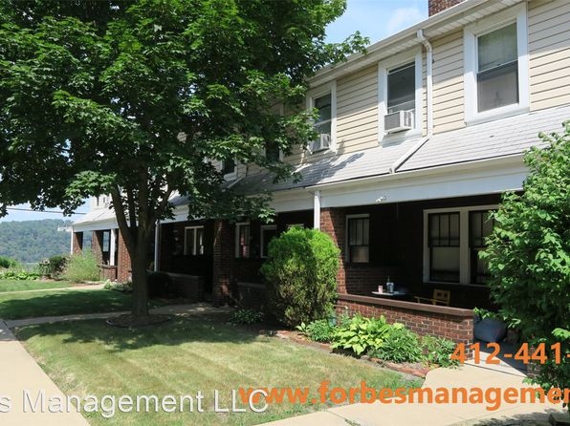](https://www.zillow.com/homedetails/1872-Morningside-Ave-Pittsburgh-PA-15206/2121732846_zpid/)](https://www.zillow.com/homedetails/1872-Morningside-Ave-Pittsburgh-PA-15206/2121732846_zpid/)

*[1907 Fox Way, Pittsburgh, PA 15203](https://www.zillow.com/homedetails/1907-Fox-Way-Pittsburgh-PA-15203/11290801_zpid/)*

$2,450/mo

* **3** bds
* **2** ba
* **1,686** sqft

- House for rent

5 days ago

[[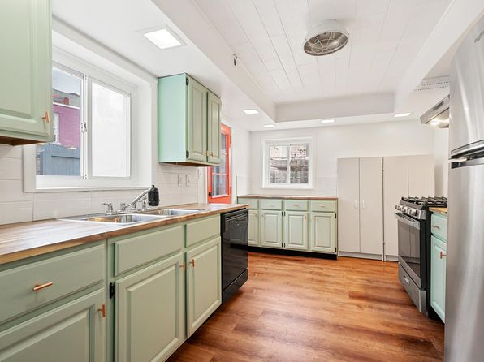](https://www.zillow.com/homedetails/1907-Fox-Way-Pittsburgh-PA-15203/11290801_zpid/)](https://www.zillow.com/homedetails/1907-Fox-Way-Pittsburgh-PA-15203/11290801_zpid/)

*[03 - 1028 E Warrington, 1028 E Warrington Ave APT 3, Pittsburgh, PA 15210](https://www.zillow.com/b/03-1028-e-warrington-pittsburgh-pa-5XjDfb/)*

$1,625/mo

* **4** bds
* **2** ba
* **--** sqft

- Apartment for rent

30 days ago

[[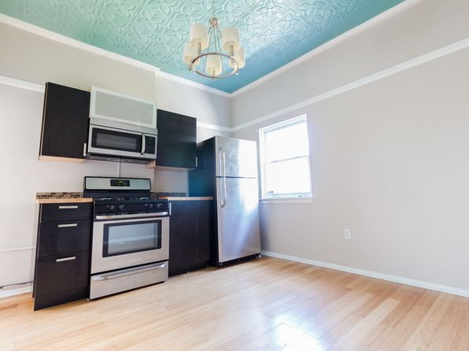](https://www.zillow.com/b/03-1028-e-warrington-pittsburgh-pa-5XjDfb/)](https://www.zillow.com/b/03-1028-e-warrington-pittsburgh-pa-5XjDfb/)

*[3217-3219 Camp Street, 3217 Camp St #3219, Pittsburgh, PA 15219](https://www.zillow.com/b/3217-3219-camp-street-pittsburgh-pa-98P83m/)*

$1,000/mo

* **1** bd
* **1** ba
* **900** sqft

- Apartment for rent

39 days ago

[[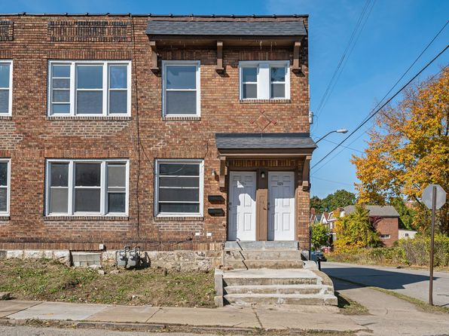](https://www.zillow.com/b/3217-3219-camp-street-pittsburgh-pa-98P83m/)](https://www.zillow.com/b/3217-3219-camp-street-pittsburgh-pa-98P83m/)

*[119 Rothesay Avenue, 119 Rothesay Ave APT 2, Carnegie, PA 15106](https://www.zillow.com/b/119-rothesay-avenue-carnegie-pa-5jBZY9/)*

$1,095/mo

* **1** bd
* **1** ba
* **--** sqft

- Apartment for rent

17 days ago

[[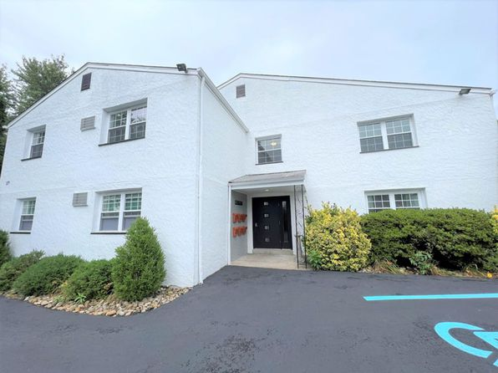](https://www.zillow.com/b/119-rothesay-avenue-carnegie-pa-5jBZY9/)](https://www.zillow.com/b/119-rothesay-avenue-carnegie-pa-5jBZY9/)

*[718 N Euclid Ave FLOOR 3, Pittsburgh, PA 15206](https://www.zillow.com/homedetails/718-N-Euclid-Ave-FLOOR-3-Pittsburgh-PA-15206/2078524075_zpid/)*

$775/mo

* **Studio**
* **1** ba
* **--** sqft

- Townhouse for rent

5 days ago

[[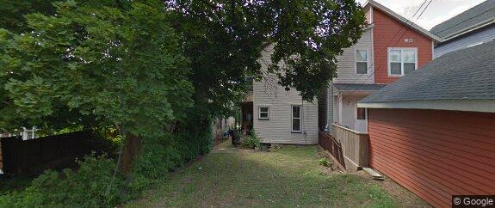](https://www.zillow.com/homedetails/718-N-Euclid-Ave-FLOOR-3-Pittsburgh-PA-15206/2078524075_zpid/)](https://www.zillow.com/homedetails/718-N-Euclid-Ave-FLOOR-3-Pittsburgh-PA-15206/2078524075_zpid/)

*[1080 Chatham Park Dr APT G, Pittsburgh, PA 15216](https://www.zillow.com/homedetails/1080-Chatham-Park-Dr-APT-G-Pittsburgh-PA-15216/59835934_zpid/)*

$1,500/mo

* **2** bds
* **1** ba
* **996** sqft

- House for rent

4 days ago

[[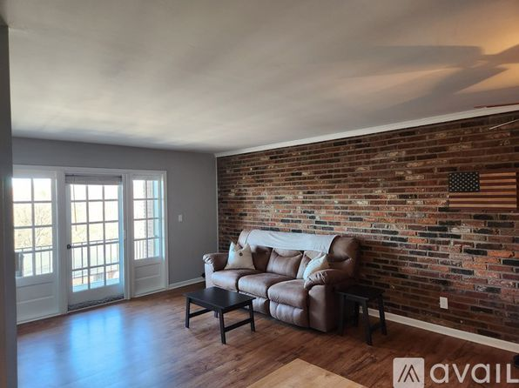](https://www.zillow.com/homedetails/1080-Chatham-Park-Dr-APT-G-Pittsburgh-PA-15216/59835934_zpid/)](https://www.zillow.com/homedetails/1080-Chatham-Park-Dr-APT-G-Pittsburgh-PA-15216/59835934_zpid/)

*[2435 Cobden St, Pittsburgh, PA 15203](https://www.zillow.com/homedetails/2435-Cobden-St-Pittsburgh-PA-15203/2099702432_zpid/)*

$1,100/mo

* **3** bds
* **1** ba
* **--** sqft

- House for rent

54 days ago

[[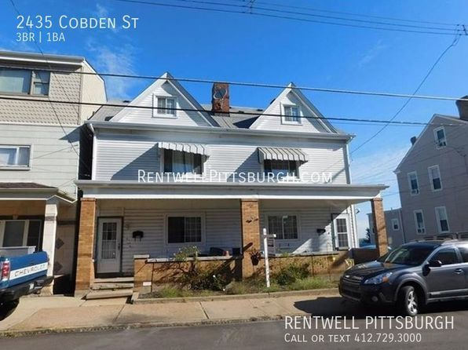](https://www.zillow.com/homedetails/2435-Cobden-St-Pittsburgh-PA-15203/2099702432_zpid/)](https://www.zillow.com/homedetails/2435-Cobden-St-Pittsburgh-PA-15203/2099702432_zpid/)

*[2623 S 18th Street Ext, Pittsburgh, PA 15210](https://www.zillow.com/homedetails/2623-S-18th-Street-Ext-Pittsburgh-PA-15210/2061761286_zpid/)*

$2,300/mo

* **6** bds
* **2** ba
* **--** sqft

- House for rent

30 days ago

[[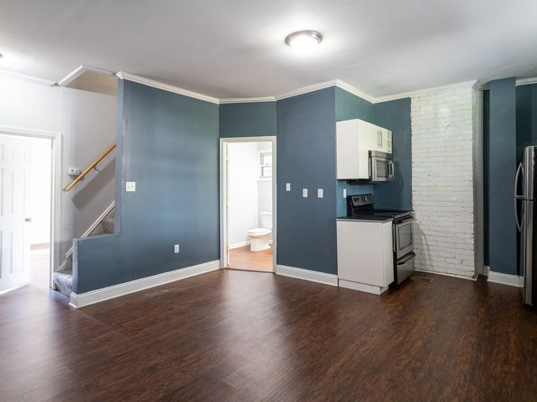](https://www.zillow.com/homedetails/2623-S-18th-Street-Ext-Pittsburgh-PA-15210/2061761286_zpid/)](https://www.zillow.com/homedetails/2623-S-18th-Street-Ext-Pittsburgh-PA-15210/2061761286_zpid/)

*[10 - 35 Mt Oliver St, 35 Mount Oliver St #3, Pittsburgh, PA 15210](https://www.zillow.com/b/10-35-mt-oliver-st-pittsburgh-pa-5ZZPrh/)*

$1,000/mo

* **2** bds
* **1** ba
* **--** sqft

- Apartment for rent

6 days ago

[[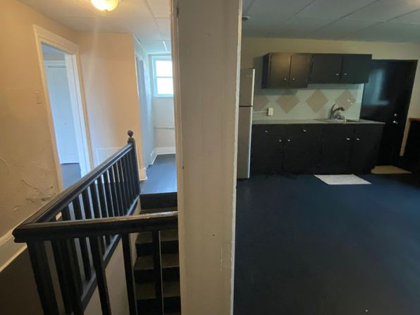](https://www.zillow.com/b/10-35-mt-oliver-st-pittsburgh-pa-5ZZPrh/)](https://www.zillow.com/b/10-35-mt-oliver-st-pittsburgh-pa-5ZZPrh/)

*[905 Maryland Ave #5806, Pittsburgh, PA 15232](https://www.zillow.com/homedetails/905-Maryland-Ave-5806-Pittsburgh-PA-15232/2059816443_zpid/)*

$1,025/mo

* **1** bd
* **1** ba
* **--** sqft

- Apartment for rent

3 days ago

[[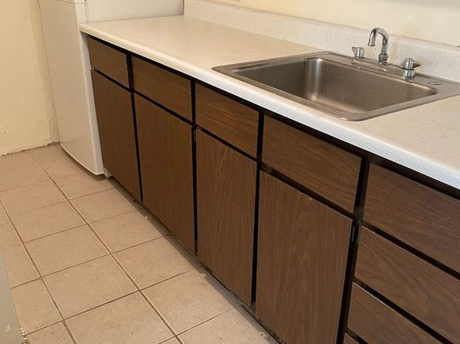](https://www.zillow.com/homedetails/905-Maryland-Ave-5806-Pittsburgh-PA-15232/2059816443_zpid/)](https://www.zillow.com/homedetails/905-Maryland-Ave-5806-Pittsburgh-PA-15232/2059816443_zpid/)

*[308 W Swissvale Ave #2, Pittsburgh, PA 15218](https://www.zillow.com/homedetails/308-W-Swissvale-Ave-2-Pittsburgh-PA-15218/2077517907_zpid/)*

$1,099/mo

* **1** bd
* **2** ba
* **750** sqft

- Apartment for rent

26 days ago

[[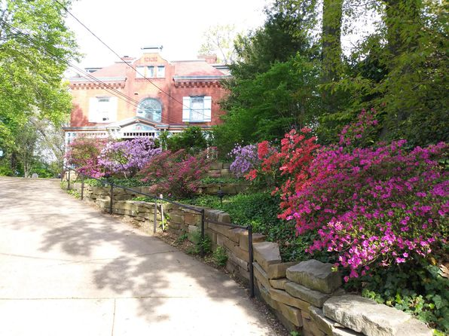](https://www.zillow.com/homedetails/308-W-Swissvale-Ave-2-Pittsburgh-PA-15218/2077517907_zpid/)](https://www.zillow.com/homedetails/308-W-Swissvale-Ave-2-Pittsburgh-PA-15218/2077517907_zpid/)

• • •

*[67 Beltzhoover Ave APT 3, Pittsburgh, PA 15210](https://www.zillow.com/homedetails/67-Beltzhoover-Ave-APT-3-Pittsburgh-PA-15210/2081637135_zpid/)*

$925/mo

* **3** bds
* **1** ba
* **--** sqft

- Apartment for rent

39 days ago

[[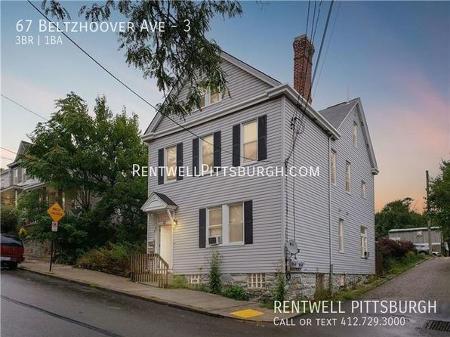](https://www.zillow.com/homedetails/67-Beltzhoover-Ave-APT-3-Pittsburgh-PA-15210/2081637135_zpid/)](https://www.zillow.com/homedetails/67-Beltzhoover-Ave-APT-3-Pittsburgh-PA-15210/2081637135_zpid/)

*[21 Hodge St #1, Pittsburgh, PA 15213](https://www.zillow.com/homedetails/21-Hodge-St-1-Pittsburgh-PA-15213/2101333461_zpid/)*

$1,050/mo

* **2** bds
* **1** ba
* **--** sqft

- Apartment for rent

Video Walkthrough

[[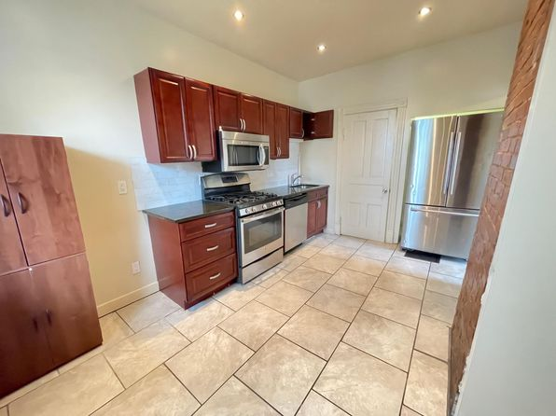](https://www.zillow.com/homedetails/21-Hodge-St-1-Pittsburgh-PA-15213/2101333461_zpid/)](https://www.zillow.com/homedetails/21-Hodge-St-1-Pittsburgh-PA-15213/2101333461_zpid/)

*[5823 Stanton Avenue | 5823 Stanton Ave, Pittsburgh, PA](https://www.zillow.com/b/5823-stanton-avenue-pittsburgh-pa-98NJDQ/)*

$959+ Studio

* **$1,649+** 2 bds

[[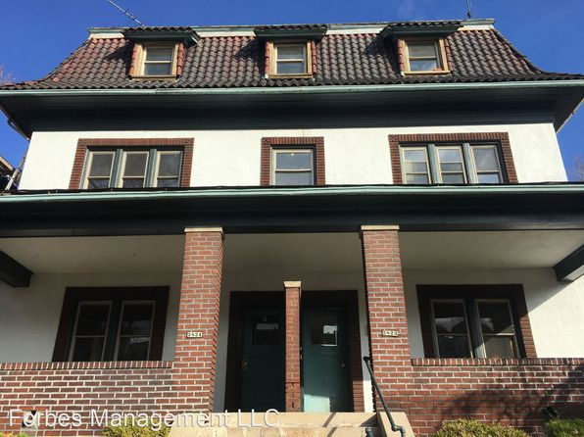](https://www.zillow.com/b/5823-stanton-avenue-pittsburgh-pa-98NJDQ/)](https://www.zillow.com/b/5823-stanton-avenue-pittsburgh-pa-98NJDQ/)

*[3220 1/2 Hardie Way, Pittsburgh, PA 15213](https://www.zillow.com/homedetails/3220-1-2-Hardie-Way-Pittsburgh-PA-15213/11419823_zpid/)*

$950/mo

* **2** bds
* **1** ba
* **1,000** sqft

- House for rent

31 days ago

[[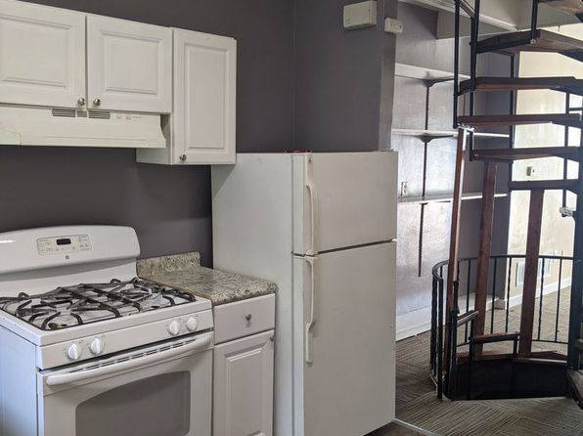](https://www.zillow.com/homedetails/3220-1-2-Hardie-Way-Pittsburgh-PA-15213/11419823_zpid/)](https://www.zillow.com/homedetails/3220-1-2-Hardie-Way-Pittsburgh-PA-15213/11419823_zpid/)

*[909 Mount Hood Dr, Pittsburgh, PA 15239](https://www.zillow.com/homedetails/909-Mount-Hood-Dr-Pittsburgh-PA-15239/11261971_zpid/)*

$1,400/mo

* **3** bds
* **1** ba
* **1,500** sqft

- House for rent

47 days ago

[[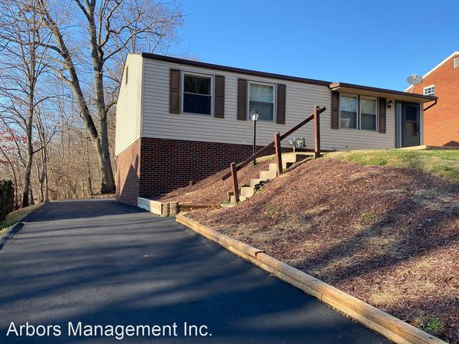](https://www.zillow.com/homedetails/909-Mount-Hood-Dr-Pittsburgh-PA-15239/11261971_zpid/)](https://www.zillow.com/homedetails/909-Mount-Hood-Dr-Pittsburgh-PA-15239/11261971_zpid/)

*[154 Parkfield St, Pittsburgh, PA 15210](https://www.zillow.com/homedetails/154-Parkfield-St-Pittsburgh-PA-15210/11647522_zpid/)*

$1,199/mo

* **2** bds
* **2** ba
* **1,100** sqft

- Townhouse for rent

30 days ago

[[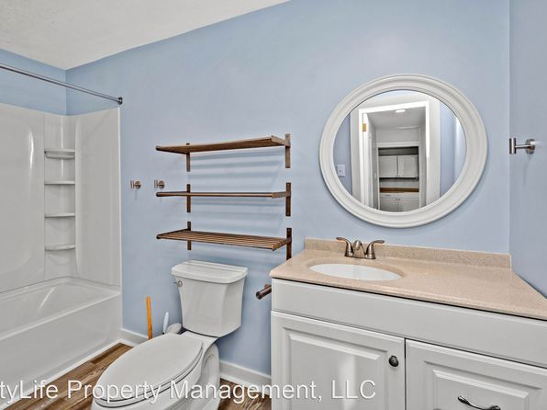](https://www.zillow.com/homedetails/154-Parkfield-St-Pittsburgh-PA-15210/11647522_zpid/)](https://www.zillow.com/homedetails/154-Parkfield-St-Pittsburgh-PA-15210/11647522_zpid/)

*[223 Whipple St, Pittsburgh, PA 15218](https://www.zillow.com/homedetails/223-Whipple-St-Pittsburgh-PA-15218/2083682539_zpid/)*

$1,225/mo

* **3** bds
* **1** ba
* **--** sqft

- Townhouse for rent

48 days ago

[[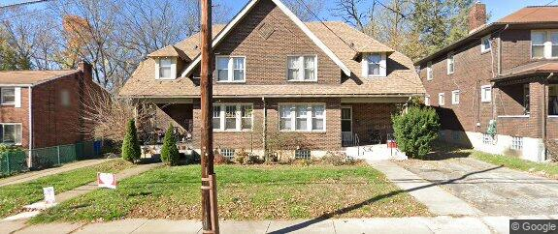](https://www.zillow.com/homedetails/223-Whipple-St-Pittsburgh-PA-15218/2083682539_zpid/)](https://www.zillow.com/homedetails/223-Whipple-St-Pittsburgh-PA-15218/2083682539_zpid/)

*[306 Gerrie Dr, Pittsburgh, PA 15241](https://www.zillow.com/homedetails/306-Gerrie-Dr-Pittsburgh-PA-15241/11609485_zpid/)*

$2,195/mo

* **3** bds
* **1.5** ba
* **--** sqft

- House for rent

24 days ago

[[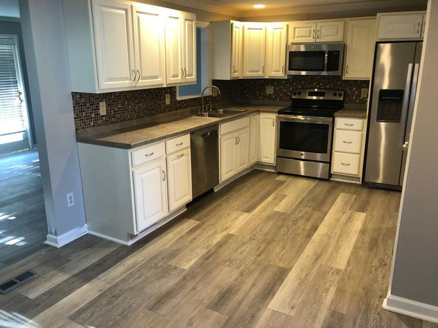](https://www.zillow.com/homedetails/306-Gerrie-Dr-Pittsburgh-PA-15241/11609485_zpid/)](https://www.zillow.com/homedetails/306-Gerrie-Dr-Pittsburgh-PA-15241/11609485_zpid/)

*[130 Dengler St, Pittsburgh, PA 15210](https://www.zillow.com/homedetails/130-Dengler-St-Pittsburgh-PA-15210/11309244_zpid/)*

$1,375/mo

* + **3** bds
  + **1** ba
  + **--** sqft

- House for rent

10 days ago

[[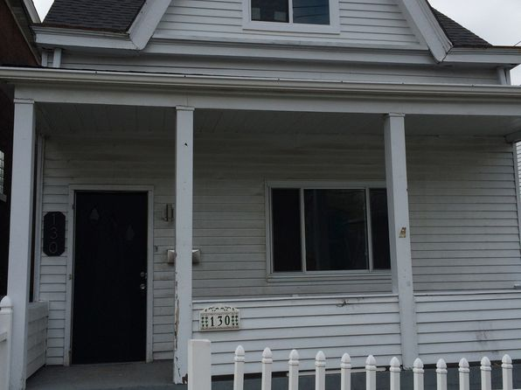](https://www.zillow.com/homedetails/130-Dengler-St-Pittsburgh-PA-15210/11309244_zpid/)](https://www.zillow.com/homedetails/130-Dengler-St-Pittsburgh-PA-15210/11309244_zpid/)

*[739 Excelsior St, Pittsburgh, PA 15210](https://www.zillow.com/homedetails/739-Excelsior-St-Pittsburgh-PA-15210/11315035_zpid/)*

$1,300/mo

* **3** bds
* **1** ba
* **--** sqft

- House for rent

19 days ago

[[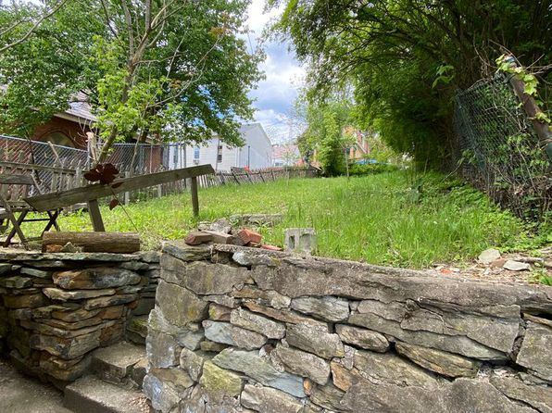](https://www.zillow.com/homedetails/739-Excelsior-St-Pittsburgh-PA-15210/11315035_zpid/)](https://www.zillow.com/homedetails/739-Excelsior-St-Pittsburgh-PA-15210/11315035_zpid/)

•

*[1827 Jancey St, Pittsburgh, PA 15206](https://www.zillow.com/homedetails/1827-Jancey-St-Pittsburgh-PA-15206/11278461_zpid/)*

$1,425/mo

* **2** bds
* **2** ba
* **934** sqft

- House for rent

6 days ago

[[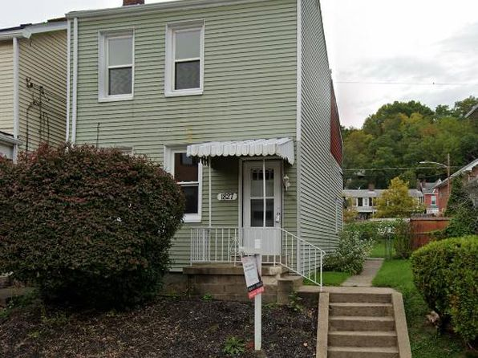](https://www.zillow.com/homedetails/1827-Jancey-St-Pittsburgh-PA-15206/11278461_zpid/)](https://www.zillow.com/homedetails/1827-Jancey-St-Pittsburgh-PA-15206/11278461_zpid/)

*[2938 W Liberty Ave APT 2, Pittsburgh, PA 15216](https://www.zillow.com/homedetails/2938-W-Liberty-Ave-APT-2-Pittsburgh-PA-15216/2102862830_zpid/)*

$545/mo

* **Studio**
* **1** ba
* **225** sqft

- Apartment for rent

13 days ago

[[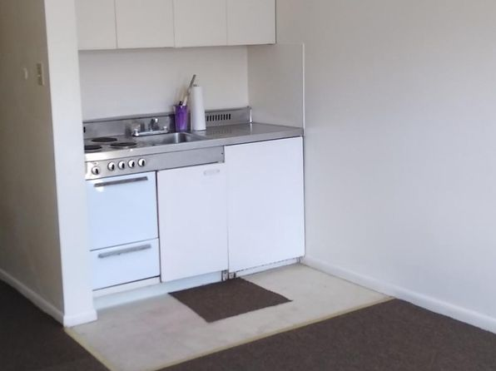](https://www.zillow.com/homedetails/2938-W-Liberty-Ave-APT-2-Pittsburgh-PA-15216/2102862830_zpid/)](https://www.zillow.com/homedetails/2938-W-Liberty-Ave-APT-2-Pittsburgh-PA-15216/2102862830_zpid/)

*[5329 Holmes St, Pittsburgh, PA 15201](https://www.zillow.com/homedetails/5329-Holmes-St-Pittsburgh-PA-15201/11614783_zpid/)*

$1,295/mo

* **2** bds
* **1.5** ba
* **--** sqft

- House for rent

24 days ago

[[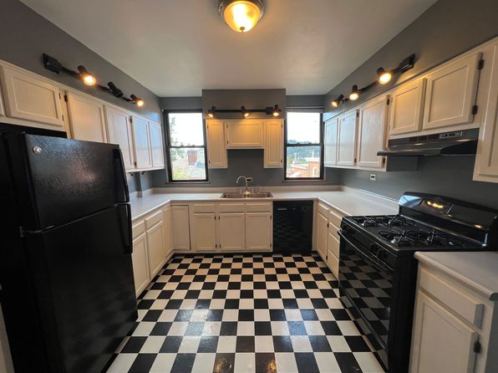](https://www.zillow.com/homedetails/5329-Holmes-St-Pittsburgh-PA-15201/11614783_zpid/)](https://www.zillow.com/homedetails/5329-Holmes-St-Pittsburgh-PA-15201/11614783_zpid/)

*[362 Flowers Ave, Pittsburgh, PA 15207](https://www.zillow.com/homedetails/362-Flowers-Ave-Pittsburgh-PA-15207/11549966_zpid/)*

$1,325/mo

* **3** bds
* **1.5** ba
* **1,300** sqft

- House for rent

39 days ago

[[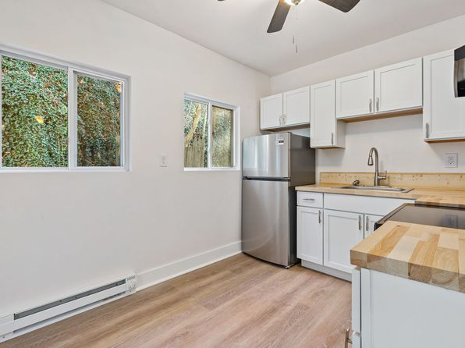](https://www.zillow.com/homedetails/362-Flowers-Ave-Pittsburgh-PA-15207/11549966_zpid/)](https://www.zillow.com/homedetails/362-Flowers-Ave-Pittsburgh-PA-15207/11549966_zpid/)

*[1932 Lacrosse St APT 3, Pittsburgh, PA 15218](https://www.zillow.com/homedetails/1932-Lacrosse-St-APT-3-Pittsburgh-PA-15218/2080933898_zpid/)*

$1,025/mo

* **1** bd
* **1** ba
* **900** sqft

- Apartment for rent

73 days ago

[[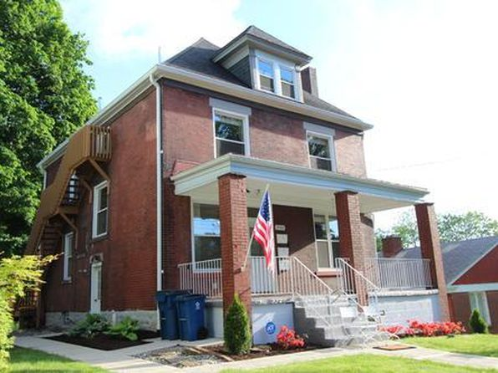](https://www.zillow.com/homedetails/1932-Lacrosse-St-APT-3-Pittsburgh-PA-15218/2080933898_zpid/)](https://www.zillow.com/homedetails/1932-Lacrosse-St-APT-3-Pittsburgh-PA-15218/2080933898_zpid/)

*[49 South 11th St, 49 S 11th St #49, Pittsburgh, PA 15203](https://www.zillow.com/b/49-south-11th-st-pittsburgh-pa-5gpmpq/)*

$2,650/mo

* **4** bds
* **2.5** ba
* **2,200** sqft

- Apartment for rent

39 days ago

[[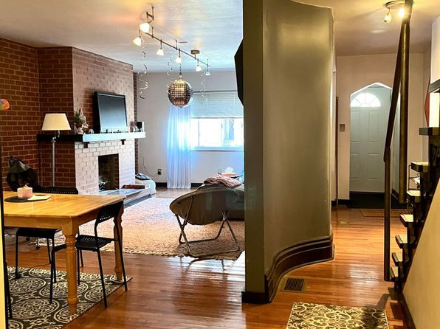](https://www.zillow.com/b/49-south-11th-st-pittsburgh-pa-5gpmpq/)](https://www.zillow.com/b/49-south-11th-st-pittsburgh-pa-5gpmpq/)

*[1230 Goe Ave, Pittsburgh, PA 15212](https://www.zillow.com/homedetails/1230-Goe-Ave-Pittsburgh-PA-15212/11268971_zpid/)*

$1,200/mo

* **3** bds
* **1** ba
* **--** sqft

- House for rent

39 days ago

[[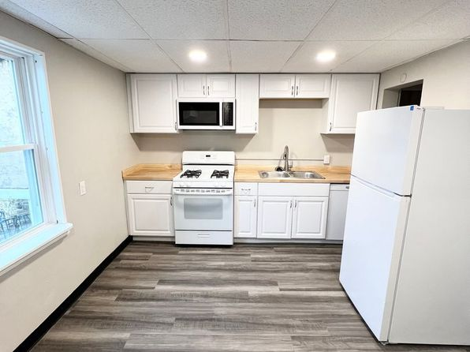](https://www.zillow.com/homedetails/1230-Goe-Ave-Pittsburgh-PA-15212/11268971_zpid/)](https://www.zillow.com/homedetails/1230-Goe-Ave-Pittsburgh-PA-15212/11268971_zpid/)

•

*[1142-1144 Shadycrest Dr, Pittsburgh, PA](https://www.zillow.com/b/1146-1148-shadycrest-dr-pittsburgh-pa-CGRmN6/)*

$1,095+ 2 bds

47 days ago

[[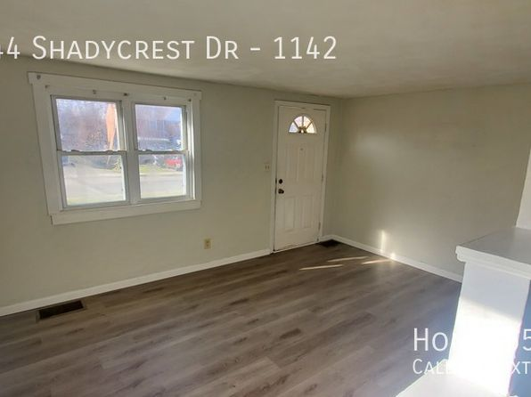](https://www.zillow.com/b/1146-1148-shadycrest-dr-pittsburgh-pa-CGRmN6/)](https://www.zillow.com/b/1146-1148-shadycrest-dr-pittsburgh-pa-CGRmN6/)

•

*[1326 Merryfield St, Pittsburgh, PA 15204](https://www.zillow.com/homedetails/1326-Merryfield-St-Pittsburgh-PA-15204/2060933109_zpid/)*

$1,075/mo

* **2** bds
* **1** ba
* **--** sqft

- Townhouse for rent

54 days ago

[[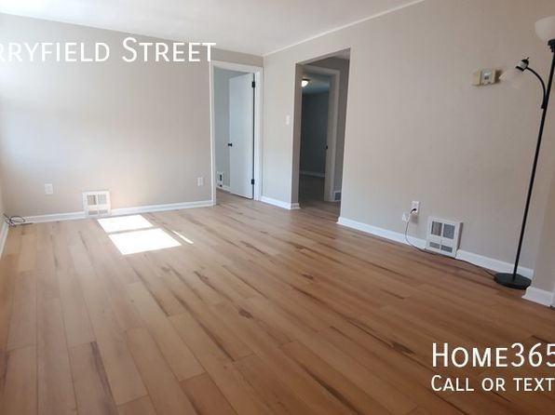](https://www.zillow.com/homedetails/1326-Merryfield-St-Pittsburgh-PA-15204/2060933109_zpid/)](https://www.zillow.com/homedetails/1326-Merryfield-St-Pittsburgh-PA-15204/2060933109_zpid/)

*[24 - 406 Kingsboro | 406 Kingsboro St, Pittsburgh, PA](https://www.zillow.com/b/24-406-kingsboro-pittsburgh-pa-5hCJPJ/)*

$975+ 1 bd

* **$1,500+** 5 bds

[[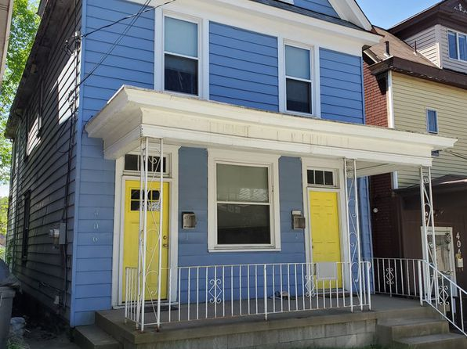](https://www.zillow.com/b/24-406-kingsboro-pittsburgh-pa-5hCJPJ/)](https://www.zillow.com/b/24-406-kingsboro-pittsburgh-pa-5hCJPJ/)

• • •

*[2420 Carey Way, Pittsburgh, PA 15203](https://www.zillow.com/homedetails/2420-Carey-Way-Pittsburgh-PA-15203/11291549_zpid/)*

$1,450/mo

* **2** bds
* **2** ba
* **--** sqft

- House for rent

72 days ago

[[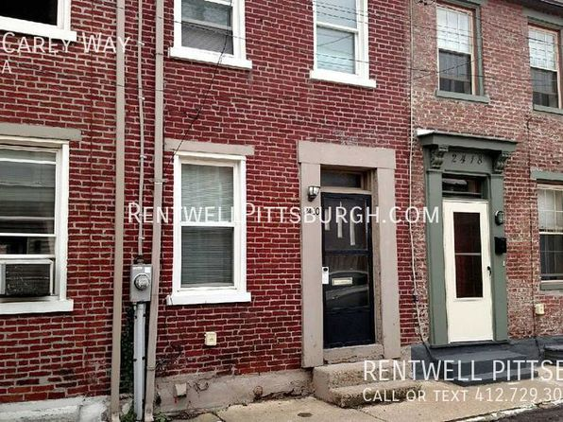](https://www.zillow.com/homedetails/2420-Carey-Way-Pittsburgh-PA-15203/11291549_zpid/)](https://www.zillow.com/homedetails/2420-Carey-Way-Pittsburgh-PA-15203/11291549_zpid/)

•

*[2422 N Meadowcroft Ave, Pittsburgh, PA 15216](https://www.zillow.com/homedetails/2422-N-Meadowcroft-Ave-Pittsburgh-PA-15216/11570300_zpid/)*

$1,495/mo

* **3** bds
* **1** ba
* **960** sqft

- House for rent

39 days ago

[[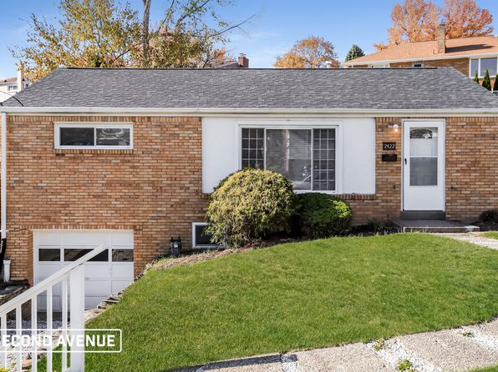](https://www.zillow.com/homedetails/2422-N-Meadowcroft-Ave-Pittsburgh-PA-15216/11570300_zpid/)](https://www.zillow.com/homedetails/2422-N-Meadowcroft-Ave-Pittsburgh-PA-15216/11570300_zpid/)

*[1934 Huron St, Pittsburgh, PA 15203](https://www.zillow.com/homedetails/1934-Huron-St-Pittsburgh-PA-15203/11307358_zpid/)*

$1,240/mo

* **3** bds
* **1.5** ba
* **1,300** sqft

- House for rent

32 days ago

[[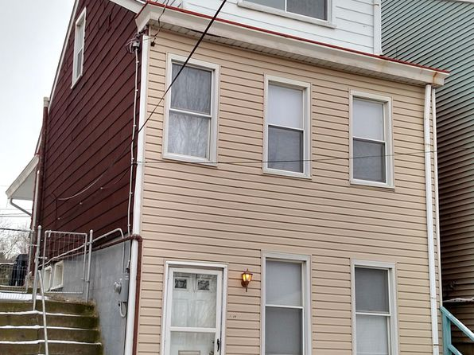](https://www.zillow.com/homedetails/1934-Huron-St-Pittsburgh-PA-15203/11307358_zpid/)](https://www.zillow.com/homedetails/1934-Huron-St-Pittsburgh-PA-15203/11307358_zpid/)

*[3350 Wallace Dr, Pittsburgh, PA 15227](https://www.zillow.com/homedetails/3350-Wallace-Dr-Pittsburgh-PA-15227/11302904_zpid/)*

$1,590/mo

* **3** bds
* **2** ba
* **1,317** sqft

- House for rent

3D Tour

[[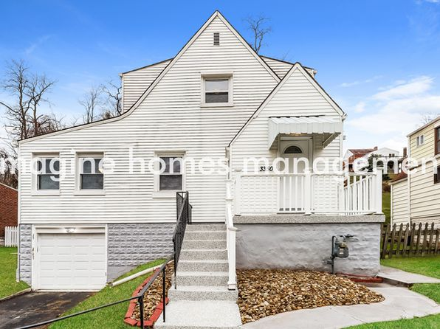](https://www.zillow.com/homedetails/3350-Wallace-Dr-Pittsburgh-PA-15227/11302904_zpid/)](https://www.zillow.com/homedetails/3350-Wallace-Dr-Pittsburgh-PA-15227/11302904_zpid/)

*[118 S Negley Ave APT 3, Pittsburgh, PA 15206](https://www.zillow.com/homedetails/118-S-Negley-Ave-APT-3-Pittsburgh-PA-15206/2089025331_zpid/)*

$1,200/mo

* **1** bd
* **1** ba
* **1,000** sqft

- Apartment for rent

49 days ago

[[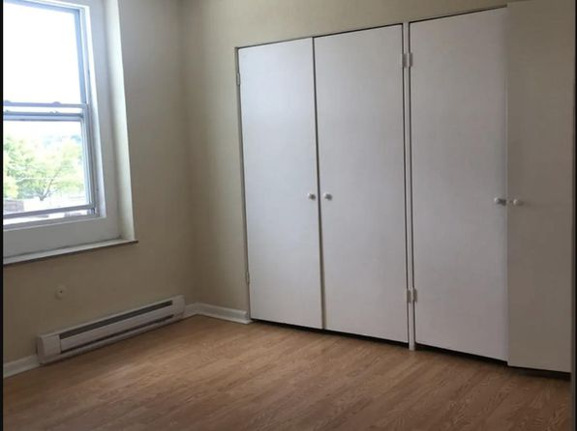](https://www.zillow.com/homedetails/118-S-Negley-Ave-APT-3-Pittsburgh-PA-15206/2089025331_zpid/)](https://www.zillow.com/homedetails/118-S-Negley-Ave-APT-3-Pittsburgh-PA-15206/2089025331_zpid/)

*[03 - 438 Kathleen, 438 Kathleen St #2, Pittsburgh, PA 15211](https://www.zillow.com/b/03-438-kathleen-pittsburgh-pa-98Nbyy/)*

$1,000/mo

* **1** bd
* **1** ba
* **--** sqft

- Apartment for rent

10 days ago

[[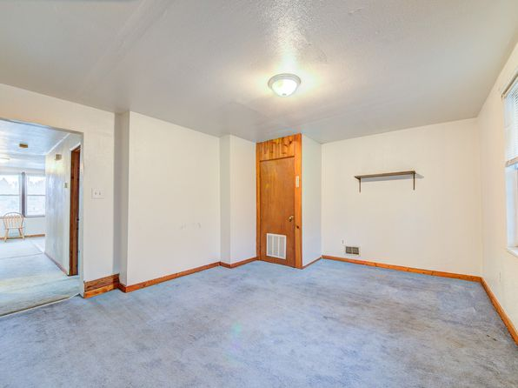](https://www.zillow.com/b/03-438-kathleen-pittsburgh-pa-98Nbyy/)](https://www.zillow.com/b/03-438-kathleen-pittsburgh-pa-98Nbyy/)

*[3056 Pinehurst Avenue, 3056 Pinehurst Ave #2, Pittsburgh, PA 15216](https://www.zillow.com/b/3056-pinehurst-avenue-pittsburgh-pa-98NxBp/)*

$1,050/mo

* **2** bds
* **1** ba
* **--** sqft

- Apartment for rent

39 days ago

[[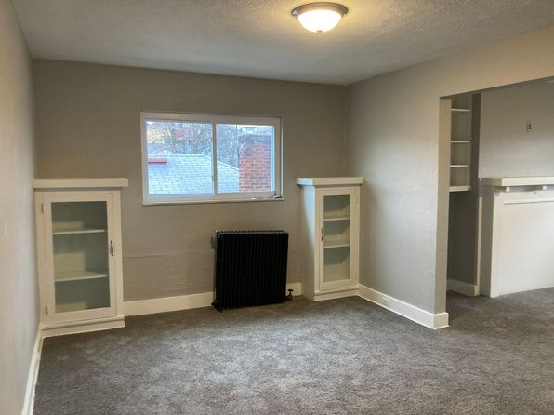](https://www.zillow.com/b/3056-pinehurst-avenue-pittsburgh-pa-98NxBp/)](https://www.zillow.com/b/3056-pinehurst-avenue-pittsburgh-pa-98NxBp/)

*[145 S. 12th Street, 145 S 12th St FLOOR 2, Pittsburgh, PA 15203](https://www.zillow.com/homedetails/145-S-12th-St-FLOOR-2-Pittsburgh-PA-15203/2060222527_zpid/)*

$2,695/mo

* **3** bds
* **2.5** ba
* **1,250** sqft

- Townhouse for rent

24 days ago

[[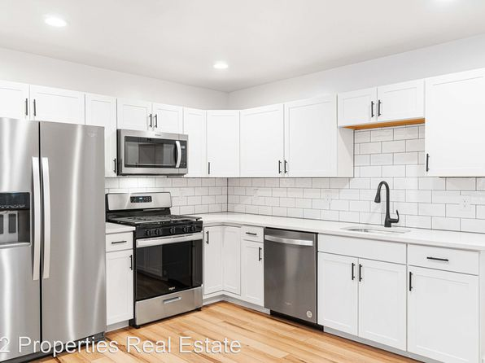](https://www.zillow.com/homedetails/145-S-12th-St-FLOOR-2-Pittsburgh-PA-15203/2060222527_zpid/)](https://www.zillow.com/homedetails/145-S-12th-St-FLOOR-2-Pittsburgh-PA-15203/2060222527_zpid/)

*[145 S. 12th Street, 145 S 12th St #1, Pittsburgh, PA 15203](https://www.zillow.com/b/145-s.-12th-street-pittsburgh-pa-9PRD6B/)*

$2,395/mo

* **3** bds
* **2** ba
* **1,200** sqft

- Townhouse for rent

24 days ago

[[](https://www.zillow.com/b/145-s.-12th-street-pittsburgh-pa-9PRD6B/)](https://www.zillow.com/b/145-s.-12th-street-pittsburgh-pa-9PRD6B/)

•

*[3722 Penn Avenue | 3722 Penn Ave, Pittsburgh, PA](https://www.zillow.com/b/3722-penn-avenue-pittsburgh-pa-98N2by/)*

$1,650+ 2 bds

[[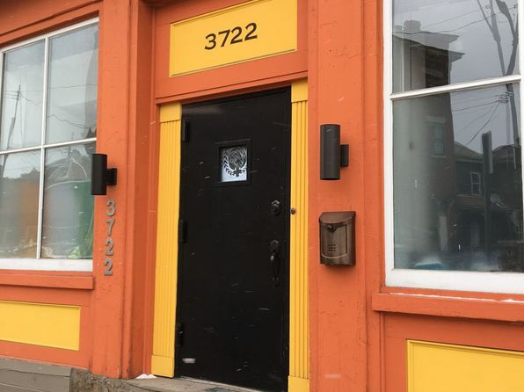](https://www.zillow.com/b/3722-penn-avenue-pittsburgh-pa-98N2by/)](https://www.zillow.com/b/3722-penn-avenue-pittsburgh-pa-98N2by/)

•

*[10130 Frankstown Rd, Pittsburgh, PA 15235](https://www.zillow.com/homedetails/10130-Frankstown-Rd-Pittsburgh-PA-15235/11415827_zpid/)*

$1,115/mo

* **3** bds
* **1** ba
* **1,150** sqft

- House for rent

26 days ago

[[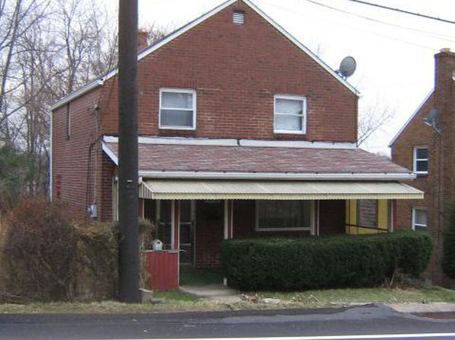](https://www.zillow.com/homedetails/10130-Frankstown-Rd-Pittsburgh-PA-15235/11415827_zpid/)](https://www.zillow.com/homedetails/10130-Frankstown-Rd-Pittsburgh-PA-15235/11415827_zpid/)

*[1305 Methyl St #1, Pittsburgh, PA 15216](https://www.zillow.com/homedetails/1305-Methyl-St-1-Pittsburgh-PA-15216/2060610550_zpid/)*

$1,400/mo

* **3** bds
* **1** ba
* **1,200** sqft

- Townhouse for rent

62 days ago

[[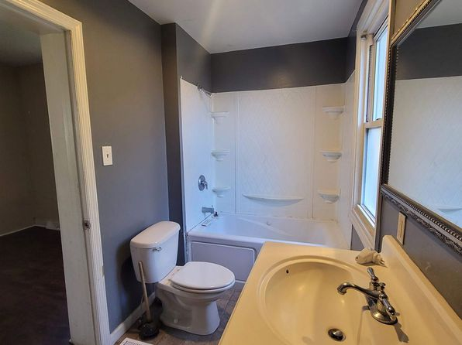](https://www.zillow.com/homedetails/1305-Methyl-St-1-Pittsburgh-PA-15216/2060610550_zpid/)](https://www.zillow.com/homedetails/1305-Methyl-St-1-Pittsburgh-PA-15216/2060610550_zpid/)

*[350 Ophelia St, Pittsburgh, PA 15213](https://www.zillow.com/homedetails/350-Ophelia-St-Pittsburgh-PA-15213/11413207_zpid/)*

$2,400/mo

* **3** bds
* **1** ba
* **--** sqft

- House for rent

38 days ago

[[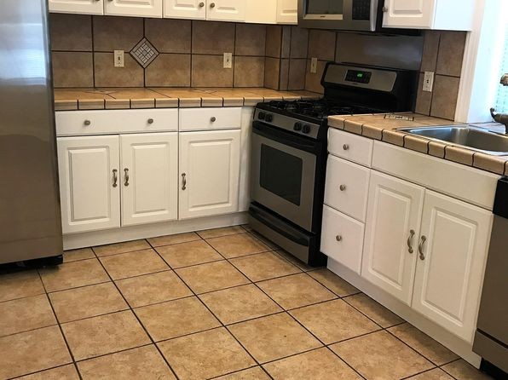](https://www.zillow.com/homedetails/350-Ophelia-St-Pittsburgh-PA-15213/11413207_zpid/)](https://www.zillow.com/homedetails/350-Ophelia-St-Pittsburgh-PA-15213/11413207_zpid/)

*[301 5th Ave, Pittsburgh, PA](https://www.zillow.com/b/301-5th-ave-pittsburgh-pa-5YLtH7/)*

$3,600+ 1 bd

* **$2,995+** 2 bds

• 3D Tour

[[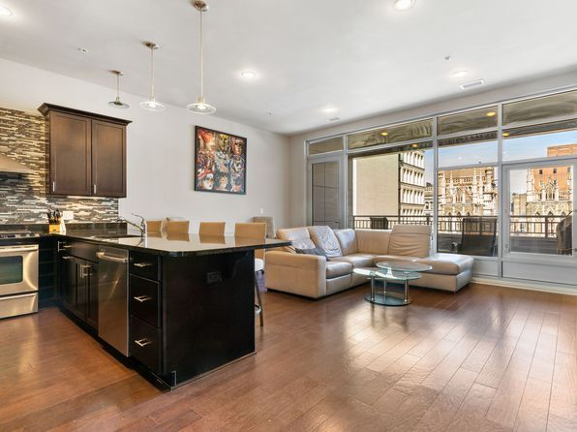](https://www.zillow.com/b/301-5th-ave-pittsburgh-pa-5YLtH7/)](https://www.zillow.com/b/301-5th-ave-pittsburgh-pa-5YLtH7/)

•

*[3 bed, 1100 sqft, $1,250, 263 Universal Rd, Pittsburgh, PA 15235](https://www.zillow.com/b/3-bed,-1100-sqft,-%241,250-pittsburgh-pa-9n43wS/)*

$1,250/mo

* **3** bds
* **1** ba
* **1,100** sqft

- Apartment for rent

63 days ago

[[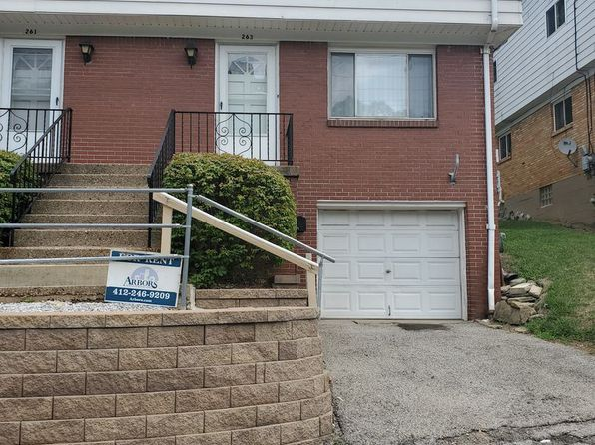](https://www.zillow.com/b/3-bed,-1100-sqft,-%241,250-pittsburgh-pa-9n43wS/)](https://www.zillow.com/b/3-bed,-1100-sqft,-%241,250-pittsburgh-pa-9n43wS/)

*[19 Pioneer Ave, Pittsburgh, PA 15229](https://www.zillow.com/homedetails/19-Pioneer-Ave-Pittsburgh-PA-15229/11406826_zpid/)*

$1,900/mo

* **3** bds
* **1.5** ba
* **--** sqft

- House for rent

31 days ago

[[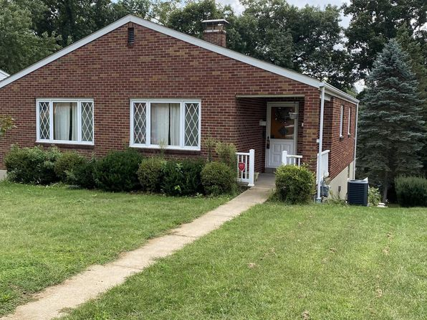](https://www.zillow.com/homedetails/19-Pioneer-Ave-Pittsburgh-PA-15229/11406826_zpid/)](https://www.zillow.com/homedetails/19-Pioneer-Ave-Pittsburgh-PA-15229/11406826_zpid/)

*[212 Emerson St, Pittsburgh, PA 15206](https://www.zillow.com/homedetails/212-Emerson-St-Pittsburgh-PA-15206/11624604_zpid/)*

$4,200/mo

* **4** bds
* **3** ba
* **3,000** sqft

- House for rent

Video Walkthrough

[[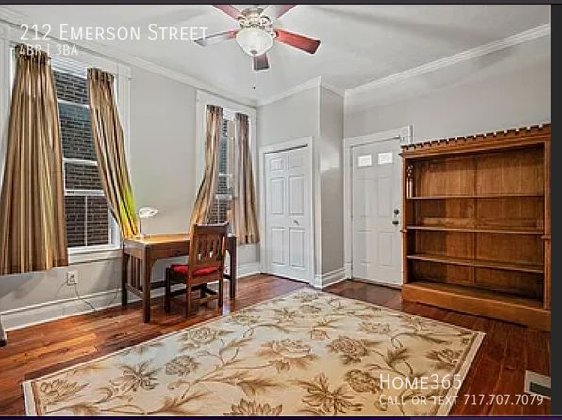](https://www.zillow.com/homedetails/212-Emerson-St-Pittsburgh-PA-15206/11624604_zpid/)](https://www.zillow.com/homedetails/212-Emerson-St-Pittsburgh-PA-15206/11624604_zpid/)

*[6121 Jackson St FLOOR 3, Pittsburgh, PA 15206](https://www.zillow.com/homedetails/6121-Jackson-St-FLOOR-3-Pittsburgh-PA-15206/2079341569_zpid/)*

$900/mo

* **1** bd
* **1** ba
* **750** sqft

- Apartment for rent

20 days ago

[[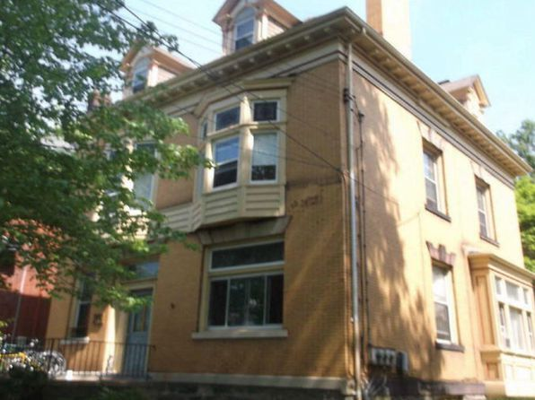](https://www.zillow.com/homedetails/6121-Jackson-St-FLOOR-3-Pittsburgh-PA-15206/2079341569_zpid/)](https://www.zillow.com/homedetails/6121-Jackson-St-FLOOR-3-Pittsburgh-PA-15206/2079341569_zpid/)

*[6826 McPherson Blvd, Pittsburgh, PA 15208](https://www.zillow.com/homedetails/6826-McPherson-Blvd-Pittsburgh-PA-15208/11286486_zpid/)*

$2,600/mo

* **3** bds
* **3.5** ba
* **1,865** sqft

- House for rent

47 days ago

[[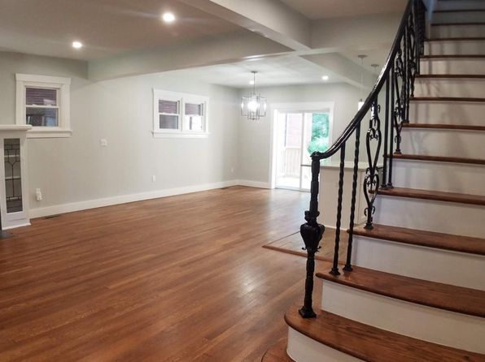](https://www.zillow.com/homedetails/6826-McPherson-Blvd-Pittsburgh-PA-15208/11286486_zpid/)](https://www.zillow.com/homedetails/6826-McPherson-Blvd-Pittsburgh-PA-15208/11286486_zpid/)

*[1807 Tustin St, Pittsburgh, PA 15219](https://www.zillow.com/homedetails/1807-Tustin-St-Pittsburgh-PA-15219/11273165_zpid/)*

$1,600/mo

* **2** bds
* **2** ba
* **--** sqft

- House for rent

23 days ago

[[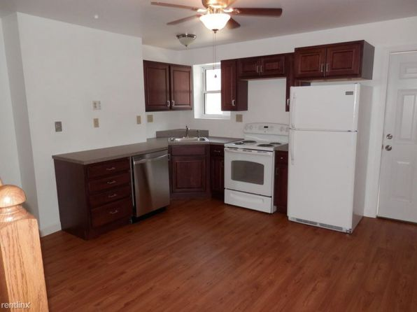](https://www.zillow.com/homedetails/1807-Tustin-St-Pittsburgh-PA-15219/11273165_zpid/)](https://www.zillow.com/homedetails/1807-Tustin-St-Pittsburgh-PA-15219/11273165_zpid/)

*[60 Magdalene St, Pittsburgh, PA 15203](https://www.zillow.com/homedetails/60-Magdalene-St-Pittsburgh-PA-15203/11307422_zpid/)*

$1,200/mo

* **3** bds
* **2** ba
* **1,500** sqft

- House for rent

39 days ago

[[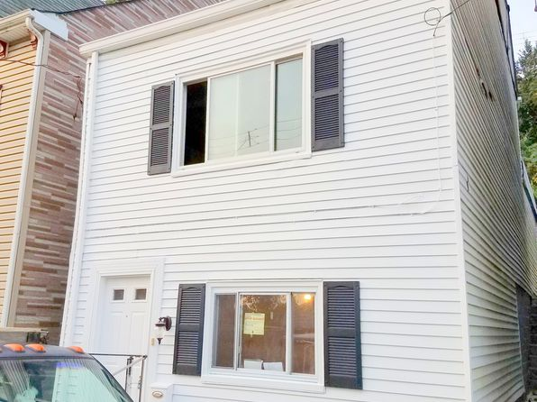](https://www.zillow.com/homedetails/60-Magdalene-St-Pittsburgh-PA-15203/11307422_zpid/)](https://www.zillow.com/homedetails/60-Magdalene-St-Pittsburgh-PA-15203/11307422_zpid/)

*[6305 Marchand St APT 26, Pittsburgh, PA 15206](https://www.zillow.com/homedetails/6305-Marchand-St-APT-26-Pittsburgh-PA-15206/2094172554_zpid/)*

$1,660/mo

* **2** bds
* **2** ba
* **--** sqft

- Apartment for rent

9 days ago

[[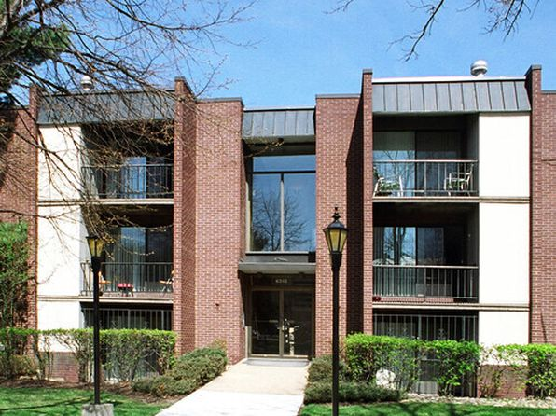](https://www.zillow.com/homedetails/6305-Marchand-St-APT-26-Pittsburgh-PA-15206/2094172554_zpid/)](https://www.zillow.com/homedetails/6305-Marchand-St-APT-26-Pittsburgh-PA-15206/2094172554_zpid/)

*[2515 Elba St APT 1, Pittsburgh, PA 15219](https://www.zillow.com/homedetails/2515-Elba-St-APT-1-Pittsburgh-PA-15219/2060354674_zpid/)*

$895/mo

* **1** bd
* **1** ba
* **--** sqft

- Townhouse for rent

41 days ago

[[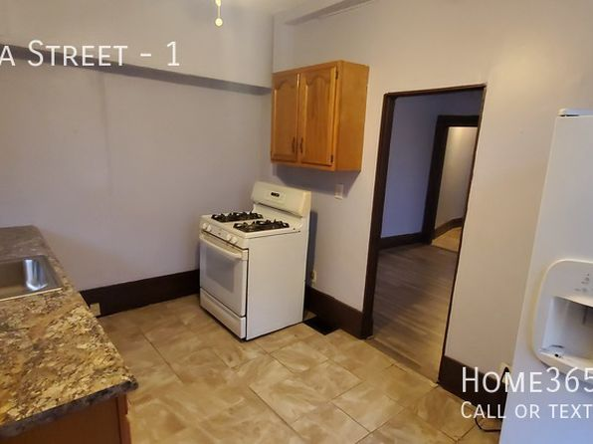](https://www.zillow.com/homedetails/2515-Elba-St-APT-1-Pittsburgh-PA-15219/2060354674_zpid/)](https://www.zillow.com/homedetails/2515-Elba-St-APT-1-Pittsburgh-PA-15219/2060354674_zpid/)

*[621-623 Lincoln Ave, 621-623 Lincoln Ave #3, Pittsburgh, PA 15206](https://www.zillow.com/b/621-623-lincoln-ave-pittsburgh-pa-C95NRV/)*

$1,200/mo

* **2** bds
* **1** ba
* **--** sqft

- Apartment for rent

64 days ago

[[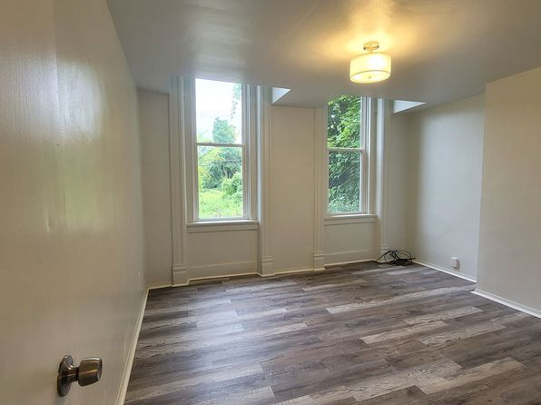](https://www.zillow.com/b/621-623-lincoln-ave-pittsburgh-pa-C95NRV/)](https://www.zillow.com/b/621-623-lincoln-ave-pittsburgh-pa-C95NRV/)

*[63 S 14th St, Pittsburgh, PA 15203](https://www.zillow.com/homedetails/63-S-14th-St-Pittsburgh-PA-15203/11474568_zpid/)*

$1,795/mo

* **3** bds
* **1** ba
* **1,300** sqft

- House for rent

60 days ago

[[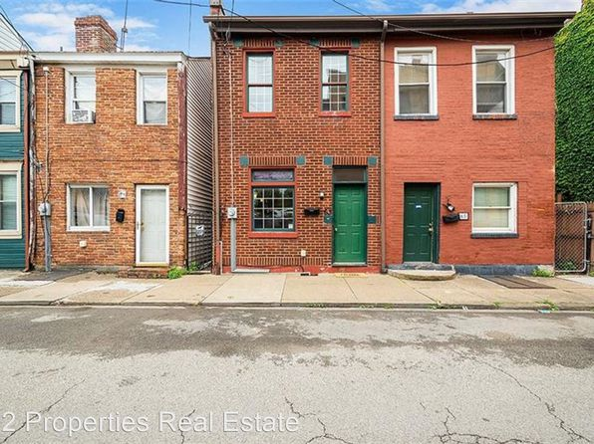](https://www.zillow.com/homedetails/63-S-14th-St-Pittsburgh-PA-15203/11474568_zpid/)](https://www.zillow.com/homedetails/63-S-14th-St-Pittsburgh-PA-15203/11474568_zpid/)

*[27 Norton St FLOOR 1, Pittsburgh, PA 15211](https://www.zillow.com/homedetails/27-Norton-St-FLOOR-1-Pittsburgh-PA-15211/2060413199_zpid/)*

$1,425/mo

* **2** bds
* **1** ba
* **825** sqft

- Apartment for rent

47 days ago

[[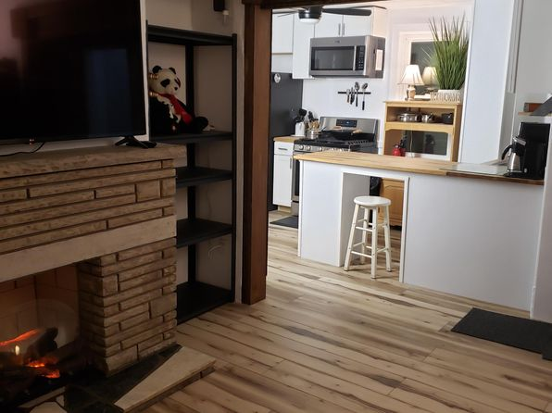](https://www.zillow.com/homedetails/27-Norton-St-FLOOR-1-Pittsburgh-PA-15211/2060413199_zpid/)](https://www.zillow.com/homedetails/27-Norton-St-FLOOR-1-Pittsburgh-PA-15211/2060413199_zpid/)

to get email alerts when listings hi